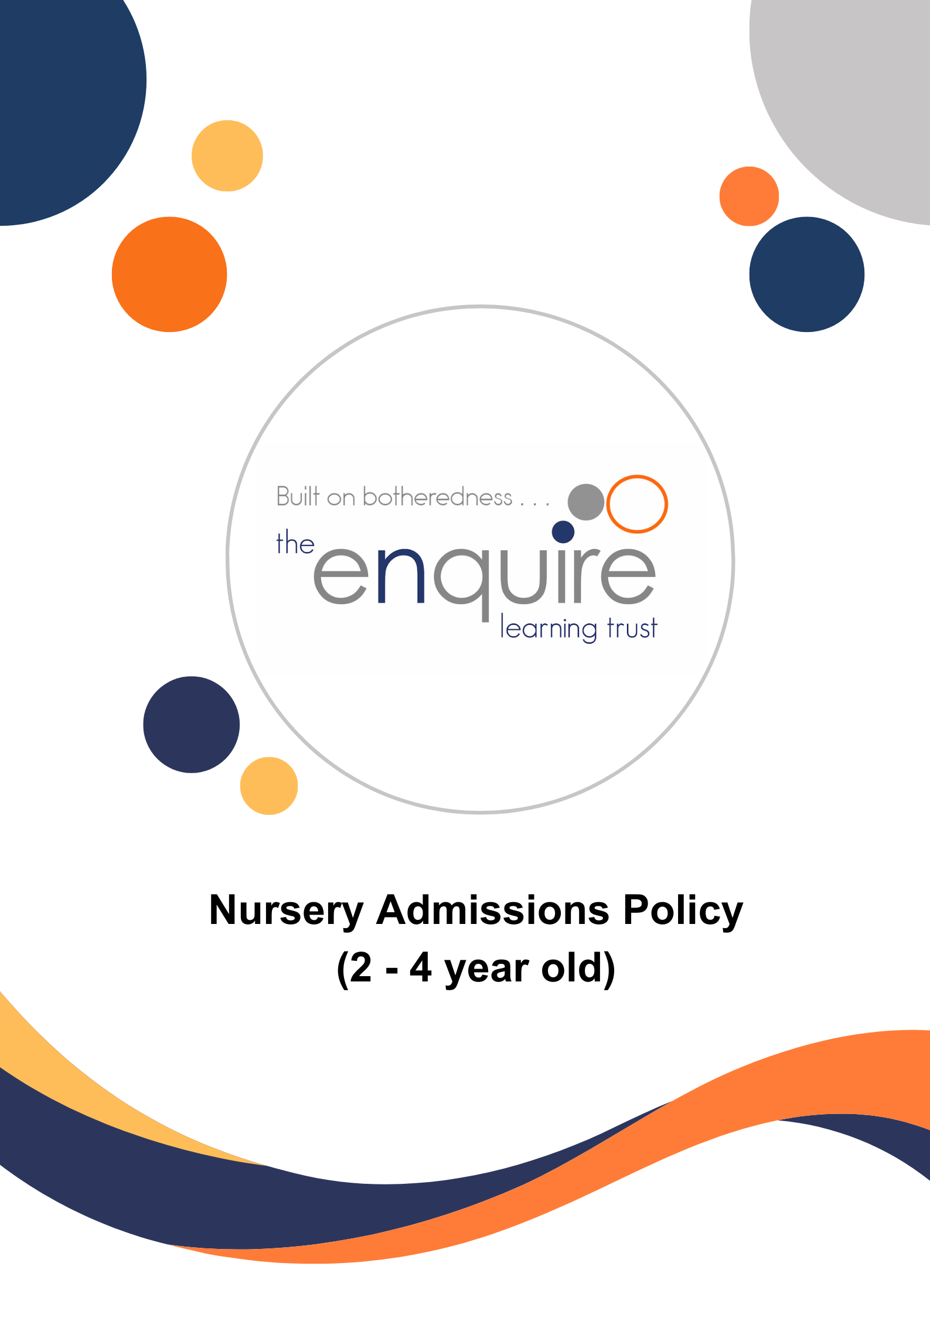

Contents

Section | Title
1 | Aims
2 | Criteria for Admission to the Nursery
3 | Decisions on Places
4 | Home Visits
5 | Waiting Lists
6 | Leavers during the year
7 | Attendance and loss of Nursery Place
8 | Transfer from Nursery into School
 | APPENDIX 1 – HM Government Childcare hours summary

Version History

Approved by: | Trustees
Last reviewed: | November 2024
Next review due by: | July 2027

Date | Author | Version | Comment
March 2022 | LT | 1 | Policy Created
December 2023 | LT | 2 | Policy updated to accommodate Government funding changes for 2024.
November 2024 | LT | 3 | Reviewed as Trust Policy  Nursery Session Options and Application Date sections removed – each academy to provide their own arrangements to parents.

- Aims

Our aims are:

  - To ensure access and entitlement to the benefits of high-quality child centred Nursery education on a fair and equitable basis, for children and families in our local community.
  - To establish an admissions policy governed by clearly defined criteria that may be articulated to parents and other professionals.
  - To help promote consistency of practice and procedure between Nursery classes in The Enquire Learning Trust.
  - To ensure, as far as possible, that all children who gain a place will fully benefit from their Nursery education with us, their needs being fully met, whilst we make the very best of our available resources.

- Criteria for Admission to the Nursery

The school will offer children a place in the Nursery from the term after their third birthday:

Child born between | Universal government funding starts
1 September – 31 December | Term beginning on or after 1 January
1 January – 31 March | Term beginning on or after 1 April
1 April – 31 August | Term beginning on or after 1 September

Places will be offered according to the criteria in the following order of priority:

  - Places will be offered on a first come first served basis in line with government ratios.
  - The Nursery will take children from the term after their second/third birthday.
  - A child will remain in Nursery until the end of the academic year in which they are 4 years old.
  - A child’s intake into Nursery may be staggered over two or more weeks.
  - Any spare places will be allocated during the year, as they become available, to children who are in the half-term after their second/third birthday or older.

- Decisions on places

  - Decisions will be made by the Principal at the Academy; decisions to offer a place will be based on the criteria and procedures laid out in this Admissions Policy.
  - Decisions will be final and there is no right of appeal.
  - The offer of a Nursery place DOES NOT mean automatic entitlement to a place in one of the Reception Classes.
  - Parents/Carers who accept a place, will be expected to commit to taking up the place for the rest of the academic year.

- Home Visits

These may be made before a child takes up their place.

- Waiting Lists

If the Nursery is oversubscribed, a reserves list will be maintained and will remain in place until the end of the relevant academic year.

- Leavers during the year

If a child is withdrawn by their parents from Nursery during the school year, we request that parents/carers must give the school a minimum of 8 weeks’ notice. The place of a child who has been withdrawn cannot be held open and will be automatically made available to allocate to a child on the waiting list. If parents/carers later wish their child to return to the Nursery, then they will have to re-apply for a place and the application will be considered according to the criteria along with any other applications at the time, unless there are special circumstances. The fact that a child has previously been in the Nursery class, or any other Nursery class, will in no way influence the decision on being offered a place.

7. Attendance & loss of Nursery place

  - If attendance and / or punctuality is poor or erratic, the Nursery teacher will talk to the child’s parents/carers and remind them that for the child to benefit fully from Nursery education attendance needs to be regular and punctual due to the great demand for places. This conversation should be recorded and dated in the child’s Learning Journey.
  - If after a period of two weeks, attendance and/or punctuality remain poor, a letter will be sent to the parents/carers inviting them to meet with the Principal.
  - If following the meeting, there is no sustained improvement in attendance and/or punctuality within an agreed period, then the child may lose their place. Parent/carers will be notified of the loss of place in writing.
  - If a child is absent for a period of three weeks without any contact from the parents and the school has been unable to make contact within this time, the child may lose their place and it may be offered to someone else. This will be decided by the Principal, and a letter explaining the situation will be sent to the parents/carers.

8. Transfer from Nursery into School

  - All parents and carers must be aware that a place in the Nursery does not guarantee a place in the academy and that they must still go through the correct Local Authority Admissions Procedure. However, the Trust Admissions Code states that where a child attends one of our Nurseries and is in receipt of Early Years or Pupil Premium funding then a place could be secured in the Reception Class.
  - The Nursery staff will liaise closely with colleagues in Reception classes to plan for a smooth transition into our Reception class, or any other chosen or allocated school. Nursery staff will send on reports and other agreed records to other schools as appropriate.

APPENDIX 1

