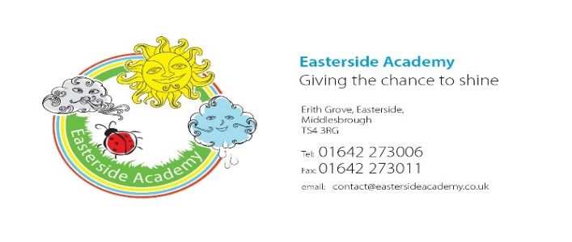

Easterside Academy PSHE/RSE Parent/Carer Questionnaire Feedback
Dear Parents/Carers,
From September 2020, the ‘Relationships Education’ aspect of PSHE becomes statutory for Primary aged children and will be taught throughout school with age appropriate lessons.
Recently, a virtual consultation time was available for parents/carers to view the current RSE policy and lesson objectives as seen on the school website, Marvellous ME and Seesaw. A questionnaire was available so that parents and carers could respond; thank you for those that have read the new documents or have sent back a questionnaire. Curriculum documents will remain available at all times via the school website. Here are some feedback examples from the responses…
What do you like about our PSE/RSE Curriculum?
You said…
- All of it sounds very useful to help my child thrive at school and in life.
- Focuses on the difficulties children can face in day-to-day life.
- That it’s taught in all years and helps them to learn as they grow and learn.
- Wide range, mostly focused on well-being and personal growth.
- That the aim is to prepare students for life in the modern world.
We said…
- Our Our aim is for all children to develop into independent, confident, successful learners with high aspirations, who are resilient and know how to make a positive contribution to their own community and wider society. We uphold and teach pupils about British Values: democracy, rule of law, individual liberty, mutual respect and tolerance of those of different faiths and beliefs.
- Our PSHE/RSE curriculum uses a wide range of resources, accredited by the PSHE association, and aims to sets out learning opportunities for each key stage, in three core themes: Health and Wellbeing, Relationships, and Living in the Wider World. We believe that our curriculum is up to date so that children leave Easterside with the knowledge, skills and strategies needed in today’s modern world.
- THRIVE is an important aspect of our curriculum which focuses on social and emotional development. Easterside academy now have three trained ‘Thrive Practitioners’ who are trained to support staff and implement 1:1 sessions with children and offer support to parents/carers.
What could we include that is not within our PSHE/RSE curriculum already?
You said…
- Mindfulness
- Not sure
- Greater fundamentals of right and wrong in the wider sense, British values.
- Loss and Bereavement (Humans and pets) and coping strategies post Covid 19.
- How can we intergrate the children back into the education setting using elements of the PSHE/RSE curriculum?
- Study skills and how core theme 1 relates to positive study habits the students can take into secondary school.
- More choice of reading books on ‘Reading Plus’.

We said…
- Mindfulness is an important aspect to everyday life here at Easterside Academy. This is incorporated through daily morning check-ins and PSHE lessons.
- British Values runs throughout our PSHE/RSE curriculum. Through the fantastic ‘Picture News’ resource, different British Values are developed through current world wide news with a thought provoking question.
- Assemblies also give children the opportunity to explore British Values and think about this in relation to everyday life and within the community.
- Loss and bereavement is explored through the ‘Health and Well-being’ strand in each Key Stage.
E.g. How different things / times / experiences can bring about different feelings for different people (including loss, change and bereavement or moving on to a new class/year group). Coping strategies, post Covid19 will be a priority that will run through many enquiry questions termly.
- Study skills are explored through ‘Living in the Wider World’. Here at Easterside Academy we also have our detailed ‘Careers’ curriculum which begins at Ey’s through to Upper KS2.
- EY’s: All about Me. KS1: Emergency services/School Roles/Enterprise. Yr 3/4:Community Links/Roles within the NHS. Yr 5/6: Wider World of Work/ International Links/Transition/ Further Education Links.
- Reading Plus is a valuable resource for use in school and at home. This resources was developed by leading reading researchers over a number of years. Any feedback or questions can be forwarded to…
https://www.readingplus.com/customer-support/
As a parent, do you feel like you need more information or guidance on specific topics? If so, which topics?
You said…
- I would like information on what lessons are planned so I am aware of what my child will be getting taught.
- I’m happy with the information.
- No
- No, I feel well prepared with the topics covered for you to complement what my children will learn at home.
We said…
- Easterside Academy are implementing the ‘Enquiry Question’ model of teaching for PSHE. Children will explore each question at the beginning of the unit of work and then revisit this at the end to show new learning and strategies that have been developed.
- All termly ‘Enquiry Questions’ and learning linked to this can be found on the school website at…
https://www.eastersideacademy.co.uk/important-information/curriculum-subjects/pshe-curriculum
- A new termly PSHE/SRE newsletter will be sent out to parents/carers showing each key stages’ learning questions and linked objectives. Links/dates will also be included to any useful websites, support sessions or events in school and external support agencies.
- Appointments are welcome with the PSHE Lead, Principal, Care Team or THRIVE Practitioners (social & emotional development needs) to discuss any further information that may be needed.
To what extent do you agree with the following statement about our SRE Policy and Curriculum: ‘I feel confident that my child will be taught about the range of RSE topics required by the DfE at an appropriate stage in their development, in a way that is sensitive to their cultural or religious background and in a way that respects the dignity and equality of all pupils.
You said…
- All scored 5: Strongly Agree.
We said…
- We are pleased that parents and carers feel confident with the teaching of PSHE/RSE at Easterside Academy and thank you all for your continued support.
As a school community, we are committed to working in partnership with parents; recent parental feedback has indicated that parents continue to be highly supportive of the school and the teaching of PSHE/RSE.
Thank You,
K.Weetman (Miss K.Weetman) PSHE Lead.

