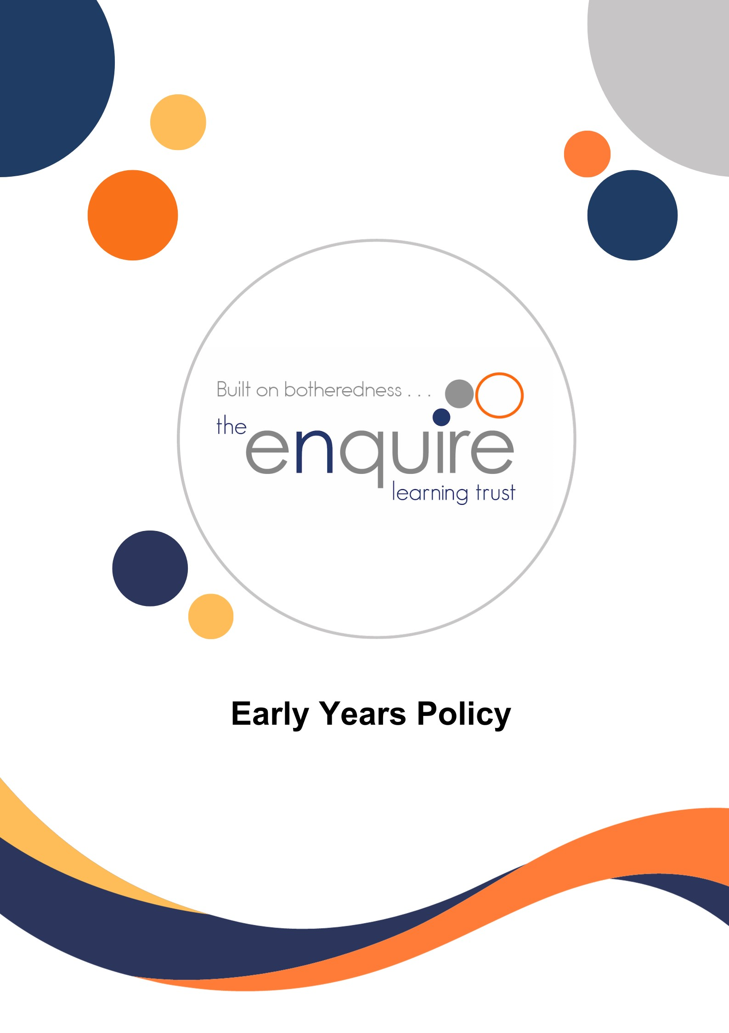

Safe Sleep Policy

Contents

Section | Title | Page
1 | Aims | 3
2 | Legislation | 3
3 | Principles | 3
4 | Early Years Responsibilities | 3
5 | Trust Responsibilities | 5
6 | Parent / Carer Responsibilities | 5
7 | Appendix 1 – Enabling Environment Equipment Procedures | 5
8 | Appendix 2 – Sleep Record | 6

Version History

Approved by: | Trustees
Last reviewed: | SEPT 2025
Next review due by: | Sept 2026

Date | Author | Version | Comment
August 24 | Delyth Linacre | 1 | NEW POLICY
August 25 | Delyth Linacre | 2 | Reviewed / updated in line with EYFS Statutory Framework 2025

1. Aims

The sleep policy aims to provide a clear framework to ensure the health, safety and wellbeing of all children who require support to sleep or rest whilst in our two-year-old provision and nursery.

2. Legislation

This policy is based on requirements set out in the statutory framework for the Early Years Foundation Stage (EYFS) for 2025.

3. Principles

In our academies we promote healthy and safe practices in helping children sleep and rest. We will ensure:

• Supporting children’s sleep is the responsibility of all DBS checked and approved staff for children in their care.
• Children’s individual needs are identified and met.
• Children’s right to health, safety and wellbeing are met.
• Family’s cultural preferences are considered.
• Sleeping and resting in nursery is a positive experience, both the child and the family feel supported throughout.
• Communication between the Nursery and the family is promoted, and this starts prior to the child starting nursery so information is shared and routines are established and agreed. • Consistency of care as far as possible.
• Families are provided with information or signposted to sources of further information or services to support sleep and bedtime routines if required.

4. Early Years Responsibilities

Our Policy requires that the key person discuss the Safe Sleep Policy with a child’s parent or carer before admission.

The Early Years will ensure that anyone who supports a child sleeping or resting in our two-year-old provision or nursery is an employee of the academy and has had appropriate safeguarding checks and is aware of procedures and responsibilities for supporting children’s sleep.

The Early Years will ensure that all staff are aware of the need for confidentiality. Personal and sensitive information will only be shared with those who need to know.

The Early Years will act according to the academy’s safeguarding policy and procedures if there are any concerns for the child’s wellbeing.

At all times the child’s safety, dignity and wellbeing is promoted.

The Trust’s Early Years settings will ensure that there are designated places for sleep and rest.

The Early Years staff work closely with parents/carers to support children’s sleep care, routines and rest so that continuity of support can be maintained between home and Early Years.

Staff will provide a positive climate to encourage parents to share information openly around the child’s developing sleep needs or if a child is having difficulty with sleeping at home and this is impacting on their daily wellbeing in the two-year-old / nursery provision.

Prior to starting in the early years provision, we discuss children’s sleeping needs and routines with families to provide consistency for the child. Information is recorded on the child’s record. As the child continues and progresses in their development in Early Years, staff will continue to discuss and update the child’s routine with the parent/carer if required.

Written records are kept of all support for sleeping. Sleeping children will be monitored by staff every 10 minutes. The time a child is put down to sleep, when they wake, and ten-minute monitoring checks are recorded by staff. This information is available to parents / carers at all times and will be checked periodically by Early Years Lead. (Appendix 3).

Children will be monitored visually when sleeping and will never be left in a separate room to sleep.

Families are supported by staff to understand the Early Years health and safety procedures for supporting rest and sleep. Staff will always try to take account of parent / carers wishes when dealing with sleeping children. However unreasonable requests by parents / carers will be discussed with the teacher and/or lead practitioner and alternatives sought e.g. Children going to sleep with bottles. We will not carry out requests of parents / carers if they feel that it could put the child in any danger.

Staff will not leave children to sleep with bottles as this provides danger of choking and does not promote good dental health.

Staff will encourage children to sleep in designated areas or quiet areas.

If a child falls asleep in the room, staff will aim to make them comfortable and safe without disturbing them.

The Early Years staff will take into account the religious views, beliefs and cultural values of the child and their family as far as possible when supporting children with sleep.

4.1 Early Years responsibilities for supporting parents with children’s sleep

For some parents / carers and families, developing sleep routines so the child has adequate rest can be daunting and difficult and can impact on the child’s wellbeing at nursery. Parents will be provided with information or signposted to support such as Health visitors.

4.2 Early Years staff responsibilities in supporting positive self esteem

Early Years staff will work with the child to promote a positive self- esteem and independence with sleep as far as is appropriate and practical. Early Years staff will remain calm and offer a supportive approach to children at all times. Staff will approach children quietly and calmly regarding the need to sleep being mindful of the child’s engagement in play. Staff will be alert and responsive to a child’s needs if showing signs of tiredness. All staff should promote regular encouragement for a child needing and settling to sleep and ensure the child is praised for following routine, helping and co-operating and being independent in getting ready for sleep or on rising.

5. Trust Responsibilities

The academy’s principal will ensure sufficient staff are trained to meet early years ratios and the developing needs of young children.

All key persons working in our settings are required to receive induction training on the Safe Sleep Policy.

The Trust’s Director of Early Years will ensure this policy is monitored and reviewed at least every three years. The policy will be ratified by Trustees.

6. Parent / Carer Responsibilities

Parent / Carers must ensure they provide all relevant information with regards sleep for their child on entry to Early Years and as the child develops, so the child’s needs can be met. This includes information about how long the child is to sleep, any routines for going to sleep or rising, any comforters requested, details of any health care professionals involved in supporting sleep or any problems or health care difficulties with sleep.

If the child requires a comforter this must be in a sealed bag/pot labelled with the child’s name.
Dummies are not encouraged within Pre-School as they can hamper a child’s speech, interaction with others and are a major cause of speech delay.

Parents / carers should work with their child’s Key Person towards a shared and agreed plan which is recorded for care and support.

Parents / carers must ensure that the Early Years always has their up-to-date emergency contact details.

7. Appendix 1 - Enabling Environment Equipment Procedures

When supporting children who need to sleep Early Years staff will ensure:

• Designated sleep / rest area in 2-year-old room with use of large, flat floor cushions (with removeable covers) or small mattress.

Where sheets are used on mattresses, they must be removed and washed after use, using non-biological washing detergent.
Clean bedding is stored in labelled covered boxes.
Torn or ripped bedding is removed immediately and replaced.
Parents are asked prior to children starting Nursery if their child has allergies to washing detergent and if so appropriate precautions taken.

• Quiet areas where children can rest if they fall asleep in 3–4-year-old room.

8. Appendix 2 – Sleep Record

Example:

Child’s Name:

Date | Time at Start of Sleep | Note 10min Checks | Wake Time | Length of Sleep | Signed  (Staff Member)

Naps are an essential part of a child’s sleep needs, and it is important to document them while they are in our care. This documentation helps staff and families identify any changes in sleep patterns. For instance, if a child is sleeping more than usual, it could be an early sign of illness and should be communicated to the family.

