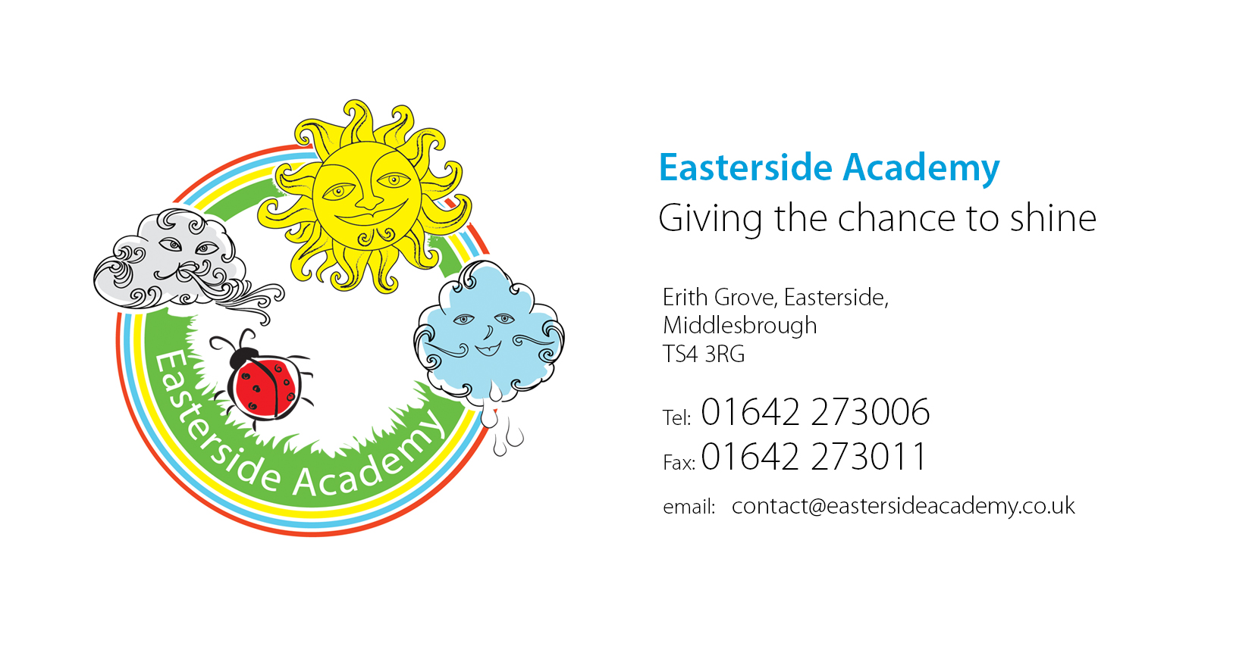

Sunday 23rd August 2020

September School Re-Opening Update

Dear Parent/Carer,
Hope this letter continues to find you all safe and well.
As Thursday 3rd September approaches, we are looking forward to welcoming all our children safely back into school! It seems such a long time since we saw some of them and we are keen to have them all back with their friends and re-engage them in learning. Your child's well-being will be of paramount importance to us and we will work with you to ensure they settle quickly back in.
I know some of you will be very anxious about your child's return to school, and I wanted to reassure you all and remind you of the information regarding the September re-opening and the measures we have put in place to mitigate risk.
If you can remember, I used the adult/child hand icon to highlight any parts that might be useful to talk about with your child/ren in order to prepare them for the beginning of term.
The safety of pupils and staff is our primary concern in this planning process and will remain so throughout.
The academy’s risk assessment for re-opening will be published on the website before re-opening.
These measures below are in line with Government, DfE and Enquire Learning Trust guidelines.

1. | Signage around school – external and internal – reminding people that social distancing is being practiced in and around school where reasonably possible. Signs will also direct parents/carers where needed for entrances and exits of classes.  Entrances / Exits  Early Years / KS1 will enter / exit through their classroom doors.  Mrs Seymour / Miss Weetman / Mrs Freeman’s will enter through the lower KS2 yard door (where Mrs Seymour’s go in now).  Mrs Seymour’s will also exit from here.  Miss Norris and all Year 5/6 pupils will enter through the upper KS2 yard door nearest the hall.  Y3/4 will exit from the hall door.  Y5/6 will wait under the KS2 sheltered space.  Please be patient at home time to allow us to get these procedures right for everyone’s safety.  If you arrive at school late – please go to the main entrance. All external doors will be closed at 9.15am. | 
2. | No visitors into the school except for those agreed by the principal and with a prior appointment. Staff will be available to pass on messages on the yard and entrances, however if you are unable to catch anyone or would like to speak to someone specifically, please call the main school office.
3. | Staggering of start / finish times  Start Times:  Children with surnames A-L to arrive between 8:45 and 9:00.  Children with surnames M-Z between 9:00 and 9:15.  Pick Up Times:  Children with surnames A-L to leave between 2:45 and 3:00.  Children with surnames M-Z between 3:00 – 3:15.  If you have children with different surnames then just pick either time to arrive – it’s more important that things are staggered than the exact grouping.
4. | Clearly marked spots / areas for pupil collection at the end of the day to support social distancing where and when needed.
5. | All staff will be verbally promoting and modelling social distancing where it is reasonable to do so. Expectations and new ‘rules’ will be shared with children on the first day back as well as through a letter before we break up.
6. | Areas of the school will have specific number of pupils / adults in at any one time e.g. toilets, cloakrooms.
7. | Classes are now ‘bubbles’ (except reception which will be classed as one bubble). Bubbles do not mix with another bubble at any point in the day.
8. | Classrooms / teaching spaces will be organised to minimise risk e.g. tables facing the front where reasonable to do so for teaching and learning. Teachers will move the tables to suit the needs of the lesson and learning as well as mitigating risk.
9. | Frequently used class resources will be given to pupils and kept in their trays to reduce sharing e.g. pencil, ruler, whiteboard. Children MUST NOT bring in any resources from home.
10. | Movement will be minimised around school. Children and adults will stay within their class ‘bubble’ as much as possible.
11. | Large gatherings such as assemblies will continue to be suspended.  There will be assemblies in the classrooms and I will do assemblies remotely to the classroom via Microsoft Teams.  Celebrations will still take place every Friday – within classrooms.
12. | Playtimes and lunchtimes will be staggered. Children to remain in their ‘bubbles’ and will not mix. Each class will have its own play equipment box.  Children will get a morning playtime; time in the lunch hall to eat and an afternoon play outside.
13. | The lunch hall will be organised to seat three class bubbles at a time – without mixing them. Bubbles will keep to their own area of the dinner hall and tables wiped down in between bubble use.  There will be either a hot or cold ‘grab bag’ option available to those having school dinners. Children will order which one they would like when the register is taken at the start of the day.  Children having packed lunches will keep their lunchbox in their classroom and eat it with their ‘bubble’ in the hall.
14. | Relevant PPE will be used by First Aiders when caring for ill or injured pupils / adults; and if intimate care is required (changing).
15. | Children will only need to bring in essential items to school. This includes:  - Academy Book Bag (needed to carry reading book)  - Lunch Box (if on packed lunches)  - Water Bottle  - Coat / Jacket
16. | Children will be taught and reminded about good hygiene and will regularly wash their hands with high quality antibacterial soap. They will also be taught and reminded about ‘catch it bin it kill it’ for tissues etc.  Hand sanitiser and tissues will be in each classroom.

The Behaviour Policy
This has been updated in light of COVID 19 and prior to the partial re-opening.
The policy can be found on our school website.
Any behaviour that puts pupils and staff at risk of infection will not be tolerated. This includes deliberately coughing, spitting at another person or not following our new procedures in place to keep everyone safe.

What happens if a member of staff or a pupil falls ill?
- Pupils, staff and other adults must not come into the school if they have coronavirus (COVID-19) symptoms, or have tested positive in the last 7 days.
- Any child or adult that becomes unwell in school and/or shows COVID symptoms will be sent home.
- If pupil/staff member displays symptoms they should self-isolate for 7 days and family members for 14 days.
- If a pupil/staff member tests positive they, and their class (bubble), should self-isolate for 14 days. Family members of the wider group do not need to

self- isolate unless the child/ staff member develops symptoms. If they experience symptoms during the 14-day period, a further 7-day isolation should begin on the day that symptoms occur.

All staff, pupils and parents are expected to engage with the Track And Trace process if they experience symptoms.

How will you keep us up to date?
I will continue to keep you updated using:
- Website ‘news’.
- APP notifications
- Marvellous Me

We are looking forward to welcoming everyone back in September! ☺

Best Wishes,

D. Linacre
Mrs D Linacre
Principal










