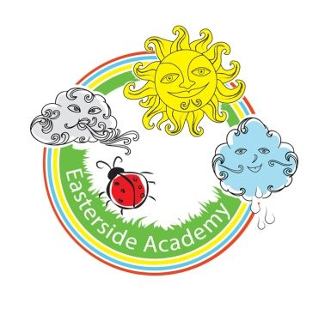**Easterside Academy Experiences and Visits Map**

**Year Group: 1/2 Cycle 2: (2019-2020)**

|  |  |  |  |  |  |  |
| --- | --- | --- | --- | --- | --- | --- |
|  | **Autumn 1** | **Autumn 2** | **Spring 1** | **Spring 2** | **Summer 1** | **Summer 2** |
| **ILP**  (Imaginative Learning Project) | Superheroes | Splendid Skies | Moon Zoom | Street Detectives | The Enchanted Woodland | Land Ahoy! |
| **Focus**  (Subject) | PE | Science | D&T | History | Science | Geography |
| **Memorable experience** | Superhero hunt and visit. | Visit to Stewart Park | Rocket/Space Ship crashed on school field | Local community  Invite elderly people into school to explain and discuss how homes have changed from what they were | Fairy Dell  Fairy Habitat  Fairy Door | Stewart Park – Captain Cook Museum |
| **Visits** | Visited by real life superhero (fireman/police) | Stuart Park  Local area walks | Life Centre | Local community | Fairy Dell | Hartlepool museum  The Endeavour |
| **Outdoor Learning** | Outdoor hunt (looking for superheroes) | Measuring shadows outside.  Make season trees using real branches from real trees and mounting them onto Plaster of Paris.  Sensory walks.  Making and flying kites. | Set up a mini solar system on the playground/field. | Practise giving directions to a partner in the school grounds.  Walks around the estate, using a map to follow our route.  Make different landscapes outdoors using soil, sand, leave, stones etc to represent what can be seen from an aerial image. | Fairy homes  Traps  Circuits (light up habitat) | Map skills  Orienteering  Floating and sinking  Search for hidden treasure found outside.  Make a treasure map – explore outdoors to see what features to include. |
| **Innovate Stage** | Dr Slime visits the school and leaves a trail. | Send a balloon on a planned journey. Plan the best place to launch it from, predict what will happen to it, write a postcard for the finder of the balloon, take photos on the launch day and display them with labels and captions. |  | How to change our local area for the better. Make a Great Big Plan. Add in new street names, a statue of a local hero, new places to play, new shops etc.  Invite parents and visitors in to view the Great Big Plan. |  | Dress up as pirates, follow a map and clues to find hidden treasure (hidden by Captain Longbeard), meet Captain Longbeard and tell him what we are going to do with his treasure – plan what we are going to say beforehand. |