Memorable Experience |  | Autumn 1 | Autumn 2 | Spring1 | Spring 2 | Summer 1 | Summer 2
 |  | Changes |  | Once upon a time |  | Off we go!
 |  | 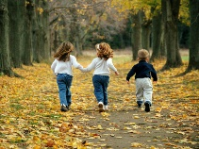 | 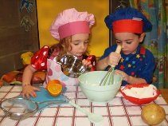 | 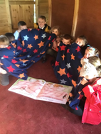 | 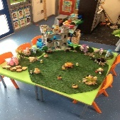 | 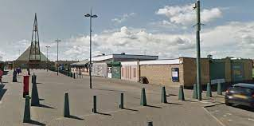
Careers |  | - Dental service ( visitor) -looking after your teeth.  - Vet (visitor)-relating to changes and care of class animal. |  | Qualities and skills focus  - Stories and role play  - Key worker group activities-in and outdoors  - Exploring rules/right and wrong |  | - Visits to the local environment –people who help us.  - Fire Service/Police visitors  - Local places of interest to children- eg. local farm  - Graduation form Early Years to Key stage One
- Care Home visits

- Early Words together
Cultural Days |  |  |  |  | Chinese New Year  Cycle 1 |  | France  Cycle 2
Well-being  Including  Outdoor Learning Focussed Activities  (with Outdoor Learning Assistant |  | THRIVE APPROACH/ OUTDOOR LEARNING
 |  |  | Use of woodwork tools |  | Planting | Planting
Links to the School Values
 |  | _{Team Work} | _{Respect} | _{Self Belief} | _{Passion} | _{Determination} | _{Honesty}
Roles and responsibilities |  | Class monitors preparation-Establishing tidy up routines
Additional opportunities and  experiences | Sport | Funky Feet Yoga bugs skills Stay and play> Mighty Warriors
 | Other | Signing Tots Cross curricular -activities in the areas Key worker groups Learning outside the classroom Early Words Together
101 things to do before leaving Easterside Academy

