Cycle 1 |  |  | Autumn 1 | Autumn 2 | Spring1 | Spring 2 | Summer 1 | Summer 2
 | Memorable Experience |  | Hancock Museum | Queen comes to tea – tea party. | Animal experience in school. | Butterfly World | Raby Castle | Grace Darling Museum
 |  |  | 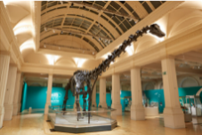 | 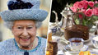 | 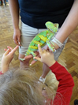 | 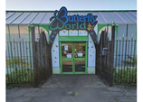 | 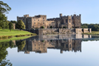 | 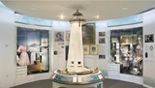
 | Careers  Experiences |  | How did dinosaurs become extinct?  Enterprise opportunity  - Class museum- -Money making project | Why did London burn down?  - Ambassador visit(Civil Engineer) | Who helps to keep us healthy?  - School nurse  - Dental service | What can we do with money?  - Mrs Cooper ABM  (school budget) | Who helps to keep us safe?  - Great North Ambulance | How can we look after each other and the world?  - Red Cross  - Tollesby Home Care worker
 | Cultural Days |  |  | France |  | Brazil |  | Spain
 | Well-being  Including  Outdoor Learning Focussed Activities  (with Outdoor Learning Assistant) |  | THRIVE APPROACH/ OUTDOOR LEARNING
 |  |  |  | Why did London burn down?  Wattle (Great Fire of London) | What makes a habitat a home?  Habitats | Minibeast, friend or foe?  Planting for minibeasts | How did castles best defend against invaders? Making weapons – use of tools
 | Links to the School Values
 |  |  | _{Team Work} | _{Respect} | _{Self Belief} | _{Passion} | _{Determination} | _{Honesty}
 | Roles and responsibilities |  | >Class Monitors >School Council > Rota Kids
 | Additional opportunities and experiences | Sport | Boro Soccer School Bell Boating-SEN school sports >Simon Carson multi sports M’bro School Sports Partnership Intrasports competition After school sports clubs
 |  | Other | Class budgets Cookery Club Central Library( Librarian/reading area monitors) Environmental City Busy Bees-art and craft club Community links-hampers/events Childrens’ University
101 things to do before leaving Easterside Academy

Cycle 2 |  |  | Autumn 1 | Autumn 2 | Spring1 | Spring 2 | Summer 1 | Summer 2
 | Memorable Experiences |  | Superhero Day | Autumn Walk | Visit to Centre of Life | Local environment walk | Guisborough Woods | James Cook Museum
 |  |  | 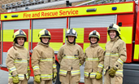 |  | 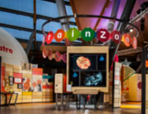 | 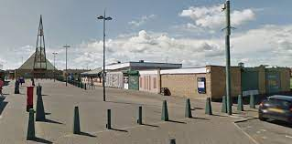 | 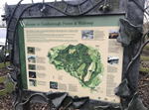 | 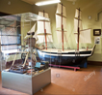
 | Careers |  | What makes a hero?  - Fire, police, ambulance, paramedics  - RNLI  - STEM ambassador- civil engineer(building regulations) |  | What jobs do people do?  Jobs Fair-school roles/shadow employees  - School Office/Site Manager/  - Principal /Vice Principal/class teacher/care team  - Kitchen and Catering staff  - STEM ambassador visit |  | What helps us grow and stay safe?  - Care Team  - Computer Leader/digital leaders  - Junior Safety Officers-JSO
 | Cultural Days |  |  | Norway |  | France |  | Australia
 | Well-being  Including  Outdoor Learning Focussed Activities  (with Outdoor Learning Assistant) |  | THRIVE APPROACH/ OUTDOOR LEARNING
 |  |  | What makes a hero?  Allotment – healthy eating | How does the weather change?  Weather and seasonal changes | What’s in Space?  Solar systems – use of tools |  | What might you find in the woods/  Animal shelters
 | Links to the School Values
 |  |  | _{Team Work} | _{Respect} | _{Self Belief} | _{Passion} | _{Determination} | _{Honesty}
 | Roles and responsibilities |  | >Class Monitors >School Council > Rota Kids
 | Additional opportunities and experiences | Sport | Boro Soccer School Bell Boating-SEN school sports >Simon Carson multi sports M’bro School Sports Partnership Intrasports competition After school sports clubs
 |  | Other | Class budgets Cookery Club Central Library( Librarian/reading area monitors) Environmental City Busy Bees-art and craft club Community links-hampers/events Childrens’ University
101 things to do before leaving Easterside Academy

