Cycle 1 |  |  | Autumn 1 | Autumn 2 | Spring1 | Spring 2 | Summer 1 | Summer 2
 |  | Memorable Experience | York Chocolate Story | Forbidden Corner | BBC Horrible Histories- Performance of ‘Stone Age song’. | Climbing Wall | Hancock Museum | American Diner
 |  |  | 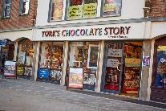 | 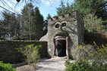 |  | 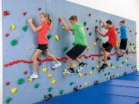 | 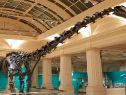 | 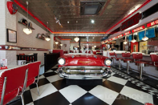
 |  | Careers | STEM  - Ambassador visit-supporting Enquiry question. |  |  | What makes a community?  - Community visits/visitors exploring jobs  How does the body work?  STEM  - Ambassador visit | Why should we eat well and look after our bodies?  - Community/School Nurse  - Dental Service | Why should we keep active and sleep well?  - Sports coach  STEM  - Ambassador visit
 |  | Cultural Days |  | France |  | Antarctica |  | USA
 |  | Well-being  Including  Outdoor Learning Focussed Activities  (with Outdoor Learning Assistant) | THRIVE APPROACH/ OUTDOOR LEARNING
 |  |  |  | Are potions real?  Making potions/natural materials/ herbs etc for potions. | Were people happier in Stone Age times? Willow shelters / Cave art – pavements / rocks / natural art |  | Who wants to live forever?  Clay pots | What does it mean to be civilised?  Making dream catchers- Willow/tools/outdoor materials.
 |  | Links to the School Values
 |  |  | _{Team Work} | _{Respect} | _{Self Belief} | _{Passion} | _{Determination} | _{Honesty}
Roles and responsibilities(Opportunities to develop citizenship/leadership skills) |  |  | - Class monitors > Eco warriors >Student Council > Rota kids
Additional opportunities and experiences | Sport |  | M’bro School Sports Partnership - Sporting interschool events locally > Intrasports competition> > > Fitness Boot camp> Swimming > > Urban Kaos > Cheer leading > Gymnastics > Football > > >> Local /Central Library( Librarian/reading area monitors) Climbing Wall Boro Soccer Skills Bell Boating-SEN school Simon Carson- Sports School Urban Kaos-dance
 | Other |  | Class budgets >Valley Music Service > Childrens’ University> > Environmental City- sports > > Apollo Arts-drama Community links-hampers Choir -ELT singing event Community Links-choir Easterside Extras Cookery Club Tees Valley Music – playing instrument
101 things to do before leaving Easterside Academy

Cycle 2 |  |  | Autumn 1 | Autumn 2 | Spring1 | Spring 2 | Summer 1 | Summer 2
 | Memorable Experiences |  | Segadunum | Tour of Middlesbrough | Seaside visit | Making poo | Viking Visitor | Zoo Lab
 |  |  | 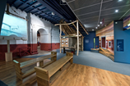 | 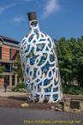 | 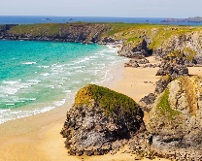 |  | 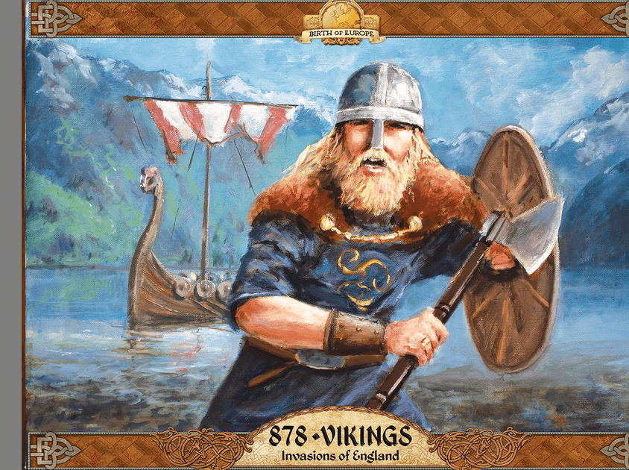 | 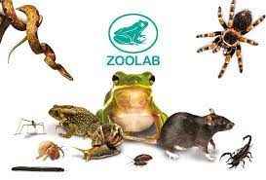
 | Careers |  |  |  | How do we manage our feelings?  - Head starters –Y5/6  - Thrive practitioners  - Care Team | How do we grow and change?  - School nurse  - STEM ambassador | How can our choices make a difference to others and the environment?  - Governors  - Rotary club members/Rota kids  - School Council | How can we manage risk?  - Junior Safety Officers(JSO)  - Pedestrian trainers  - Police -e-safety  STEM –Ambassador visit
 | Cultural days |  |  | Germany |  | France |  | Japan
 | Well-being  Including  Outdoor Learning Focussed Activities  (with Outdoor Learning Assistant) |  | THRIVE APPROACH/ OUTDOOR LEARNING
 |  |  | How did the fire of Colchester start?  Outdoor willow houses/Roman Shields |  | How did Pompeii become a lost city?  Fire pit- Making ash and experience fire, poetry/senses. | Where did all the food go?  Prepare and cook food outdoors |  | Predator or prey?  Outdoor mosaics using natural materials from the school grounds.
Roles and responsibilities  (Opportunities to develop citizenship/leadership skills) |  |  | - Class monitors > Eco warriors >Student Council > Rota kids
Additional opportunities and experiences |  | Sport | M’bro School Sports Partnership - Sporting interschool events locally > Intrasports competition> > > Fitness Boot camp> Swimming > > Urban Kaos > Cheer leading > Gymnastics > Football > > >> Local /Central Library( Librarian/reading area monitors) Climbing Wall Boro Soccer Skills Bell Boating-SEN school Simon Carson- Sports School Urban Kaos-dance
 |  | Other | Class budgets >Valley Music Service > Childrens’ University> > Environmental City- sports > > Apollo Arts-drama Community links-hampers Choir -ELT singing event Community Links-choir Easterside Extras Cookery Club Tees Valley Music – playing instrument
101 things to do before leaving Easterside Academy

