 |  |  | Autumn 1 | Autumn 2 | Spring1 | Spring 2 | Summer 1 | Summer 2
Cycle 1 | Memorable Experience |  | Alnwick Castle Visit | European Exhibition | Ice sculptor | Skinningrove Mining Visit | Salthome RSPB Centre | A day in the life of an Ancient Egyptian
 |  |  | 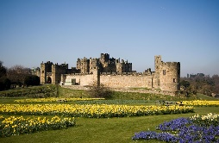 |  | 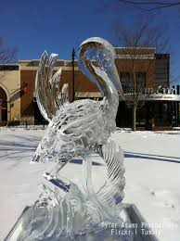 | 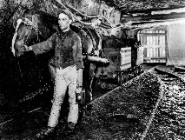 | 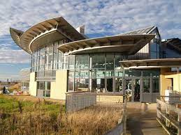 | 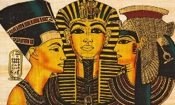
 | Careers |  | Job application process  - Adam Walker/ D Elliott governor/ director of firm  - Real experiences involved in job application.-:  - Letter Writing  - Interview  -Contact of Employment  - Training  - Appraisal  STEM  Scientists/ links with industry | What decisions do people make about money?  - My Money Week  - Barclays/Virgin/Nat west bank  - Class budget  - Financial instuitions visitors | How can we help in an accident or emergency?  - St Johns Ambulance  - S Callaghan- first aid training | Protected characteristics’ and British Values  - MP/Councillor visit | How can drugs affect health?  - Outside Agencies linked to drugs  - STEM ambassador  - Visits to local industry/Middlesbrough College/Teesside University/CAD  Secondary School Transition- Y6 | What jobs would we like?  - Jobs Fair/ Carousel/Job speed dating  - Visits to industry/places of work  - Y6 Enterprise  Fiver Challenge
- Gambia links-fundraising, role of a volunteer, penpals
- HMS Protector-links
- Game of Life -Simon Carson
- Digital Leaders Children challenging Industry project
- Stepping Out -David Foster
 | Cultural Days |  |  | France |  | Chile |  | Egypt
 | Well-being  Including  Outdoor Learning Focussed Activities  (with Outdoor Learning Assistant) |  | THRIVE APPROACH/ OUTDOOR LEARNING
 |  |  |  | Is it possible to stay safe during the war?  Tools – joining techniques – structures. Poppies – growing food – land army – sustainable living | How important are rivers?  Shaduf / tools / use of pulleys | How healthy is your heart?  Fire Pit – cooking – sustainable living – growing food. |  | Who were the Maya? Mayan Collage – masks with outdoor materials – Jade death mask – Pakal the great.
 | Links to the School Values
 |  |  | _{Team Work} | _{Respect} | _{Self Belief} | _{Passion} | _{Determination} | _{Honesty}
Roles and responsibilities |  |  | Rota Kids School Council Eco warriors JSO Digital leaders RPMs House Captains/Vice Captains Ambassadors Class Monitors Whole School monitors Headstarters
Additional opportunities and experiences |  | Sport | Sports Week . Sporting interschool events locally > Class budgets > Graduation > Battle of the generations > Urban Kaos >Cheer leading >Yoga > Wheelchair basketball > Basketball >Gymnastics > Football >Cookery Club > Boxercise> Boro soccer skills > Bell Boating-SEN school sports >Simon Carson sports school> M’bro School Sports Partnership> Intrasports competition> Climbing Wall Carlton residential Fitness Boot Camp Swimming
 |  | Other | Greenpower Kit Car-links with ambassadors Community links-hampers> choir > ELT events-choir >Childrens’ University> Environmental City> Apollo Arts>Game of Life > Easterside Extras Overnight camping on school field-Outdoor People Book Club >> Local /Central Library( Librarian/reading area monitors) > Links with FE> Music lessons-Tees Valley Music- recorders/ peripatetic playing an instrument> Secondary School links > Community Links- community event /choir
101 things to do before leaving Easterside Academy

 |  |  |  | Autumn 1 | Autumn 2 | Spring1 | Spring 2 | Summer 1 | Summer 2
Cycle 2 | Memorable Experiences |  |  | Compass Adventure overnight experience. | Remembrance Service cenotaph | River Tees Trip | Dissect a heart  with Dr Spencer (M’bro College) | Saltburn Fieldwork | Mayan Cultural Day
 |  |  |  | 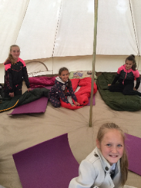 | 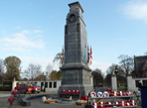 | 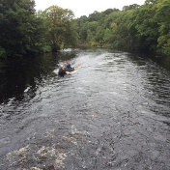 | 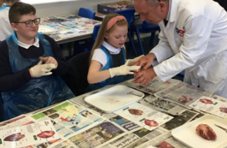 | 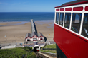 | 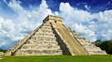
 | Careers |  |  | Job application process  - Adam Walker/ D Elliott governor/ director of firm  - Real experiences and audiences involved in job application process  -Letter Writing  -Interview  -Contact of Employment  -Training  -Appraisal  STEM  Scientists- links with industry. | How can we keep healthy as we grow?  - Sports coaches/PTs  - Sports Village/Visit  - Visits by professional sports men and women  - Dementia Friends  - Thrive practitioner  - Red Cross | How important are rivers?  Links with English  - Visitors -journalists/ radio/TV presenters/researchers/technicians.  - Visits to TV, radio and newspaper  - Computing links | How healthy is your heart?  - Dr R Spencer_ Middlesbrough College  - Community nurse | Where should we go on holiday?  - Employees of local industries/FE institutions  - Visits to local industry/Middlesbrough College/Teesside University/CAD  - Travel Agent  Secondary School Visits -Transition (Y6) | Jobs of the future  - Jobs Fair/ Carousel/Speed job dating  - Visits to industry> Local and Central Library  - Y6 enterprise-Fiver challenge
 | Roles and responsibilities |  |  | - Gambia links-fundraising, role of a volunteer, penpals  - HMS Protector-links  - Game of Life -Simon Carson  - Digital Leaders Children challenging Industry project  - Stepping Out -David Foster
 | Cultural Days |  |  |  | Poland |  | France |  | Mexico
 | Well-being  Including  *Outdoor Learning Focussed Activities  (with Outdoor Learning Assistant) |  |  | THRIVE APPROACH/ OUTDOOR LEARNING
 |  |  |  | Could the Great plague strike again? Plants/ flowers for dying materials. Large-scale weaving. | What's so 'great' about Europe? - Hapazome printing. |  | How safe were Victorian mines? Tools - creating structures - making a safety alert system for a mine – pulleys | What makes things move?  Lifecycles - classification of plants/ flowers/ animals / pond dipping. | How did Egyptians prepare for the afterlife?  Cooking – fire pit - Egyptian flatbreads.
 |  | Links to the School Values
 |  |  |  | _{Team Work} | _{Respect} | _{Self Belief} | _{Passion} | _{Determination} | _{Honesty}
Roles and responsibilities  (Opportunities to develop citizenship/leadership skills) |  |  |  | Rota Kids School Council Eco warriors JSO Digital leaders RPMs House Captains/Vice Captains Ambassadors Class Monitors Whole School monitors Headstarters (Well being Champions)
Additional opportunities and experiences |  |  | Sport | Sports Week . Sporting interschool events locally > Class budgets > Graduation > Battle of the generations > Urban Kaos >Cheer leading >Yoga > Wheelchair basketball > Basketball >Gymnastics > Football >Cookery Club > Boxercise> Boro soccer skills > Bell Boating-SEN school sports >Simon Carson sports school> M’bro School Sports Partnership> Intrasports competition> Climbing Wall Carlton residential Fitness Boot Camp Swimming
 |  |  | Other | Greenpower Kit Car-links with ambassadors Community links-hampers> choir > ELT events-choir >Childrens’ University> Environmental City> Apollo Arts>Game of Life > Easterside Extras Overnight camping on school field-Outdoor People Book Club >> Local /Central Library( Librarian/reading area monitors) > Links with FE> Music lessons-Tees Valley Music- recorders/ peripatetic playing an instrument> Secondary School links > Community Links- community event /choir
101 things to do before leaving Easterside Academy

