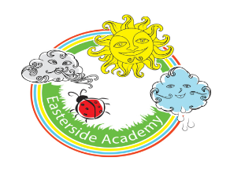We would like to welcome you into our Reception Class at Easterside Academy
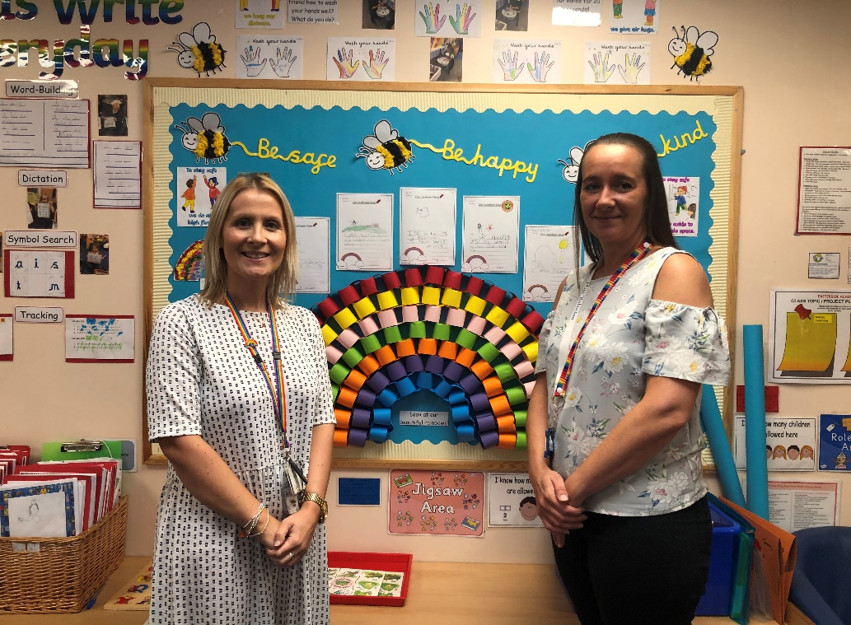
Hello from Miss Firman (Teacher) and
Miss Robinson (Teaching Assistant)
We cannot wait to meet you!

