Behaviour Policy COVID-19 Update
May 2020
This update is to be read in conjunction with EPA’s Behaviour and Sanctions Policy, February 2020.

Due to COVID-19, we recognise that children need to behave differently when they return to us. We have put new routines in place and included new rules to support social distancing to support us in trying to keep both children and staff safe.

Arriving and departing at Eastfield:
Arriving and departing from Eastfield is being completed on a ‘staggered’ basis to try and maintain social-distancing between different groups of children and parents. Each group is being given a specific arrival and departure time. This information is available on the school’s website and individual year group’s ‘Home Learning Platforms’.

The School Day:
The school day looks very different in order to maintain social-distancing between individual children within a group and between groups of children:
- Staggered arrival & departure times.
- Staggered timetabled opportunities to use the toilets – children will be able to go to the toilets outside of these times, but they will always be supervised by an adult to ensure social-distancing at all times.
- Staggered timetabled opportunities to use the outside areas at break and lunchtimes.
- Lunches to be consumed in classrooms to maintain social-distancing & supervised by the same adult (wherever possible to limit the number of staff coming into contact with the children).
- Children to maintain a 2m distance from other children and adults at all times.
- Children to be based in one classroom at all times.

Hygiene:
Hygiene is very important in safeguarding our children against COVID-19. Therefore:
- Children will wash their hands:
- On entry to the school
- After break
- Before lunch
- After lunch
- Before they go home
- Each child in (Y1 to Y6) will have a cardboard box file that will contain their essential equipment (pencil, pencil sharpener, glue, crayons, scissors & a ruler) that they will wipe down with an antibacterial wipe at the end of the day before they leave. They will not share their equipment with other pupils.
- If children and staff, cough and/or sneeze they will ‘catch it, bin it, kill it’. | 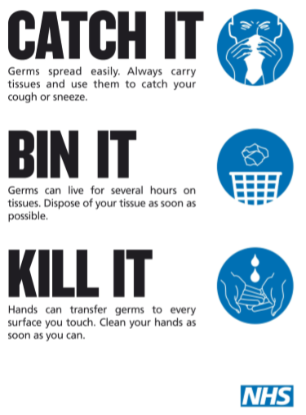
- Children will be encouraged by staff at all times to avoid touching their mouths, nose & eyes with their hands.
- Hand sanitiser will be available at all times for both children and staff to use.
- Tables and work spaces will be wiped down by staff at break and lunch times.
- If children feel unwell, at any time, they will be encouraged to tell and adult.

In the event of any child who coughs and/or spits towards any other person in school, this will be treated with the upmost seriousness and may result in the child receiving a fixed term exclusion as this behaviour is highly dangerous. Each incident will be treated on a case by case basis.

Positive Handling:
In MySpace, physical intervention may be considered in the event of a serious incident where child welfare/safety is apparent (all children have a Positive Handling Plan in place & associated risk assessment; de-escalation strategies are always used in the first instance).

