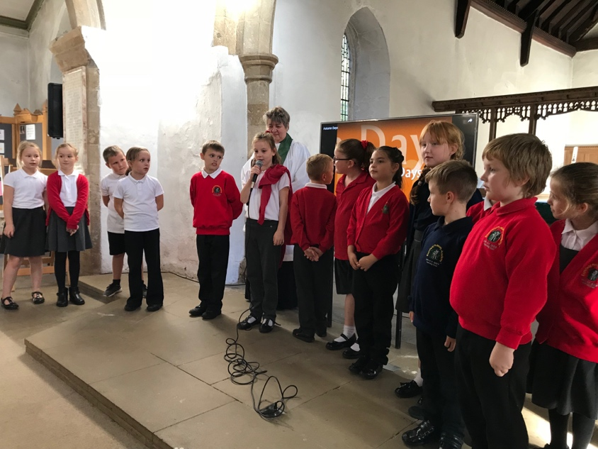
Harvest Festival 2018

On Tuesday 9th October 2018, Year 3 and 4 delivered a Harvest Festival assembly in school and were invited to St Andrew’s Church in the afternoon.

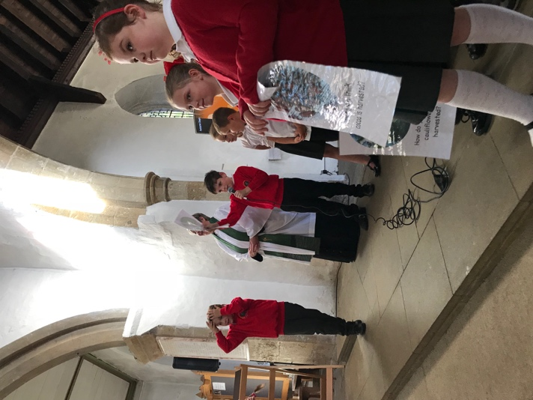
We invited Elaine from the Food Bank to come and explain a little bit about what she does and how the donations helped many families in Immingham. She told us, last year, her service fed over 300 people in Immingham and provide food parcels to over 100 families.
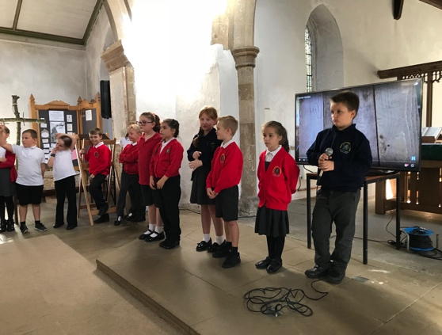
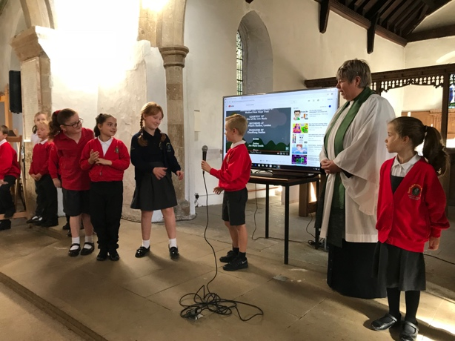
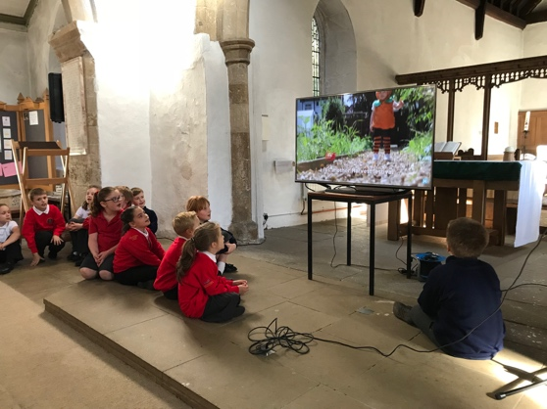
In the afternoon, we all walked down to St Andrews Church where we met with Reverend Julie and we invited our parents too. Elaine came too and told us the story of the man with the magic stone! In the story, everyone in the village all contributed to a vegetable to a stewing pot and there was that much, all the villagers were able to be eat. The moral of the story was: if we all pull together as a town and look after one another, nobody should go hungry.

After the festival, we walked back to school and we were lucky enough to find conkers!

