**EASTRY CHURCH OF ENGLAND PRIMARY SCHOOL**

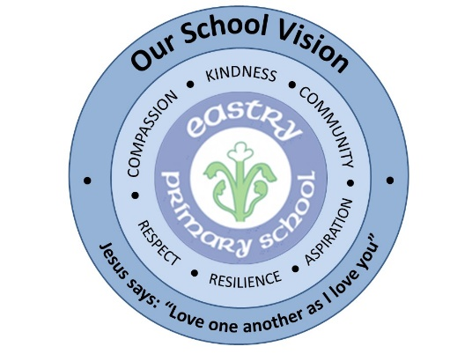

**Behaviour Policy**

**June 2025**

|  |  |
| --- | --- |
| Policy lead | Sarah Moss |
| Date approved by Governing Body | 12 June, 2025 |
| Governor signature | Teaching, Learning & Inclusion Sub-Committee |
| Review date | June, 2026 |

**School Vision**

Our Behaviour Policy helps us create a caring, stimulating and secure environment in which staff and pupils can safely work, play and learn, and to encourage the involvement of parents and carers in the development of their child.

Our Behaviour Policy reflects the School’s Christian Vision, is fully inclusive, reflecting the school’s SEN policy, and promotes equality of opportunity for all pupils and staff regardless of their sexual orientation, race, religion or disability.

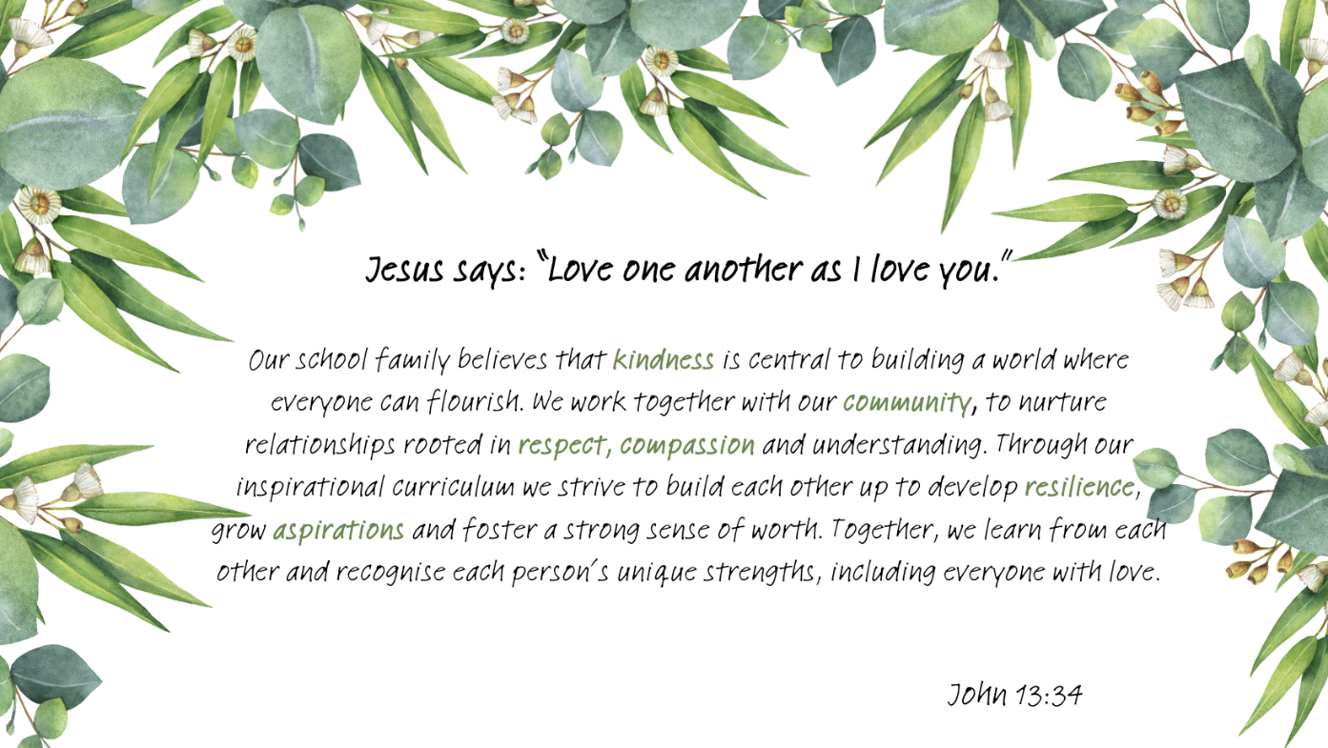

**What we believe about Behaviour Management**

We believe that every child should feel loved and valued and know their worth as an individual.  As a nurturing school; we believe that all behaviour is communication and that it is our job to unpick what a child is trying to communicate to us through their behaviour (be that positive or negative).  We believe that every child has the right to learn and that no child has the right to disrupt the learning of others. We believe that every staff member, child and parent has a responsibility to positively contribute to the ethos of our school through the behaviours we display. Establishing a sound, positive and caring ethos is an essential prerequisite for learning. We recognise how our behaviours, both positive and negative, impact on the people in our community and as such, have actively engaged all stakeholders in developing this policy.

As a trauma informed school, staff have an awareness of Adverse Childhood Experiences (ACEs), the impact of Trauma on each individual and attachment needs. This is central to the relationships between adults and children and supports staff in being aware of focus children, identifying possible triggers and supporting them throughout the school day. All staff endeavour to employ PACE to build strong and trusting relationships with the children. **Playfulness** – helps children to realise that they are worthy enough of other’s time Acceptance– how they are now is good enough

**Curiosity** – genuine care and questions to find out where the children are at and what is important to them

**Empathy** – all emotions are normal and valid

We expect that our pupils will show outstanding behaviour at all times, reflecting our school Vision Values:

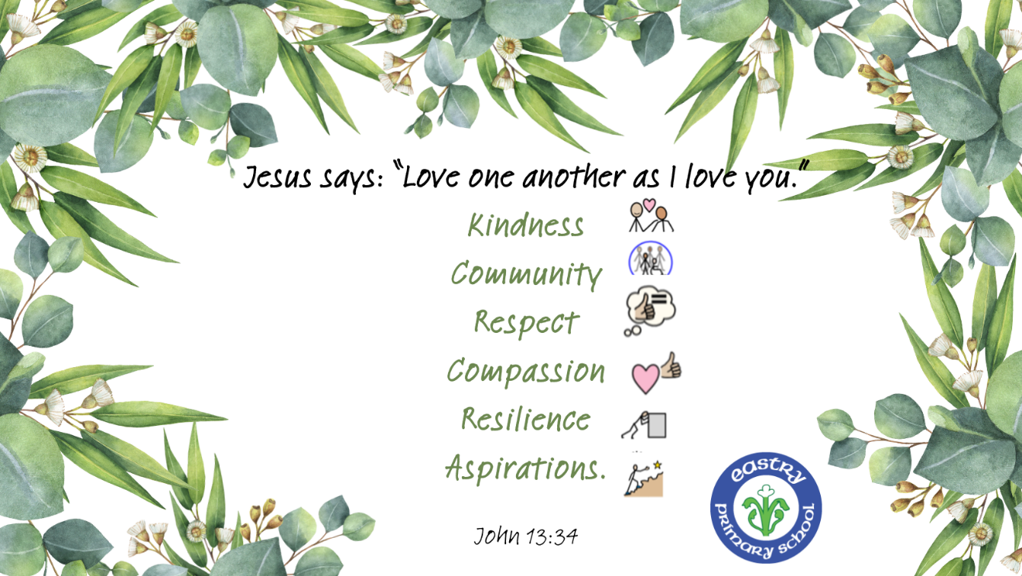

Our Christian Vision are encompassed within our school rules:

* **Be Safe**
* **Be Kind**
* **Be Ready to Learn**

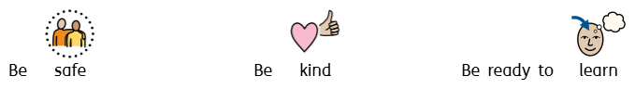

It is important that there is good communication between children, staff and parents so that everyone is aware of the school's expectations in terms of behaviour.

It is expected that parents and pupils will sign and return the Home, School Agreement.

Behaviour is the shared responsibility of all adults working with children within our school. This will include students on work experience or teaching practice and any voluntary assistants in school.

Staff will work collaboratively to ensure that this policy is consistently applied across the school.

**Aims of the Policy**

* To encourage a calm, purposeful and happy atmosphere within school
* To foster positive, caring attitudes towards everyone where achievements at all levels are valued
* To encourage increasing independence and self-discipline so that each child learns to accept responsibility for their own behaviour
* To have a consistent approach to behaviour throughout the school with parental cooperation and involvement.
* To raise children’s self-esteem
* To provide clear boundaries for acceptable behaviour to ensure physical and emotional safety
* To help children, staff and parents have a sense of direction and a feeling of common purpose.
* Staff will be treated with respect and courtesy and feel valued and appreciated.
* Ensure appropriate behaviour and language throughout the school.
* Encourage and praise greater effort in both work and behaviour.
* Ensure that parents are informed and involved in decisions and conversations regarding their child where appropriate.
* Prevent bullying.

**Staff Responsibilities**

* To treat all children fairly and with respect
* To help all children to develop their full potential
* To provide a challenging, interesting and relevant curriculum
* To create a safe and pleasant environment both physically and emotionally
* To use positive and negative consequences clearly and consistently
* To be a good role-model
* To recognise and value the strengths of all children
* To offer a framework for teaching the personal, social and emotional skills and abilities that underpins the school’s behaviour policy.
* Fostering and promoting good relationships within children and parents, encouraging a sense of belonging within the school and wider community.
* Offering equal opportunities in all aspects of school life and recognising the importance of different cultures.
* Rejecting all bullying or harassment in any form.
* Caring for, and taking pride in, the physical environment of the school.
* Working as a team, supporting and encouraging each other.

**Parents’ Responsibilities**

* To make children aware of appropriate behaviour
* To encourage independence and self-discipline
* To show an interest in all their child does in school
* To support the school in implementing this policy
* To be aware of the school rules.
* Caring for, and taking pride in, the physical environment of the school.

**Children’s Responsibilities**

* To do their best
* To contribute to their own learning
* To treat others, their belongings and the environment with respect
* To show consideration for others
* To consider the effects of their actions on others

**Curriculum**

At Eastry, through our curriculum, we aim to teach children understand themselves and others. Through PSHE (Personal, Social, Health & Education) (please refer to PSHE Policy including RHSE – Relationships, Sex & Health Education) address our ethos and expectations directly. We believe that an appropriately structured and differentiated curriculum and effective learning contribute to good behaviour.

**Rewards**

At Eastry we reward good behaviour, as we believe that this will develop an ethos of kindness and co-operation. This policy is designed to promote and acknowledge good behaviour and raise self-esteem and pride, rather than merely to deter anti-social behaviour. We praise and reward pupils for good behaviour, social skills and work throughout the school day in a variety of ways including:

|  |  |
| --- | --- |
| Daily rewards | Dojo points (moving your peg/name up)  Verbal praise  High 5s  Celebrations e.g. marshmallow clap  Sharing excellent learning with staff members  Stickers  Headteacher’s award |
| Weekly celebration | Star of the Week (linked to our question to ponder and school values awarded in Friday worship)  Dojo Champion of the Week (child with the most dojo points that week in EYFS)  Class reward time  Good Fridays  Out of school achievements e.g. music/ sports awards  Dojo shop  Secret Phone call home  Learning Power Certificate  Star Reader |
| Personalised rewards | Behaviour charts  Reward time  Class incentives |



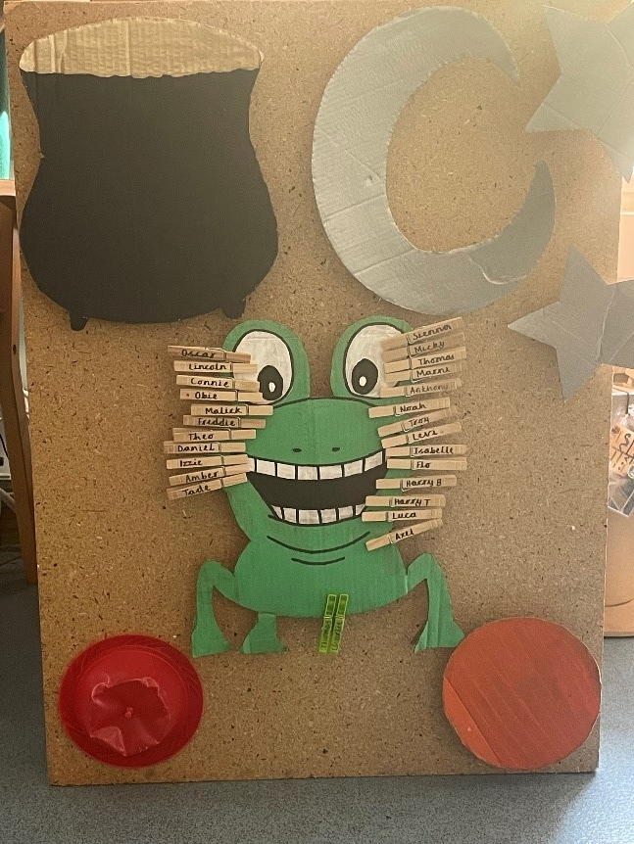

More specifically:

* ***Instant praise*** is given and will be related to our school rules and values. Child can be told by any staff member that they can move their peg/name up. Class teacher adds dojo points for each child at the end of each session.
* ***Dojo reward shop***: In years 1-6 children Each time a child earns 25 points, they can win a prize, therefore prizes will be awarded at: 25 points, 50 points, 75 points, 100 points etc.
* When a child earns 300 points, they are awarded a certificate.
* There are 5 rewards to choose from in each class and these are decided on by each class things such as bringing a soft toy to school, sitting on a VIP table, sitting next to a friend etc.
* ***Secret Phone call home***: teachers nominate a child they are particularly impressed with each week for a phone call home from the Headteacher

**Sanctions:**

Considering Trauma informed practices and our nurture principles we believe that in order for children to feel safe and secure they need clear and consistent boundaries. Boundaries help children to feel safe and secure. They show the child that the adult knows what they are doing and that they can be looked after We are firm on the behaviour, gentle on the child.

At Eastry we acknowledge that when this rule is broken, it makes other pupils feel anxious or unsafe. Therefore, incidents are responded to in a way that catches the child in the moment and addresses the behaviour.

All behaviours are therefore dealt with in the following way:

Reflect on behaviour

Use emotion zones of regulation or emotion coaching

Revision of provision and reflection on behaviour

no

yes

Behaviour stops or changes

Adjust provision

Follow behaviour plan steps

no

yes

Unmet need

With this in mind we have a scaled system for sanctions that promote reflection, restoration and behaviour change. Sanctions should be private to avoid shame.

**Level 1: Remind** 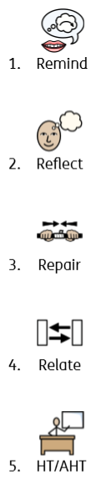

**Examples may include but not limited to:** talking in class, behaviour in worship, calling out, being rude

**What happens:** a teacher talks to the child and reminds them of what is expected

**Level 2: Reflect **

**Examples may include but not limited to:** repeat offences of 1 level behaviours or purposeful poor behaviour choices.

**What happens:** the child is given a quiet space to reflect on their behaviour e.g. at the back of the class or just outside. For infants this will be 5 mins, for juniors this will be 10 mins.

**Level 3: Repair** 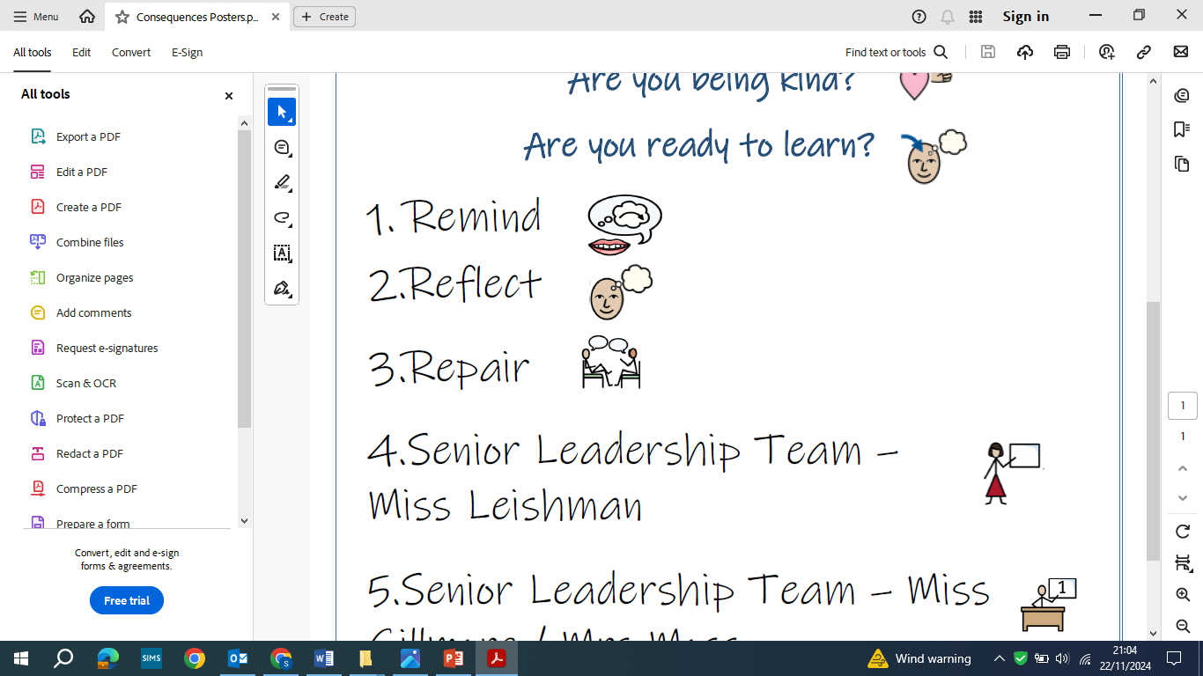

**Examples may include but not limited to:** repeat offences after a level 2 sanction, swearing, stopping other children from learning.

**What happens**: Teacher talks through feelings and choices and direct reflection, using restorative approach. (Reflect time may be needed again here). Class teacher communicates with parents ideally face to face or over the phone. If a child gets 3 level threes in a week the

**Level 4: Relate** (with a member of the senior leadership team- Miss Leishman) 

**Examples may include but not limited to:** repeat offences after level 3, unsafe behaviours (climbing / running / not following instructions).

**What happens:** Quiet working and reflection in year 6. Class teacher communicates with parents

**Level 5: Senior Leadership Team Involved **

**Examples may include but not limited to:** Repeat offence or failure to engage with step 4, intentionally hurting another child / member of staff intentionally, danger to themselves, racial language, bullying, cyberbullying, child on child abuse

**What happens:** Discussion with child and letter home or conversation with the parent about behaviour from senior leadership team. Individual report. For serious incidents, internal suspension, suspension or exclusion will be considered on a case by case basis.

At any time, and using their professional judgement, staff reserve the right to accelerate the sanction process.

*Whilst we have provided some examples of behaviours, we recognise that this list of behaviours is not exhaustive and that each negative behaviour incident would have to be considered in line with the child’s developmental understanding and specific needs.*

**Recording behaviours**

All behaviours are recorded on either class behaviour logs or individual behaviour logs. These are reviewed at least termly by the Senior Leadership team.

**Behaviour Support Plans**

We have consistent expectations for all learner. We recognise that some children may require additional support in order to meet these expectations. In these cases, a behaviour plan is devised in collaboration with parents/carers. Behaviour plans may include individual reward charts, restructured school timetables, resources to support learning, staff mentors or individualised sanctions. Behaviour Plans are shared and reviewed with children, staff and parents/carers. In some cases, risk assessments of a child’s behaviour are also completed.

**Recognising the impact of SEND on behaviour** We recognise that pupils’ behaviour may be impacted by a special educational need or disability (SEND). When incidents arise, we will consider them in relation to a pupil’s SEND, although we recognise that not every incident of misbehaviour will be connected to their SEND. Decisions on whether a pupil’s SEND had an impact on an incident of misbehaviour and appropriate consequence will be made on a case-by-case basis but we have high expectations of all learners. We will also look at trying to anticipate and remove any potential triggers to help children to modify their behaviours.

**Behaviour outside of school premises:**

Behaviour consequences may also be used where a pupil has misbehaved off-site when representing the school. This means misbehaviour when the pupil is; taking part in any school organised or school-related activity, travelling to or from school, wearing school uniform or is in any other way identifiable as a pupil of our school. Consequences may also be applied where a pupil has behaved in a way that could have repercussions for the orderly running of the school, poses a threat to another pupil or could adversely affect the reputation of the school. Consequences will only be given out on school premises or elsewhere when the pupil is under the lawful control of a staff member (e.g. on a school-organised trip).

**Reasonable force:** Reasonable force covers a range of interventions that involve physical contact with pupils. All members of staff have a duty to use reasonable force in the following circumstances; to prevent a pupil from causing disorder, hurting themselves or others, damaging property or committing an offence. Incidents of reasonable force will always be used as a last resort, be applied using the minimum amount of force, be used for the minimum amount of time possible, be used in a way that maintains the safety and dignity of all concerned and be recorded and reported to parents.

**Confiscation, Searches, Screening:** In the rare event that searching, screening and confiscation is required, this will always be conducted in line with the DfE’s latest guidance on searching, screening and confiscation.

**Internal Suspension** If a child has demonstrated behaviours that the Senior Leadership Team deem as unsafe and present a safeguarding risk to children including themselves, staff or visitors then we may internally suspend. The length of the suspension will be considered in response to each individual case, parents will be informed and we will seek support in this decision. Children will be set learning to complete by their Class Teacher and will have appropriate rest breaks. All internal isolations will be recorded on the behaviour logs

**Suspension and Exclusion:** is seen as a last resort when all other support has failed. Headteachers can use suspension and permanent exclusion in response to serious incidents or in response to persistent poor behaviour which has not improved following in-school sanctions and interventions. Only the Headteacher may suspend a child and this is always carried out in consultation with parents/carers. The Chair of Governors and Local Authority is informed and parents/carers have the right to appeal. The suspension period is at the discretion of the Headteacher.

**To support behaviour external agencies may be contacted.**

**External agencies could include:**

Specialist teaching and learning service

KPAS

Educational psychologist

Social services

Early Help

**Playtimes and lunchtimes**

Playtimes and lunchtimes are the least structured time in the school day and therefore we are aware this may increase the chances of negative behaviours for vulnerable children. We recognise this and have taken the following steps to provide the best possible provision:

* Provided Teaching Assistants for each playground for break and lunch times, to support children with difficult behaviour in particular.
* Adults model games to play outside and actively engage in play with the children
* Peer playground buddies to play with younger children and structure games.
* Use staff well known to the children throughout the day for consistency of experience.
* Synergy intervention – This is an additional provision targeted at key children. A range of social games and activities are used to model and teach social skills specific to the children’s needs.

**Bullying**

It is implicit in our School Values that bullying will not be tolerated. It is unacceptable that children or adults will be hurt verbally, physically or emotionally. Children are actively encouraged to tell a member of staff if there is any concern about bullying taking place. The Headteacher and staff will be closely involved in resolving these incidents. (Refer to the Anti-Bullying Policy)

**Prejudicial Behaviour** This can be a factor in radicalisation and extremism. It is unacceptable that children or adults will be subject to this. Children are actively encouraged to tell a member of staff if there is any concern about this taking place. The Headteacher and staff will be closely involved in resolving these incidents. (Refer to the Anti-Bullying Policy)

**Records of Events**

Continuous behaviour occurrences that will be recorded on behaviour logs and will be reviewed by the senior leadership team.