WHOLE SCHOOL PROJECT BASED LEARNING
During this period of closure, we have complied a list of project-based learning activities that you can complete as a family. The aim of these is to provide the children with a balance of skills that draw on all areas of the curriculum or some ‘life-skills’. These can be completed as a family or independently depending on the age of your child. Why not try doing 1 a day? You can share your projects with us on Class Dojo

Learn more about Bees- natures superheroes. Make a nest for nesting bees.  https://www.worldbeeday.org/en/did-you-know/117-how-to-make-a-nest-box-for-solitary-bees.html | Can you tell the time on an analogue clock? | Can you design a new collar for Maddie dog? | Think about:  5 Things I Can See 4 Things I can Touch 3 Things I Can Hear 2 Things I Can Smell 1 Thing I Can Taste | Create a time capsule of this time: https://www.coventry.gov.uk/downloads/file/32470/covid-19_time_capsule
Social distancing requires us to be 2m apart- what can you find that is 2m or further, what does 2m look like? Can you compare other items? | Create a lockdown scrapbook of everything you have been up to | Look at a map- plan a route to a destination of your choice, use the key to look at different places on the map | Listen to the bird song, can you identify what songs you can hear. https://www.woodlandtrust.org.uk/blog/2019/04/identify-bird-song/ This website might help you | Can you fold and put your clothes away. Try different hangers and different ways of folding
Learn hello in as many languages as you can- then teach your family | Make a smoothie – what combinations of fruit are the best?  Try peanut butter and banana – my favourite! | Write a children’s story for the Fledglings! | Create a life story time line of your life so far, include photos, milestones and achievements. | Research your chosen career and plan a way of reaching you aspirations – how much would you earn? What qualifications/skills would you need? What would you have to do and where would you work?
Learn a song or a poem in different language- see  www.mamalisa.com | Make a grass head with some old tights and googly eyes!  https://www.lifeeducation.org.au/parents/yates-how-to-grow-a-grass-head | Research a period in history and try out an activity based on it www.english-heritage.org.uk/kids www.english-heritage.org.uk/teachingresources | Go on a beach walk. How many different types of shells/pebbles can you see? | Follow a recipe to make a healthy meal.
Make a healthy fruit smoothie to help you eat some of your 5 a day- banana is a good base to start with! | Go for a walk in some woodland and collect some medium sized sticks.  Cut out a shape from some hard cardboard (you may need help from an adult) - hearts and stars work well!  Using strong glue, use some thin sticks to create an outline, and then fill with the rest of the sticks!  Hang or paint if you wish! | Make an identification chart for when we can use the school pond again! | Change your bed. | Design an eco friendly car of the future.
Sort out you books at home- organise them into genre or alphabetical order of author.  See if there are some you may want to donate to somebody else or save for a book swap with your friends, when you see them again! | Play boggle as a group.  Make a 3 x 3 grid – each person writes 2 letters.  Start a 2 minute timer – how many words can you think of? Who can write the longest list? | Try a wild challenge www.rspb.org.uk/wildchallenge  Design a garden - what would you grow and where, what else would you have in your garden? A patio, a play area, trees? How could you make your garden wildlife-friendly? | Plan a local walk following a map using streetmap/google maps etc. | Plan and complete a home treasure hunt.
Dig out old board games for a family games evening- you may find some you had forgotten about. | Collect some woodland materials and natural resources to make a hanging mobile. | Can you propogate some plants from cuttings  https://playofthewild.com/2020/01/08/top-tips-for-propagating-plants-in-water-or-soil/ | Play a family quiz. Can you host and make up your own questions? | Set yourself a personal goal to practise and improve each day.
Plan a menu for a picnic to hold indoors or in your garden; what will be your healthy eating choices? | Write a haiku to describe one day in lockdown. | Learn to draw something new: I have looked for a website with some drawing ideas - sorry if it has already been used - and found #DrawWith Rob, a children's author and illustrator (http://www.robbiddulph.com/draw-with-rob) | Research another chosen country and their culture; food, language, customs, places, costume etc. | Make your own Powerpoint presentation on a chosen subject of interest.
Wat can be recycled?  Recycling at home – help with the recycling. Sort recycling into groups – what goes in each bin, why? Can you think of ways to reduce your houesehold’s recycling? | Watch a film with your family. Can you each take a part and recreate a scene from the film. | Use Google Earth to find places you know – your house, football stadiums, places you’ve visited. Eastry School. | Draw the view from your window. You could start with the frame of the window crating the frame of your picture.  Do you have a street view or a garden view?  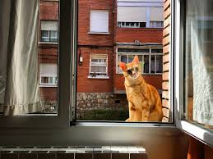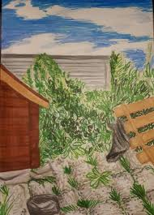 | Making giant bubble wands…  https://myfrugaladventures.com/2015/07/how-to-make-a-giant-bubble-wand/  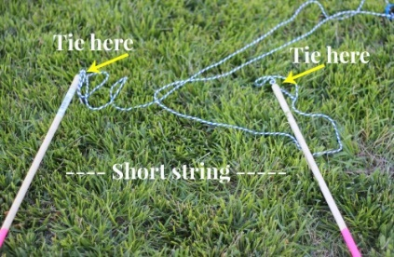  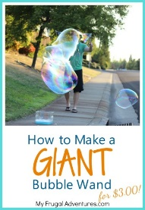
Get creative.  Make ‘Welcome Back!’ bunting that we can display around the school when we are all back together.  Lots of different online sites with ideas for different types of bunting. | Make a sundial.  Very good ideas on https://wwww.wikihow.com/Make-a-sundial  Differentiated activities | Design your own board game | Flower pressing  No fancy flower presses needed!  Natural history museum has a really good guide to doing this and how you can use the pressed flowers and plants  Creatively  Hyyps://www.nhm.ac.uk/discover/how-to-press-flowers.html | Design a VE day medal  https://wwwtwinkl.co.uk/resources/t3-h=123-design -a- ve-day- medal activity-sheets  How about designing a medal for the NHS/carers/key workers for their work during the Lockdown?
Upcycle old magazines/comics  https://www.brit.co/magazine-wall-art/  (You can do this without a glue gun) | Maurice Escher – look online at the art created by Maurice Escher using tessellations.  Have a go at creating your own tessellations.  www.shodor.org/interactivate/activities/Tessellate/ | Make salt dough and do some modelling, there is a recipe on https://www.bbcgoodfood.com/howto/guide/how-make-salt-dough-recipe  You can make anything you like | Learn how to make your favourite sandwich, can you make this on your own? | Try a new sport or join a sport someone else in your family enjoys.
Make an ice lolly | See how long you can make a daisy chain | Make a bug hotel for your garden beasties! | Make a sock bunny;  https://www.youtube.com/watch?v=TU1gAK4RhFA | Learn a song or a dance to share with a grandparent or relative who is isolating so that they can watch it virtually.
Make a book mark for someone you love. | Grow a vegetable in a pot in your house or in the garden | Make a wind chime. You can use anything you can find at home, a hoop and some string or make a mobile for your bedroom | Try making a mobile of the solar system. You can use foam balls or ping pong balls, paint them the different colours of the planets and then hang them on a hoop. | Try making your own Word Search for a family or friend. You could use words based on a hobby they like to do.
Get a parents or siblings to put 10 small items in a sock and see if you can guess what they are. Then you try and find 10 more things and see if they can guess what they are. | Using playing cards for a maths/memory game;  for the younger children lay all cards face down and try and match the pairs by taking it in turns to turn two cards. For older children try turning pairs or threes to try and make a total of 15 (Jacks, Queens and Kings count as 10) | Growing large salt crystals would be fun.  Instructions at  https://www.stem.org.uk/resources/elibrary/resource/31669/growing-crystals | Make your own bird feeder  https://www.rspb.org.uk/fun-and-learning/for-kids/games-and-activities/activities/make-a-recycled-bird-feeder/ | Watch the clouds.. what can you see?
Make a pizza from scratch! What toppings are you going to use? | Create your own sports day! What activities are you going to have? How many activities? How will you keep track of the score? | Make your own crossword for a family member or friend. | Create your own comic! Design your superhero and write and illustrate their adventures. | Create your own ball game! What are the rules?
Make a pinwheel - https://www.wikihow.com/Make-a-Pinwheel | Make your own table football https://www.bbc.co.uk/cbbc/thingstodo/bp-how-to-make-table-football | Make your own marble run out of recycled tubes https://www.edenproject.com/learn/for-everyone/how-to-make-a-recycled-marble-run | Create a lock down Newsletter, complete with book reviews and jokes. Send it to your friends and family. | Create a hopscotch using tape or chalk.
Set up a café at home, create a menu and use your maths skills to work out how much family members should pay for their snack or lunch.  Perhaps you could bake some cupcakes to sell too! | Make a bee water station:  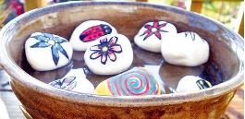 | Write an invitation to a family event: ​Invite a family member to one of the following: ​ ​- (​talent show, music show, magic tricks, jokes ​) In your invitation think about the time, date and place. How will you design the invitation? Who will deliver it? Share the ​https://family.gonoodle.com/activities/milkshake​ ​movement and mindfulness video with their family. Who was the best? Which part did they enjoy? Could you create a video of your own? | Interview a family member:  - interview a family member that doesn’t live at home with you. Who did they live with? Who is in their family? Have they got any family traditions they follow and why. | How many different creatures can you make from eggboxes?
Can you create a self portrait? Can you find different materials around the house to help? ​ | Family tree​:  - Look at photographs of your family members and discuss where they would go on a family tree. Have you met everyone? Is there anyone you could interview and find out more about? | Design a personal coat of arms shield for the family:  Find out what a coat of arm shield means. Think about their design. What could you draw? What does it mean to you ? Think about the colours and shapes. Maybe if you have some cardboard around the house you could make a shield to give to a family member. | Collect some sticks and make a family for Stick man.  https://minimadthings.com/blogs/news/stick-family | Practice your drawing skills.  https://drawastickman.com/  Check out these science ideas to experiment with different materials.  https://www.science-sparks.com/stick-man-activity-ideas/

