

Behaviour Curriculum

Inspiring independent learners to thrive in a changing world

The Eccleston Primary School Behaviour Curriculum
Welcome to our Behaviour Curriculum
At Eccleston Primary School, we are incredibly proud of the exemplary behaviour of our children. To support our children’s character development, we define the behaviours and habits that we expect to see. We want our children to grow into adults who understand Fundamental British Values. As with any type of learning, practice will support the development of the knowledge they need to become upstanding British citizens. Practice of the behaviours we teach will enable routines to become automatic that positively shape how they feel about themselves and how other people perceive them. We link our behaviours to our school values, and how these values are demonstrated by the leaders of our School Houses (see below) and through the guidance provided by the Education Endowment Foundation (EEF).





Teaching the Behaviour Curriculum
Nursery to Year 6  Relationships are the key to the success of our curriculum, spend time building them with the class. | Autumn 1 | Autumn 2 | Spring 1 | Spring 2 | Summer 1 | Summer 2
 | Explicit teaching of the full behaviour curriculum  Explicit teaching of the leaders of our School Houses | Ongoing revision of the content | Longer recap of the behaviour curriculum and the leaders of our School Houses | Ongoing revision of the content | Longer recap of the behaviour curriculum and the leaders of our School Houses | Ongoing revision of the content

The curriculum content is taught explicitly during the first week in Autumn Term as a lesson, or group of lessons, as appropriate, in place of a PSHE lesson. Children should learn the content of the curriculum so that they can recall the information and act upon it. At the start of each term, the behaviour curriculum is revisited with the children, and it is shared again at the beginning of each half term. Teachers and support staff will demonstrate these behaviours and ensure children have time to discuss and develop their understanding of these behaviours. For example, lining up should be explicitly taught in the classroom but must be reinforced in various locations around the school to ensure consistency throughout the school. It is expected that all children know the content of the Behaviour Curriculum.
While this curriculum is for all pupils, it will be adapted in different year groups depending on the pupils’ ages and must consider individual children's SEND needs. Sensitivity must always be applied when teaching the Behaviour Curriculum.

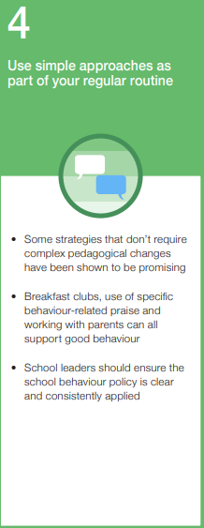
Curriculum Content
The curriculum content will be covered in depth at the start of Autumn Term 1, it will be revisited at the start of each half term and referred to when required.
Behaviour
Children know that there are three behaviour expectations at Eccleston Primary School and they understand the expectations. These are to:
- Be Respectful
- Be Responsible
- Be Safe

Be Respectful
Using good manners
Hold doors open for people
Talk kindly to other pupils
Say good morning/good afternoon to adults
Respect others right to learn
Respect school property by looking after it
Use a calm and polite tone of voice
Value differences
Lining up
Contributing
Playtime and lunchtime behaviour
Be Responsible
Read at home and make sure it is recorded in your planner
Remember to bring PE kit when it is your PE day
Wearing correct school uniform
Tidying up your own workspace and the classroom
Accepting responsibility if you make a mistake and saying sorry
Arriving at school
In the dinner hall
Completing work in books
General classroom expectations
Playtime and lunchtime behaviour
Be Safe
Sitting calmly in the classrooms and taking brain breaks when needed
Excellent walking
Playing games that do not become too physical
Using good manners
Playtime and lunchtime behaviour

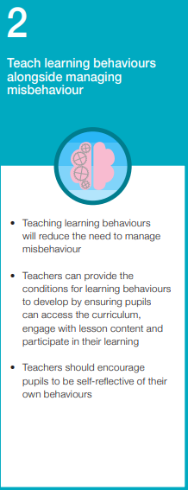
Our Routines
Excellent Walking
Children know that we walk around school using Excellent Walking.
Children know that Excellent Walking means:
- Calmly
- Quietly
- Single file
We know Excellent Walking is used around school to keep everyone safe and to ensure that the learning of other children is not disrupted as we move around school.

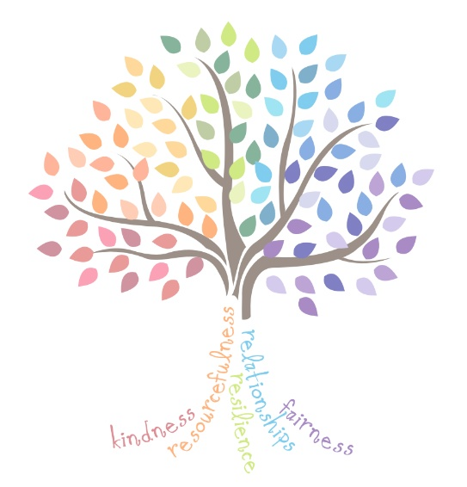
Lining Up
Children know the expectations when lining up:
- Attention on the speaker
- Feet forward
- Calm and quiet

Contributing
Children know that we expect everyone to contribute in class and this means:
- Listening to the class teacher or whoever has been invited to speak
- Considering responses before sharing
- Waiting to be invited to speak
- Sharing answers/contributions in a clear voice using full sentences
- Challenging contributions with kindness
- Building on what others have said

Arriving at School
- Arrive at school on time
- Use Excellent Walking at all times
- Greet staff and others with a ‘good morning’ or another polite welcoming phrase
- Hang up coats and put things away in the right place
- Know to sit down at the desk and complete the morning activity and if I need some extra help, speak to one of the adults and they will be happy to help

Using Good Manners
- Always say ‘please’ when asking for something
- Always say ‘thank you’ when receiving something or when someone does something kind
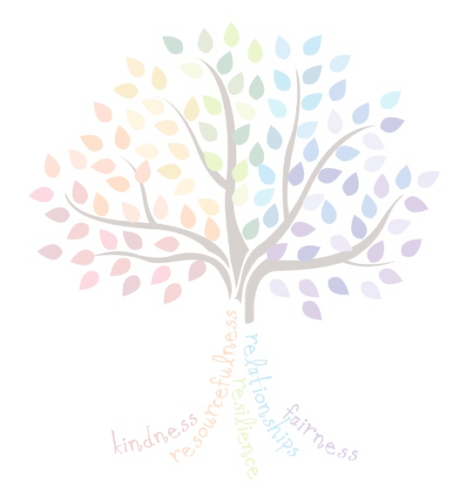
- Say ‘good morning/afternoon’ to adults when passing them
- Show gratitude to others by thanking them for what they say
- Use a calm and polite tone to show respect

Playtime and Lunchtime Behaviour
- Walk to and from my classroom using Excellent Walking
- Play safely without hurting anyone
- Avoid play fighting
- Be kind to others by including them in games and sharing equipment
- Understand that someone who is kind behaves in a caring and helpful way towards other people
- Understand the end of break and lunchtime whistles:
- First Whistle – Stand still and wait quietly
- Second Whistle – Excellent Walking into class lines

In the Dinner Hall
- Walk to the hall using Excellent Walking
- Line up with respect, collect the tray and sit down sensibly
- Talk using an inside voice
- Use the knife and fork when required
- Use good manners at all times, saying ‘please’ and ‘thank you’ when receiving food and drink
- Leave the seat when invited to
- After lunch has been eaten, clear any rubbish into the correct recycling bin
- Leave the hall, use Excellent Walking

Completing Work in Books - Behaviour for learning
- Write in line with the Nelson handwriting scheme, joined up to be encouraged from Year 2
- Write the date at the top of every piece of work: short date for maths, long date for everything else
- Underline using a ruler
- Start writing from the margin
- Use one digit per square in maths books
- Use a pencil and ruler to draw lines
- Correct mistakes with one straight line though the error

General Classroom Expectations
- When leaving seats to sharpen pencils, collect books and other items, do so calmly
- Use the toilet at break and lunchtime, only if desperate will it be used during lesson time, or if adaptations are needed for specific needs. Greater flexibility will be given for EYFS and KS1 children.
- Keep the desk clear of distractions
- Take responsibility for keeping the learning environment organised
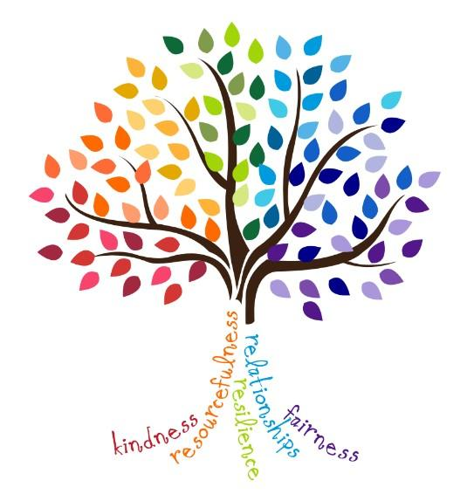
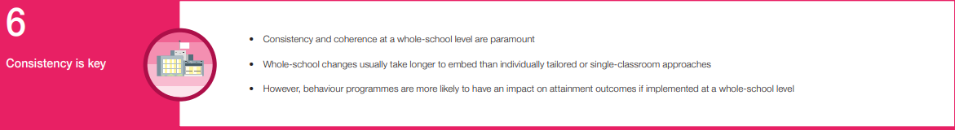
- Show active listening when the teacher, or someone who has been invited to speak, is talking

