

Behaviour Policy

Inspiring independent learners to thrive in a changing world

Introduction
This is a statement of the aims, principles and strategies for promoting positive behaviour at Eccleston Primary School. This policy is to be supported and followed by the whole school community. We create a calm, secure and purposeful working environment for all in which everyone is valued and encouraged to develop confidence and self-discipline. The content has been developed inline with section 89 of the Education and Inspections Act 2006.

Purpose
This policy outlines school systems for behaviour. It is a primary aim of our school that every member of the school community feels valued and respected, and that each person is treated fairly and well. Our challenge centres on high expectations for every child and each child being accepted as a unique individual. We are a caring community, whose values are built on mutual trust and respect for all.

Aims and expectations of the Behaviour Policy

Consistency
All staff understand the need for consistency in creating a successful learning environment. Rules must be followed throughout the school day and the children know the rewards and consequences that are in place. All children are treated fairly. We are inclusive, some children however with Special Educational Needs may require specific behavioural strategies and consequences.

- The primary aim of the behaviour policy is as a means of promoting good relationships, so that people can work together with the common purpose of helping everyone to learn.
- The school behaviour policy is therefore designed to support the way in which all members of the school can live and work together in an effective, considerate and supportive way. It aims to promote an environment where everyone feels happy, safe and secure.
- At Eccleston Primary School we encourage respect for other people and their property, self-discipline, fairness and honesty. We believe children should have the right to learn and teachers the right to teach without any unnecessary interruption.
- The school has set rules that everyone should adhere to.
- The school rewards good behaviour, as it believes that this will develop an ethos of kindness and fairness, whilst developing good relationships. This policy is designed to promote good behaviour, rather than merely deter negative behaviour.
- We treat all children fairly and apply this behaviour policy in a consistent way.

At Eccleston Primary School there are three simple rules:

- Be Respectful
- Be Responsible
- Be Safe

Behaviour for Learning
Teachers have a shared dialogue to promote excellent behaviour for learning with our school values integral to this:
- Relationships
- Resourceful
- Resilience
- Fairness
- Kindness

Each staff member follows the Eccleston Primary School blueprint for securing the very best behaviour:
1. Connection before correction—Building relationships with children is important. Make
children feel valued and important and feel like they belong.
2. New day, new start— start each day with a positive attitude and a fresh approach.
3. Meet and greet— Teachers welcome every child by name as they enter the
classroom/building each morning.
4. Three rules = Be Responsible, Be Respectful, Be Safe (displayed in each classroom)
5. Recognition Board — a praise / wow board (in a style determined by the class teacher)
for displaying achievements (academic, social, learning behaviours) to be refreshed on a
regular basis.
6. Reflective time — as appropriate, children could use a calm space in the classroom or outside the room, in clear sight, if that is what they required to support their regulation.
7. Smooth and quiet transitions— at the end of playtime, the first whistle indicates that
children stop playing and stand still. A second whistle signals that all children line up calmly and quietly in their classes. Class teachers will be ready for their classes with doors open welcoming the children back into the classroom.
8. Restorative 5 — What happened? What were you thinking and feeling? Who was affected? What could we do to put things right? How can we do things differently in the future?

Rewards and consequences
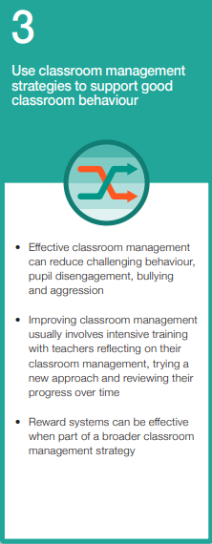

Rewards
We praise and reward children for good behaviour in a variety of ways:
- Teachers congratulate children on achievements and success both inside and outside of school.
- The headteacher always wants to see the children’s hard work and celebrate their successes.
- Each week one child from each class is Star of the Week. These children receive certificates and badges, to reinforce their behaviour, in the weekly Celebration Assembly and will have a celebratory hot chocolate during assembly in the best seats in the assembly.
- Green cards are given for demonstrating our school values. They will be sent home with the child to share with families. Green cards will be tracked on Arbor. Aim for 5 per week.
- House points are given individually to children for a range of things and added to their house pot. These are counted up weekly and as a team the children are working towards achieving a goal. Once teams reach 100 points, they will be rewarded with a ‘treat’ that is decided by the school council. This might consist of different activities, and may include; outdoor play with games, ice lollies etc. This will be a time for the whole house to come together and be celebrated.
- The school acknowledges all the efforts and achievements of children, both in and out of school, for example, music or swimming certificates and these are celebrated in class.
- The Headteacher will choose children for personalised positive phone calls home from them to their parents/carer to share their child’s positive behaviour - book will be in the staffroom.

Consequences
There will be times when children behave unacceptably. Children need to discover where the bounds of acceptable behaviour lie. Each case is treated individually. Children are generally reminded that they are responsible for their own behaviour and that breaking rules has consequences.

Most behaviour difficulties are dealt with by the class teacher. The teacher’s aim will be to settle the child back to work in a firm but caring manner.

The school employs several consequences to enforce the school rules, and to ensure a safe and positive learning environment. A system of Reflection Time, Red Cards and a clear progression of consequences is followed. The children are very clear about this cumulative progression and understand the consequences of their behaviour.

Any Red Cards given by welfare staff should be shared with the class teacher of the child, the teacher will use their professional judgement and further knowledge of the child/the child’s circumstances, to determine whether the Red Card will be issued. Where possible, in breakfast and after school club the class teacher/SLT’s advice should be sought. SLT will always be contactable by phone between 7.45am and 6pm.

It should also be made very clear that it is the behaviour that is unacceptable, and any consequence should address this, not be made personal to the child.

The Headteacher / Deputy Headteacher monitors children on a regular basis by checking the behaviour logs kept on CPOMS.

Consequence steps
Steps | Actions | Example of behaviour
1)  Verbal reminder | Verbal reminder, with the child given clear direction about which behaviour is unacceptable.  Gentle encouragement, a ‘nudge’ in the right direction, “This is your first reminder.” | -Chatting with peers during instruction.  -Fidgeting excessively.  -Making unnecessary noises  -Interrupting others  -Leaving the seat without permission  -Making off-topic comments
2)  Second verbal reminder | A second, clear verbal warning, delivered privately wherever possible, making the learner aware of their behaviour and clearly outlining the consequences if they continue, “This is your second reminder, the next time will need some reflection time.”  Direct the child to consider where they feel they are within the Zones of Regulation and guide them to the appropriate toolkit.  Reminders will be logged against a class register, out of sight of the children. This will be used when there is a change of teacher and avoid toxic shaming. | Repeated examples of step 1.
3) Reflection time | If behaviour continues, the child will be taken out of the room for a short discussion with the teacher, or teaching assistant for approximately 5 minutes (teachers to call to another class if another adult is required). Identifying any barriers to learning will happen here. Check-in to see if everything is alright.  Direct the child to consider where they feel they are within the Zones of Regulation and guide them to the appropriate toolkit.  If reflection time is needed during a breaktime, or at lunchtime, the child would stay near a member of staff on duty for a 5 minute period, or longer if the member of staff deems that they need more time to regulate. | Repeated examples of steps 1 and 2.
4)  Change of space | If the behaviour persists, the child will be given one final reminder and then will work in another classroom for at least a 15 minute period. Year 1 and 2 will use each other’s rooms. Year 3 and 4 will use each other’s rooms. Year 5 and 6 will use each other’s rooms.  Upon returning to class, if there is no improvement, continue to the next step.  If this is regularly required, it needs to be logged on the Whole Class Profile. | Child appears dysregulated and professional judgement is used to give them space to support their regulation.
5)  Red Card | For more serious examples of behaviour, a child will be given a Red Card. This will result in a phone call home from the class teacher or support staff. The following break, pupils should report to the Headteacher or Deputy Headteacher for ten minutes of their break, giving them a five minute break before returning to class.  During this time, a restorative conversation will take place with reference to the Zones of Regulation. The Zones will be outlined on the back of lanyards to support the interactions.  If these behaviours are recurring, a Positive Behaviour Tracker will be considered, where the teacher can check in on the child’s behaviour after each session of the day and the headteacher will sign this at the end of each week. | The following are examples of what may constitute a straight Red Card:  -Swearing (both using hand gestures and verbal)  -Verbal abuse/inappropriate language  -Any act of violence  -Threatened violence  -Any rough play (which is not tolerated) which results in injury  -Defiance or refusal  -Exposing parts of the body  -Touching someone else inappropriately  -discriminatory language
6)  Internal exclusion | If the behaviour continues after the range of warnings prior to this step, the learner will spend time with the Headteacher/Deputy Headteacher out of the classroom for a period of time that reflects the behaviour.  A restorative conversation will take place with reference to the Zones of Regulation.  A phone call home will be made to explain the situation and a meeting with parents/guardians will be arranged. | As in step 5 but repeated following all reminders and support given.
7) Suspension | If the behaviour continues, a suspension will be considered. A meeting with the child’s family will take place to discuss the length of suspension and a reintegration meeting will take place when the child returns to school.
8) Permanent exclusion | If there is no alternative to keep the learner and others safe, permanent exclusion is the final step.
There may be occasions when the behaviour of a child is too disruptive, repetitive in spite of reflection and change of space, or serious enough to warrant a departure from this progression of consequences. This procedure may involve:
- A verbal warning by the Headteacher or Deputy Headteacher concerning future conduct.
- Withdrawal from the classroom for an appropriate period of time to support regulation.
- A letter to parents informing them of their child’s unacceptable behaviour.
- A meeting with parents, at which a warning is given about further consequences, unless there is an improvement in the child’s behaviour.
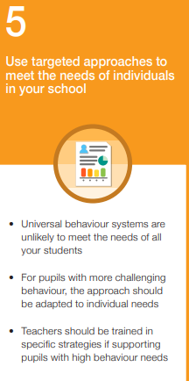
- If the problem is severe or recurring, exclusion procedures are implemented.
- Permanent exclusion.
Parents have the right of appeal to the Governing Body against any decision to exclude their child. NB: A particularly serious problem could result in suspending the normal procedure and a child being taken home straight away.

Some children may have specific difficulties which warrant a separate system of rewards and consequences relevant to their individual needs (Individual Behaviour Plan). There are systems in place to support the children and their families where behaviour is consistently disruptive and the range of rewards and consequences are not effective. These may include multi agency working e.g. SEN/Inclusion, Children and Family Well-Being Service, Educational Psychologist, Pupil referral units and/or alternative provision.

Inclusion
This policy is written in respect of all our children. The school recognises that, at times, some children may have emotional/behavioural difficulties and that further support could be needed to enable inclusion and also to maintain our high expectations of behaviour. These strategies may be different to those used with other children and will depend on the needs and age of the child. These will include: access to the school nurse, Compass Bloom support, referrals to outside agencies for specialist advice and support, team building, our SENCO and Family Learning Mentor Drop-Ins, Educational Psychologist referral, Behaviour Support Plans, regular meetings with parents, referral to the Neurodevelopmental Pathway, specific circle time sessions or social communication groups/self-esteem groups.

The Equality Act 2010 requires that a school must not discriminate against any pupil and as such has a duty to consider reasonable adjustments for students with identified needs that may pose a barrier or difficulty when following the requirements of the school policy.
Guidance for schools can be found in the Lancashire Behaviour Toolkit. http://www.lancsngfl.ac.uk/projects/behaviourattend-new/index.php?category id=18 Also, the Lancashire Local Offer for SEND. https://www.lancashire.gov.uk/children-education-families/special-educational-needs-anddisabilities/

Fixed-term and permanent exclusions
Good behaviour in schools is essential to ensure that all pupils benefit from the opportunities provided by education. Therefore, the government recognises that school exclusions, managed moves and off-site direction are essential behaviour management tools for headteachers and can be used to establish high standards of behaviour in schools and maintain the safety of school communities.

For the vast majority of pupils, suspension and permanent exclusions may not be necessary, as other strategies can manage behaviour. However, if approaches towards behaviour management have been exhausted, then suspensions and permanent exclusions will sometimes be necessary as a last resort. This is to ensure that other pupils and teaching staff are protected from disruption and can learn in safe, calm, and supportive environments. Only the Headteacher has the power to exclude a pupil from school. The Headteacher may exclude a pupil for one or more fixed periods, for up to 45 days in any one school year. The Headteacher may also exclude a pupil permanently. It is also possible for the Headteacher to convert a fixed-term exclusion into a permanent exclusion, if the circumstances warrant this. If the Headteacher excludes a pupil, they inform the parents/carers immediately, giving reasons for the exclusion. At the same time, the Headteacher makes it clear to the parents that they can, if they wish, make representation to the Governing Body. The Headteacher informs the parents who to contact should they wish to.

Schools are under a duty to provide suitable full-time education for an excluded pupil from the sixth school day of any fixed period of exclusion of more than five consecutive school days. Local authorities are under a duty to provide suitable full-time education from the sixth school day of a permanent exclusion.

It is reasonable to expect that schools will endeavour to set and mark work for all excluded pupils during the first five days of any exclusion (although there is no legal duty to do so). The Headteacher informs the Local Authority and the governing body about any permanent exclusion, and about any fixed-term exclusions.

The governing body itself cannot either exclude a pupil or extend the exclusion period made by the Headteacher.

The governing body has a discipline committee which is made up of between three and five members. This committee considers any exclusion appeals on behalf of the governors. When an appeals panel meets to consider an exclusion, they consider the circumstances in which the pupil was excluded, consider any representation by parents and the LEA, and consider whether the pupil should be reinstated.

If the governors’ appeals panel decides that a pupil should be reinstated, the Headteacher must comply with this ruling.

The governing board must also comply with their statutory duties in relation to pupils with Special Educational Need (SEN) when administering the exclusion process, including (in the case of the governing board of relevant settings) using their ‘best endeavours’ to ensure the appropriate special educational provision is made for pupils with SEN and (for all settings) having regard to the Special Educational Need and Disability (SEND) Code of Practice.

CPOMS
All behaviour Step 5 or above will be recorded on CPOMS. Behaviours below Step 5 do not need to be recorded on CPOMS unless the member of staff deems it necessary. Behaviour logs will be monitored by the Headteacher and SLT.

‘CPOMS is the market leading software application for monitoring child protection, safeguarding and a wide range of pastoral and welfare issues. Working alongside our schools existing safeguarding processes, CPOMS is an intuitive system to help with the management and recording of child protection, behavioural issues, bullying, special educational needs, domestic issues and much more. Using CPOMS, schools can ensure that pupils are safe and fully supported whilst school staff can focus on teaching and learning and providing the necessary support’.

Serious Incident Logs
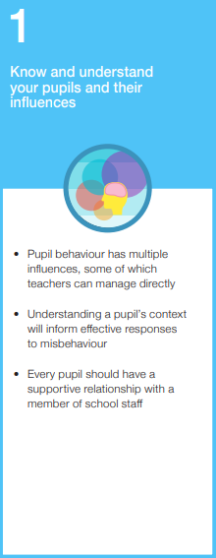
Serious incidents are logged onto CPOMS. Challenging behaviour can take the form of verbal abuse, physical abuse, assault, defiant refusal, and absconding. These incidents are ones that might give rise to disciplinary or legal action or become a matter of public interest. Any behaviour which results in exclusion must always be recorded.

The role of school staff
It is the responsibility of the class teacher to provide interesting, challenging and well-paced lessons that motivate and engage the interest of pupils. It is sometimes necessary for staff to intervene where incidents involve children from other classes. We believe that incidents should be dealt with immediately.

The staff in our school have high expectations of the children in terms of behaviour, and they strive to ensure that all children work to the best of their ability. They should ensure that the school rules are enforced in their class, and that their class behaves in a responsible manner during lesson time.

The staff will get to know each child in their class and really develop an understanding of them. Staff will develop supporting relationships with the children in their class. Staff will consider the children’s experiences and consider behaviours through a trauma informed lens.

The class teacher reports to parents about the progress of each child in their class, in line with the whole– school policy. The class teacher may also contact a parent if there are concerns about the behaviour or welfare of a child. If misbehaviour is persistent, the staff seeks help and advice from the Headteacher, as necessary, to support and guide the progress of each child.

As part of staff induction at Eccleston, the behaviour policy is shared and discussed with SLT. For existing members of staff, CPD is provided should this be identified as an area for development or requested by the staff member.

The role of the Headteacher
It is the responsibility of the Headteacher, under the School Standards and Framework Act 1998, to implement the school behaviour policy consistently throughout the school, and to report to governors, when requested, on the effectiveness of the policy. It is also the responsibility of the Headteacher to ensure the health, safety and welfare of all children in the school.

The Headteacher supports the staff by implementing the policy, by setting the standards of behaviour, and by supporting staff in the implementation of the policy.

The Headteacher keeps records of all reported serious incidents of misbehaviour.
The Headteacher has the responsibility for giving fixed-term exclusions to individual children for serious acts of misbehaviour. For repeated or very serious acts of anti-social behaviour, the headteacher may permanently exclude a child. School governors and the Local Authority will be informed.

The role of school
Schools are required to have, and to ask parents to sign, a Home School Agreement that outlines the responsibilities of the parent and the school; including those around behaviour and attendance.

The role of parents and carers
The school works collaboratively with parents, so children receive consistent messages about how to behave at home and at school. We try to build a supportive dialogue between the home and the school. We firstly monitor and then inform parents if we have concerns about their child’s welfare or behaviour.

Parents have a clear role in making sure their child is well behaved at school. We expect parents to support their child’s learning, and to cooperate with the school, as set out in the home–school agreement. If they do not, the school or local authority may ask them to sign a parenting contract or may apply for a court-imposed parenting order.

If the school has to use reasonable consequences to discipline a child, parents should support the actions of the school.

Parents must take responsibility for their child, if excluded, and ensure that they are not in a public place without good reason during school hours. If they do not, the school or local authority may issue a penalty. Parents are expected to attend a reintegration interview following any fixed period exclusion from primary school. Failure to attend may make it more likely that the local authority will apply for a Parenting Order.

The role of governors
The governing body has the responsibility of setting down these general guidelines on standards of discipline and behaviour, and of reviewing their effectiveness. The governors support the Headteacher in carrying out these guidelines.

The Headteacher has the day-to-day authority to implement the school behaviour and discipline policy, but governors may give advice to the Headteacher about particular disciplinary issues. The Headteacher must take this into account when making decisions about matters of behaviour.

Bullying
Bullying is deliberate hurtful behaviour that is repeated over a period of time that intentionally hurts another individual or groups either physically or emotionally. This can be name calling, violence, threatened violence, isolation, ridicule or indirect action such as spreading unpleasant stories about someone. It is one of the things that prevent young people from being healthy, feeling safe, enjoying and achieving, making a positive contribution and achieving economic well-being. We believe that Eccleston Primary School is a community where everyone feels safe, secure and valued. This is promoted through our values curriculum. Bullying of any sort prevents this from happening and will not be tolerated. We pride ourselves on being totally committed to inclusion and consider ourselves a fully inclusive school, therefore we will not tolerate bullying behaviour towards any of our pupils, including pupils with disabilities, racist, religious, gender, sexual or homophobic bullying. This fits in with our Single Equality policy and our extensive work in this area. We openly discuss differences between people and family situations in class and through assemblies.

Child-on-Child abuse including sexualised abuse
Child-on-Child abuse is defined as abuse between children under 18 years of age. Eccleston Primary School has a zero-tolerance approach to abuse, including child-on-child abuse.

Eccleston Primary School will refer to the specific guidance in Keeping Children Safe in Education Part five: Child on Child Sexual Violence and Sexual Harassment and Lancashire
Procedures. 5.31 Peer Abuse (proceduresonline.com)

All staff are aware that child-on-child abuse can occur between pupils of any age and gender, both inside and outside of school, as well as online. All staff are aware of the indicators of child-on-child abuse, how to identify it, and how to respond to reports. All staff will also recognise that even if no cases have been reported, this is not an indicator that child-on-child abuse is not occurring. All staff will speak to the DSL if they have any concerns about child-on-child abuse.

All staff challenge inappropriate behaviour between peers and will not tolerate abuse as “banter” or “part of growing up”.
Child-on-child abuse can be manifested in many different ways, including:
- Bullying, including cyberbullying and prejudice-based or discriminatory bullying.
- Abuse in intimate personal relationships between peers.
- Physical abuse – this may include an online element which facilitates, threatens and/or encourages physical abuse.
- Sexual violence – this may include an online element which facilitates, threatens and/or encourages sexual violence.
- Sexual harassment, including online sexual harassment, which may be standalone or part of a broader pattern of abuse.
- Causing someone to engage in sexual activity without consent.
- The consensual and non-consensual sharing of nude and semi-nude images and/or videos.
- Upskirting.
- Initiation and hazing-type violence and rituals, which can include activities involving harassment, abuse or humiliation used as a way of initiating a person into a group, and may also include an online element.

All staff are clear as to the school’s policy and procedures regarding child-on-child abuse and the role they have to play in preventing it and responding where they believe a child may be at risk from it.

All staff are made aware of the heightened vulnerability of pupils with SEND, who evidence suggests are more likely to be abused than their peers. Staff will not assume that possible indicators of abuse relate to the pupil’s SEND and will always explore indicators further. If staff believe there may be an underlying need for behaviour, they should speak to the SENDCO in the first instance.

All staff are made aware of the heightened vulnerability of LGBTQ+ pupils, who evidence suggests are also more likely to be targeted by their peers. In some cases, pupils who are perceived to be LGBTQ+, regardless of whether they are LGBTQ+, can be just as vulnerable to abuse as LGBTQ+ pupils. The school’s response to sexual violence and sexual harassment between pupils of the same sex will be equally as robust as it is for incidents between children of the opposite sex.

Pupils will be made aware of how to raise concerns or make a report and how any reports will be handled. This includes the process for reporting concerns about friends or peers. Pupils will also be reassured that they will be taken seriously, be supported, and kept safe. This process will be continually reviewed by the DSL / SLT.
The school’s procedures for managing allegations of child-on-child abuse are outlined below. Staff will follow these procedures, as well as the procedures outlined in the school’s Anti Bullying Policy.

Eccleston Primary School and the Headteacher (Designated Safeguard Lead) will consider:
- the wishes of the victim in terms of how they want to proceed
- the nature of the alleged incident
- the ages of the children involved
- the development stages of the children involved
- any power imbalance between the children
- is the incident a one-off or a sustained pattern of abuse
- are there ongoing risks to the victim, other children, school or college staff
- contextual safeguarding issues.

Following a report of sexual violence, the designated safeguarding lead (or deputy) will make an immediate risk and needs assessment, considering:
- the victim
- the alleged perpetrator
- all other children (and if appropriate adult students and staff)
- Risk assessments will be recorded and kept under review as a minimum termly
- Refer to Guidance in Keeping Children Safe in Education Sept 2025, Part 5.

Cyberbullying
‘Cyberbullying is the use of Information Communications Technology (ICT), particularly mobile phones and the internet, deliberately to upset someone else.’ (DCSF 2007).
Cyberbullying is a ‘subset’ of bullying, i.e. it is a method (a way) of bullying. Cyberbullying can be dealt with in school as all other forms of bullying are, but there are a few specific considerations that need to be addressed concerning it:

- Some cyberbullying is deliberate and aggressive.
- Some incidents are unintentional with the sender not realising or understanding the consequences of their actions (immediate or long-term), due to uses in technology.
- The sender does not see the impact of the message on the receiver.
- In cyberbullying ‘bystanders’ more easily become perpetrators – by the passing on of messages/images or contributing to online polls.

We ensure a “zero tolerance” approach towards bullying, ensuring bullying behaviour is unacceptable and always challenged. Accurate reports of bullying are recorded and taken seriously. Pupils will be listened to, will know that it is good to tell, who to tell and how to tell. A clear and swift response is provided to any report of bullying behaviour. Parents will be informed of any incident, listened to and will be kept informed of how their concerns are being dealt with. We believe in direct action, immediate intervention and constant reinforcement to pupils. The Head teacher reports incidents of bullying to governors and also looks at trends or patterns from all serious behaviour incidents including bullying.

Reasonable Force
What is reasonable force?
- The term ‘reasonable force’ covers the broad range of actions used by most teachers at some point in their career that involve a degree of physical contact with pupils.
- Force is usually used either to control or restrain. This can range from guiding a pupil to safety by the arm through to more extreme circumstances such as breaking up a fight or where a pupil needs to be restrained to prevent violence or injury.
- ‘Reasonable in the circumstances’ means using no more force than is needed.
- Schools generally use force to control pupils and to restrain them.
- 'Control' means either passive physical contact, such as standing between pupils or blocking a pupil's path, or active physical contact such as leading a pupil by the arm out of a classroom.
- 'Restraint' means to hold back physically or to bring a pupil under control. It is typically used in more extreme circumstances, for example when two pupils are fighting and refuse to separate without physical intervention.
- School staff should always try to avoid acting in a way that might cause injury, but in extreme cases it may not always be possible to avoid injuring the pupil.

Who can use reasonable force?
- All members of school staff have a legal power to use reasonable force.
- This power applies to any member of staff at the school. It can also apply to people whom the Headteacher has temporarily put in charge of pupils such as unpaid volunteers or parents accompanying pupils on a school organised visit.

When can reasonable force be used?
Reasonable force can be used to prevent pupils from hurting themselves or others, from damaging property or from causing disorder.
- In a school, force is used for two main purposes – to control pupils or to restrain them.
- The decision on whether or not to physically intervene is down to the professional judgement of the staff member concerned and should always depend on the individual circumstances.
- The following list is not exhaustive but provides some examples of situations where reasonable force can and cannot be used.
- Schools can use reasonable force to: remove disruptive pupils from the classroom where they have refused to follow an instruction to do so; prevent a pupil behaving in a way that disrupts a school event or a school trip or visit; prevent a pupil leaving the classroom where allowing the pupil to leave would risk their safety or lead to behaviour that disrupts the behaviour of others; prevent a pupil from attacking a member of staff or another pupil, or to stop a fight in the playground; and restrain a pupil at risk of harming themselves through physical outbursts.

Confiscations
There are two sets of legal provisions which enable school staff to confiscate items from pupils:
- The general power to discipline enables a member of staff to confiscate, retain or dispose of a pupils' property as a punishment. Staff are protected against liability for damage to, or loss of, any confiscated items provided they have acted lawfully and reasonably.
- Power to search without consent for 'prohibited items' including:
  - Knives and weapons
  - Alcohol
  - Illegal drugs
  - Stolen items
  - Tobacco and cigarette papers
  - Pornographic images
  - Any article that has been or is likely to be used to commit an offence, cause personal injury or damage to property
  - Any item banned by the school rules which has been identified in the rules as an item which may be searched for.
  - Weapons and knives and extreme or child pornography must be handed to the Police. Otherwise, it is for the Headteacher to decide if and when to return an item, or whether to dispose of it.

Conduct outside the school gates
Teachers have a statutory power to discipline pupils for misbehaving outside of school premises.

Headteachers have a specific statutory power to regulate pupils' behaviour in these circumstances 'to such an extent as is reasonable.' Where it has been witnessed by a staff member or reported to the school.

School may discipline for any misbehaviour when the pupil is;
- taking part in any school-organised or school-related activity
- travelling to or from school
- wearing the school uniform
- in some other way identifiable as a pupil at the school or where a pupil’s behaviour;
- could have repercussions for the orderly running of the school
- poses a threat to another pupil or member of the public
- could adversely affect the reputation of the school

Appropriate consequences would be determined by the individual circumstances and school will always make contact with parents to discuss the matter.

EYFS
Children in Reception follow the Whole School Behaviour Policy.
Within EYFS, children are constantly receiving positive verbal praise for their achievements, good behaviour and attitudes within the setting. Staff always ensure the children know when they are proud of a child and their behaviour. Children receive the same green cards as school to reward children who are consistently demonstrating our school values:
- Being kind
- Being resilient
- Being resourceful
- Building relationships
- Being fair

These green card certificates go home for the parents to share in the joy and pride of their child’s achievements.

If a child is demonstrating behaviours that need to be addressed, then staff will begin the sanction procedure. Such behaviours may include:
- Hurting others (physical)
- Being unsafe (physical)
- Not listening (defiance or refusal)
- Being repeatedly unkind (verbal)
- Swearing (by gesture and hand)

First the child will be spoken to about the behaviour and why it is not the type of behaviour that we would like to have in class. This conversation would use appropriate language, with the adult talking to the child at their eye level. If the behaviour was to continue then the child would be issued with a verbal warning. The child would then be spoken to again and would be told that if the behaviour was to continue then they would next receive some ‘Time out’. Time out is when a child is removed from where the behaviours are taking place and asked to sit on the carpet. When placed in time out, the child will be spoken to by staff about the behaviours that have led to the time out. The child will then be asked to sit and think about the behaviours and calm down if needed. Time out will be for a maximum of three minutes.

Parents will be notified that their child has received time out, either by a conversation at the end of the session or via a phone call home, if the child is going to after school club. The behaviour will also be logged onto CPOMS, identifying ‘behaviour’ or ‘communication’ as the type of incident.

Beechbuds Nursery
In Beechbuds we teach children to respect each other, our environment and show kindness. It is the role of the adult to be a key role model to children, demonstrating kindness and respect to all people and teaching children how to care for the environment around us.
We always begin the process of teaching behaviour with positive praise and reinforcement. Staff will award stickers for individual children when the school’s values have been shown by a child. Staff will also praise children by sharing their work with the whole group and with other members of the staff team including Mrs Thomas the EYFS Lead Practitioner. Children’s work and photographs of progress will be displayed within the learning environment to help build children’s self-confidence and self-esteem.

On a Friday, in Beechbuds, one child is awarded a Star of the Week certificate in class, which goes home with them. The star of the week is awarded to a child who has demonstrated outstanding achievements, whether it be academically or socially.

As part of the teaching process, at times adults will remind children about how we show kindness to others. This will begin with:
-Talking to the children about showing good behaviour
-Reminding children about no longer continuing with any unwanted behaviours
-If a child has continued with the unwanted then a time out of the space where the child is will be given. The child will be sat in the calm area of the classroom with a visual three-minute timer.
-When the timer is complete a member of staff will have a restorative conversation with the child.
-The member of staff will ask the child to apologise to another child / children or member of staff
-The child will then return to activities in class.
-A phone call home will then be made to inform the parents.

If a child hurts another child, then a time out will be given instantly, followed by the same procedure as above.

If two time outs are given within one daily session, then Mrs Thomas (EYFS Lead Practitioner) will have a restorative conversation with the child.

Complaints
If the school has to use reasonable consequences to punish a child, parents should support the actions of the school. If parents have any concern about the way that their child has been treated, they should initially contact the class teacher. If the concern remains, they should contact the Headteacher. If these discussions cannot resolve the problem, a formal grievance or appeal process can be implemented following the complaints procedure.

Monitoring
The Headteacher monitors the effectiveness of this policy on a regular basis. The Headteacher also reports to the governing body on the effectiveness of the policy and, if necessary, makes recommendations for further improvements.
The school keeps a record of incidents of misbehaviour on CPOMS. The Headteacher / Deputy Headteacher will monitor this regularly.
The Headteacher keeps a record of any pupil who is suspended for a fixed-term, or who is permanently excluded.
It is the responsibility of the governing body to monitor the rate of suspensions and exclusions, and to ensure that the school policy is administered fairly and consistently.

Review
The staff will review the behaviour system annually, or if at any time it is considered that improvements can be made.
The governing body reviews this policy annually. Governors may, however, review the policy earlier than this, if the government introduces new regulations, or if the governing body receives recommendations on how the policy might be improved, and in response to feedback from parents.

This policy does operate in isolation but links closely to:
- Anti-Bullying Policy
- Attendance Policy
- Complaints Policy
- Home/School Agreement
- Whole School Safeguarding Policy
- SEND Policy

Appendix 1 - Zones of Regulation
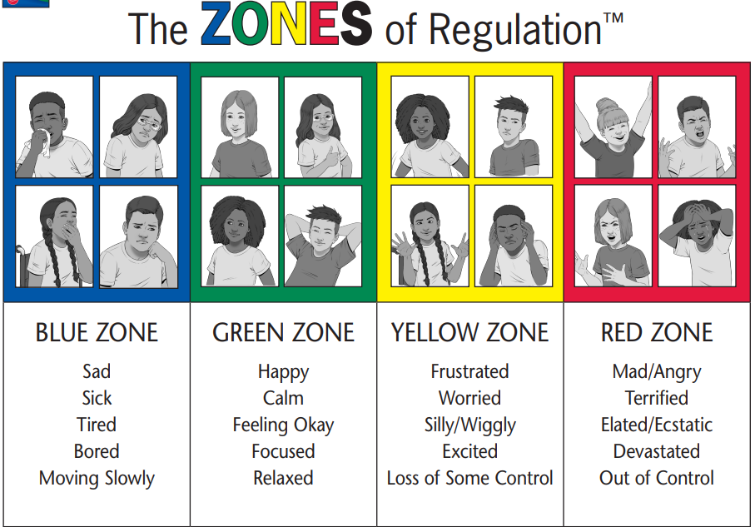

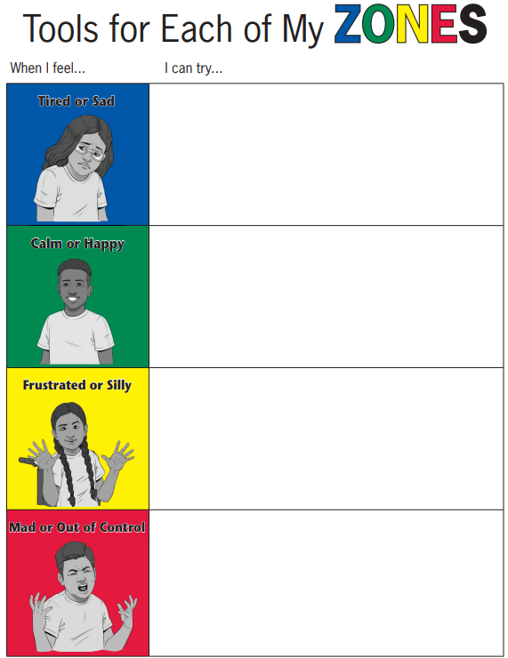

Review of the Behaviour Policy
Reviewed: July 2025
Next Review Date: July 2026

