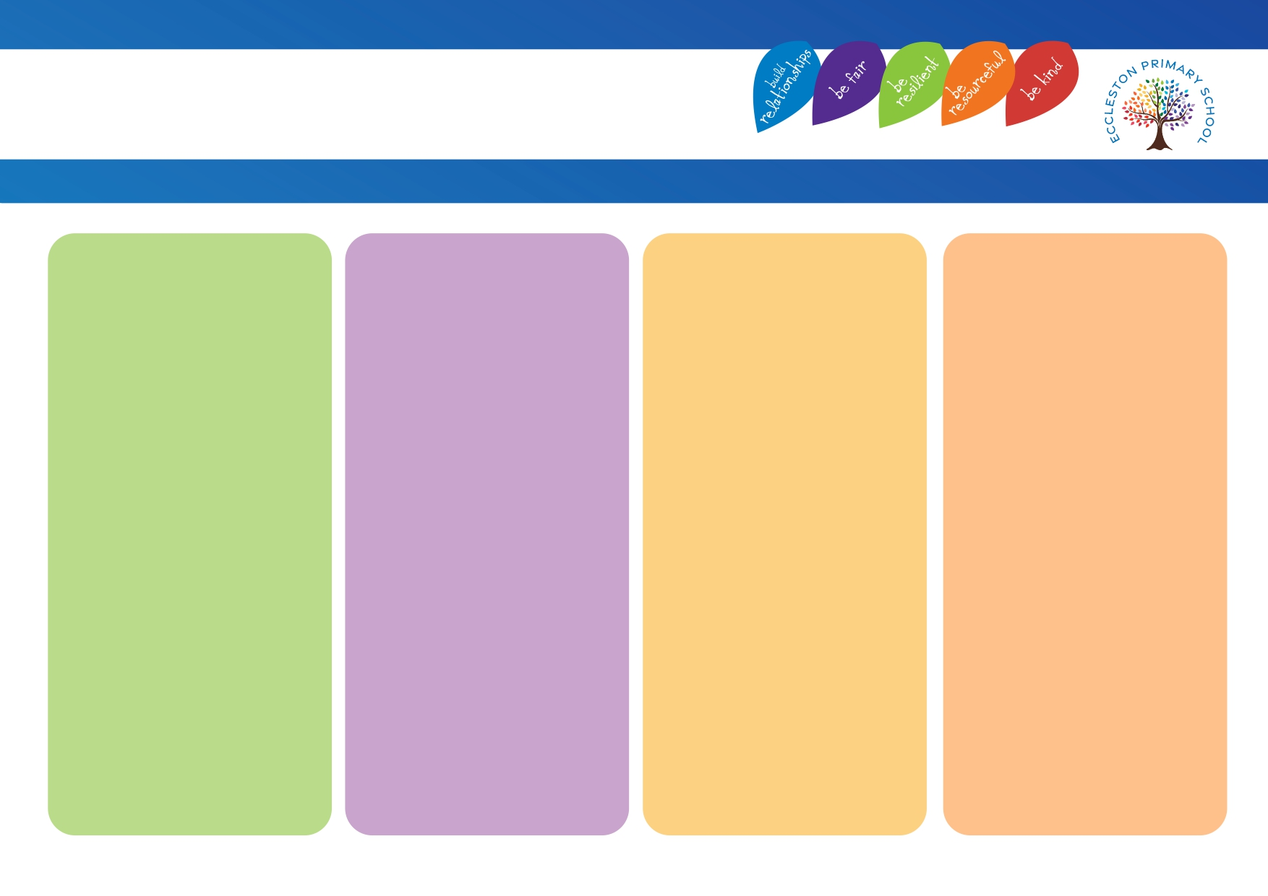
Strategies that adults use
• I do, we do, you do approach.
• Task management boards.
• Now / next boards.
• Daily IDL (Year 3 and Year 4)
• Weekly IDL (Year 5)
• Helicopter approach used.
• Flexible grouping.
• Think, pair, share.
• Worked examples / backward fading.
• Compare, contrast and categorise.
• Track with ruler – reading.
• Share screen on iPads.

Adaptations
• Additional reading opportunities.
• Extra sessions / daily sessions of IDL.
• Precision Teaching.
• Paired Reading.
• Pre / post teaching.
• Ready to Progress Intervention (Maths).
• Rapid Catch-Up Intervention (Phonics).
• Handwriting Intervention.
• Times tables Intervention.
• Same day intervention.

Physical Environment
• Subject working walls.
• Resources.
• Access to iPads.
• Reminders / prompts on desks – used on an individual basis for children and specific to them.

Intensive Support
• Support / advice followed from other professionals – such as, Specialist Teacher / EP etc.
• Personalised curriculum / timetable.
• Pupil passport.

Cognition & Learning
Eccleston Provision Map

