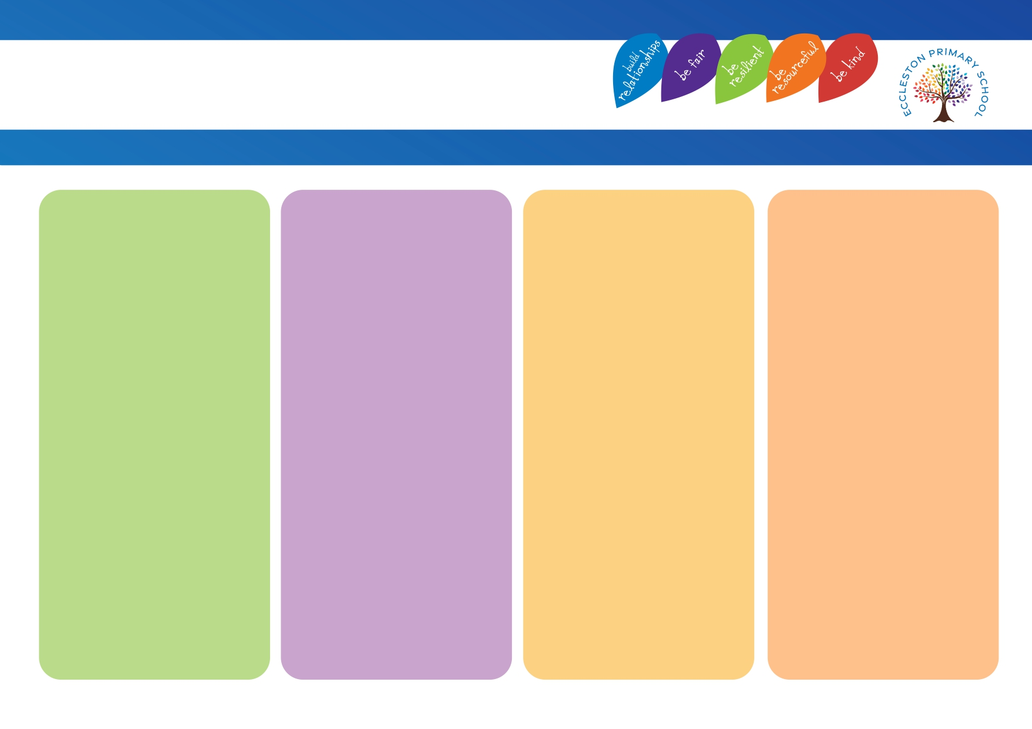
Strategies that adults use
• Use visual support. E.g. real objects, practical activities, pictures, videos.
• Using gestures, pointing, showing to support understanding while talking.
• Give thinking time so child can plan how to respond or plan how to complete a task.
• Short instruction in the order that should be followed.
• Adult modelling / building on responses.
• Get their attention, e.g. “3,2,1 eyes on me.” / say names of children before giving an instruction.
• Give simple instructions We wouldn’t say – “In a moment it is break time so, before you get your fruit, I want you to finish your sentence you are writing then line up at the door.” Instead – “Finish your sentence. Line up at the door.”
• Give extra thinking time and processing time. Pause between key points and don’t talk for too long.
• Say It Again, Better.
• Oracy carefully planned into learning opportunities across the curriculum.
Adaptations
• Awareness of blank level questions – adjust the complexity of questions based on the language of the child.
• Sentence starters.
• Scaffolded worksheets.
• In listening activities, tell children what to focus on or what to listen out for. For example, I want you to listen for who is in the story. Use visual supports to remind them.
• Highlighting, underlining or emboldening key words or putting them in different colour.

Physical Environment
• Visuals. E.g. working walls (vocabulary presented on these)
and visual timetables.
• Classroom clutter free.
• Equipment clearly marked and labelled.
• Vocabulary colours selected throughout school for displays to support with retrieval.
• Consistent approach to displays throughout classrooms.
• Managed background noise levels.
• Clear and consistent routines.
• Oracy posters in each classroom, celebrating oracy opportunities across the curriculum.

Intensive Support
• WellComm – either 1:1 or small groups.
• Speech and Language involvement followed.
• Time to Talk Intervention.
• Link below for a toolkit of resources.
https://www.southwestyorkshire.nhs.uk/cslt-resources/?fwp_cslt_resource_ages=5-11-years
• Pupil passport.

Communication & Interaction
Eccleston Provision Map

