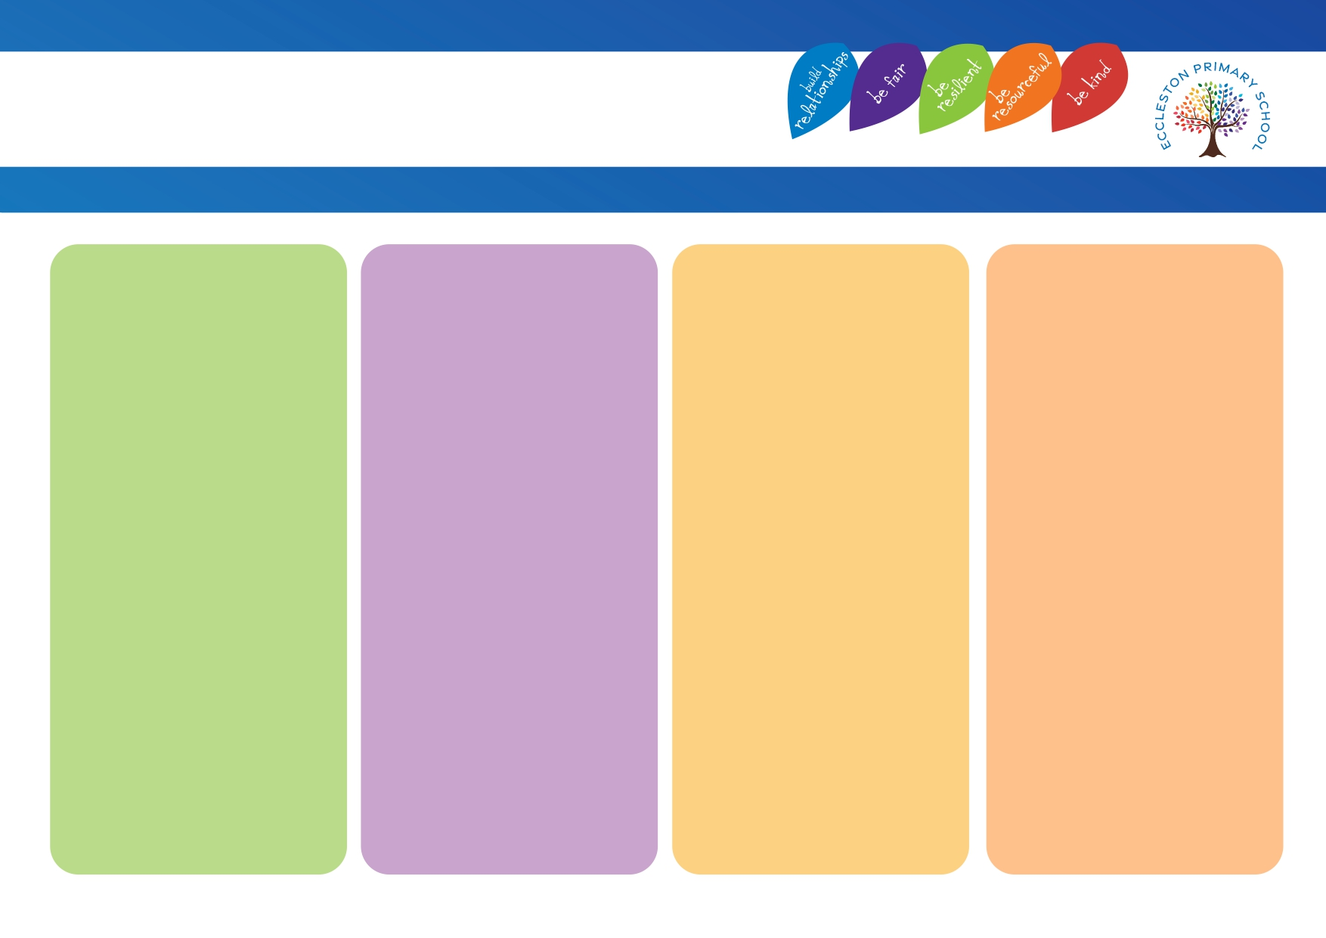
Using Technology
• Teacher using technology within their teaching.
• Teacher to use technology to model worked examples.
• Children to record their learning.
• Share screen to show pupils work or to jointly review misconceptions.
• Children to photograph flipchart paper / working wall / worked examples etc. allowing children to then access on their iPad.
•Features on the iPad used, e.g. magnifier / immersive reader etc.
•Instructional apps.
•Non – instructional apps e.g. note taking apps.
Speech generating apps.
•Make abstract or complex concepts visible.

Flexible Grouping
• Helicopter approach.
• Children moved around where support needed.

Scaffolding
• Class routines.
• Equipment for children to independently access.
• Use of concrete resources.
• Word banks.
• Sentence stems.
• Sentence starters.
• Worked examples.
• Working walls.
• Visual – like a partially completed model.
• Written – such as a list of words and phrases.
• Verbal – as in reteaching key content to a child who has picked up a misconception.

Cognitive and metacognitive strategies
• Retrieval practice / overlearning.
• Modelling.
• Working walls.
• Visual prompts / visual aids.
• Resources including technology.
• Introducing content in small steps.
• Help pupils consider ways to remember new information.
• Opportunities for students to plan, monitor and evaluate their own learning.
• Classroom clutter free / calming environment / displays.

Explicit Instructions
• I do, we do, you do approach.
• Checking pupil understanding.
• Communicating clearly and succinctly.
• Using carefully selected videos.
• Modelling how to complete a task.
• Chunking up.
• Simplified language.
• Visuals.
• Task management boards.
• Visual timetables.
• Now and next boards.

Eccleston Primary School
EEF ‘Five a day’

