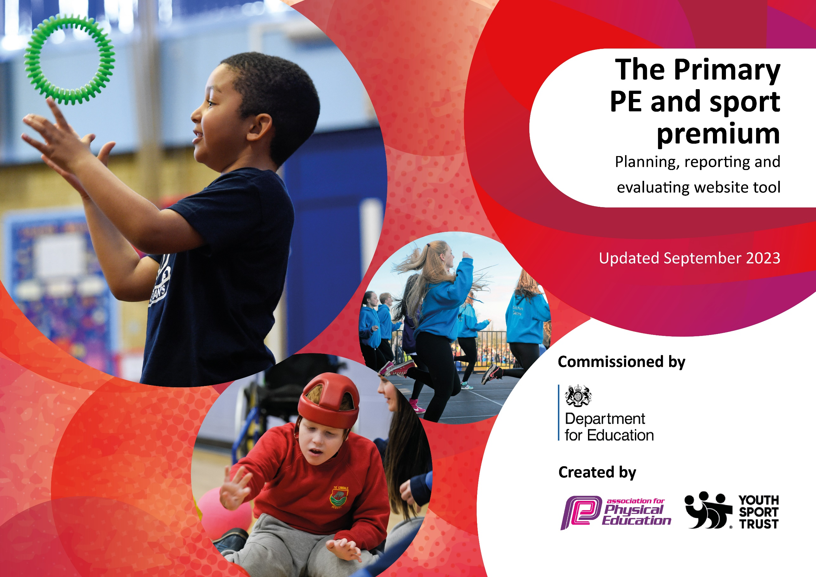

Review of last year’s spend and key achievements (2022/2023)

Activity/Action | Impact | Comments
To ensure children have a wide range  of opportunities to be physically active  at lunchtimes  (To Purchase the Opal  outdoor play and learning  programme – to be fully implemented  over 18 months)  To ensure children are given chances  to be active during the school day.  To involve all children positively in  physical activity for at least 30 minutes  per day.  For all staff to be confident using the  Lancashire PE scheme and app on the  iPad – to begin to use it for  assessment.  To ensure the children have the  experience and choice of a wider range  of sports and activities to take part in  both during and after the school day.  To compete in inter-school  competitions and intra-school  competitions. | All staff enthusiastic and  motivated in ensuring children  are physically active during break  times.  Children had a wider range of  equipment accessible to them to  allow them to be physically active  during break times.  All children including girls, SEN,  and non- sporty children were more active during break times.  All children including girls, SEN  and non – sporty children  observed using new equipment  during break times and joining in  physical activities.  Children more active at  breaks and lunchtimes when  engaged in a wider variety of activities.  Staff used the Lancashire PE app in lessons  and are began to record evidence  to use for assessment as well as using the  assessment tool.  All children in year 5 gained  confidence on their bikes.  Orienteering program bought into  and courses set up for KS1 and KS2  Bespoke maps of school and  courses used.  All children in year 5 gained  confidence on their bikes.  Orienteering program bought into  and courses set up for KS1 and KS2  Bespoke maps of school and  courses used.  Clubs were successful  in all year groups and  had a high uptake.  Chorley School Sports Partnership  delivered high quality extracurricular  sports clubs .  Sports Cool also provided Ultimate  Frisbee clubs to KS1 and KS2 -  these clubs have been hugely  popular with large uptake of pupils  in all year groups  A Girls’ Football after school  coaching session was  successful with good intake and  great improvements in skills seen.  We took part in  competitions between other  schools in activities such as  Netball, Football, Rounders and swimming.  We held a Sports day for KS1  and KS2 this year with parents  attending as well.  KS1 had a half day session  from CSSP competing in level 1  competitions against their peers. | We introduced more equipment and games to play outside as well as new playground markings to use. The children have reacted positively to all of these.  At the end of the year, we began planning the introduction of Opal Play for next year and look forward to continuing with it to see a further impact on the children.  Staff confident after discussions. We will continue to use the App for recording assessments.  All staff worked hard to ensure that the children were motivated and enthusiastic about a wider variety of activities, events, competitions and clubs throughout the year

Key priorities and Planning for 2023/2024

Action – what are you planning to do | Who does this action impact? | Key indicator to meet | Impacts and how sustainability will be achieved? | Cost linked to the action
Teaching assistant to oversee lunchtime activities, PALS and lead 2 after school sport activities/clubs  Introduce Opal Play activities at lunchtimes (Outdoor Play and Learning)  Purchase Equipment  CSSP lessons and after school clubs  e.g. CPD for teachers.  Allocate staff members for clubs linked to competitions throughout the year. | Teaching assistant, Lunchtime supervisors, pupils taking an active part  Opal Play Team, Teaching assistant, Lunchtime supervisors, pupils taking an active part  Staff and pupils  Primary generalist teachers.  CSSP staff, Swimming instructors, Sports Cool as outside instructors.  Teaching staff who gain CPD  Pupils who gain skills and wider variety of sports/competitions/clubs  Staff and pupils | Key indicator 1 -The engagement of all pupils in regular physical activity – the Chief Medical Officer guidelines recommend that all children and young people aged 5 to 18 engage in at least 60 minutes of physical activity per day, of which 30 minutes should be in school.  Key indicator 2: The profile of PESSPA being raised across the school as a tool for whole school improvement  Key indicator 4: Broader experience of a range of sports and activities offered to all pupils.  Key Indicator 3: Increased confidence, knowledge, and skills of all staff in teaching PE and sport.  Key indicator 5: Increased participation in competitive sport. | More pupils meeting their daily physical activity goal, more pupils encouraged to take part in PE and Sport Activities.  Funding allocated for next year to ensure continuation.  Opal Play team set up with regular meetings to ensure objectives are being met.  Equipment checked regularly. Funding allocated for next year to ensure continuation.  Primary teachers more confident to deliver effective PE supporting pupils to undertake extra activities inside and outside of school, including teaching water safety and swimming and as a result improved % of pupil’s attainment in PE.  Pupils develop wider range of skills.  Children accessing and enjoying a wider range of sports and activities, increasing their skills and active minutes. | £3731.2 costs for staffing to support lunchtime sessions, Pals and after school clubs – plus training lunchtime supervisors for Opal Play  £8244.72 costs for Storage and equipment for Opal Play  £4055.04 costs for new sports equipment to enrich PE lessons  £8891 – costs for teachers to undertake CPD, working alongside experienced coaches from Chorley School Sports Partnership delivering lessons, CPD, after school coaching, competitions. CPD working alongside experienced swimming instructors and outside coaches. Equipment checks and repairs.  Enrollment fee for Chorley Big Sing  Costing included in key indicator 3 above

Key achievements 2023-2024

Activity/Action | Impact | Comments
Introduction of Opal play to staff, governors, children and parents  Increased active minutes at school.  Increased participation in clubs and competitions  Use Lancashire App effectively to teach and assess PE Staff more confident and equipped to teach and assess high quality PE lessons. | The whole school staff and governors were introduced to Opal Play this year and the enthusiasm and commitment to the program has been fantastic. An Opal play working team was set up and they have been working hard with their Opal Play mentor to work through objectives and targets to get the scheme up and running.  The children were introduced to Opal Play in an assembly and have already started donating, collecting and playing with smaller items at playtimes – their enthusiasm to begin exploring, being active and learning new things at playtimes is wonderful to see.  We have had a high uptake of clubs and competitions this year across each year group, ensuring a wide range of coverage and activities.  We have entered teams into competitions, both Chorley School Sports Partnership and Cluster School events, including football, girls’ football, tag rugby, netball, cross country and basketball. We came top of the league in the Chorley Basketball league.  Our teachers deliver high quality, effective PE lessons which support all pupils to achieve their full potential. The children are engaged and learning new skills with enthusiasm. The staff use the Lancashire app to capture achievements and record accurate assessments. | After a great start setting up an 18 month action plan, assessing school grounds, planning play zones, completing risk assessments and training staff we are in a great place to continue our Opal Play journey into next year; we have a whole school plan to overhaul playtimes over the next 12 months. We will be introducing further areas for the children to play in such as a mud kitchen, stage and music area, sand pit, digging zones and much more.  After a pupil voice survey, we worked hard to provide our children with a wider variety of clubs that matched their wants and needs.  The PE coordinator uses the App to organise the whole school curriculum and oversee the assessments across the school.

Swimming Data
Meeting National Curriculum requirements for swimming and water safety.

Question | Stats: | Further context  Relative to local challenges
What percentage of your current Year 6 cohort can swim competently, confidently and proficiently over a distance of at least 25 metres? | 91% | Year 6 take part in swimming lessons at a local high school – an hour each week for the first half of the year.
What percentage of your current Year 6 cohort can use a range of strokes effectively [for example, front crawl, backstroke, and breaststroke]? | 69%

What percentage of your current Year 6 cohort are able to perform safe self-rescue in different water-based situations? | 97% | All children successfully took part in the safe self- rescue training at the pool and were very confident on the whole.
If your schools swimming data is below national expectation, you can choose to use the Primary PE and sport premium to provide additional top-up sessions for those pupils that did not meet National Curriculum  requirements after the completion of core lessons. Have you done this? | Yes/No
Have you provided CPD to improve the knowledge and confidence of staff to be able to teach swimming and water safety? | Yes/No | Our teaching staff work closely with the swimming staff at the pool and take an active part in lessons.

Signed off by:

Head Teacher: | Mr Craig Todd
Subject Leader or the individual responsible for the Primary PE and sport premium: | Mrs Lucy Mansfield – Year 2 Teacher
Governor:
Date: | 9.7.24

