

Handling of Complaints Policy

Inspiring independent learners to thrive in a changing world

Handling of Complaints Policy

The Policy and Procedures for the Handling of Complaints at Eccleston Primary School

Introduction and Scope
We care about what you think
The Policy of this School is to work in partnership with parents/carers and the wider community. Therefore, any person, including members of the public, can make a complaint. We try hard to do our best for all our pupils. Your views help us plan for the future. We like to know when things are going well. We also want parents/carers to tell us about their worries, concerns, or complaints as soon as possible. It is much easier for the school to sort out a recent problem than something that happened some time ago.

Our commitment to you
- We will deal with your concern or complaint in a professional manner.
- It will be looked into thoroughly, fairly and as quickly as possible.
- We will keep you up-to-date with what we are doing.
- We will apologise if the school has made a mistake.
- We will tell you what we are going to do to put things right.

What to do first
If you have a concern about anything we do, you can tell us by telephone, speak to us in person or in writing. If any of these are difficult for you, a friend or advocate can speak to the school on your behalf. Most concerns or complaints will be sorted out quickly either by putting things right or by explaining the school’s actions to you.
In accordance with equality law, we will consider making reasonable adjustments if required, to enable complainants to access and complete this complaints procedure. For instance, providing information in alternative formats, assisting complainants in raising a formal complaint or holding meetings in accessible locations. We take our duties under equality law seriously and we encourage any person having difficulty accessing this procedure to contact us immediately in order that reasonable adjustments can be made.
Complainants should not approach individual governors to raise concerns or complaints. They have no power to act on an individual basis and it may also prevent them from considering complaints at the Review Stage of the procedure.
Try to go to the member of staff involved or your child’s class teacher (primary schools) who will either deal with your issue or pass you on to someone who is more able to help.
Please remember that the beginning or end of the school day can be a very busy time. If you talk to a teacher at these times, for practical reasons, it may not be possible to sort things out there and then. Be prepared for them to make an appointment to see you or to ring you at a more convenient time.
In considering concerns or complaints, the school will ensure that they are dealt with effectively and with fairness to all parties. Where possible, complaints will be resolved informally. Where a complaint has not been resolved informally, then the formal procedures set out in section “6(ii)” will be followed. Where your concern or complaint is considered sufficiently complex or serious, the school may choose to investigate formally from the outset.

2. What is a concern or a complaint?
- A concern or a complaint is defined as:
  - An expression of dissatisfaction about the conduct/operation of the school.
  - The conduct of, actions or lack of actions by a member of staff/the Governing Board/an individual governor.
  - Unacceptable delay in dealing with a matter or the unreasonable treatment of a pupil or other person.
- This procedure does not cover complaints or concerns that are dealt with under other statutory procedures, including those listed in the following table, as separate procedures apply.

Note: i) Serious complaints or allegations relating to the abuse of children, assault, criminal or financial matters are also subject to separate procedures. The table following is not exhaustive, and separate procedures may exist for other categories. ii) For complaints regarding governors, the school will follow this Policy to resolve the issue.
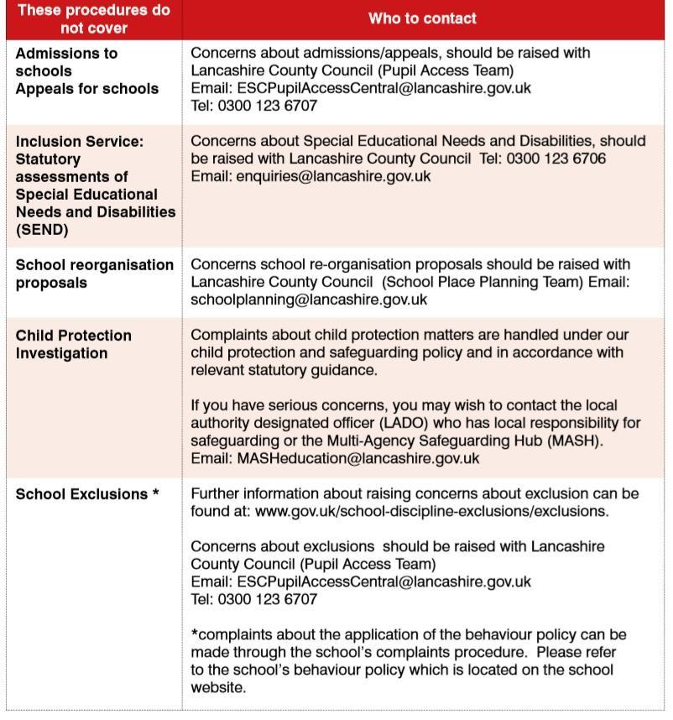
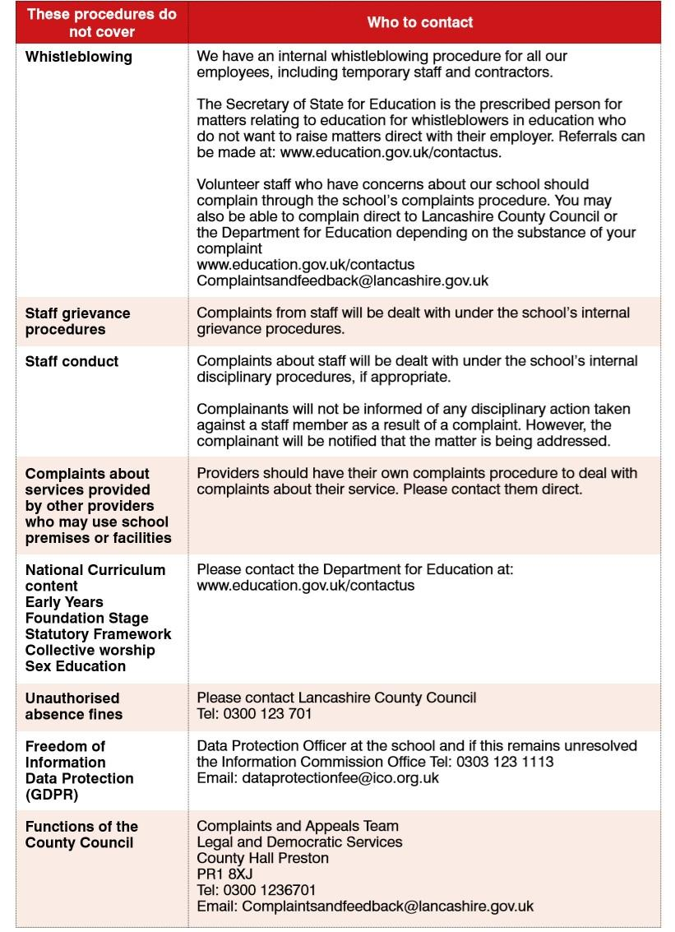

Anonymous Complaints
The school will always give serious consideration to concerns and complaints that are brought to its attention. However, anonymous complaints will not normally be considered.

Unreasonable Complaints
There is a right to raise a complaint against a school and an expectation that the individual will exhaust the school’s procedures. If the individual contacts the school again with the same issue, this could be seen as unreasonable, and the school may choose not to respond.
The school should seek advice from Governor Services and their Legal Adviser, prior to taking the decision not to progress the complaint further. The school should not stop responding to a complaint because an individual is viewed as difficult to deal with or asks complex questions. The school may refuse to respond to the subject matter but not the correspondent. The DfE provide additional guidance in ‘Best Practice Guidance for School Complaints Procedures’ (January 2019 and updated in March 2019).
See:https://www.gov.uk/government/publications/school-complaintsprocedures/best-practiceadvice-for-school-complaints-procedures-2019

Making a complaint
The school expects that the majority of complaints to be made within three months of the incident being complained of. The school will consider complaints beyond this time frame in exceptional circumstances only.
Dependent on the type of complaint, the following table is a guide to whom it should be referred to:
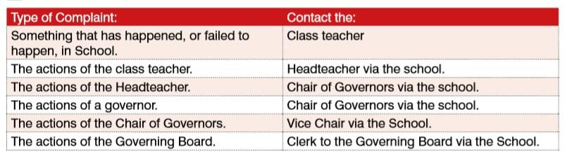

Roles and Responsibilities of the Complainant
The complainant will receive a more effective response to the complaint if they:
- explain the complaint in full as early as possible.
- co-operate with the school in seeking a solution to the complaint.
- respond promptly to requests for information or meetings or in agreeing the details of the complaint.
- ask for assistance as needed.
- treat all those involved in the complaint with respect and
- refrain from publicising the details of their complaint on social media and respect confidentiality.
The school/Governing board would in most cases hope to resolve concerns and complaints at an informal stage, but the procedures allow for formal consideration of a complaint and a review stage if matters cannot be resolved.
The school is committed to dealing with complaints as speedily as possible and would plan to complete each stage within 20 school days. From time to time, it may not be possible to complete the process in that timescale. Where it is not possible, the complainant will be informed of any delays.
Where complaints are made against an individual member of the school staff or a governor, the individual will be informed of the complaint at the earliest opportunity and certainly before any investigation commences.

The Complaint Procedure
- Informal Stage
The school will seek to resolve complaints informally by telephone call, brief meeting or email/letter as appropriate. If the complaint is unable to be resolved at this stage, the school will ask you to put your concerns or complaint in writing and the ‘Formal Stage’ - Paragraph 6(ii) of the procedures will commence from the date that the letter is received by the school.
If the school has not heard from you within 20 school days, it will assume that you do not want to take things any further and the complaint will be closed.
For concerns regarding the Headteacher, the complainant should put the complaint in a sealed envelope marked ‘private and confidential’ and addressed to the Chair of Governors via the School. Under Data Protection legislation, the school is not permitted to provide the personal details of the Chair of Governors, but the school will forward the envelope to Chair as soon as possible.
- Formal Stage
This stage will commence when the:
  - Informal complaint has not been resolved to the satisfaction of the complainant. Or
  - Complainant has indicated they wish to go straight to the formal stage. Or
  - School feels that the complaint is inappropriate for an informal resolution.
The person responsible for investigating the complaint will:
  - Following receipt of the written complaint, formally acknowledge receipt of the complaint and ensure the complainant receives an up to date copy of the School’s Complaint Policy and Procedures. It should be clarified what the complainant feels would put things right if it is not clear in the correspondence.
Note: It is acceptable for someone else to submit the complaint on behalf of the complainant with their knowledge and consent.
  - Seek advice, as appropriate. (Dependent on the nature of the complaint, this could include: the Clerk to the Governing Board; Legal Services; Schools’ HR Team; the School’s Adviser; the Schools’ Finance Officer; Pupil Access Officer or other appropriate Lancashire County Council Officer.)
  - Inform the member of staff (or governor) if the complaint concerns them and provide them with a copy of the complaint and the School’s Policy and Procedures.
  - Arrange and complete a full investigation of the complaint.
  - Prepare a report following the investigation; consider whether the complaint is substantiated or unsubstantiated and consider what actions may need to be taken.
  - Advise the complainant, in writing, of the outcome of the investigation.
Should the Complaint Remain Unresolved
  - When a complaint remains unresolved, the complainant can request a review by the Complaints Review Committee to be arranged. This request must be received by the Clerk to the Governing Board with 20 school days of the notification from the Headteacher/Chair of Governors. The request must be in writing, set out the grounds as to which matters remain unresolved and include any relevant documentation.
Note: If the Clerk to the Review Committee does not hear from the complainant within 20 school days of the notification of the outcome of the investigation, the complaint will be closed.
  - The Headteacher/Chair of Governors should make a record in the Complaints Register* of the complaint and its outcome. This record may need to be updated by the Chair of the Review Committee in due course. * Note: This is a requirement for Academies and strongly recommended for maintained schools.
- Complaints Review Committee
In very exceptional circumstances where the complaint has not been resolved by the Headteacher/Chair of Governors, a meeting of the Complaints Review Committee will be arranged to review the complaint. The request must be made in writing to the Clerk to the Governing Board via the school. The request for the review must clearly set out the matters which remain unresolved.
The Clerk to the Governing Board will acknowledge receipt and will convene the Complaints Review Committee. It is not expected to take more than 20 days to convene but the Clerk to the Committee will update the complainant as appropriate.
The clerk will request copies of written evidence and will circulate the papers 5 working days before the Committee meets. The committee will not normally accept, as evidence, recordings of conversations that were obtained covertly and without the informed consent of all parties being recorded.
The committee will also not review any new complaints at this stage or consider evidence unrelated to the initial complaint to be included. New complaints must be dealt with from Stage 1 of the procedure.
The meeting will be held in private. Electronic recordings of meetings or conversations are not normally permitted unless a complainant’s own disability or special needs require it. When a request for the meeting to be recorded is received, this must be with the clerk in advance of the meeting taking place. The consent of all parties concerned must be obtained. The request and the decision will be recorded in the minutes of the meeting.
The Committee will:
- Consist of 3 governors who have no prior knowledge of the complaint.
- With the Clerk, prepare an Agenda and invite the Headteacher and/or Chair of
Governors, (as appropriate) and the complainant to the meeting.
Note: It is the responsibility of the Headteacher/Chair of Governors and the complainant to secure their own witnesses and neither party can dictate who the other party brings.
- Consider the written materials.
- Consider the complaint and the Headteacher’s (or Chair of Governor’s) action. • Seek advice and support as necessary.
- Consider the oral evidence provided at the meeting.
If the complainant is invited to attend the meeting, they may bring someone along to provide support. This can be a relative or friend. Generally, we do not encourage either party to bring legal representatives to the committee meeting. However, there may be occasions when legal representation is appropriate. For instance, if a school employee is called as a witness in a complaint meeting, they may wish to be supported by union and/or legal representation.
At the end of their review, the Complaints Review Committee will:
- Determine whether to dismiss or uphold the appeal in whole or part.
- Where upheld, decide on recommendations that should be reported to the Governing Board by the Chair of the Review Committee.
- Advise the Headteacher/Chair of Governors (as appropriate) and complainant of their findings.
- Advise the complainant of any further action they may wish to take if they remain dissatisfied.
Following the review, the Chair of the Committee will arrange for the School’s Complaints Register to be amended to include a brief summary of the complaint and the findings of the Complaints Review Committee. In addition, the Chair of the Committee will ensure that the matter in general terms and any recommendations be reported to the Governing Board.
This concludes the School’s Complaints Procedure.

Withdrawal of a Complaint
If the complainant wishes to withdraw their complaint at any time, they will be asked to confirm this in writing.

The Role of the Local Authority
The role of the Local Authority (LA) is prescribed by legislation. In responding to complaints about schools, the LA will explain to the complainant:
- That schools are self-managing and are responsible for administering procedures that deal with complaints made against them.
- The appropriate procedures for their complaint and refer them to the Headteacher, Chair of Governors or Clerk, as appropriate.
- The school may seek advice and support from the appropriate Local Authority Officer or the school’s Adviser.

Social Media
Whilst the school accepts that complainants have a right to an opinion and make it public through the use of social media, complainants are reminded that they are not entitled to use social media to defame or harass individual staff or governors.

Calculation of time
All references in this Policy to ‘days’ should be taken to mean school days and therefore will not include weekends, school holidays or INSET days.

Next stage
After closing a complaint, should the school receive a duplicate complaint, (e.g. from a spouse; partner, a grandparent, child etc), about the same subject the school will inform the new complainant that the school has already considered that complaint and the local process is complete. The complainant can contact the Department for Education (DfE) if they are dissatisfied with the school’s handling of the original complaint.
However, if there are any new aspects to the complaint, the school will investigate and deal with this under the complaint’s procedure.
If the original complainant believes the school did not handle their complaint in accordance with the published complaints procedure or they acted unlawfully or unreasonably in the exercise of their duties under education law, they can contact the Department for Education after they have completed Stage 2.
The Department for Education will not normally reinvestigate the substance of complaints or overturn any decisions made by the school. They will consider whether the school has adhered to education legislation and any statutory policies connected with the complaint.
The complainant can refer their complaint to the Department for Education online at: www.education.gov.uk/contactus, by telephone on: 0370 000 2288 or by writing to:
Department for Education School Complaints Unit Piccadilly Gate, Store Street Manchester. M1 2WD
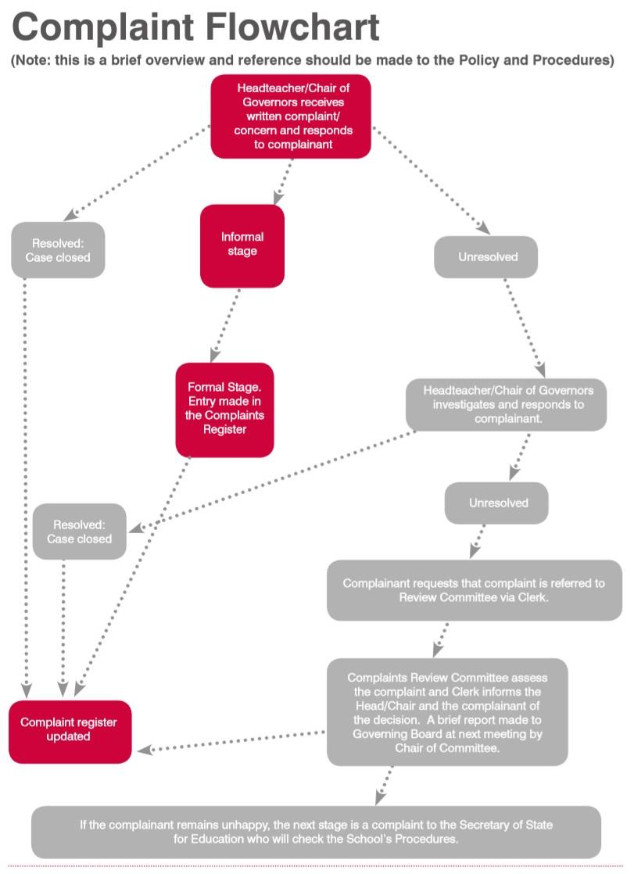

Review of Handling of Complaints Policy
Reviewed: October 2025
Next Review Date: October 2026

