

Medicine Safety Policy

Inspiring independent learners to thrive in a changing world

AIMS OF THIS POLICY STATEMENT

- To support regular attendance of all pupils;
- To ensure all staff understand their roles and responsibilities in administering medicine;
- To ensure parents understand their responsibilities in respect of their children’s medical needs;
- To ensure medicines are stored and administered safely.

Where children are unwell and not fit to be in school, and where they are still suffering from an infection which may be passed to others, children should remain at home to be cared for and looked after.

The school is committed to ensuring that children may return to school as soon as possible after an illness, (subject to the health and safety of the school community) and that children with chronic health needs are supported at school. This policy statement sets out clearly a sound basis for ensuring that children with medical needs receive proper care and support in school.

Prescription medicines
- Medicines should only be brought to school when essential (where it would be detrimental to the child’s health if the medicine were not administered during the school day).
- All medicines should be taken directly to the school office by a responsible adult.
- When children are attending breakfast club, medicines can be handed to a responsible school adult.
- Medicines will only be accepted in the original container as dispensed by a pharmacist and with the prescriber’s instructions for administration.
- Medicines will only be accepted for administration if the ‘Parental Agreement for Administering Medicine’ form is completed by parents/carers. (This form can be found on our website, is available from the school office and can be found in this policy as Appendix A).
- The appropriate dosage spoon should be included with all medicines sent to school.
- Any medicine administered will be recorded by the staff member on the ‘Record of administering medicine’ form – Appendix B.

Non-prescription medicines
- We will NOT administer medicines that have not been prescribed by a doctor.
- If a doctor has advised paracetamol and/or ibuprofen, in conjunction with a prescription, this can be added to the ‘Parental Agreement for Administering Medicine’ form and will only be administered in this situation.
- Where necessary, these medicines should be administered by parents/carers prior to coming to school. If a child needs further medication throughout the day consideration must be taken as to whether the child is well enough to attend school.
- Cough sweets and lip balms are not permitted in school due to the risk of choking and cross-contamination.

Controlled drugs
- The supply, possession and administration of some medicines are controlled by the Misuse of Drugs Act 2005 and its associated regulations. Some may be prescribed as medication for use by children and young people.
- Once appropriate information and training has been received any member of staff may administer a controlled drug to the child or young person for whom it has been prescribed.
- Staff administering medicine should do so in accordance with the prescriber's instructions. The appropriate Health Care Plan needs to be completed and updated annually by the parent/carer with support from Health Care professionals and the class teacher.
- It is permissible for schools to look after a controlled drug, where it is agreed that it will be administered to the child or young person for whom it has been prescribed.
- A controlled drug, as with all medicines, should be returned to the parent/carer when no longer required to arrange for safe disposal (by returning the unwanted supply to the local pharmacy). If this is not possible, it should be returned to the dispensing pharmacist (details should be on the label).
- Misuse of a controlled drug, such as passing it to another child or young person for use, is an offence. There should be an agreed process for tracking the activities of controlled drugs and recognition that the misuse of controlled drugs is an offence.

Roles and responsibilities of school staff
- The Headteacher is responsible for putting this policy into practice and for developing detailed procedures. Day-to-day decisions will normally fall to the Headteacher or to the Deputy Headteacher, in the absence of the Headteacher.
- The Headteacher will ensure that staff receive appropriate training on the policy and are properly supported. Appropriate training will take place annually and will include whatever conditions are appropriate to the children attending school.
- The Headteacher will ensure that all parents and staff are aware of the policy and procedures for dealing with medical needs, by including it in ‘New Intake Meetings’ and packs, by placing information in newsletters and on the school website. This policy is included in the induction training for new staff and is updated and discussed in staff meetings throughout the school year.
- Staff at Eccleston Primary School are expected to do what is reasonable and practical to support the inclusion of all pupils. This will include administering medicines or supervising children in self-administration. However, as they have no legal or contractual duty, staff may be asked, but cannot be directed, to do so.
- Staff with children with medical needs in their class or group are informed about the nature of the condition, and when and where they may need extra attention. The child’s parents/carer, previous class teacher and health professionals provide this information.
- All staff are aware of the likelihood of an emergency arising and what action to take if one occurs. Back up cover should be arranged for when the member of staff responsible is absent or unavailable. At different times of the day other staff may be responsible for children, such as lunchtime supervisors, supply teachers. Welfare staff are also provided with training and advice on a half termly basis.
- A Health Care Plan may reveal the need for some staff to have further information about a medical condition or specific training in administering a particular type of medicine or in dealing with emergencies. Staff will not give medicines without appropriate training from health professionals. When staff agree to assist a child with medical needs, the school will ensure appropriate training in collaboration with local health services.
- Staff must complete the ‘Parental Agreement for Administering Medicine’ form.
- A form will be kept each time medicine is administered within school time.
- Relevant staff will be trained on how to administer Adrenaline Auto-Injectors (AAIs), on diabetes and on any other appropriate conditions to our children. Annual staff updates are carried out regarding this policy.

Parent/Carers responsibility
- In most cases, parents/carers will administer medicines to their child themselves out of school hours, but where this is not possible, parents of children in need of medication must ensure that the school is accurately advised about the medication, its usage and administration.
- Parents must complete the ‘Parental Agreement for School to Administer Medicine’ form, (found on our school website , the school office, or in this policy) before a medicine can be administered by staff.
- Primary school children may be able to manage their own medication, under adult, supervision but again, only with parental agreement given through the appropriate paperwork as above.
- Parents/carers are responsible for ensuring that all medication kept in school e.g. asthma pumps, Adrenaline Auto-Injectors (AAIs), are kept up to date;
- Parents/carers are responsible for notifying the school if there is a change in circumstances e.g. If a child is deemed to be no longer asthmatic.

Long-term and complex needs
Where a child has significant or complex health needs parents should give full details on entry to school or as the child first develops a medical need. Where appropriate, a health care plan may be put in place involving the parents, class teacher and, if appropriate, relevant health care professionals. Health Care Plans are updated annually in the Autumn Term. Staff receive up-to-date training from relevant professionals on appropriate medical conditions for children in our school, so that they can respond effectively to individual children’s needs.

Safe storage of medicines
The school is responsible for ensuring that all medicines are stored safely.
- Asthma inhalers are labelled clearly with the child’s name and stored in the sturdy yellow medication box for each class.
- If medicines need to be refrigerated during the day they will be stored in the staffroom, with access only for staff.
- Adrenaline Auto-Injectors (AAIs), are labelled clearly with the child’s name and stored in the sturdy yellow medication box for each class.

Record keeping
- Parents/carers must complete the ‘Parental Agreement for Administering Medicine’ form, if they require their child to receive medicine whilst at school.
- Parents/carers, with the support of school staff and where appropriate health care professionals, must complete a Health Care Plan for children with long term or complex medical conditions. These plans must be updated annually by the class teacher who will meet with the parents.
- Although there is no legal requirement for schools to keep records of medicines given to pupils, it is good practice to do so. Therefore, at Eccleston Primary School, staff complete and sign a record each time they give medicine to a child, on the ‘Record for administering medicine’.

Managing medicines on school trips
On school visits, the teacher is responsible for taking any medicines required. They may agree to take temporary responsibility for administering medicine e.g. antibiotics following the above procedure. Any Medical Information for individual children should be recorded on the ‘Risk Assessment’ for the trip.

Emergency procedures
The emergency procedures for individual children are written into their individual care plans and reflect their own individual and unique needs. In the case of a general medical emergency, staff will notify the Headteacher, or most senior member of staff who will contact emergency services if required. Parents will then be notified and asked to respond. Any emergency medical care will not be delayed if parents are unable to attend school immediately, in this instance a member of staff will accompany the child. Parent details are available for every child on our electronic MIS – Arbor.

Review of the Medicine Safety Policy
Reviewed: November 2025
Next Review Date: November 2026

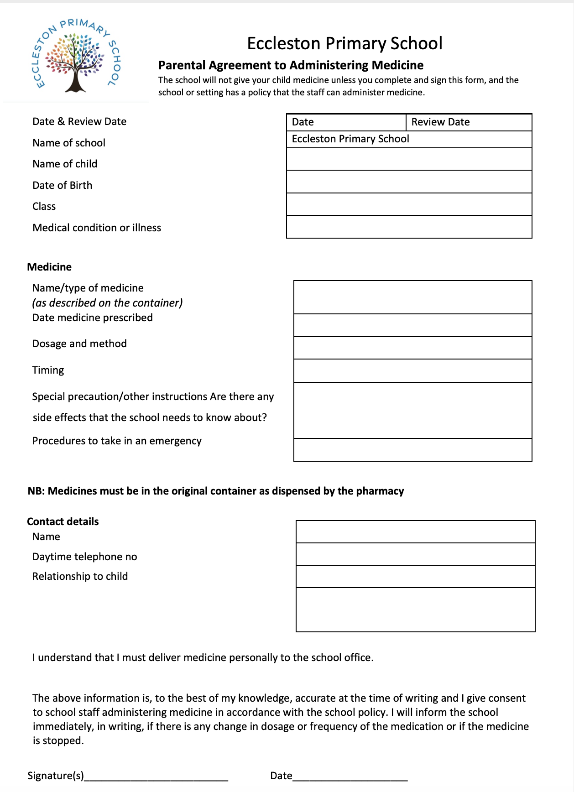
Appendix A

Appendix B
