Parent Voice 2025 – 26 Action Plan
Question | Actions
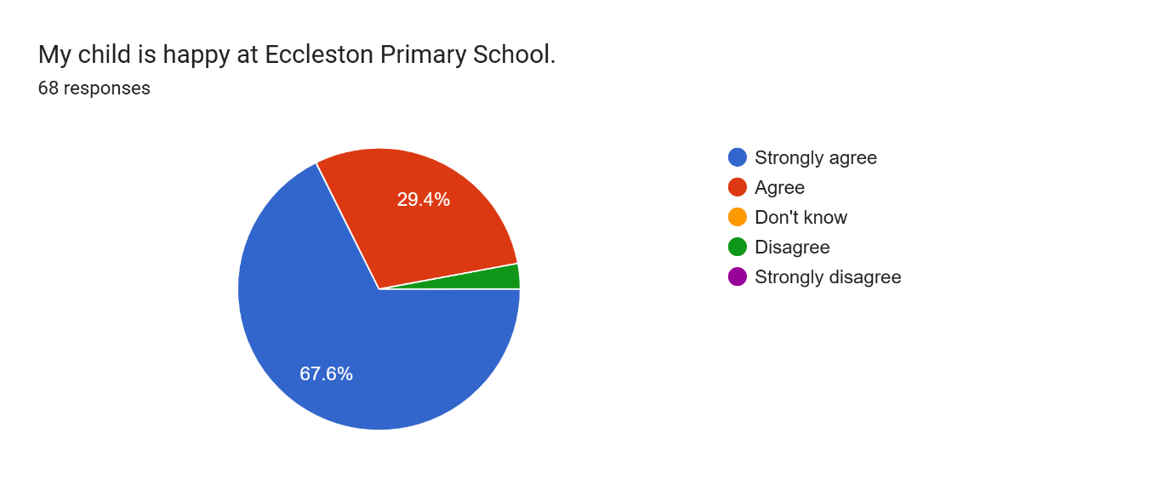 | Any children who are presenting as unhappy now have the tools to explain their feelings through the Zones of Regulation.  Encourage parents to communicate with staff to ensure staff are fully aware, especially if the child is not sharing their feelings.
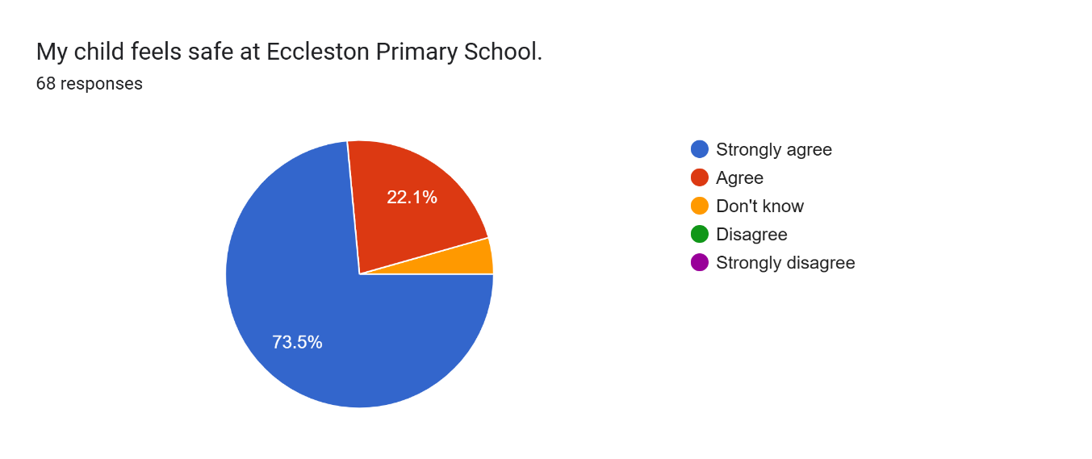 | Continue.
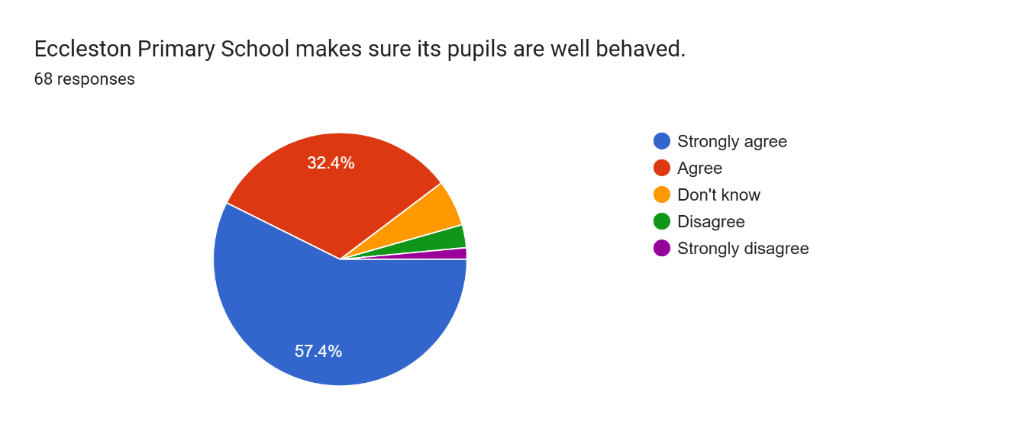 | Continue to follow the Behaviour Policy and communicate with parents effectively.  3 parents disagreed with this statement. Behaviour is excellent across the school, supported by a new, trauma informed behaviour policy and behaviour curriculum.  Continue to be vigilant around behaviour and communicate the families appropriately.
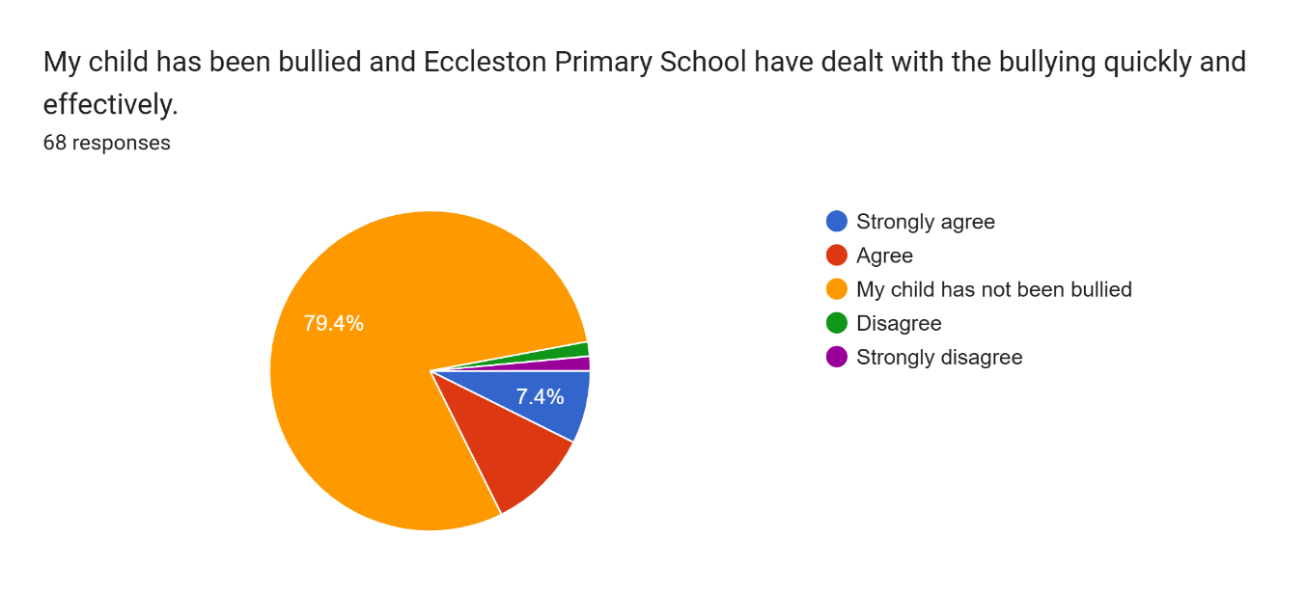 | Mostly excellent news. However, 2 families have reported that we have not responded quickly and effectively. Reiterate to staff the importance of tackling bullying in line with our behaviour policy.  Reports of bullying are minimal across school. There have been reports of some incidents outside school, which have been actioned with the families.
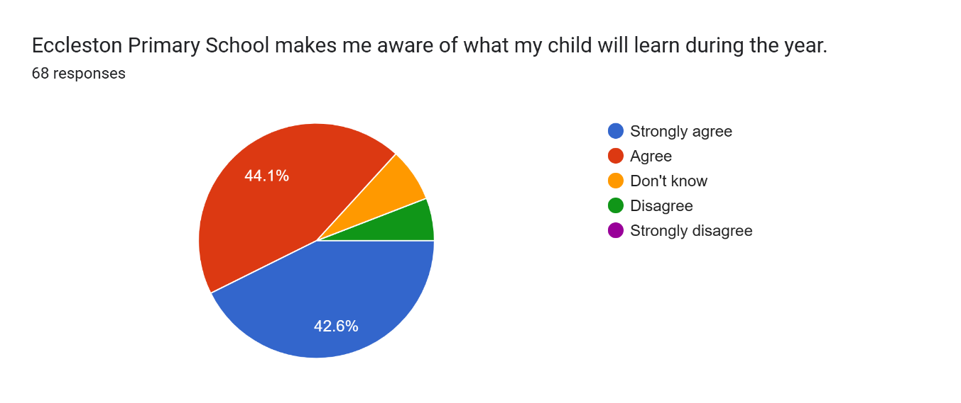 | Signpost parents to the website where ‘Year Group Overviews’ showcase the learning for the academic year, as per last year.  Encourage more families to attend ‘Meet the teacher’ where these documents are shared and discussed.  Send out termly overviews as a printed document for children to take home and put on the fridge.  Resend the documents directly on ParentApps.
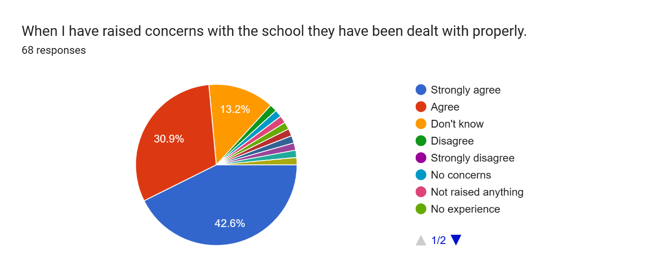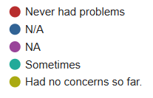 | Majority of comments are positive or that there have been no issues.  Reassure families on the newsletter that any concerns will be dealt with and that appointments can be made with the class teachers or headteacher as appropriate.  Ensure families know that they can drop in to raise concerns and if someone is available, they will be able to speak to a member of staff.  1 family disagreed with this statement, it is not clear what it relates to, as we communicate with parents whenever concerns are raised.
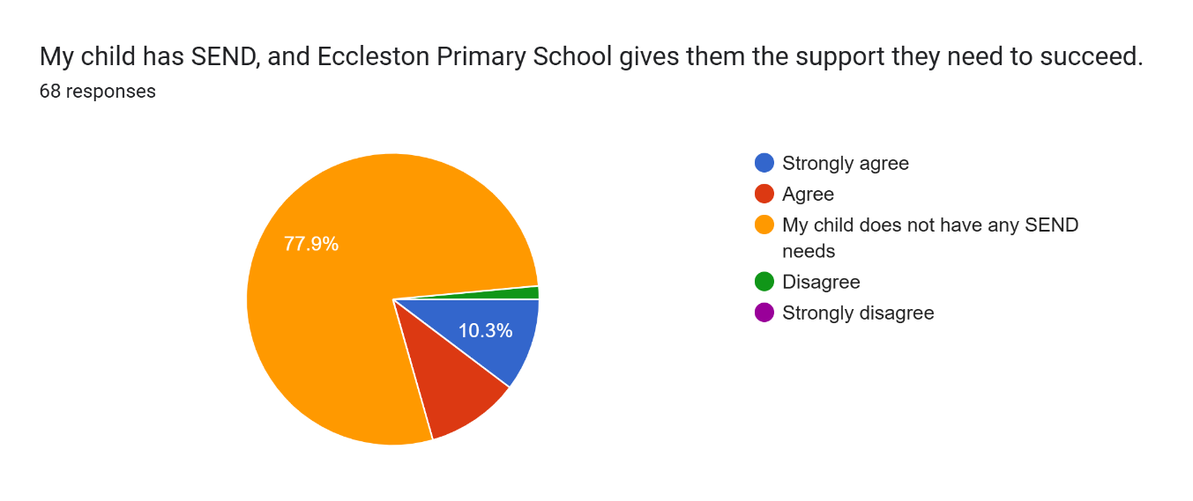 | This is overwhelmingly positive. 1 family do not agree with the statement. This has not been communicated with school, and we are not able to identify who this is. We will remain open and approachable, keen and willing to support our children.
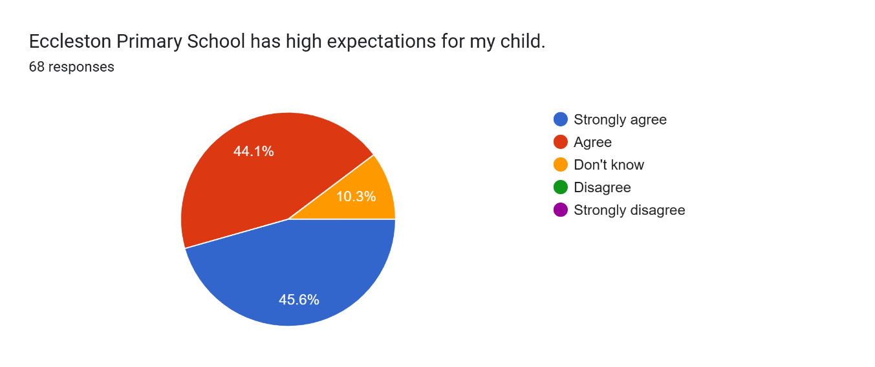 | Encourage families to attend parents’ evening and open events.
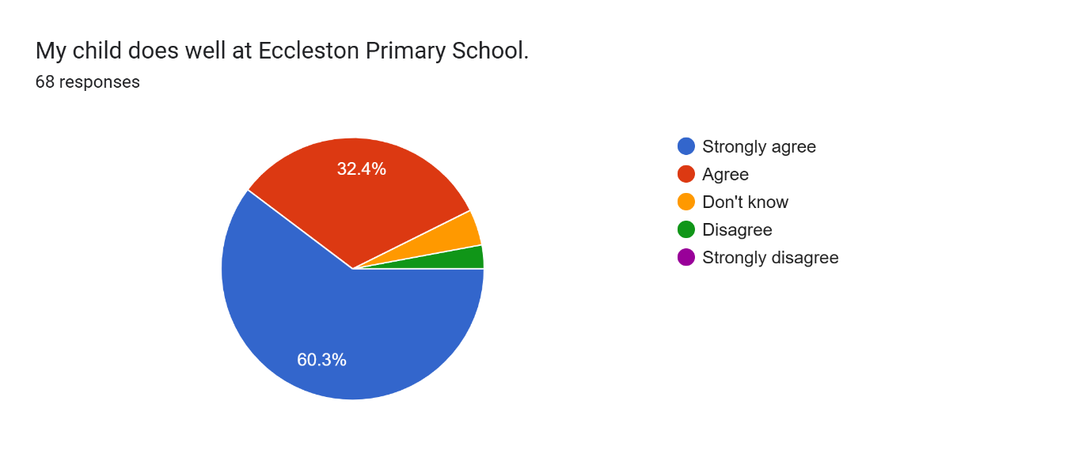 | 2 families disagree with this statement, we will continue to showcase the successes of our children though social media, newsletters, direct messages, communication from teachers and phone calls home.
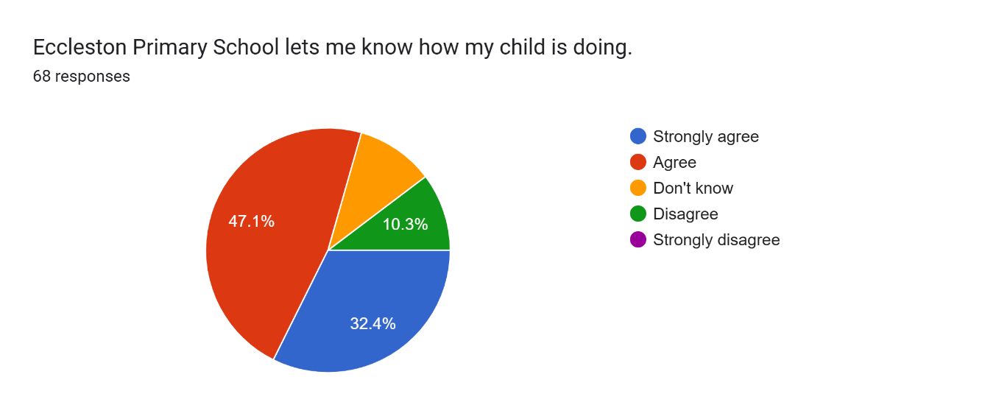 | Currently we hold two parents' evenings, showcasing books and learning and write a formal end of year report.  Reassure parents that there is an open door policy for them to check in about their child.  Positive phone calls home may also support this.  Signposting parents to X/Twitter and the newsletter to show the amazing work that our children are doing.  We hosted art galleries, rock steady gigs and sports day last year.
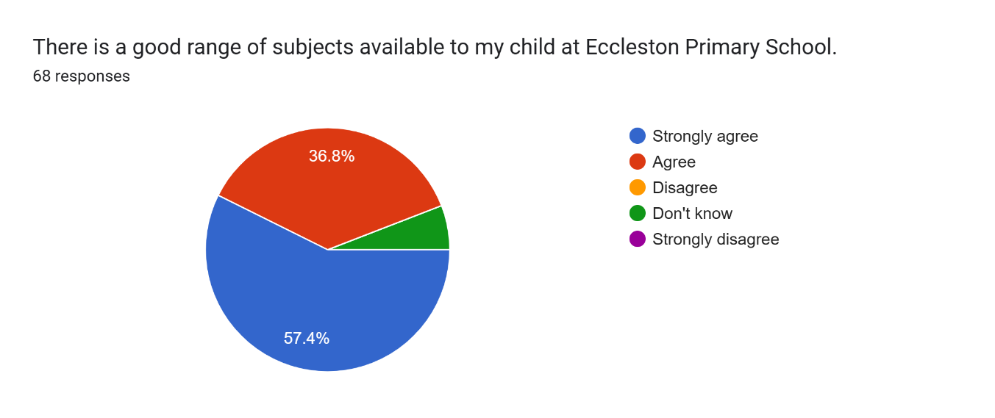 | Share ‘Year Group Overviews’ to showcase coverage.
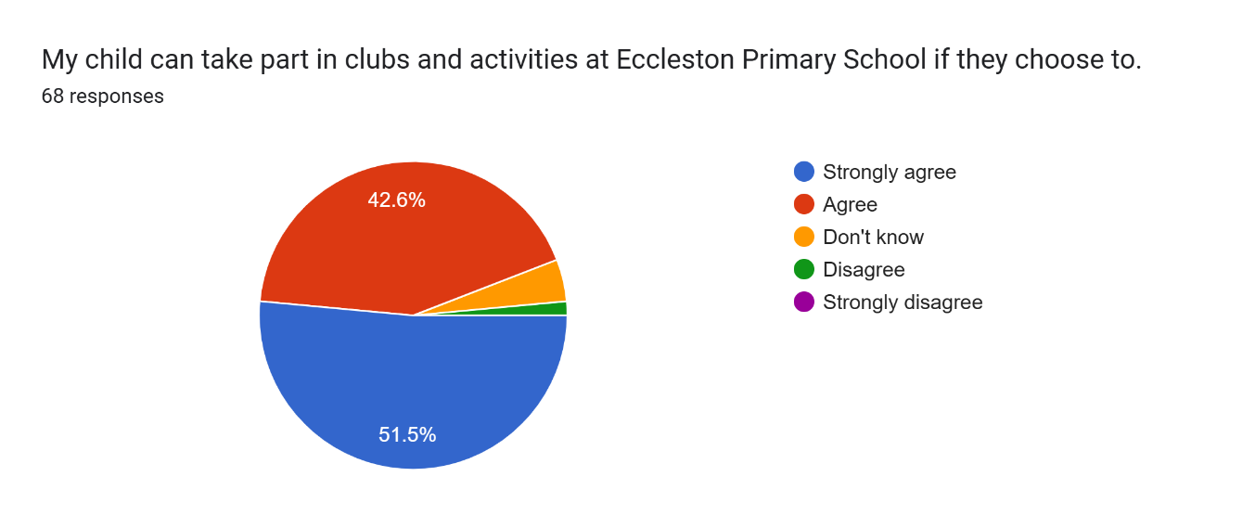 | Continue to offer a wide range of clubs.  Ask the school council what clubs they would want to see at school.
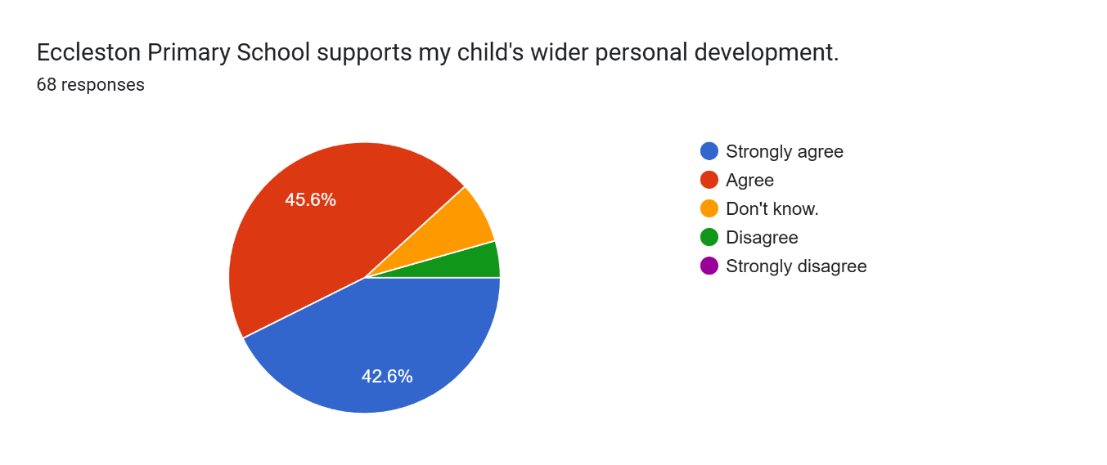 | Continue to share key events at school, visiting speakers and assembly content.  Signpost parents to X/Twitter when we have had the fire service and other enrichment opportunities in school.  Continue to offer a range of educational trips to support learning.
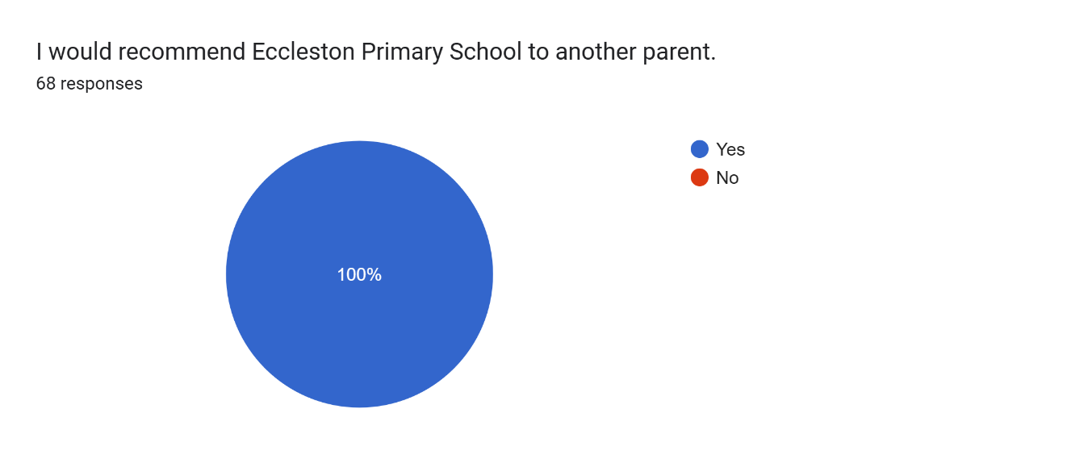 | This is wonderful news!

