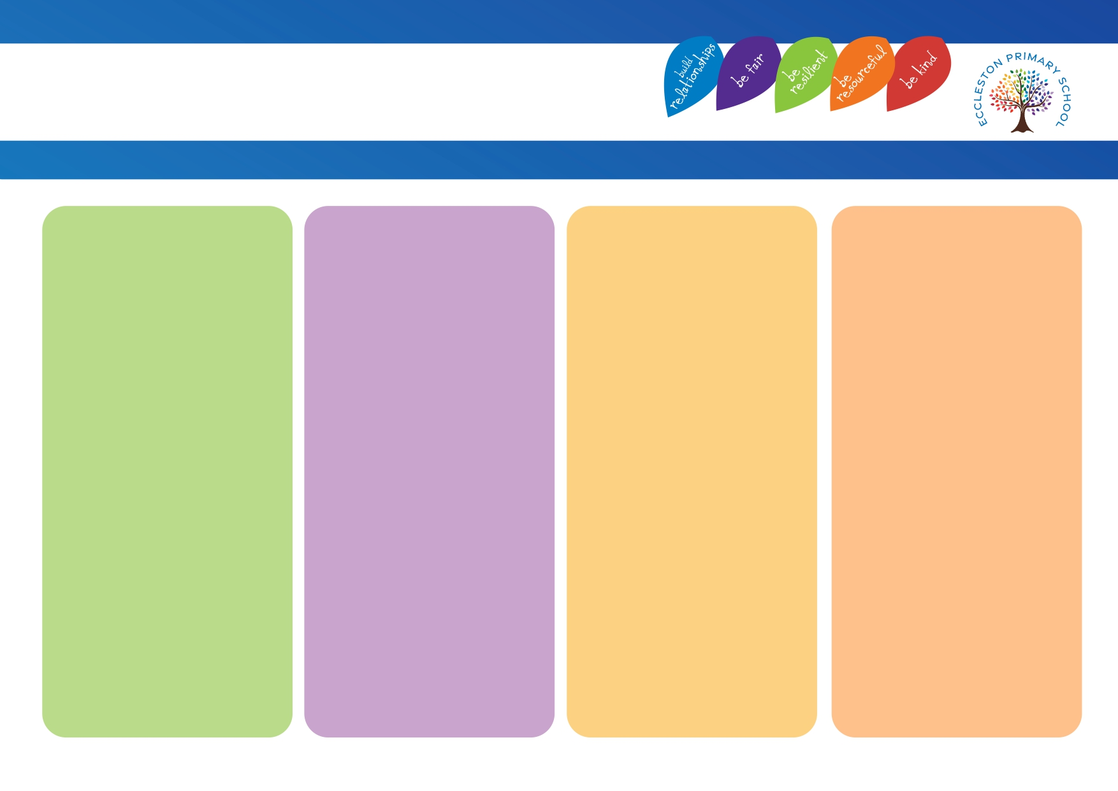
Strategies that adults use
• Fine and gross motor skill activities incorporated into daily activities (EYFS).
• Outdoor learning opportunities.
• Seating plans.
• Multisensory teaching methods.

Adaptations
• Movement breaks – as and when required.
• Access to ear defenders.
• Access to sensory toys.
• Use of specialist equipment.
• Wobble cushions.
• Sloping boards for desks.
• Colour overlays.
• Pencil grips.
• Adapted text size.
• Adapted reading books – e.g. bigger print or print in a straight line.
• Motor Skills United.
• Write from the Start.
• Handwriting Intervention.
• Fine motor activities.
• Gross motor activities.

Physical Environment
• School building is accessible for all.
• Classrooms have age-appropriate furniture and environments.
• Managed background noise levels / lighting.
• Classroom clutter free.

Intensive Support
• Individual support with self – care where appropriate.
• Individual workstation.
• Specialist seating.
• Movement breaks – structured.
• Sensory circuits.
• Recommendations followed by external services, such as OT / Physio/ HI Specialist teacher / VI Specialist teacher / School Nursing Team etc.
• Risk assessments as required.
• Pupil passport.

Physical and Sensory
Eccleston Provision Map

