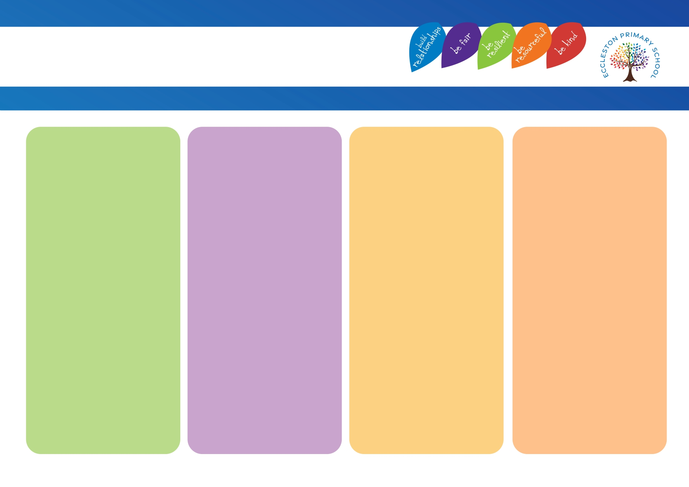
Strategies that adults use
• Whole school behaviour policy / behaviour curriculum.
• Whole school assemblies.
• Praise and high expectations.
• Transition support. E.g. visuals, reminders, countdowns, positive reinforcement, modelling.
• Children responsibilities – School Council / School Ambassadors / Maths Ambassadors / Reading Ambassadors / Sports Ambassadors / Well-being Ambassadors / Eco Team.
• Class roles and responsibilities.
• PSHE planned lessons – Scarf.

Adaptations
• Feelings thermometer used to track day.
• Positive moment of the day – children complete.
• WOW moment of the day / week shared with home – school complete.
• Check-ins throughout lessons / day. E.g. with visuals or resource or verbally.
• Specific class stories chosen.
• Friendship support groups.
• Small group support at breaktimes / lunchtimes.

Physical Environment
• Zones of regulation used / display in each classroom.
• Break out space provided / resources available in these areas.
• Class visual timetable.

Intensive Support
• Compass Bloom – 1:1 / small groups.
• Daily check-ins.
• Social stories.
• Support during unstructured times. E.g. breaktimes / lunchtimes.
• Morning meet and greet.
• Personalised behaviour plans / emotional first aid plans.
• Enhanced transition support.
• Soft landing – support with regulation prior to learning demands.
• Family support worker check-ins.
• Involvement from other agencies.
• Pupil passport.

Social, Emotional and Mental Health
Eccleston Provision Map

