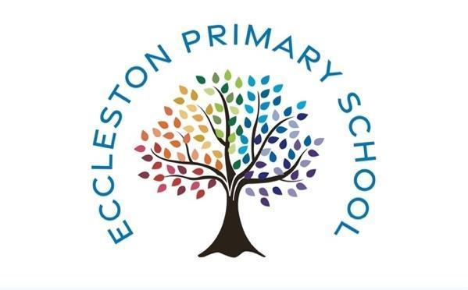

jmu
Eccleston Primary School
Computing Curriculum

Whole school definition: Computing is the process of using computer technology to complete a given goal-oriented task.

National Curriculum Computing - Purpose of study
A high-quality computing education equips pupils to use computational thinking and creativity to understand and change the world. Computing has deep links with mathematics, science, and design and technology, and provides insights into both natural and artificial systems. The core of computing is computer science, in which pupils are taught the principles of information and computation, how digital systems work, and how to put this knowledge to use through programming. Building on this knowledge and understanding, pupils are equipped to use information technology to create programs, systems and a range of content. Computing also ensures that pupils become digitally literate – able to use, and express themselves and develop their ideas through, information and communication technology – at a level suitable for the future workplace and as active participants in a digital world.
Aims
The national curriculum for history aims to ensure that all pupils:
- can understand and apply the fundamental principles and concepts of computer science, including abstraction, logic, algorithms and data representation
- can analyse problems in computational terms, and have repeated practical experience of writing computer programs in order to solve such problems
- can evaluate and apply information technology, including new or unfamiliar technologies, analytically to solve problems
- are responsible, competent, confident and creative users of information and communication technology.

EYFS – see Development Matters 2021 for detailed examples of how to support learning in EYFS
Understanding the World: People and communities, the world and technology. Practitioners should support children in experiencing a range of technologies – using cameras, photocopiers, CD players, tape recorders and programmable toys, in addition to computers.

Computing Curriculum Statement

Whole school definition: Computing is the process of using computer technology to complete a given goal-oriented task.

Intent

At Eccleston Primary School, our vision is to inspire independent learners to thrive in a changing world and ensure every child develops a healthy relationship with technology. At our school we value and recognise the contribution that technology can make for the benefit of all pupils, staff, parents, governors and society. We strive to provide safe opportunities in computing to motivate, inspire and raise standards across the curriculum. Everyone in our school community will be equipped with the digital skills to meet developing technology with confidence, enthusiasm and prepare them for a future in an ever-changing world.

We want our children to be creators and innovators not just mere consumers of digital content. The idea of the children as digital creators is what underpins our planning and computing units. Our children are taught to understand that technology is an integral part of modern life and the key to the future is to harness and understand technology’s potential. Computing is a constantly evolving subject that involves solving complex problems, being able to collaborate with others, learn from mistakes and refine solutions.

Our computing curriculum is designed to be easy to follow, with logical sequenced steps that will equip all children with the essential skills and knowledge they need to use technology safely and creatively.

Our Computing Curriculum’s aims are:
- To ensure all pupils develop a strong foundation in computational thinking and digital literacy.
- To equip pupils with the skills to thrive in a technology driven world.
- To foster creativity, problem-solving, and critical thinking through engaging Computing lessons.

Our pupils will be able to use technology purposefully and safely, understand basic programming concepts, and critically evaluate digital content. By the end of Key Stage 2, pupils will have experience in coding, web design, and digital presentations, and a solid understanding of online safety. Computing supports broader curriculum goals by developing problem-solving skills, fostering creativity, and encouraging teamwork.

Here at Eccleston Primary School, we believe safety is paramount. We promote and model a balanced digital life, recognising that amongst the many positives that technology has to offer, risks exist and children need to be taught to manage their digital lives properly. We strive to model and educate our children to use technology creatively, positively, responsibly and safely. Our curriculum supports the key aims of the government’s Internet Safety Strategy (Digital Literacy / UK Council for Child Internet Safety (UKCCIS) framework) of supporting children to stay safe and make a positive contribution online, as well enabling teachers to develop effective strategies for understanding and handling online risks.

Implementation: How is Computing taught at Eccleston Primary School?
At Eccleston Primary School, computing planning is overseen by the subject leader and delivered through Purple Mash and bespoke lesson plans tailored to pupil needs. Lessons are timetabled weekly for all year groups. Pupil work on Purple Mash is saved and teachers monitor pupil progress. Feedback is given verbally during lessons and through responses on Purple Mash. Purple Mash provides pre-made resources for teachers (including lesson plans, slideshows and activities) and interactive software for pupils to apply their skills. All computing units link to one of the following areas, however, most units will include aspects of all strands.
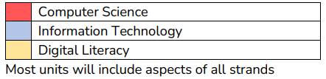

Units are then available for each year group. Units do not need to be taught in any specific order but can be seen in the example below. All year groups begin with Online Safety at the beginning of the academic year.
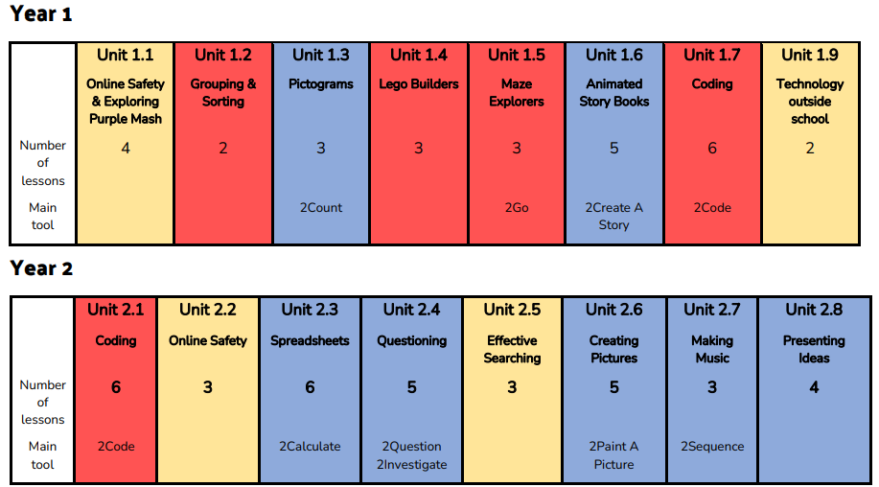
We participate in annual events such as Safer Internet Day and anti-bullying week.
Impact
We constantly monitor to ensure the children have learnt the things we’ve taught them and if they are struggling, we can introduce additional support the next time they encounter that objective. Impact is about how we know what you do is making a difference. If children are keeping up with the curriculum, they are deemed to be making good or better progress.
We measure the impact of our curriculum through the following methods:
- Pupil discussions and interviewing the pupils about their learning (pupil conferencing).
- Pupil work recorded on Purple Mash and assessment/feedback on content creation.
- Governor monitoring with our subject computing link governor.
- Pupil self-reflection.
- A reflection on standards achieved against the planned outcomes (progression/what to observe in learning).
- Learning walks and reflective staff feedback (teacher voice).
- Formative and summative approaches.

Computing Coverage Overview - Year 1
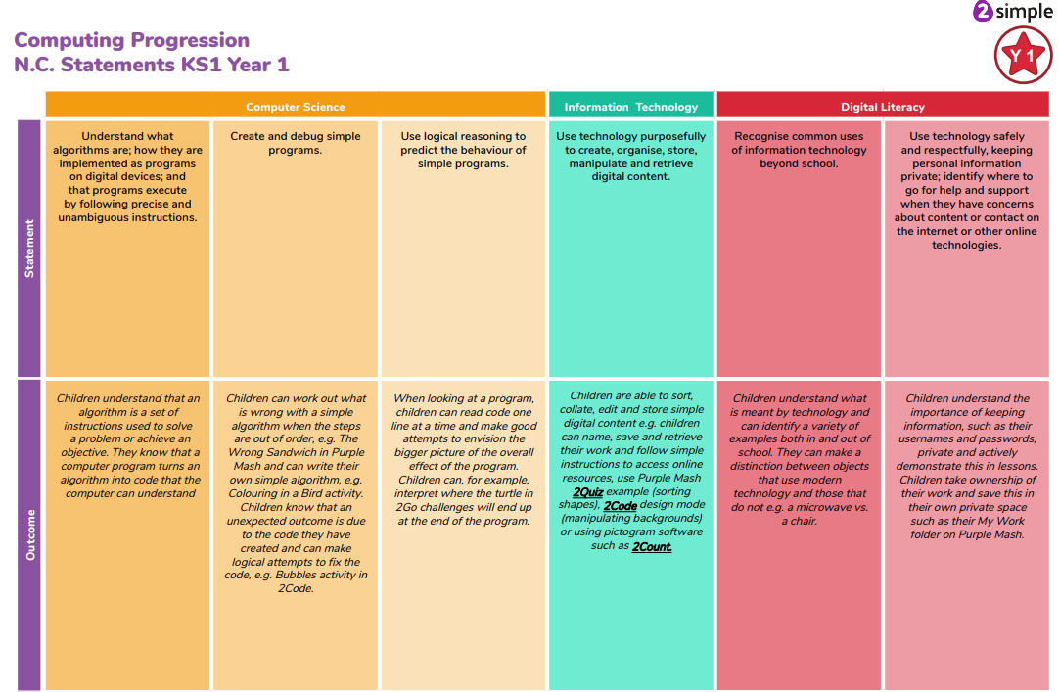
Computing Coverage Overview - Year 2
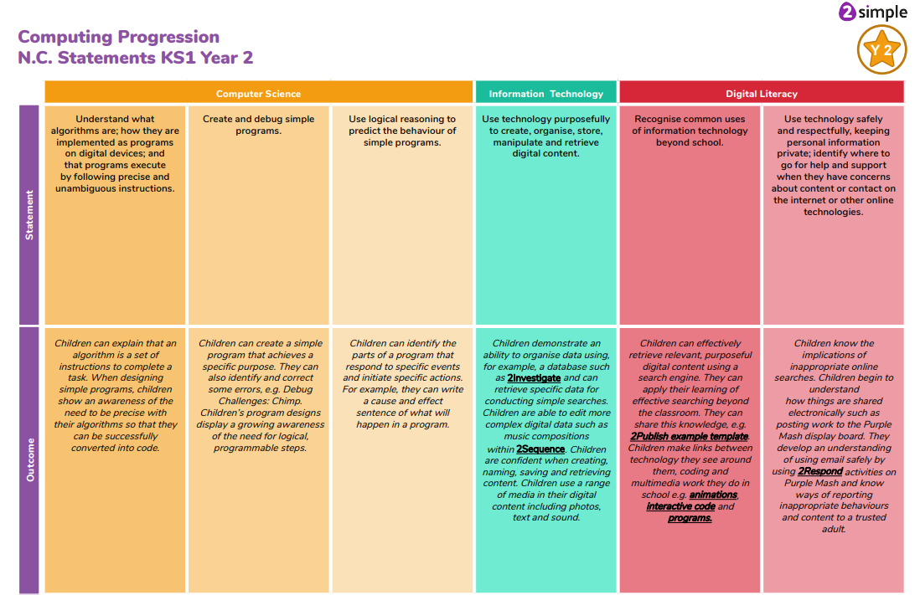
Computing Coverage Overview - Year 3
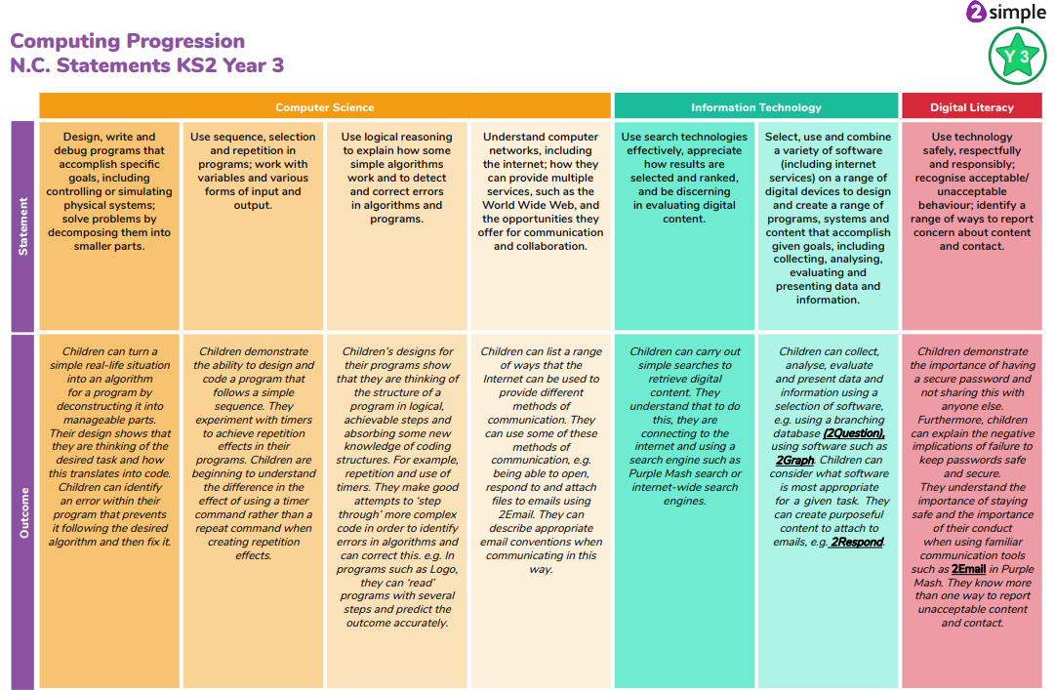
Computing Coverage Overview - Year 4
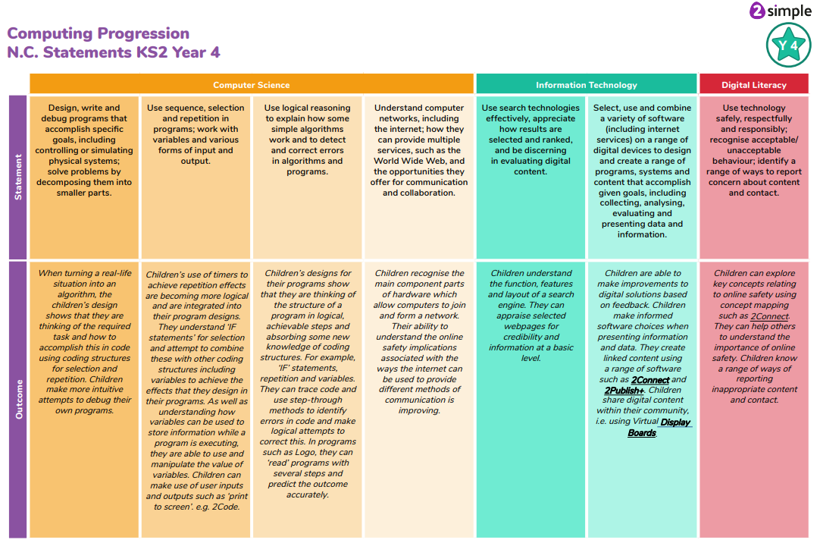
Computing Coverage Overview - Year 5
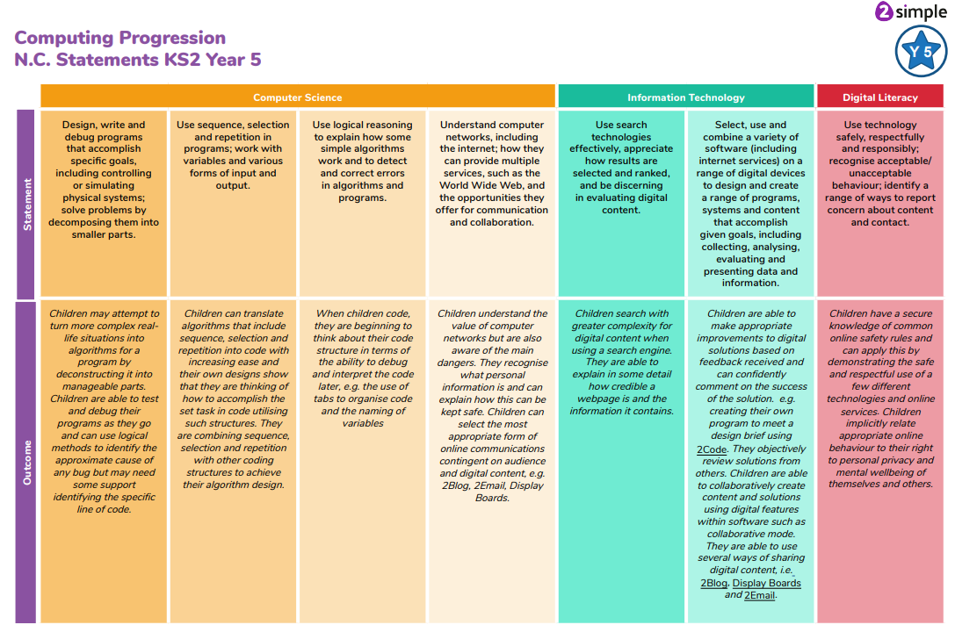
Computing Coverage Overview - Year 6
