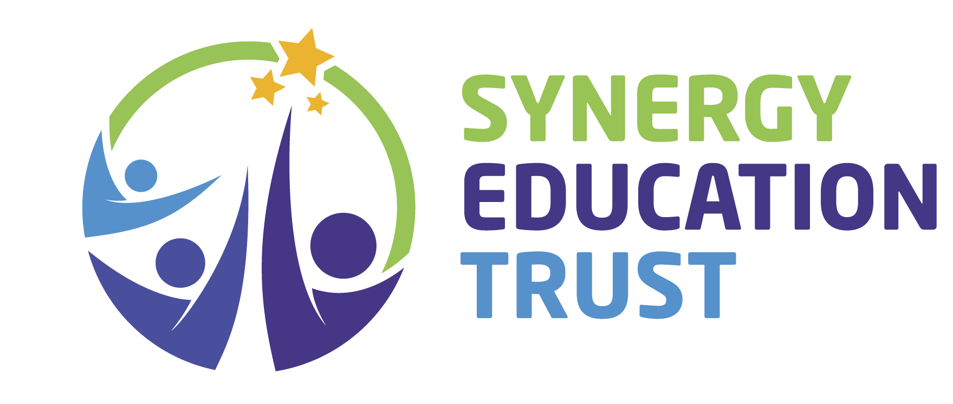

RSE & PSHE Policy

Current version/Level: | v.1
Created by: | Suzanne Hamilton
Created on: | 13.4.26
Next Review Date: | April 2027
Previous review dates: | N/A
Adopted by Trustees on: | TBC

Content

1. Policy Statement
2. School-Specific Information
3. Aims of RSE and PSHE
4. Statutory Content
4.1 Relationships Education (Primary & Secondary)
4.2 Sex Education (Secondary)
4.3 Health Education
4.4 SEND RSHE Requirements
5. Curriculum Design
6. Teaching and Learning
7. Safeguarding and Handling Sensitive Issues
8. Parental Engagement and Consultation
All Synergy Schools will:
9. Assessment and Monitoring
10. Staff Training
11. Roles & Responsibilities
Trust Level
School Level
12. Inclusion and Equalities
13. Policy Review

Appendices
Appendix A – School RSHE Curriculum Map
Appendix B – Parent Consultation Summary
Appendix C – SEND RSHE Adaptation Model
Appendix D – External Agencies and Partnerships

1. Policy Statement
This policy sets out how the school will deliver Relationships, Sex and Health Education (RSHE) and Personal, Social, Health and Economic (PSHE) education in line with the Department for Education’s 2026 statutory requirements. RSHE will be factual, inclusive, age and developmentally appropriate, and taught within a safe and respectful environment. It will comply with the Equality Act (2010), Keeping Children Safe in Education (KCSIE), and current DfE guidance.

2. School-Specific Information
Local Values / Ethos Statement | The purpose of Educational Diversity is to understand, nurture and meet the various needs of our students. Understanding our students supports us in developing resilient learners who are confident enough to challenge themselves and take control of their future.  At Educational Diversity we recognise and value the importance of teaching a strong and relevant PSHE curriculum which prepares our students for life in a modern society, both within and beyond school. The PSHE curriculum is a necessary part of a young person’s full educational entitlement.  At Educational Diversity we are committed to providing a broad and balanced curriculum that promotes pupils’ spiritual, moral, cultural, mental, and physical development, and prepares them for the opportunities, responsibilities, and experiences of later life. We believe that a strong PSHE education is important to help our pupils develop into well rounded members of society, who can make a positive contribution to their community. The vision for pupils, staff and other members of the school community is to always look to achieve our personal best in every aspect of school life.  Trauma and Nurture  "Understanding the SEMH needs of pupils is absolutely essential in developing a whole school approach to improving mental health and behaviour in schools" (from Mental Health and Behaviour in Schools).  At Educational Diversity we use Boxall Profiling to identify needs and support students.  Working Together  We work with other agencies to support students and their families. Underpinning our work is the Blackpool Families Rock Approach and the Six Principles of Nurture. We also refer students and their families to relevant services such as Youtherapy/Counselling/CASHER/CAMHS etc.  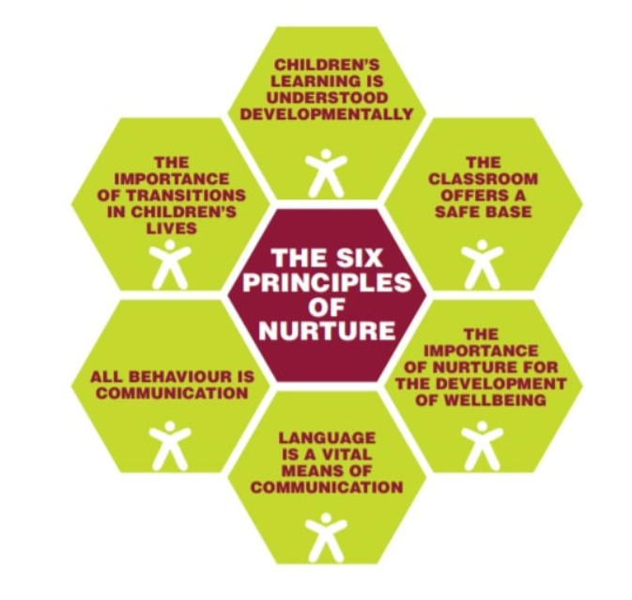  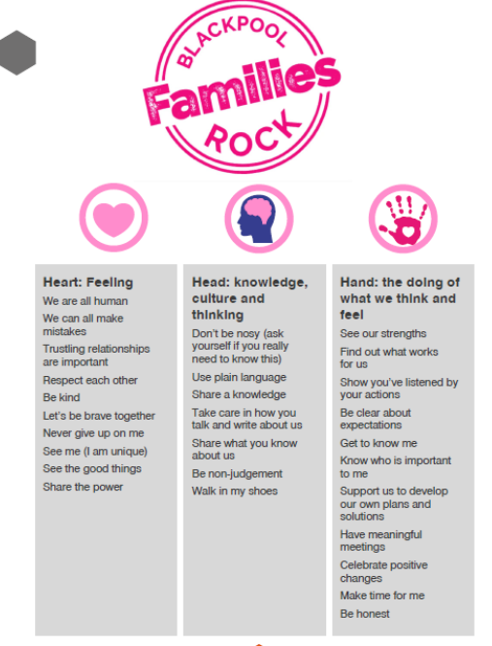  The 6 Principles of Nurture (NurtureUK) underpin our ethos. We have NurtureUK Status and use these approaches to understand and support students who are experiencing or have experienced trauma in their lives.  - The classroom offers a safe base.  - Children's learning is understood developmentally.  - The importance of nurture for the development of well-being.  - Language is a vital means of communication.  - All behaviour is communication.  - The importance of transition in children's lives.
Curriculum Approach (e.g., weekly RSHE lesson / drop-down days) | Timetabled weekly lessons across the Key Stages  2026 PSHE with RSE
Named RSHE Lead | Simon Coulter
Named Link Governor | TBC
How RSHE is communicated to parents (website links, newsletters, sessions) | Website - Curriculum Documents | Educational Diversity  Induction  School Newsletters  Parent Consultations  Text/calls

3. Aims of RSE and PSHE
- Develop knowledge, skills and attitudes for safe, respectful relationships, including understanding consent and personal boundaries.
- Recognise and manage risk on- and offline (digital consent, data privacy, scams, monetisation, deepfakes/AI-generated content).
- Understand physical health, mental wellbeing and emotional literacy, including help-seeking.
- Understand puberty, reproductive and menstrual health; at secondary/post-16, cover women’s health topics such as menopause and endometriosis.
- Make safe choices regarding substances, peer influence and exploitation; know the law and how to get help.
- Develop life skills including first aid, health protection, and digital literacy.

4. Statutory Content
All Synergy Schools will ensure their curriculum includes statutory content.

4.1 Relationships Education (Primary & Secondary)
- Families and people who care for us; diversity of families
- Friendships and respectful relationships; bullying and discrimination
- Consent and boundaries; sequential consent learning
- Online relationships and digital behaviour.

4.2 Sex Education (Secondary)
- Intimate relationships, sexual health, contraception and STIs
- Pregnancy choices and where to seek support
- Law relating to sex, relationships and images
- Addressing harmful narratives (e.g., misogyny, incel culture)

4.3 Health Education
- Mental wellbeing, emotional regulation and resilience
- Physical health, fitness and healthy eating
- Risk behaviours: smoking, alcohol, vaping and drugs
- Health protection: vaccinations, dental health, hygiene, sleep and sun safety
- Online safety: AI/deepfakes, fraud, scams, digital consent and data privacy
- Basic and age-appropriate first aid

4.4 SEND RSHE Requirements
- Adaptations including visuals/symbols, modelling, overlearning and personalised pacing
- Explicit teaching of boundaries, body autonomy and safe choices
- Accessible communication and assessment methods

5. Curriculum Design
All Synergy Schools will:
- Embed safeguarding content and cross-curricular links (Science, Computing, PE, Personal Development and Humanities Sessions).
- Use high-quality, evidence-informed resources (e.g., PSHE Association-aligned, POL-Ed, NHS/public health).
School-specific curriculum details: Educational Diversity
Our curriculum is mapped across KS1–KS4 and available via Curriculum Documents | Educational Diversity

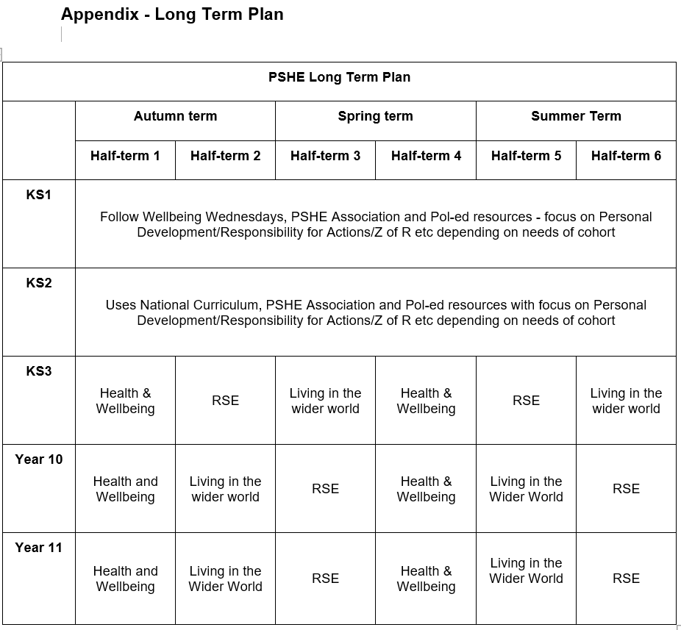

6. Teaching and Learning
All Synergy Schools will teach content through:
- Discrete RSHE/PSHE lessons complemented by assemblies, theme weeks and enrichment.
- Trauma-informed and inclusive pedagogy; safe-space protocols and accurate, inclusive language.
- SEND adaptations and reasonable adjustments as standard practice.
School-specific delivery approaches:
- Small group teaching/1-1 teaching
- Visitors and other professionals support delivery
- Assemblies
- Form time activities
- Cross curricular links
- Personal Development Sessions

7. Safeguarding and Handling Sensitive Issues
All Synergy Schools will:

- Follow school safeguarding procedures for disclosures; do not promise confidentiality.
- Signpost pupils to appropriate internal and external support.
- Ensure teaching does not stigmatise individuals or groups and complies with the Equality Act (2010).
Link to School’s Safeguarding Policy : Safeguarding at Educational Diversity | Educational Diversity

8. Parental Engagement and Consultation

All Synergy Schools will:

- Publish policy and curriculum overviews; provide parent information sessions prior to sensitive units.
- Explain the right to withdraw from non-statutory sex education only and provide alternative meaningful education.
- Establish feedback loop for parents and carers.
School-specific parent engagement plan:
- Parent Consultation
- Communication via Arbor
- Parents are informed prior to delivery of sensitive units

9. Assessment and Monitoring
All Synergy Schools will:

- Assess understanding, application and personal development using age-appropriate methods.
- Use pupil voice, work samples/portfolios and lesson observations to evaluate impact.
- Participate in the Trust RSE QA cycle and act on findings.

10. Staff Training
All Synergy staff will:

- Safeguarding boundaries in RSHE; managing sensitive discussions.
- Online safety (including AI/deepfakes), women’s health, harmful sexual behaviours.
- SEND RSHE adaptations and first aid teaching competence.
School-specific training programme:
- PSE Lead in Blackpool – Sam Richardson
- POL- Ed online training
- National College courses – safeguarding, Online Safety etc
- SEND training

11. Roles & Responsibilities

Trust Level
- DCEO / Executive Team: Strategic oversight and compliance.
- School RSE/PSHE Lead: Policy, curriculum, CPD and QA.
- School SENDCo: SEND adaptations and guidance.

School Level
- Headteacher: Ensures statutory compliance and resourcing.
- DSL/Deputies: Safeguarding oversight and staff advice.
- Governors: Monitor policy implementation and impact.
School-specific staffing and responsibilities:
- Head teacher – Vic O Farrell
- Deputy Head/DSL – Kathryn Bastow
- PSHE/RSHE Lead (and Deputy DSL) – Simon Coulter
- Deputy DSLs – Hayley Wootton & Michelle Mortimer
- PSHE /RSHE Teachers

12. Inclusion and Equalities
All Synergy School Leaders will:

- Ensure content reflects diversity of families, identities and beliefs.
- Ensure staff avoid stereotypes and discriminatory language; challenge prejudice-based behaviour.
- Provide accessible formats for SEND and EAL learners.

13. Policy Review
- This policy will be reviewed annually or sooner if guidance changes.
- Following parental consultation and as part of Trust QA and governor scrutiny.

Appendices

Appendix A – School RSHE Curriculum Map

Appendix B – Parent Consultation Summary
- Arbor messages/emails regarding new policy
- Arbor messages/emails regarding areas of teaching/learning

Appendix C – SEND RSHE Adaptation Model
- Identified on One Page Pupil Profile or Plan, Do and Review Documents
- Part of EHCP advice
- Advice from Speech and Language Therapists

Appendix D – External Agencies and Partnerships
List relevant partners and purpose of engagement:
Local Health/Sexual Health Team | NHS Sexual Health  School Nurse Drop Ins
School Nursing | Sharon Rotherham
Police/Pol￼Ed | Online
St John Ambulance/Red Cross | RNLI
Other | - Awaken  - Drugs Workshops  - Blackpool Football Club – Safer Streets  - Shine- Mental Health

