

Speech, Language & Communication Policy

Approved by: | Head Teacher | Date: September 2019
Last reviewed on: | July 2025
Next review due by: | July 2028

Rationale

This policy should be read in conjunction with the Special Educational Needs Policy, the Teaching and Learning Policy and the Curriculum Policy.

Speech and Language Communication Needs (SLCN) is an umbrella term that covers difficulties related to speech sound development, understanding and using language, or communicating with others. Speech refers to articulation and production of sounds. Language is understanding and use of vocabulary of grammar. Social communication is the use of verbal and non-verbal communication to understand and participate in interactions.
SLCN is one of the four SEND Areas of Need. Areas of difficulties with speech, language and communication can have an impact on a students’ ability to express emotions, to understand everyday instructions and to build friendships.

Research by Speech and Language UK (2023) summarised that approximately 1 in five pupils have difficulty speaking and understanding words and that they are;
- six times more likely to be behind in English at age 11
- eleven times more likely to be behind in maths at age 11
- likely to have more mental health problems
- twice as likely to be unemployed as an adult
(Listening to unheard children, Speech and Language UK, 2023.)

The RCSLT (2022) identified the following links between SLCN and SEMH:
- One in eight (12.8%) 5 to 19 year olds had at least one mental disorder when assessed in 2017.
- Children with a mental disorder are five times more likely to have problems with speech and language.
- 81% of children with emotional and behavioural disorders have significant unidentified language deficits.
- People with a primary communication impairment are at greater risk of a secondary mental health disorder, commonly anxiety or depression.
- Children with persistent developmental language disorder from preschool to early primary school may be more likely to have social, emotional and behavioural difficulties (particularly behavioural difficulties).
- Between 40% and 54% of children with behaviour problems have language impairment.
(RCSLT-promoting-SEMH-factsheet.pdf, RCSLT, 2022)

According to the DfE (2025) One in seven pupils nationally, are estimated to be neurodivergent. Despite the increasing awareness, lack of expertise puts these students at higher risk of bullying, absence, behaviour and poor mental health. Our population at Educational Diversity, have experienced many of these difficulties and in most cases their needs have not yet been identified. Neurodiversity is the broad range of different ways brains develop and work. There are many different neurodevelopment disorders such as; ADHD, Autism, Developmental Language Delay and Dyslexia to name a few. It is common for a neurodivergent person to have more than one neurodevelopmental disorder. Some neurodivergent conditions, particularly Autism, can mean students having more significant difficulties with; verbal and non verbal communication, social communication and difficulties expressing and regulating emotions.

Introduction

We believe in creating an enjoyable and safe learning environment where every student feels valued and wanted. At Educational Diversity, our mission is to provide an adaptive and nurturing space that ensures each child feels included and cherished, allowing them to flourish.
We prioritise inclusivity, trauma-informed practices and unconditional positive regard, offering a welcoming school with abundant positive enrichment opportunities. Our aim is to be a place that students, parents and staff can be proud of, cultivating a creative curriculum that prepares students for future success.
We focus on building resilience and encouraging collaborative work to achieve positive outcomes, supporting each child in integrating successfully into society. Our goal is to ensure that every student feels included and capable of reaching their full potential.
Our friendly and professional staff are dedicated to making our school a happy place, with a child-centred environment tailored to the unique needs of young people. We provide a fresh start for students, helping them transition back into mainstream education with confidence.
At Educational Diversity, we see ourselves as an intervention, not a destination, ensuring every child receives the support they need to thrive, flourish, and succeed.

In line with our SEND policy, we have a graduated approach for speech and language support to ensure early identification, appropriate intervention and monitoring systems are in place.

Objectives

- To ensure there are communication enriched environments across both Educational Diversity centres.
- To use formal and informal assessments to gain a detailed picture of each young person’s SLCN from the moment they are inducted to Educational Diversity.
- To ensure staff have information, guidance, knowledge and resources to help support the SLCN of the young people within Educational Diversity
- To provide specific and individualised packages of support for SLCN, delivering targeted and specialist support.
- To deliver highly differentiated support to young people identified with SLCN, either specified within their Education, Health and Care Plan, or from needs arising from formal and informal assessments.
- Utilise the expertise from Happy Talk as part of our graduated approach to SLCN.

Graduated Approach

All of our students are on the SEND register as SEN K. They are monitored under the Code of Practice through SEND graduated approach.
All pupils have a One Page profile as a working document for pupils to share their voice on; interests, strengths and aspirations. One Page profiles also have a SEND section in which the student’s primary mode of communication is recorded along with any individual strategies and interventions.
The Risk Matrix outlines and identifies the level of provision a student is likely to require. The Matrix provides a structured response to measure Impact against intervention. Impact is the level of SLCN need against how likely SLCN intervention is to aid a student’s SLCN improvement. This not only helps to prioritise intervention where a pupil has multiple SLCN or SEND needs but to also help identify which pupils require targeted and specialist support. The graduated approach also helps the SENDCo and Happy Talk identify where other professionals are better placed to meet the students needs either alongside, prior or instead of SLCN intervention. Students may move between tiers of intervention across their time at Educational Diversity, responsive to the students needs and level of intervention at a given time.

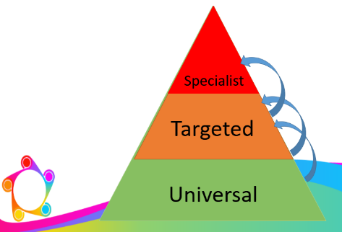
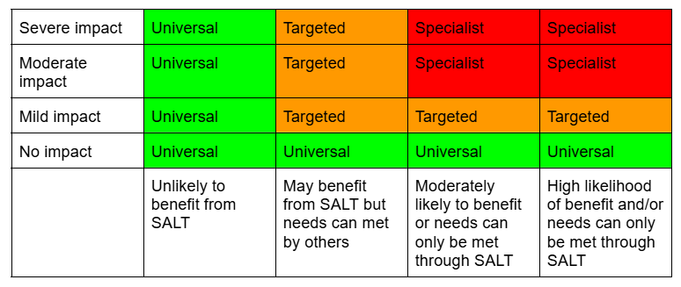

Universal Support

Universal level support for students is everyone's responsibility. It encompasses communication enriched environments to ensure all pupils, regardless of SLCN, are supported in our inclusive and supportive environments, consistent with our trauma informed approaches.

- Reducing background noise: Minimise distractions in the classroom, such as unnecessary background noise or visual clutter, to help pupils focus on verbal instructions and conversations.
- Modelling effective communication: Adults in the setting should demonstrate good communication habits, such as speaking clearly, maintaining eye contact, and using gestures to support speech.
- Encouraging peer support: Facilitating positive interactions with peers with strong communication skills can help children to pick up new vocabulary, expressions and social communication skills. This can be supported by adult-led small group work, role-play activities and games.
- Creating a positive atmosphere: An encouraging environment where children feel comfortable asking for help and expressing their thoughts fosters better communication. Consistently praise their efforts, rather than their achievements.
- Using structure and routine: Predictable schedules and consistent routines reduce stress for pupils, as they become familiar with what is expected and can anticipate what comes next.
- Providing communication breaks: Offer regular breaks for children who may need time to regroup and process language-heavy tasks. A quiet corner or relaxation space can be beneficial.
- Displaying communication-friendly resources: Posters, word walls, emotional check-ins and other communication aids should be visible around the classroom. This gives children accessible tools to refer to when they need help expressing themselves.
(Whole School Send, 2024)

Pupils are monitored on a universal level by the class teacher who will provide updates to parents at parent consultation. Happy Talk may also conduct universal observations to monitor the communication enriched enrichments providing feedback to staff to maintain high expectations and consistency.

The SENDCo and Happy Talk have half termly meetings to discuss developments and to organise staff CPD opportunities to ensure staff are equipped with the knowledge and understanding to support pupils with universal interventions such as; Zones of Regulation, Comic strip conversations and vocabulary walls. These are key in supporting our students Social, Emotional and Mental Health needs.

Targeted Support

Targeted support is a team responsibility in that it involves identification, assessment and intervention. On induction, the SENDCo requests SEND files so that any student already receiving SLCN support at their previous setting is identified in a timely manner and referred to Happy Talk for observations and informal assessments. As part of our SEND graduated approach, our well trained staff are advised to refer students to the SENDCO when they have;
- Observed a student who may be struggling with social communication resulting in difficulties with non- verbal and verbal communication, initiating conversations and expressing their emotions.
- Monitored progress and identified a pupil having difficulty with reading comprehension tasks, following multi step instruction and producing coherent written work.
- Considered behaviour patterns and have taken a considered approach to reflect if certain behaviours are communication or as a result or difficult communicating appropriately.
- Communicated with parents or carers to gain information about any barriers.

Happy Talk will then work with the SENDCo in conducting observations of an identified student at structured and unstructured times. They may also consider interventions that will help to target specific areas for development. If at this point the SENDCo feels more formal information gathering needs to take place as part of a plan- do- review then a student may be identified as needing specialist support.
Interventions may be implemented on a one to one basis or as a whole group. Where possible a member of staff may accompany an intervention to upskill the member of staff.
Targeted interventions may include; Emotional literacy, social thinking, Lego therapy and Psychoeducation.

Specialist Support

Specialist support is the highest level of intervention and is delivered by Happy Talk speech and language therapists. It encompasses formal assessments specific to the needs of the student. Happy Talk will formulate a report with standardised scores to outline functioning, needs and if required differential diagnosis. They will also provide recommendations and developmental targets. Reports are not only shared with parents but with teaching staff along with required resources. Intervention will be completed on a one to one basis followed by monitoring and feedback to the SENDCo. Some students may require more than one episode of specialist intervention.

Reports may be used as specialist evidence for referrals to other professionals such as; Audiology, Neuro developmental pathway for Autism screening or Learning Disability and Neuro team for ADHD assessment. Happy talk can also provide diagnosis of Developmental Language Disorder or speech sound disorder.

Specialist support, when identified in a timely manner, should be a short term support strategy with the aim of SLCN being met at the targeted or universal level.

