

**Educational Diversity**

**Accessibility Policy**

| **Approved by:** | Management Committee | **Date:**  October 2024 |
| --- | --- | --- |
| **Last reviewed on:** | October 2024 | |
| **Next review due by:** | October 2027 | |



**Contents**

Introduction

Values and Aims

Policies and Documents

Disability and SEND

Cognition and Learning Needs

Physical Needs

Social and Emotional Needs

Reasonable adjustments

Monitoring and reviewing

Accessibility Action Plan

**Introduction**

The purpose of this plan is to show how Educational Diversity intends, to increase the accessibility of our school for disabled pupils. Educational Diversity is committed to providing an environment that enables full curriculum access, that values and includes all pupils, staff, parents, carers and visitors regardless of their education, physical, sensory, social, spiritual, emotional and cultural needs.

We endeavour to

* Increase the extent to which disabled pupils can participate in the school curriculum;
* Improve the environment of the school to increase the extent to which disabled pupils can take advantage of education and associated services;
* Improve the delivery to disabled pupils of information which is provided in writing for pupils who are not disabled.

The SEN and Disability Act 2001 extended the Disability Discrimination Act 1995 (DDA) to cover education. The DDA is now covered within The Equality Act (2010). The Management Committee of a school has three key duties towards disabled pupils, under Part 4 of the DDA:

* Not to treat disabled pupils less favourably for a reason related to their disability;
* To make reasonable adjustments for disabled pupils, so that they are not at a substantial disadvantage;
* To plan to increase access to education for disabled pupils.

**Our Ethos, Expectations and Values**

**Trauma and Nurture**

"Understanding the SEMH needs of pupils is absolutely essential in developing a whole school approach to improving mental health and behaviour in schools" (from [Mental Health and Behaviour in Schools](https://www.gov.uk/government/publications/mental-health-and-behaviour-in-schools--2)).

At Educational Diversity we use Boxall Profiling to identify needs and support students.

**Working Together**

We work with other agencies to support students and their families. Underpinning our work is the Blackpool Families Rock Approach and The Six Principles of Nurture. We also refer students and their families to relevant services such as Counselling/CASHER/CAMHS etc.

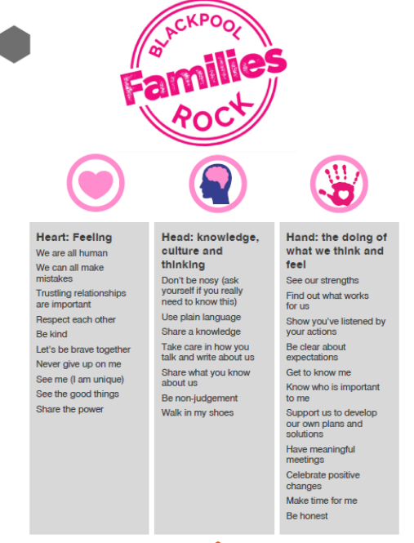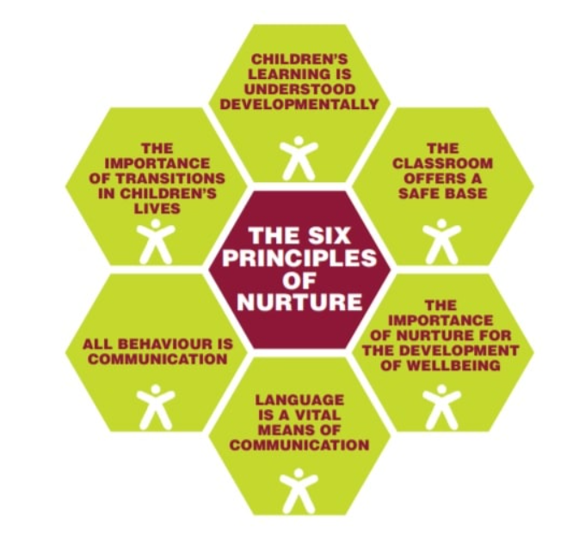

The 6 Principles of Nurture (NurtureUK) underpin our ethos. We have NurtureUK Status and use these approaches to understand and support students who are experiencing or have experienced trauma in their lives.

* Children's learning is understood developmentally.
* The classroom offers a safe base.
* The importance of nurture for the development of well-being.
* Language is a vital means of communication.
* All behaviour is communication.
* The importance of transition in children's lives.

As a staff team, we explored what we wanted our students to be. These were some of the keywords and phrases identified

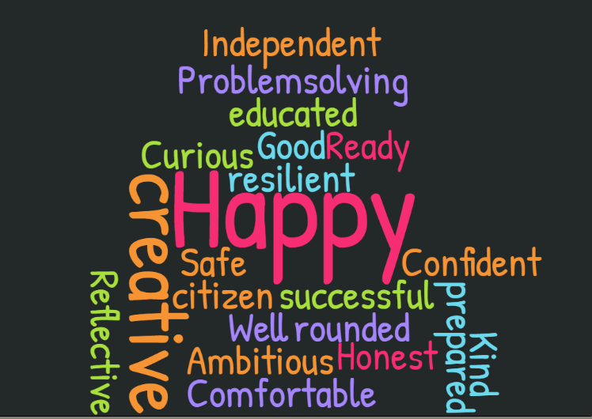

**Values and Aims**

Educational Diversity is a collaborative and purposeful learning environment, composed of stakeholders with a wide range of diverse needs. We pride ourselves in ensuring all pupils and staff are valued, cared for, listened to and challenged to reach their full potential. We are therefore equally ambitious for our disabled pupils and staff. Our culture ensures harassment and discrimination linked to disability is eliminated whilst ensuring positive attitudes towards people with disabilities are promoted.

**Documents and Policies**

The Accessibility Plan should be read in conjunction with the following school policies, strategies and documents:

* Curriculum Intent
* Equality Objectives
* Health and Safety Policy
* Special Educational Needs and Disabilities Policy
* SEND information Report
* Relationship and Behaviour Policy
* Complaints Policy
* Educational Visits and Trips Policy

**Disability and Special Educational Needs**

Many children who have SEN will also be defined as having a disability under the DDA. It is likely that many of the pupils who have significant SEND will have an Education, Health and Care Plan. Others who are at SEN Support may also have impairments that may count as disabled. However, not all children who are defined as disabled will have SEN. For example, those with severe Asthma, Arthritis or Diabetes may not have SEN but may have rights under the DDA. Similarly, not all children with SEN will be defined as having a disability under the Disability Discrimination Act. In particular, some children whose social, emotional and mental health difficulties have their origins in social or domestic circumstances may fall outside the above definition.

**Possible Overlap of SEND and DDA Disability Definition for Children and Young People**

| **Special Educational Needs** | **Both SEN + Disabled** | **Disabled** |
| --- | --- | --- |
| Mild Dyslexia  Social, Emotional and  Mental Health Difficulties (SEMH)  Mild Dyspraxia  Minor Speech Impairment  Mild Learning Difficulties  Poor short term memory  Word finding and  recognition problems  Organisational problems | Long term Mobility / Motor difficulties  Learning Difficulties  (significant)  Hearing Impairment/Deaf  Visual Impairment/Blind  Incontinence  Significant Dyslexia  Epilepsy  Non-verbal  ADHD  Autism  SEMH (factors other than social e.g. medical conditions/mental health)  Attachment Disorder | Asthma  Diabetes  Cancer and in recovery  Mental Health Issues  Disfigurement  Eating Disorders  Significant Disfigurement  Sickle Cell Anaemia  Gross Obesity  Very Short Stature  Stroke paralysis  Incontinence due to a long term condition  Paraplegia |

**Cognition and Learning Needs**

Educational Diversity aims to positively support all pupils' learning needs and assist them in their personal, social, physical, emotional, moral, spiritual and cultural development through the delivery of a broad and balanced curriculum that:

* Provides a well-planned and structured high quality curriculum which includes academic and social experiences.
* Demonstrates differentiation in resources and assessment opportunities (Functional skills, GCSE’s etc)
* Bespoke progression plan, when required, that are regularly monitored and reviewed
* Ensuring the pupils' entitlement to National Curriculum subjects and encouraging the highest possible levels of attainment and achievement through:
* The implementation of the Assessment, Recording and Reporting policy and practice which include statutory tasks/tests, external examinations, continuous teacher assessment and processes to monitor and challenge pupil progress and achievement.

Educational Diversity develops independence and respect for others in preparation for a responsible adult life after leaving our provision through:

* The delivery of a broad and balanced 14-19 curriculum which affords all pupils the opportunity to learn through work related contexts either through skills programme or work experience.
* Opportunities to take part in relevant external examinations and assessment units.

The SENDCo in conjunction with the Headteacher, operates in a strategic way:

* Evaluating the effectiveness of interventions and relative effectiveness;
* Observing lessons and sampling lesson planning, looking specifically at target groups of pupils (including those with disabilities) and reviewing assessment of learning;
* Monitoring the appropriateness of pupil groupings;
* Monitoring the deployment of Special Support Assistants (SSAs).

**Physical Difficulties**

At Educational Diversity we ensure physical difficulties are not a barrier to pupils’ learning, social interaction, safety or health and wellbeing by;

* Adopting operational practices that support movement around school and essential daily routines for pupils with physical needs.
* Adapting the timetable and curriculum, if necessary, to ensure pupils have full access to a personalised progression plan. This is highlighted on their individual one page pupil profile.
* Ensure accurate records are kept to monitor progress, effect movement within the staged response set out in the Code of Practice and continually improve provision for pupils with physical disabilities.
* Monitor Health Care Plans for statemented /IPRA pupils. Regularly review and communicate pupil progress to teachers, pupils, their parents and other involved parties as appropriate.
* Liaise with outside agencies and disseminate information with relevant staff, parents and pupils.
* Liaise with and advise fellow teachers; provide training on physical disability issues.
* Utilise technologies to adapt resources or to remove barriers to learning.

**Social and Emotional Mental Health Needs**

At Educational Diversity we ensure social and emotional needs are not a barrier to pupils’ learning, social interaction, safety or health and wellbeing by;

* Providing opportunities for pupils to have access to appropriate guidance, advice and support on a diverse range of issues.
* All pupils have had access to Kooth training independently.
* Ensure pupils receive appropriate and timely advice and guidance relating to PSHE.
* Opportunities to attend coffee mornings with external charities and agencies of support for pupils and their families.
* Adaptations are made to interventions such as; Zones of Regulation to ensure Provide Learning Mentors for identified pupils.
* Monitor and regularly review the programmes and support given to pupils via the pastoral team.
* Provide careers advice for Year 11 pupils.
* Liaise with outside agencies ( advisory team/ educational psychologist) to provide guidance, advice and strategies to support staff and parents, making referrals where advised.

**Reasonable Adjustments**

The DDA requires schools and local authorities to make reasonable adjustments to ensure that disabled pupils, staff and parents are not at a substantial disadvantage. Reasonable adjustments meet the statutory requirements when they:

* Act to prevent disabled pupils, staff and parents being placed at a substantial disadvantage
* Are aimed at all disabled pupils, staff and parents
* Are anticipatory
* Enable pupils to participate in education and associated services

When deciding if a reasonable adjustment is necessary to avoid placing disabled pupils at a substantial disadvantage, we need to consider the potential impact on disabled pupils in terms of:

* Time and effort
* Inconvenience
* Indignity or discomfort
* Loss of opportunity
* Diminished progress

Where appropriate, we endeavour to provide facilities to support parents with language barriers (interpretation), sight (larger print) and hearing difficulties (sign language interpreter).

School trips are planned on the basis that all pupils are included. SEND children have access to the same activities, clubs, trips and residential trips as the rest of the school. Pre-emptive planning and risk assessments are in place to ensure that children with SEND are able to access their full entitlement.

Under the Equality Act (2010), the school will ensure that they make reasonable adjustments to ensure disabled pupils are not placed at a substantial disadvantage to their peers. This may include providing additional staff and accessible transport or ensuring the venue is appropriate to the needs of the pupil concerned.

**Monitoring and Reviewing**

The responsibility for monitoring this policy lies with: The Senior Leadership Team in charge of Curriculum (Learning) and Relationships and Behaviour as well as the SENDCO, for issues relating to pupil identification, support and monitoring. This is achieved by:

* Monitoring the curriculum offers and courses for students.
* Monitoring and reviewing individual pupil timetables for identified pupils as necessary.
* Issuing the Special Needs Register lists to all staff and updating these termly.
* Conducting statutory annual reviews for pupils with EHCPs and those with progression plans.
* Acting upon causes for concern and targeted support referrals from teaching and pastoral staff.
* The drawing up, implementing and evaluating of Health Care Plans for pupils with EHCPs and progression plans.
* Allocating support to particular lessons and evaluating its effectiveness through teacher feedback, observations and pupil progress.
* Information gathering on pupil monitoring and progress in preparation for reviews.
* Monitoring progress in interventions by observations, oversight of assessments and analysis of pupil results.
* Monitoring the impact of the pastoral team through data, pupil voice and case studies.
* Monitoring and reviewing the enjoyment and impact of the PSHE curriculum through pupil voice and pupil response to issues.
* Regular liaison with the SENCO regarding whole school issues such as teaching and learning, staffing needs and putting the policy into practice.

**Accessibility Development Plan**

**Aims**

1.Increasing the extent to which disabled pupils can participate in the school curriculum;

2.Improving the environment of the school to increase the extent to which disabled pupils can take advantage of education and associated services

3. Improving the availability of accessible information

| **Link to Aim** | **Target** | **Actions** | **Impact** |
| --- | --- | --- | --- |
| 1 | To effectively enhance provision for pupils to reintegrate into the most appropriate provision. | Reintegration coach to be employed  Engagement coach to support with post 16 links  Teachers on LINK to coordinate and conduct follow up visits |  |
| 2 | To ensure all staff have an understanding of the SEND code of practise and procedures in place to support pupils with an EHCP | Training provided by the SENDCO; Referrals, APDR, AReas of Need and universal/ targeted and specialist support offer.  Graduated approach processes devised, rolled out and training provided |  |
| 3 | To enhance accessibility for parents and parents in contributing to the annual review process | Lead teachers of DEV, PEGASUS and ATHENA to support SENDCo in gathering of views  SENDCO to support parents in pupils in using the HUB |  |
| 3 | To further develop the One Page Pupil Profile to ensure pupil/parent voice is evident whilst information sharing with other professionals | SLT to gather feedback from staff  SLT to generate a proforma  Teachings staff and SSAs to attend training  Each pupil to have a detailed and accurate OPP that can be shared at Parent consultations |  |
| 1 | To ensure staff continued to be trained to support pupils in range of different needs; ASC, ADHD, Dyslexia/ Dyscalulia, Trauma informed practice, sensory needs, speech and language needs | Staff to use appraisal cycle to identify training requirements  SENDCo to audit staff training and intervention needs  Advisory team to support with training all staff  SENDCo to build a team of SEND champions that lead training in their areas of expertise  Utilise SALT to provide training in speech and language needs. |  |
| 1 | To further develop interventions to support pupils who are not reaching expected attainment levels | Induction staff to conduct baseline assessments  Boxall assessments to be conducted with individual target generated for pupils  SLT curriculum leads to audit assessment in their subjects and review qualification offer  SENDCO to conduct a training audit to establish skills set within the team  Contract speech and language therapists with a universal, targeted and specialist approach who can advise on and provide intervention input.  SEND advisory team to conduct observations and provide feedback on interventions for specific groups of pupils or individuals where needed.  Zones of Regulation to be developed further in a consistent way across both sites |  |
| 2 | To enhance visibility of Educational Diversity within the community | To create a logo that is brandable across sites  To develop and create new signage externally  To develop bespoke artwork in areas of the school buildings that support pupils' wellbeing.  SEND Newsletter  SEND Coffee mornings with external services, parents and pupils |  |
| 2 | To develop areas of the school building | SENDCO to conduct audit of spaces  SENDCO to develop sensory circuit spaces  SALT to audit communication friendly classroom and advise  Pastoral to develop their own hub with more accessible entrance and meeting spaces for work with families  YOUtherapy to develop therapy rooms for sessions with pupils |  |