Educational Diversity
Chrysalis & Respite Offer KS3-4
2022-23

Rationale & Context

The purpose of this paper is to provide clarity regarding the commissioned services available from Educational Diversity to support mainstream secondary academies in meeting the needs of some of their vulnerable young people. This paper specifically focuses upon Chrysalis and Respite placements:

- Chrysalis KS3 - early intervention
- Respite KS3 & KS4 - crisis prevention

Both provisions take place in the Willows building and offer a similar curriculum model (detailed below).

Chrysalis KS3 - early intervention

The purpose of this provision is to enable a graduated approach for secondary students through the offer of a six week early intervention programme that supports positive behaviour change. Students within this provision are dual registered between their mainstream school and Educational Diversity.

The young people will be referred by key professionals within mainstream settings who have an overview of learning and behaviour. These referrals will be agreed by the Chrysalis Lead in conjunction with the Assistant Headteacher of Educational Diversity. The young people will attend the placement for a determined period, depending upon holiday patterns.
Group 1 | Group 2 | Annual price  (for 1 group place) | Annual price  (for 2 group places) | Spot-buy price  (per pupil, per group)
6 week programme | 6 week programme | £10,000 | £20,000 | £3600

The provision is for KS3 students only, with six programmes running throughout the academic year. In order to support all 8 academies, there will be a maximum of 8 students in each group.

Please note, Year 7 pupils will not be allocated a place during the first half term of any academic year.

Annual prices
Some academies have commissioned an annual offer, of either one or two places per cohort. If for whatever reason they do not refer a pupil for one of their placements, where possible we will allow a place to roll over into the next cohort. However, we cannot guarantee this and any such decision will occur via an internal panel and will be communicated with the school at the earliest opportunity.

Objectives
- To support, and empower young people, to remain and succeed within mainstream education.
- To provide young people who are ready to make positive behaviour change with key strategies to help them take more responsibility for their actions.
- To develop resilience, raise self-esteem and encourage independent learning.
- Ensure that all young people make progress academically, alongside their social, emotional, and mental health needs.
- To identify any unmet learning needs such as SLCN and provide recommendations for secondary colleagues that will help address barriers to learning.
- To support successful re-integrations back into mainstream provision.
- To work with secondary colleagues to identify strategies to support their students upon return to mainstream.
- To support mediation between the young person and school where relevant, using restorative approaches.

School day
09:00 - 14:30, providing 25 guided learning hours.

Academic
A key area to consider as part of the placements is ensuring referred students do not fall behind with their core academic learning. To reduce this potential risk, the core subject (English, maths and science) content will be maintained through the use of remote learning platforms such as google classroom. Schools are required to support the continued academic learning of their students via remote learning.

The curriculum at Chrysalis KS3 will be supplemented with specialist support using the following:

- Know How - NLP, CBT - child focused, emotional wellbeing and mindfulness. Celebrating their successes, team building and promoting diversity. This will be developed and will be bespoke to the students, aiming to help them better understand themselves and their behaviour.
- Project based learning, will include employability and aspirational work.
- Enrichment opportunities.

Assessments
If the referring school chooses, additional support with regards to assessments can be provided. These may include SLCN screener, PASS and NGRT that may be useful, with a view to help better understand the students’ needs.

Reports
A written report will be provided at the end of each placement and will include a range of information, data and strategies to help support the students as they transition back to their base school.

Referring schools will be expected to maintain ownership of their students, whilst dual registered: attending the provision to maintain contact with students, plan reintegration and share strategies.

Referrals
- Calendar for each cohort and deadline for referrals
- Checklist for referrals (This should be a key reference document to be revised)
- Referral forms should be completed in line with the referral windows

Respite KS3 & KS4 - crisis prevention

The purpose of this provision is to enable a graduated approach for secondary students through the offer of either a three or six week crisis intervention programme that seeks to instil positive behaviour change. Students within this provision will be dual registered between their mainstream school and Educational Diversity.

The young people will be referred from key professionals within mainstream settings who have an overview of learning and behaviour. These referrals will be agreed by the Chrysalis Lead in conjunction with the Assistant Headteacher of Educational Diversity. The young people will attend the placement for the agreed time period, depending upon holiday patterns. Towards the end of a respite placement, a formal review meeting will take place with the intention that the student will return to single registration with their base school.

The respite provision for 2022/23 is delivered on a rolling 3 or 6 weekly cycle of placement windows. Academies are invited to refer for a respite place at key dates only, as opposed to making urgent, last minute requests. These dates are in line with the Chrysalis cohorts.

Two options are available throughout the academic year for mainstream colleagues to commission:

Option 1 | Option 2
3 week programme | 6 week programme
Spot-buy price  (per pupil) | Spot-buy price  (per pupil)
£1,800 | £3,600

The provision is for Year 7-10 students only, running over 6 terms throughout the academic year. There will be a maximum of 8 students in the group consisting of either 3 or 6 week placements.

School day
09:00 - 14:30, providing 25 guided learning hours.

Objectives
- To provide young people who are ‘at crisis point’ in terms of their presenting behaviours at school, with a temporary educational setting.
- To provide an opportunity for young people to reflect upon their situation and consider options to improve their experiences at school.
- To support young people to develop self-regulation and coping strategies to help their return to mainstream setting.
- To support mediation between the young person and school where relevant, using restorative approaches.

Academic
A key area to consider as part of the placements is ensuring referred students do not fall behind with their core academic learning. To reduce this potential risk, the core subject (English, maths and science) content will still be maintained through the use of remote learning platforms such as google classroom. Schools are required to support the continued academic learning of their students via remote learning.

The curriculum for respite will be supplemented with specialist support using the following:

- Know How - NLP, CBT - child focused, emotional wellbeing and mindfulness. Identifying their challenges, celebrating their successes, team building and promoting diversity. This will be developed and will be bespoke to the students, aiming to help them better understand themselves and their behaviour.

The aim of the programme is to support and empower the students to remain and succeed within mainstream education.

Assessments
If the referring school chooses we can offer some additional support with regards to assessments. These may include SLCN screener, PASS and NGRT that may be useful, with a view to help better understand the students’ needs.

Reports
A written report will be provided at the end of each placement and will include a range of information, data and strategies to help support the students as they transition back to their base school.

Referring schools will be expected to maintain ownership of their students, whilst dual registered: attending the provision to maintain contact with students, plan reintegration and share strategies.

Referrals
- Calendar for each cohort and deadline for referrals
- Referral forms should be completed in line with the referral windows
- Respite Agreement Forms - these will be emailed out to the school once the referral has been accepted

Historical data

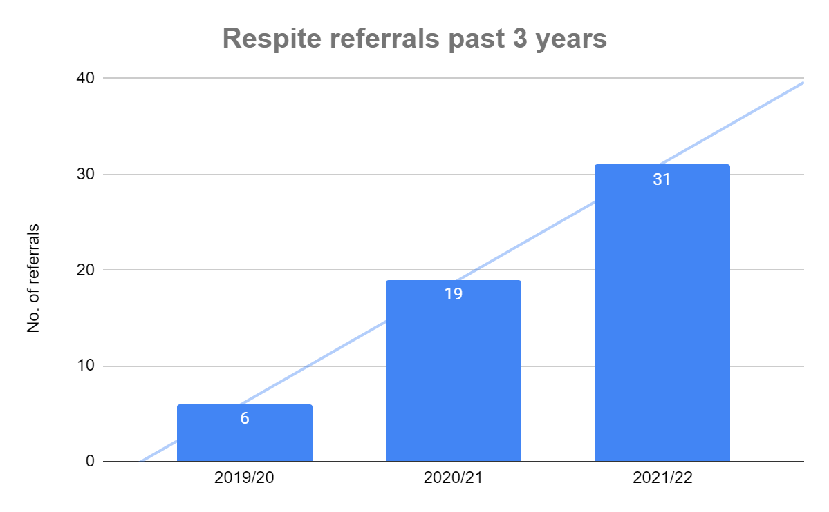
Below are the figures for respite referrals made over the last 3 academic years. 2019/20 can be viewed as an anomaly due to the school closures across the country. The subsequent 2 years do show an increased demand through referrals made, with figures calculated up to the end of April 2022.

