National Recognition for Blackpool PRU

Educational Diversity, the Pupil Referral Unit in Blackpool, has successfully achieved national recognition for becoming a ‘nurturing school’. This is exciting news not only for the school itself but also for the students who attend.

“... we believe that wellbeing is paramount in our staff, students and parents. Fostering good relationships and modelling behaviour is a key part of our service and something we have been proud of before, during and ever since Covid-19 hit.”
(Teacher, Educational Diversity)
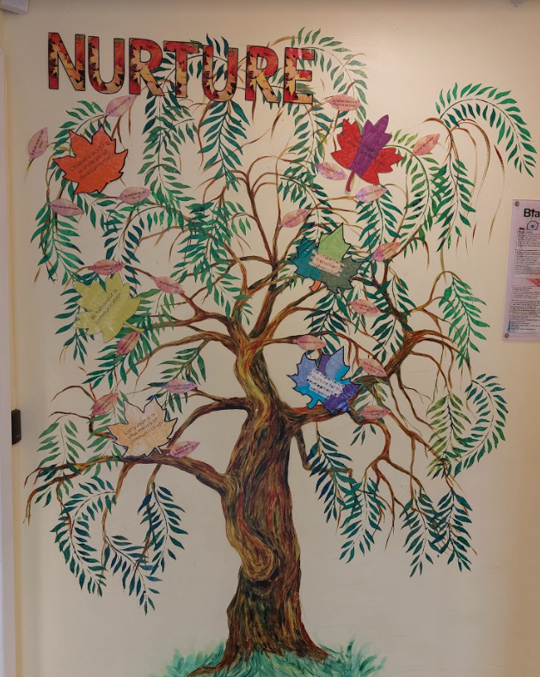
Educational Diversity caters for children aged 7-16 who are unable to attend mainstream school for a variety of reasons due to their social, emotional, mental health and / or medical needs. The staff at the PRU have always cared for their students and have led the local drive across Blackpool schools to always seek to understand the whole child. This approach has helped the PRU to meet the often complex needs of their children, which in turn helps them achieve better outcomes and life chances.

Collaboration with local schools, supported by the charity Right to Succeed (with National Lottery Community Funding), led by a school leader from the PRU, resulted in 5 local schools embarking on a whole school journey to achieve the nurtureuk National Nurturing Schools Award. Educational Diversity is the first school to achieve this award but the others are sure to follow suit shortly.

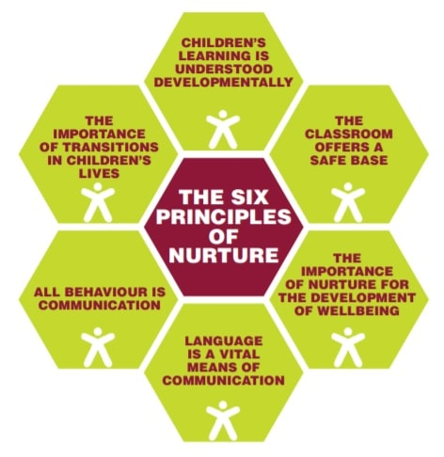
Nurture UK is a charitable organisation that aims to ‘improve the life chances of children and young people’. There is evidence to suggest that ‘the six principles of nurture have successfully underpinned nurturing approaches for over 50 years’ (nurtureuk.org). These six principles of nurture are at the heart of everything Educational Diversity does and achieves:

“I’m really happy with the school altogether … They take the time to explain things to my daughter calmly and in different ways so that she understands. They also take the time to communicate with me often.”
(Parent of a student from Athena)

When two Year 10 pupils, Gabby and Christina, were asked to describe how they feel about their school in one word, they said: “safe” and “nurturing”. This is something the staff are really proud of and something the assessors identified as strength.

Some photos of the nurturing environments that can be found across the three sites at Educational Diversity: Pegasus, Athena and Willows:

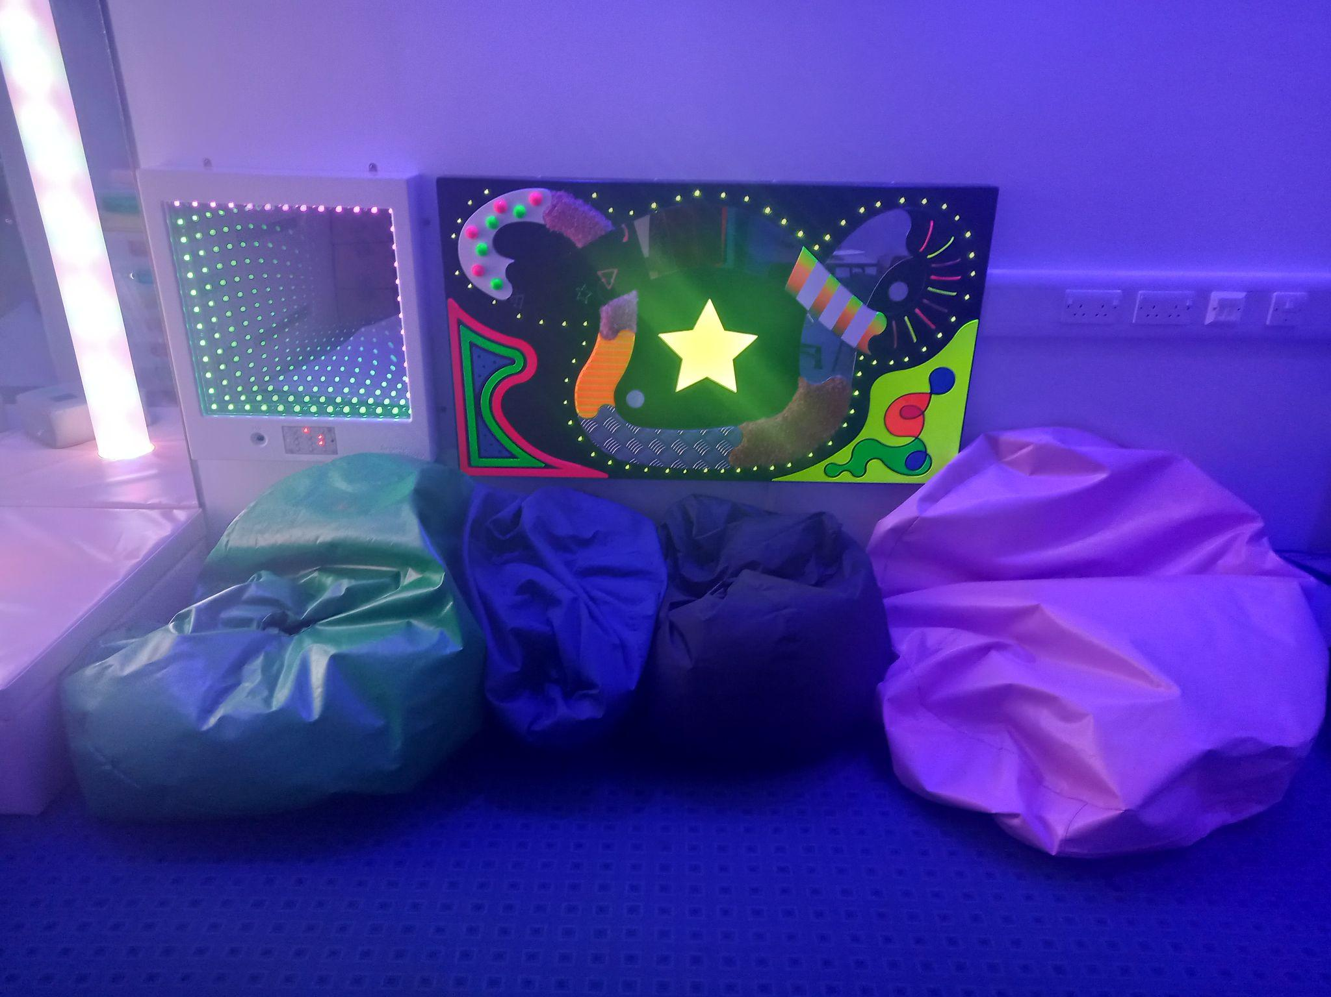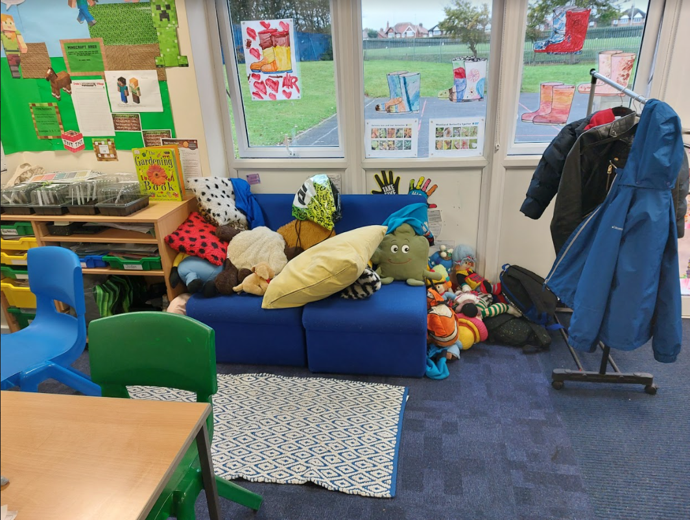

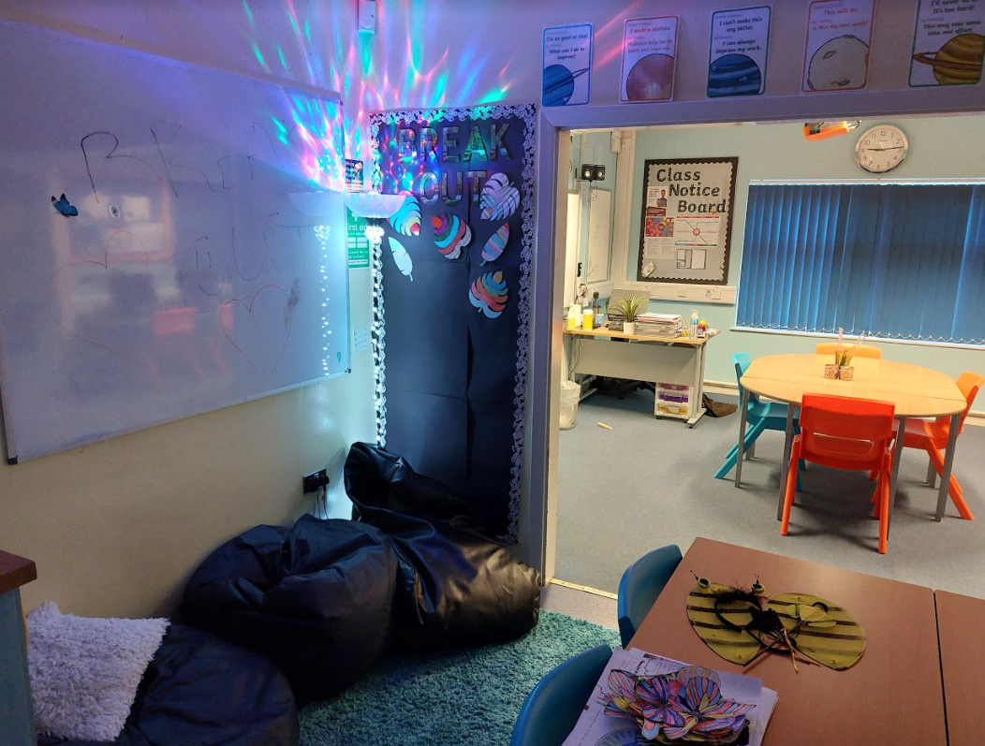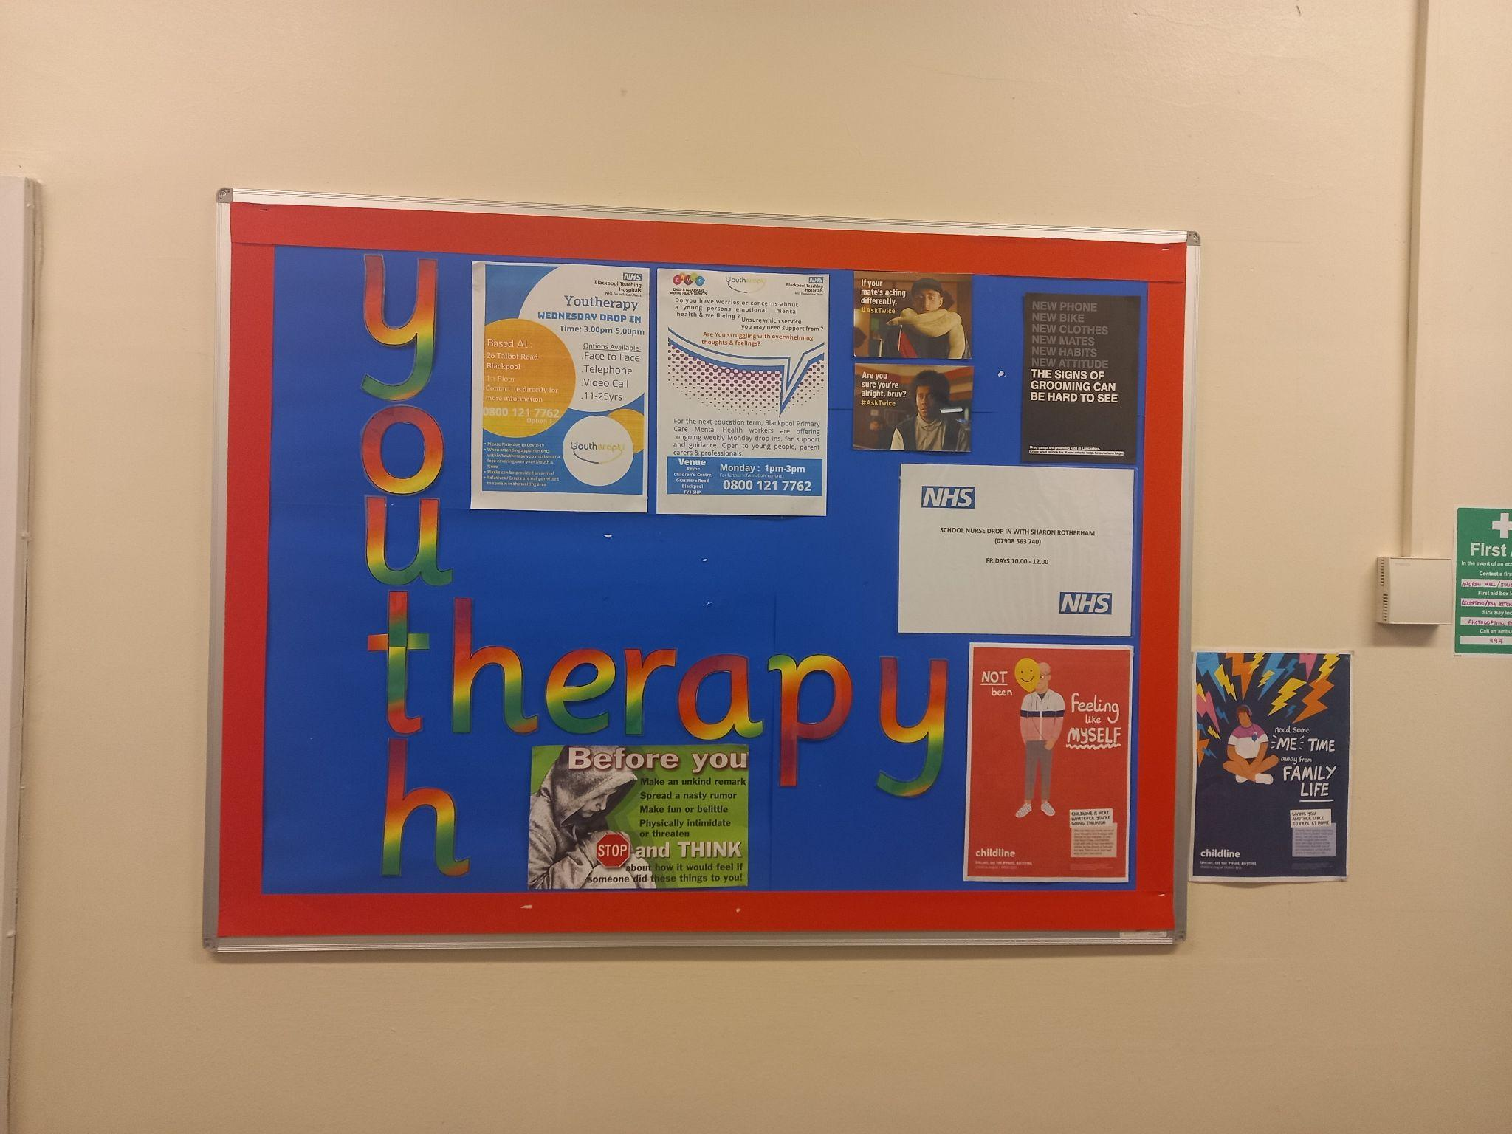
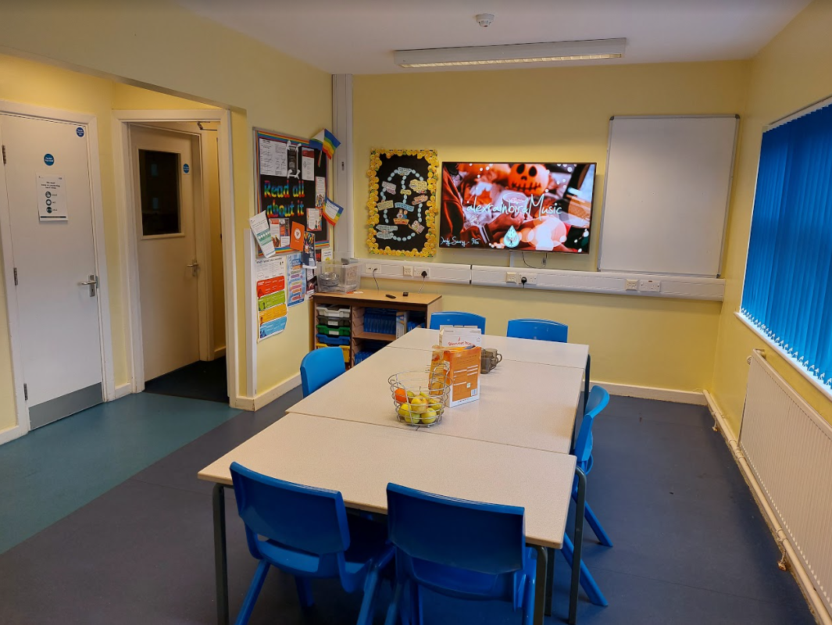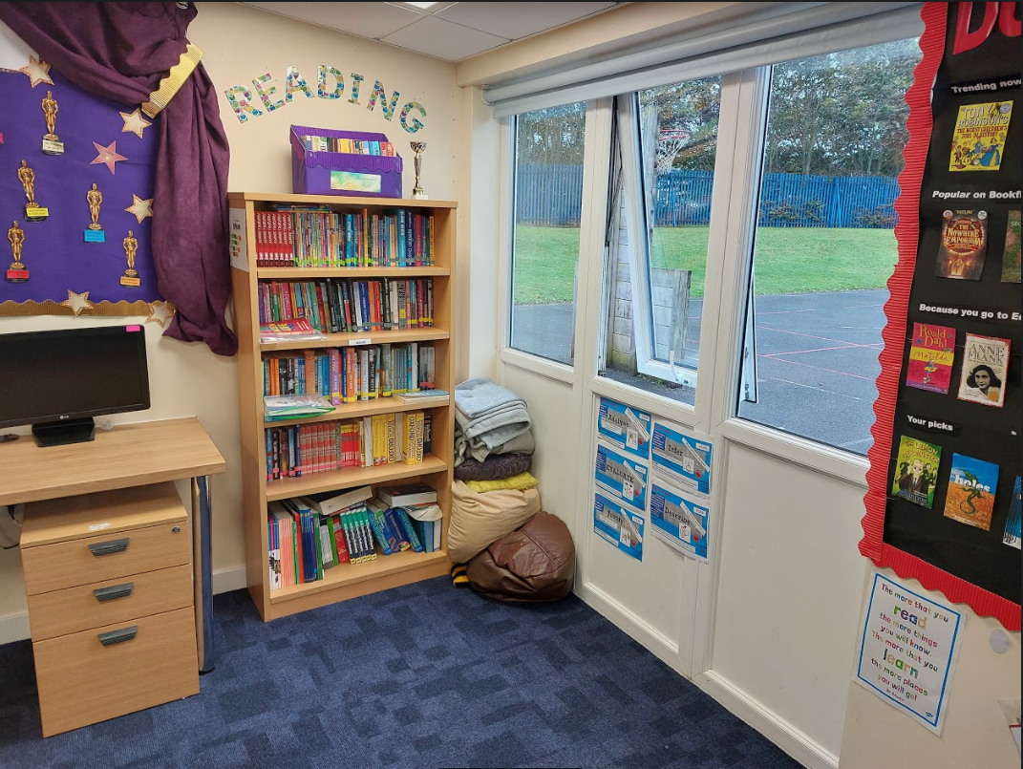

For further information about the work carried out at Educational Diversity, feel free to contact Victoria O’Farrell, the Headteacher:
Tel. 01253 476660 Mob. 07833483430
Email: vofarrell@eddiversity.blackpool.sch.uk
You can also follow activities on Facebook and Twitter.

For more information about nurture in schools: Nurtureuk.org

