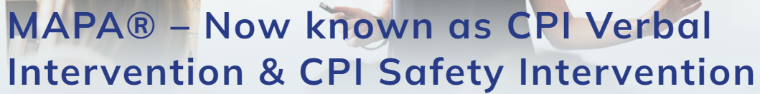

Educational Diversity is a CPI Approved Training Centre for delivering MAPA / Safety Interventions
MAPA
(The Management of Actual or Potential Aggression)
Safety Interventions

Foundation Level - FULL course
This is a fully accredited BLENDED LEARNING course comprising of:
- 2.5h online learning
- 6h face to face session

Our Certified Instructors will deliver the training using a blended learning model, combining both online and classroom based training, detailed below:

Online learning - participants will receive a link to complete the online part of the programme, which should take approximately 2.5 hours. The link will be sent out 2 weeks prior to the face to face session and must be completed in advance of that session. A workbook will be provided to support the online learning.

Face to face session - This will be a 6 hour session, delivered either as 1 full day or 2 twilights. It will include time to reflect on the online learning as well as time to learn the practical disengagements and holding skills and techniques. For the classroom based session, protective measures will be in place, in line with government guidance, details of which will be shared with all participants and includes expectations for both instructors and participants.

Programme Content:
- Identify and know how to respond to various levels of crisis behaviour
- Recognise how managing your own consistent, calm, adult behaviour in order to influence a positive outcome in a crisis situation
- Learn strategies to strengthen non-verbal communication.
- Develop limit setting strategies when verbally intervening to do-escalate defensive behaviours
- Learn safety intervention strategies to maximise safety and minimise harm.
- Explore the Physical Skills Review Framework and key legal and professional considerations when using restrictive interventions.
- Explore the Decision making Matrix when assessing Risk Behaviour
- Demonstrate and practice non-restrictive and restrictive interventions that are consistent with a set of physiological principles.
- Explore a framework to help guide staff and the individuals in distress through a process of re-establishing the relationship.

Who is the course for?
Anyone who has responsibility for supporting young people who can display aggressive behaviour, and who may require the use of physical interventions to help maintain the safety of all involved.

The full course must be completed if candidates have had no previous experience of MAPA / Safety Intervention training or if their previous accreditation is out of date. Both online and face to face sessions must be completed.

A judgement must be made by the school that training is required, giving consideration to the ‘risk of doing the training versus the risk of not doing the training’. All schools will be asked to complete a Training Needs Analysis prior to attending the training.

To book a course, please contact simon.coulter@eddiversity.blackpool.sch.uk

