

**Educational Diversity**

**SEND Policy**

| **Approved by:** | Management Committee | **Date:** October 2024 |
| --- | --- | --- |
| **Last reviewed on:** | October 2024 | |
| **Next review due by:** | October 2025 | |



**Contents**

* Context
* Aims and objectives
* Vision and value
* [Legislation and guidanc](https://docs.google.com/document/d/1GMWXBy_QAW18OkEyIoPAvng7rBZUjpLm/edit#heading=h.19c6y18)e
* Inclusion and equal opportunities
* Definitions
* Roles and responsibilities
* SEN information report
* Our Graduated Approach
* Expertise and training of staff
* Links with external professional agencies
* Admission and accessibility arrangements
* Complaints about SEND provision
* Monitoring and evaluation arrangements
* Links with other policies and documents

**Context**

This policy has been created by our SEND team in liaison with the Management Committee, Senior Leadership Team, School Staff and parents of students with SEND.

Educational Diversity’s accommodation is split between two sites. One site is predominantly for students who have been referred to the Athena panel due to medical and/or mental health issues, our AP and Vocational Students are also based here. The other site is predominantly for those students who have been permanently excluded. We also have students who attend our short-stay provisions.

All children at Educational Diversity are here because they need support above that which a mainstream school is able to provide. As part of our graduated approach, students are all considered to have SEND and are placed on the school’s SEND register as SEN K, accessing our universal offer. This offer then becomes more targeted or specialist if they arrive at the school with a local authority decision to issue an EHCP or have an EHCP in place.

Our universal offer ensures children are taught in small class sizes whilst being supported in lessons by a Special Support Assistant. If students still have barriers to accessing the curriculum, then the childl will be referred to the SENDCo, Amy Heard. This process involves the students being assessed in the four broad areas of needs so that appropriate support strategies or referrals to external providers can be implemented in a timely manner.

**Aims and Objectives**

Our Special Educational Needs and Disabilities (SEND) Policy aims to:

* Make sure our school fully implements national legislation and guidance regarding students with SEND.

It sets out how our school will:

* Support and make provision for students with special educational needs and disabilities
* Provide students with SEND access to all aspects of school life
* Help students with SEND fulfil their aspirations and achieve their best
* Help students with SEND become confident individuals living fulfilling lives
* Help students with SEND make a successful transition into adulthood
* Communicate with childen with SEND and their parents or carers and involve them in discussions and decisions about support and provision for the student
* Explain the roles and responsibilities of everyone involved in providing for students with SEND.
* Communicate with, and involve, students with SEND and their parents or carers in discussions and decisions about support and provision for the child. Make sure the SEND policy is understood and implemented consistently by all staff.

**Trauma and Nurture**

"Understanding the SEMH needs of pupils is absolutely essential in developing a whole school approach to improving mental health and behaviour in schools" (from [Mental Health and Behaviour in Schools](https://www.gov.uk/government/publications/mental-health-and-behaviour-in-schools--2)).

At Educational Diversity we use Boxall Profiling to identify needs and support students.

**Working Together**

We work with other agencies to support students and their families. Underpinning our work is the Blackpool Families Rock Approach and The Six Principles of Nurture. We also refer students and their families to relevant services such as Counselling/CASHER/CAMHS etc.

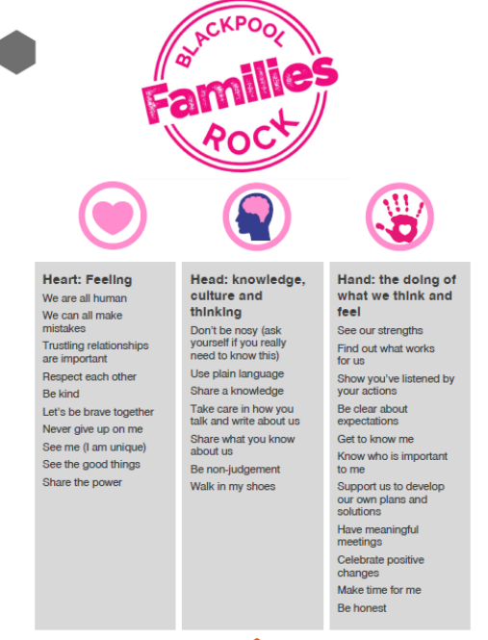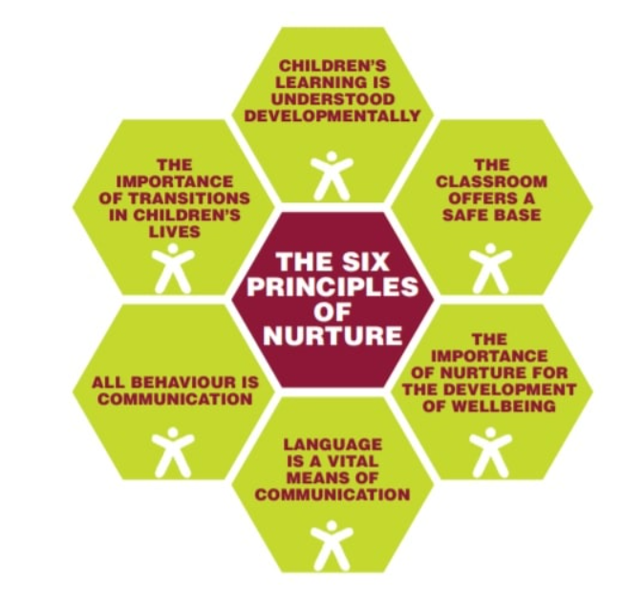

The 6 Principles of Nurture (NurtureUK) underpin our ethos. We have NurtureUK Status and use these approaches to understand and support students who are experiencing or have experienced trauma in their lives.

* Children's learning is understood developmentally.
* The classroom offers a safe base.
* The importance of nurture for the development of well-being.
* Language is a vital means of communication.
* All behaviour is communication.
* The importance of transition in children's lives.

As a staff team, we explored what we wanted our students to be. These were some of the keywords and phrases identified.

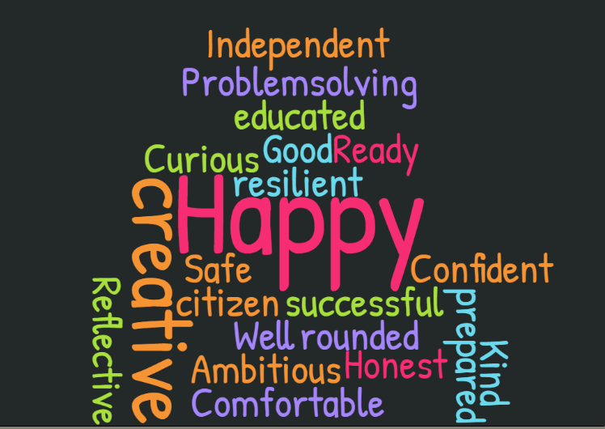

**Legislation and Guidance**

* This is based on the statutory [Special Educational Needs and Disability (SEND) Code of Practice](https://www.gov.uk/government/publications/send-code-of-practice-0-to-25) and the following legislation:
* [Part 3 of the Children and Families Act 2014](http://www.legislation.gov.uk/ukpga/2014/6/part/3), which sets out schools’ responsibilities for students with SEND.
* [The Special Educational Needs and Disability Regulations 2014](http://www.legislation.gov.uk/uksi/2014/1530/contents/made), which set out local authorities’ and schools’ responsibilities for education, health and care (EHC) plans, SEN co-ordinators (SENDCOs) and the special educational needs (SEN) information report.
* The [Equality Act 2010](https://www.legislation.gov.uk/ukpga/2010/15/contents) (section 20), which sets out the school’s duties to make reasonable adjustments for students with disabilities.
* The [Public Sector Equality Duty](https://www.legislation.gov.uk/ukpga/2010/15/part/11/chapter/1) (section 149 of the Equality Act 2010), which set out the school’s responsibilities to eliminate discrimination, harassment and victimisation; and advance equality of opportunity and foster good relations between people who share a protected characteristic (which includes having a disability) and those who don’t share it.
* The [Governance Handbook](https://www.gov.uk/government/publications/governance-handbook), which sets out our Management Committee’s responsibilities for students with SEND.
* The [School Admissions Code](https://www.gov.uk/government/publications/school-admissions-code--2), which sets out the school’s obligation to admit all students whose education, health and care (EHC) plan names the school, and its duty not to unfairly disadvantage children with a disability or with special educational needs.

**Inclusion and Equal Opportunities**

At Educational Diversity we strive to create an inclusive teaching environment that offers all students, no matter their needs and abilities, a broad, balanced and challenging curriculum. We are committed to offering all students the chance to thrive and fulfil their aspirations.

We achieve this by making reasonable adjustments to teaching, the curriculum and the school environment to make sure that students with SEND are included in all aspects of school life.

**Definitions**

**Special Educational Needs (SEN)**

* A student has SEN if they have a learning difficulty or disability that requires special educational provision to be made for them.

They have a **learning difficulty or disability** if they have:

* A significantly greater difficulty in learning than most others of the same age, or
* A disability which prevents or hinders them from making use of facilities of a kind generally provided for others of the same age in mainstream schools

**Special Educational Provision** is an educational or training provision that is additional to, or different from, that made generally for other children or young people of the same age by mainstream schools and post-16 institutions.

**Disability**

Students are considered to have a **disability** if they have a physical or mental impairment that has a substantial and long-term adverse effect on their ability to do normal daily activities.

At Educational Diversity we have regard to the SEND Code of Practice when carrying out our duties towards all SEND students and ensure that parents / carers are informed by the school that SEND provision is being made for their child. We make reasonable adjustments for students with disabilities, so that they are not at a substantial disadvantage compared with their peers.

**The 4 Areas of Need**

The needs of children with SEND are grouped into 4 broad areas. Students can have needs that overlap more than one area and their needs may change over time.

Adaptations and interventions will be selected that are appropriate for the students’ particular area(s) of need, at the relevant time. As part of the [Blackpool Local Offer](https://www.blackpool.gov.uk/Residents/Education-and-schools/Local-offer/Professionals/Graduated-approach/Graduated-approach.aspx) Graduated approach these interventions will be tracked and monitored.

Students must not be regarded as having a learning difficulty solely because the language of their home is different from the language in which they will be taught.

| **AREA OF NEED** |  | |
| --- | --- | --- |
| Communication and interaction | Students with needs in this area have difficulty communicating with others. They may have difficulty understanding what is being said to them, have trouble expressing themselves, or do not understand or use the social rules of communication.  Students who are on the autism spectrum often have needs that fall in this category. |
| Cognition and learning | Students with learning difficulties usually learn at a slower pace than their peers.  A wide range of needs are grouped in this area, including:   * Specific learning difficulties, which impact 1 or more specific aspects of learning, such as: dyslexia, dyscalculia and dyspraxia * Moderate learning difficulties * Severe learning difficulties * Profound and multiple learning difficulties, which is where students are likely to have severe and complex learning difficulties as well as a physical disability or sensory impairment |
| Social, emotional and mental health | These needs may reflect a wide range of underlying difficulties or disorders. Students may have:   * Mental health difficulties such as anxiety, depression or an eating disorder * Attention deficit disorder, attention deficit hyperactive disorder or attachment disorder * Suffered adverse childhood experiences   These needs can manifest in many ways, for example as challenging, disruptive or disturbing behaviour, or by the student becoming withdrawn or isolated. |
| Sensory and/or physical | Students with these needs have a disability that hinders them from accessing the educational facilities generally provided.  Students may have:   * A sensory impairment such as vision impairment, hearing impairment or multi-sensory impairment * A physical impairment   These students may need ongoing additional support and equipment to access all the opportunities available to their peers. |

**Roles and Responsibilities**

**Our SENDCO Team**

Our SENDCO at Educational Diversity is Amy Heard and the Assistant SENDCO is Vivien Counsell-Thomas. Both Amy and Vivien hold the National Award for SEN Coordination (SENDCO Award). We have an open door policy.

Amy Heard: [amy.heard@eddiversity.blackpool.sch.uk](mailto:amy.heard@eddiversity.blackpool.sch.uk)

Vivien Counsell-Thomas: [vivien.counsell-thomas@eddiversity.blackpool.sch.uk](mailto:vivien.counsell-thomas@eddiversity.blackpool.sch.uk)

**The SENDCO team are responsible for:**

* Informing any parents/carers that their child may have SEN and then liaise with them about the student’s needs and any provision made.
* Working with the headteacher and Management Committee SEND Link to determine the strategic development of the SEND policy and provision in the school.
* Having day-to-day responsibility for the operation of this SEND policy and the co-ordination of specific provisions made to support individual students with SEN, including those who have EHC plans.
* Providing professional guidance to colleagues and liaising and working with staff, parents, and other agencies to make sure that students with SEN receive appropriate support and high-quality teaching.
* Advising on the graduated approach to providing SEN support and adaptive teaching methods appropriate for individual students.
* Liaising with other professionals in relation to ‘Our Children’ who have SEND.
* Advising on the deployment of the school’s delegated budget and other resources to meet students’ needs effectively.
* Being a point of contact for external agencies, especially the local authority (LA) and its support services, and working with external agencies to ensure that appropriate provision is provided.
* Liaising with potential next providers of education to make sure that the student and their parents are informed about options and that a smooth transition is planned.
* When a student moves to a different school or institution: Making sure that all relevant information about a student’s SEN and the provision for them are sent to the appropriate authority, school or institution in a timely manner.
* Working with the headteacher and Management Committee to make sure the school meets its responsibilities under the Equality Act 2010 with regard to reasonable adjustments and access arrangements.
* Making sure our school keeps its records of all students with SEND up to date and accurate.
* Organising and conducting EHCP annual reviews in line with statutory timelines; ensuring all professionals involved with the child are invited to contribute and attend.
* With the headteacher, monitoring to identify any staff who have specific training needs regarding SEN, and incorporate this into the school’s plan for continuous professional development.
* With the headteacher, regularly reviewing and evaluating the breadth and impact of the SEND support the school offers or can access, and co-operating with the LA in reviewing the provision that is available locally and in developing the local offer.
* Preparing and reviewing information for inclusion in the school’s SEN information report and any updates to this policy.
* With the headteacher and teaching staff, identifying any patterns in the school’s identification of SEN, both within the school and in comparison with national data, and use these to reflect on and reinforce the quality of teaching.

**Our Management Committee is responsible for:**

Our Management Committee is responsible for making sure the following duties are carried out, though the duties can be delegated to a committee or an individual:

* Co-operating with the LA in reviewing the provision that is available locally and developing the local offer.
* Doing all it can to make sure that every student with SEND gets the support they need.
* Making sure that students with SEND engage in the activities of the school alongside students who don’t have SEND.
* Informing parents when the school is making special educational provision for their child.
* Making sure that the school has arrangements in place to support any students with medical conditions.
* Providing access to a broad and balanced curriculum.
* Having a clear approach to identifying and responding to SEND.
* Providing an annual report for parents on their child’s progress.
* Recording accurately and keeping up to date the provision made for students with SEND.
* Publishing information on our website about how we are implementing our SEND policy, in a SEN information report.
* Publishing information about the arrangements for the admission of disabled children, the steps taken to prevent disabled children being treated less favourably than others, the facilities provided to assist access of disabled children, and the school’s accessibility plans.
* Making sure that there is a qualified teacher designated as SENDCO for the school and that the key responsibilities of the role are set out, and monitoring the effectiveness of how these are carried out.
* Determining our approach to using their resources to support the progress of students with SEND.
* Making sure that all students from year 8 until year 13 are provided with independent careers advice.

**The Management Committee SENDis responsible for**

* Helping to raise awareness of SEND issues at Management Committee meetings.
* Monitoring the quality and effectiveness of SEND provision within the school and updating the governing board on this.
* Working with the headteacher and SENDCO to determine the strategic development of the SEND policy and provision in the school.

**The Headteacher is responsible for:**

* Working with the SENDCO and MC SEND link to determine the strategic development of the SEND policy and provision within the school.
* Working with the SENDCO and school Management Committee to make sure the school meets its responsibilities under the Equality Act 2010 with regard to reasonable adjustments and access arrangements.
* Having overall responsibility for, and awareness of, the provision for students with SEND, and their progress within a broad and balanced curriculum.
* Having responsibility for monitoring the school’s notional SEN budget and any additional funding allocated by the LA to support individual students.
* Making sure that the SENDCO has enough time to carry out their duties.
* Having an overview of the needs of the current cohort of students on the SEND register.
* Advising the LA when a student needs an EHC needs assessment, or when an EHC plan needs an early review.
* With the SENDCO, monitoring to identify any staff who have specific training needs regarding SEN, and incorporate this into the school’s plan for continuous professional development.
* With the SENDCO, regularly reviewing and evaluating the breadth and impact of the SEND support the school offers or can access, and co-operate with the LA in reviewing the provision that is available locally and in developing the local offer.
* With the SENDCO and teaching staff, identifying any patterns in the school’s identification of SEN, both within the school and in comparison with national data, and use these to reflect on and reinforce the quality of teaching.

**Our Teachers are responsible for:**

* Setting high expectations for every child and aiming to teach them the full curriculum, whatever their prior attainment.
* Working closely with any teaching assistants or specialist staff to plan and assess the impact of support and interventions, and consider how they can be linked to classroom teaching.
* Planning and providing high quality teaching that is adapted to address potential areas of difficulty to ensure that barriers to learning are reduced and every childl reaches their potential, across a broad and balanced curriculum.
* Planning and reviewing support for children with SEND on a graduated basis, in collaboration with parents, the SENDCO and, where appropriate, thechildren themselves
* Being aware of the needs, outcomes sought, and support provided to any child with SEND they are working with.
* Understanding and implementing strategies to identify and support vulnerable children with the support of the SENDCO.
* Keeping the relevant figures of authority up-to-date with any changes in behaviour, academic developments and causes of concern. The relevant figures of authority include the headteacher.
* Teachers should communicate with parents regularly to:
  + - Set clear outcomes and review progress towards them
    - Discuss the activities and support that will help achieve the set outcomes
    - Identify the responsibilities of the parent, the student and the school
    - Listen to the parents’ concerns and agree their aspirations for the student

**Parents/Carers**

Parents/carers should inform the school if they have any concerns about their child’s progress or development.

Parents/carers of a student on the SEND register are always given the opportunity to provide information and express their views about the student’s SEND and the support provided. They are invited to participate in discussions and decisions about this support.

They will be:

* Invited to termly meetings to review the provision that is in place for their child.
* Asked to provide information about the impact of SEN support outside school and any changes in the student’s needs.
* Given the opportunity to share their concerns and, with school staff, agree their aspirations for the student.

The school will take into account the views of the parent or carer in any decisions made about the student.

**Children**

Children are always given the opportunity to provide information and express their views about their SEND and the support provided. They are invited to participate in discussions and decisions about this support.

This might involve the child:

* Explaining what their strengths and difficulties are
* Contributing to setting targets or outcomes
* Attending review meetings
* Giving feedback on the effectiveness of interventions

The student’s views are taken into account in making decisions that affect them, whenever possible

**SEND Information Report**

Our school publishes a SEN information report on our website <https://eddiversity.com>. which sets out how this policy is implemented at Educational Diversity

Our ‘Information Report’ is updated annually and as soon as possible after any changes to the information it contains.

Both Educational Diversity’s SEND Information Report and the LA Local Offer are key documents to inform decisions about needs and provision (including involvement of outside agencies) and to monitor the progress of individual children.

**Our Graduated Approach**

**Our graduated approach is built upon a hierarchy of need.**

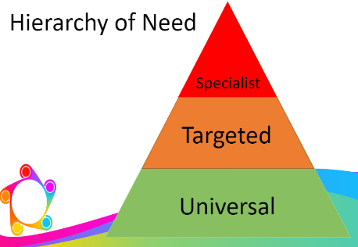

All of our students are on our SEND register. They are monitored under the Code of Practice through SEND Universal Support as follows:

* + - * All children have a One Page Profile (OPP) as a working document for children to share their voice on interests and aspirations.
      * Progress is monitored on a regular basis and parents/carers contacted at least three times a year to ensure they are fully involved in the support measures being used by the school.

If a student is joining Educational Diversity, and:

* Their previous setting has already identified that they have SEN
* They are known to external agencies
* They have an Education, Health and Care Plan (EHCP)

Then we work in a multi-agency way to make sure we get relevant information before the student starts at school, so support can be put in place as early as possible. They will already be identified as ‘targeted’ or ‘specialist’ SEN support.

We assess each student’s current skills and levels of attainment, on entry, which will build on previous settings and Key Stages, where appropriate.

These include:

* Cognitive Ability Testing (CAT),
* Reading Comprehension (New Group Reading Test),
* Dyslexia Screener,
* Pupil Attitudes to Self and School (PASS),
* Progress in English, Maths & Science (KS2&3 only),
* BKSB English & Maths (KS4 only).
* Boxall Profiling

Further assessments may be carried out by the SENDCO should they be deemed necessary.

**Identification of Needs at Targeted and Specialist Support**

Class teachers make regular assessments of progress for all students and identify those whose progress:

* Is significantly slower than that of their peers starting from the same baseline
* Fails to match or better the child’s previous rate of progress
* Fails to close the attainment gap between the child and their peers
* Widens the attainment gap

Class teachers or specialist support staff may then make a [targeted support referral](https://drive.google.com/file/d/1gFjDcI3nmesbl1ZPHFJQOx9Fy4w_MkK5/view?usp=drive_link) to the SEND Team. [Targeted support observations](https://drive.google.com/file/d/1m0R2NyOzV2fGmi1txBFjfZF7TzLXZ9dD/view?usp=drive_link) and any other relevant assessments such as; [Sensory Diet needs assessment](https://drive.google.com/file/d/1HQLhyulGZFzz77QppjPb3AzN-FkhyS2S/view?usp=drive_link) will then be conducted when it is deemed necessary.

As part of our [Graduated Approach](https://drive.google.com/file/d/1_O8vJ2Uralh7isVi-fri8a4t0Fp3XKkc/view?usp=drive_link), progress is assessed across the four broad areas of need;

**Cognition and Learning,**

**Communication and/or Interaction,**

**Social Emotional Mental Health**

**Physical and/or Sensory.**

Our SENDCO works alongside teaching staff to assess and set SMART targets as part of an individual Assess, Plan, Do, Review approach.

1. **Assess**

The student’s form tutor will carry out a clear analysis of the student’s needs. The views of the student and their parents will be taken into account. The SENDCO may be consulted as required and we may also seek advice from external support services.

The assessment is reviewed regularly to help make sure that the support in place is matched to the student’s needs. For many students, the most reliable way to identify needs is to observe the way they respond to an intervention.

1. **Plan**

In consultation with the parents and the student, the form tutor decides which adjustments, interventions and support will be put into place, the expected outcomes, and a clear date for review. The SENDCO may be consulted at this point.

All staff who work with the student are made aware of the student’s needs, the outcomes sought, the support provided and any teaching strategies or approaches that are needed. This information will be recorded on our management information system, SIMS, and will be made accessible to staff in a One Page Profile (OPP)and Individual Learning Plan (ILP).

Parents will be made fully aware of the planned support and interventions, and may be asked to reinforce or contribute to progress at home.

1. **Do**

The student’s class or subject teacher retains overall responsibility for their progress. They will work closely with any SSA or specialist staff involved, to plan and assess the impact of support and interventions and how they can be linked to classroom teaching**.**

The SENDCO will support the teacher in further assessing the student’s particular strengths and weaknesses, in problem solving and advising on how to implement support effectively.

1. **Review**

The effectiveness of the support and interventions and their impact on the student’s progress will be reviewed in line with the agreed date. The impact and quality of intervention will be evaluated within a multi networking approach. Students who need more specialist support may be entitled to an EHC plan. The plan is a legal document that describes the needs of the student, the provision that will be put in place, and the outcomes sought. Requests for statutory assessment are made via the Local Authority (LA) and may be requested by school or parents. This may or may not result in the issuing of an EHCP. The process takes 20 weeks from the submission of the application.

**Evaluating the Effectiveness of SEND Provision**

We evaluate the effectiveness of provision for students with SEN by:

* Tracking students’ progress
* Carrying out the review stage of the graduated approach in every cycle of SEN support
* Monitoring by the SENDCO
* Holding annual reviews for students with EHC plans
* Getting feedback from the student and their parents
* Receiving guidance from experts in the field of SEN

# Expertise and Training for Staff

Regular training is provided for teaching and support staff. The headteacher and the SENDCO continuously monitor to identify any staff who have specific training needs and will incorporate this into the school’s plan for continuous professional development.

# Links with External Professional Agencies

At Educational Diversity we recognise that we are not always able to meet all the needs of every student. Whenever necessary the school will work with external support services such as:

* Speech and Language Therapists- Happy Talk Ltd
* Specialist Teachers or Support Services
* Educational Psychologists
* Occupational Therapists, Speech and Language Therapists or Physiotherapists
* General Practitioners
* School Nurses
* Child and Adolescent Mental Health Services (CAMHS)
* Pupil Welfare Services
* Children’ Social Care
* School Home Support
* Paediatricians, including the Neurodevelopmental Pathway

# Our Admission and Accessibility Arrangements

A child’s placement in our school is as a result of a permanent exclusion, through an agreed managed move or through a dual register arrangement. At induction, SENDCo will ensure all relevant requests are made to previous settings.

Please see the Accessibility Plan on our website.<https://eddiversity.com>.

# Complaints about our SEND Provision

Where parents have concerns about our school’s SEND provision, they should first raise their concerns informally with the headteacher. We will try to resolve the complaint informally in the first instance. If this does not resolve their concerns, parents are welcome to submit their complaint formally.

Formal complaints about SEND Provision in our school should be made to the headteacher in the first instance. They will be handled in line with the school’s complaints policy, which can be found on our website.

If the parent or carer is not satisfied with the school’s response, they can escalate the complaint. In some circumstances, this right also applies to the students themselves.

To see a full explanation of suitable avenues for complaint, see pages 246 and 247 of the [SEN Code of Practice](https://www.gov.uk/government/publications/send-code-of-practice-0-to-25).

To find out about disagreement resolution and mediation services in our local area, please see this [website](https://www.blackpool.gov.uk/Residents/Education-and-schools/Local-offer/Parents/If-you-disagree-with-a-decision.aspx).

# Monitoring and Evaluation Arrangements

**Evaluating the Effectiveness of this Policy**

We are constantly looking for ways to improve our SEND Policy. We will do this by evaluating whether or not we are meeting our objectives set out in this policy

We evaluate how effective our SEND provision is with regards to:

* All staff’s awareness of students with SEND
* How early students are identified as having SEND
* Students’ progress and attainment once they have been identified as having SEND
* Whether students with SEND feel safe, valued and included in the school community
* Comments and feedback from students and their parents

**Monitoring this Policy**

This policy will be reviewed by the SENDCO **every year**. It will also be updated when any new legislation, requirements or changes in procedure occur during the year.

It will be approved by the Management Committee

# Link with other Policies and Documents

This policy links to the following documents:

* SEN Information Report
* The Local Offer
* Accessibility Plan
* Relationships and Behaviour Policy
* Equality Information and Objectives
* Supporting Students with Medical Conditions Policy
* Pupil Attendance Policy
* Safeguarding / Child Protection Policy
* Complaints policy

**Appendix - Categories of Needs Definitions**

**Communication and Interaction**

Children and young people with speech, language and communication needs (SLCN) have difficulty in communicating with others. This may be because they have difficulty saying what they want to, understanding what is being said to them or they do not understand or use social rules of communication. The profile for every child with SLCN is different and their needs may change over time. They may have difficulty with one, some or all areas of the different aspects of speech, language or social communication at different times of their lives.

*Department of Education (2015)*

**Speech, Language and Communication Needs (SLCN)**

Children with SLCN cover the whole ability range. children may have difficulty in understanding information conveyed through spoken language. Their acquisition of speech and oral language skills may be significantly behind their peers and their speech may be poor or intelligible. Children with language impairments find it hard to understand and/or use words in context. They may use words incorrectly with inappropriate grammatical patterns, have a reduced vocabulary or find it hard to recall words and express ideas. They may also hear or see a word but not be able to understand its meaning or have trouble getting others to understand what they are trying to say.

Please note that children whose first language is not English should not be recorded as SLCN unless they also have a special educational need in this area.

*Department of Education and Skills (2003)*

**Autism**

Children with autism are described as having persistent difficulties with social communication and social interaction. Children often have restricted and repetitive patterns of behaviours, activities or interests which include sensory behaviour. These behaviours are present since early childhood and may limit and impair everyday functioning.

*American Psychiatric Association (2013)*

**Cognition and Learning**

Support for learning difficulties may be required when children and young people learn at a slower pace than their peers, even with appropriate differentiation. Learning difficulties cover a wide range of needs, including moderate learning difficulties (MLD), severe learning difficulties (SLD), where children are likely to need support in all areas of the curriculum and associated difficulties with mobility and communication, through to profound and multiple learning difficulties (PMLD), where children are likely to have severe and complex learning difficulties as well as a physical disability or sensory impairment. Specific learning difficulties (SpLD), affect one or more specific aspects of learning. This encompasses a range of conditions such as dyslexia, dyscalculia and dyspraxia.

*Department of Education (2015)*

**Moderate Learning Difficulties (MLD)**

children with MLD will have attainments well below expected levels in all or most areas of the curriculum,

despite appropriate interventions. Their needs will not be met by normal differentiation and

the flexibilities of the National Curriculum. Children with MLD have much greater difficulty than their peers in acquiring basic literacy and numeracy skills and in understanding concepts. They may also have associated speech and language delay, low self-esteem, low levels of concentration and underdeveloped social skills.

*Department of Education and Skills (2003)*

**Severe Learning Difficulty (SLD)**

Children with severe learning difficulties have significant intellectual or cognitive impairments. This has a major effect on their ability to participate in the school curriculum without support. They may also have associated difficulties in mobility and coordination, communication and perception and acquisition of self-help skills. Children with SLD will need support in all areas of the curriculum. They may also require teaching of self-help, independence and social skills. Some children may use signs and symbols but most will be able to hold simple conversations and gain some literacy skills.

*Department of Education and Skills (2003)*

**Profound and Multiple Learning Difficulty (PMLD)**

Children with PMLD have severe and complex learning needs, in addition they have other significant difficulties, such as physical disabilities or a sensory impairment. Children require a high level of adult support, both for their learning needs and also for personal care. They are likely to need sensory stimulation and a curriculum broken down into very small steps. Some children communicate by gesture, eye pointing or symbols, others by very simple language.

*Department of Education and Skills (2003)*

**Specific Learning Difficulties (SpLD)**

SpLD is an umbrella term which indicates that children display differences across their learning. Children with SpLD may have a particular difficulty in learning to read, write, spell or manipulate numbers so that their skills in these areas is below their performance in other areas. Children may also have problems with short term memory, organisational skills and coordination. Children with SpLD cover the whole ability range and the severity of their impairment varies widely.

*Department of Education and Skills (2003)*

Dyslexia

Dyslexia is a learning difficulty that primarily affects the skills involved in accurate and fluent word reading and spelling. Characteristic features of dyslexia are difficulties in phonological awareness, verbal memory and verbal processing speed. Dyslexia occurs across the range of intellectual abilities. It is best thought of as a continuum, not a distinct category, and there are no clear cut-off

points. Co-occurring difficulties may be seen in aspects of language, motor coordination, mental calculation, concentration and personal organisation, but these are not, by themselves, markers of dyslexia. A good indication of the severity and persistence of dyslexic difficulties can be gained by examining how the individual responds or has responded to well founded intervention. *Rose (2009)*

Dyscalculia

Developmental Dyscalculia is a specific learning difficulty that is characterised by impairments in learning basic arithmetic facts, processing numerical magnitude and performing accurate and fluent calculations. These difficulties must be quantifiably below what is expected for an individual’s chronological age and must not be caused by poor educational or daily activities or by intellectual impairment.

*American Psychiatric Association (2013)*

Dyspraxia

Children with dyspraxia are affected by difficulties in controlling or coordinating movement. These coordination impairments can make it difficult for children with dyspraxia to write, type and engage in many activities required on a daily basis. In some cases it can also affect a child’s speech.

*O’Connell (2015)*

**Social, Emotional and Mental Health Difficulties (SEMH)**

Children and young people may experience a wide range of social and emotional difficulties which manifest themselves in many ways. These may include becoming withdrawn or isolated, as well as displaying challenging, disruptive or disturbing behaviour. These behaviours may reflect underlying mental health difficulties such as anxiety or depression, self-harming, substance misuse, eating disorders or physical symptoms that are medically unexplained. Other children and young people may have disorders such as attention deficit disorder, attention deficit hyperactivity disorder or attachment disorder.

*Department of Education (2015)*

**Sensory and/or Physical Needs**

Some children and young people require special educational provision because they have a disability which prevents or hinders them from making use of the educational facilities generally provided. These difficulties can be age related and may fluctuate over time. Many children and young people with vision impairment (VI), hearing impairment (HI) or a multi-sensory impairment (MSI) will require specialist support and/or equipment to access their learning, or habilitation support. Children and young people with an MSI have a combination of vision and hearing difficulties.

Some children and young people with a physical disability (PD) require additional ongoing support and equipment to access all the opportunities available to their peers.

*Department of Education (2015)*

**Visual Impairment (VI)**

VI refers to a range of difficulties from partial sight through to blindness. Children with visual impairments cover the whole ability range. For educational purposes, a child is considered to be VI if they require adaptations to their environment or specific differentiation of learning materials in order to access the curriculum.

*Department of Education and Skills (2003)*

**Hearing Impairment (HI)**

Children with HI range from those with a mild hearing loss to those who are profoundly deaf. They cover the whole ability range. For educational purposes, children are regarded as having a HI if they require hearing aids, adaptations to their environment and/or particular teaching strategies in order to access the concepts and language of the curriculum.

*Department of Education and Skills (2003)*

**Multi-Sensory Impairment (MSI)**

Children with multi-sensory impairment have a combination of visual and hearing difficulties. They are sometimes referred to as deaf blind but may have some residual sight and/or hearing. Many also have additional disabilities but their complex needs mean that it may be difficult to ascertain their intellectual abilities. Children should only be recorded as MSI if their sensory impairment is their greatest need.

*Department of Education and Skills (2003)*

**Physical Disability (PD)**

There is a wide range of physical disabilities and children cover the whole ability range. Some children are able to access the curriculum and learn effectively without additional educational provision. They have a disability but do not have a special educational need. For others, the impact on their education may be severe. Similarly a medical diagnosis does not necessarily mean a child will have SEND. It depends on the impact the condition has on their educational needs.

There are a number of medical conditions associated with physical disability which can impact on mobility, such as cerebral palsy, spina bifida and muscular dystrophy. Children with physical disabilities may also have associated sensory impairments, neurological problems or learning difficulties.

*Department of Education and Skills (2003)*