What are we learning? | Key Themes and books  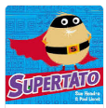  Starting School Growing Up Families Superheroes Magic  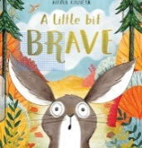  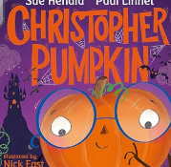  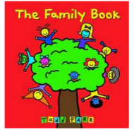  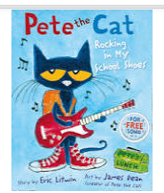 |  |  | Key Experiences  Starting school and becoming part of Egerton.  Learning about ourselves, our feelings, our community and family.  Walk around the school, meeting new people.  Making friends, feeling safe and happy.
PSED (Personal, Social and Emotional Development)  - What makes me special/ my special people  - Who can help me?  - Feelings  - Self-care and self-regulation techniques  - Developing relationships  - Class rules: Behavioural expectations in the class/boundaries set |  | 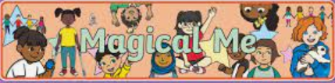  It’s Good to be Me  Reception  Autumn Term  2026  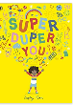 |  | Maths  - Baseline/getting to know you  - Matching  - Sorting  - Comparing amounts  - Compare Size/mass/capacity  - Exploring patterns
CLL (Communication and Language)  - Talking about family/ routines and special occasions.  - Following instructions in routines.  - Developing listening skills.  - Developing social phrases e.g. ‘good morning!’  - Asking why.  - Engaging in story times. |  |  |  | UW (Understanding the World)  - Talk about members of their immediate family and the relationship to them, name and describe people who are familiar to them.  - Learn about themselves and special things in their own lives.  - Talk about the features of their immediate environment with visual representations e.g., around school, seating maps and notice common signs and logos.  - Take part in Forest Fun sessions identifying natural resources found in the outdoor areas.  - Discuss the changes we can see around us and we leave Summer and enter Autumn.
PD (Physical Development)
- Develop skills needed to dress and undress for PE
- Develop confidence and movement skills using apparatus and space outdoors.
- Develop and refine fine motor skills and hand eye coordination needed for writing.
- Develop a good pencil grip
Literacy  - Listen and enjoy sharing and joining in with a wide range of books, poems and songs.  - Phonics - start to learn to read and write phase 2 sounds.  - Develop listening and speaking skills in a range of contexts.  - Give meaning to marks they make. Understand that thoughts can be written down.  - Start to blend known sounds to read simple regular words e.g. mum, dad.  - Write their name with a name card or try to write it from memory. |  |  |  | EAD (Expressive Arts and Design)  - Join in with role play activities with friends and adults  - Create collaboratively, sharing ideas, resources and skills.  - Create self-portraits using line drawing and paint  - Develop storylines in their pretend play.  - Move to music.  - Explore different actions to songs.  - Feel the steady beat in music.
How you can help at home
We greatly encourage and appreciate your involvement in your child’s learning and you are always welcome to ask questions or seek advice on how you can support your child’s learning at home. Here are a few ideas.
Personal Social & Emotional Development  - Give your child lots of opportunities to make decisions, give opinions and discuss their feelings e.g. what fruit shall we buy? How does that story make you feel? What did you like best?  - Encourage their attempts at independence and don’t worry when they don’t always get things right e.g. dressing themselves, doing up fastenings, tidying up.  - Show them how to resolve conflicts peacefully. For example, if they are upset because they don’t want to do something, offer them some simple choices with the same outcome e.g. would you like this or that story before you go to bed?  - Value and praise their efforts, especially when trying something new.  - Take them to parks and places where they can spend time with other children.  - Play simple turn taking games.  - Talk to them about healthy food choices and why they are important. |  |  | Communication and language  - Make time for conversations with your child daily.  - Share and talk about stories and information in books.  - Play with them, commenting on what you are doing.  - Echo back what they say with new words added.  - Be aware of too much background noise e.g. tv, radio etc.  - Sing nursery rhymes.    Please speak to us if you have any concerns about your child’s language development.
Physical Development

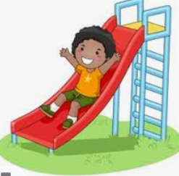
- Provide opportunities, such as visits to the park, to encourage your child to be physically active. Encourage and show them how to move in different ways, e.g. hopping, jumping, skipping.
- Sing action songs and rhymes and encourage them to dance along to music.
- Encourage mark making in lots of different ways e.g. using paints, pens, chalks on a pavement, sticks in mud etc.
- Play puzzle and threading activities to help develop hand-eye coordination.
- Show your child how to hold a pencil correctly between thumb and forefinger.
- Help your child to form letters correctly using the resources sent from school.
- Help them to practise learning to write their name, with a capital letter at the beginning and lower case letters after.

Mathematics  - Count everything with your child, from ducks on the pond to stairs up to bed.  - Sing counting songs and rhymes to help teach your child about numbers and order, as well as rhythm and rhyme e.g., ‘Five Little Monkeys’, ‘Ten in the Bed’.  - Play counting-based games such as dominoes, uno, snakes and ladders or number snap.  - Play ‘spot the number’–focus on the numerals 0 to 9, and challenge your child to find them everywhere–on front doors, clocks, car registrations, birthday cards and more.  - Involve your child in everyday activities such as shopping and cooking to help them understand mathematical concepts such as weight, capacity, sharing and measuring. |  |  | Literacy  - Share stories and books daily with your child. Talk to them about what they have heard, drawing attention to the pictures and print.  - Visit the library to encourage and develop your child’s interest and excitement in books and stories.  - Talk to them about the world around them and enjoy rhymes, poems and songs together.  - Support your child’s developing reading and writing skills by engaging with the resources and activities sent home from school. These will include story books to listen to and talk about, letters to practise sounding and, when ready, simple regular and irregular words to practise reading. When appropriate, simple books for your child to read will also be sent home for them to share.
Understanding the World  - Draw your child’s attention to the world around them. Talk to them and encourage them to talk to you about things that they see, smell, hear and feel and the changes they notice throughout the year.  - Encourage their natural curiosity and support their ability to ask and answer questions by exploring changing materials such as freezing water or helping with simple cooking activities.  - Read and talk about information books based on their interests.  - Look at photos of family members and themselves when they were younger. Talk about the past from your own and their own personal experiences. Talk about what different people do at home, at school and in the wider community. Ask questions such as, ‘what would you like to do when you grow up?’ |  |  | Expressive Arts and Design  - Encourage them to draw, make pictures and models of what they are interested in, see or experience.  - Encourage them to build and create props for play using everyday junk materials e.g., turning an empty cardboard box into a castle for a toy.  - Keep a ‘busy box’ with things like string, tape, wrapping paper scraps, lolly sticks, stickers and straws that your child can use to make whatever they want. Ask them to talk about their creations.  - Use drama to act out things from daily life. It could be doctors, mothers, fathers, shopkeepers, firefighters – whatever your child likes. At story time, encourage your child to act out roles from a story with movements or sounds.  - Put on some favourite music to get them moving. Encourage them to march, roll, stamp, hop, slide and twirl. Point out sounds with steady beats, like a ticking clock or a dripping tap. Encourage your child to clap, tap, march or bang to the beat. Help them develop a sense of rhythm with songs, and rhymes like ‘Incy wincy spider’, ‘Heads and shoulders’, ‘Five little monkeys’ and ‘Jack and Jill’.

