Nursery
 | Autumn 1 | Autumn 2 |  | Spring 1 |  | Spring 2 |  | Summer 1 |  |  | Summer 2
Title | It’s all about me! | Who keeps us safe? |  | Once upon a time |  | How does your garden grow? |  | Down on the Farm |  |  | Are we there yet?
General Themes | My Family  Family trees  My Face  Autumn  Fireworks/Bonfire night | Christmas  Autumn  Remembrance Day |  | Fairy/traditional Tales  Winter  Chinese New Year |  | Planting  Minibeasts  Bug hotels |  | Farm animals  Caterpillars  May Day |  |  | Father’s Day  Sports Day  Nursery Leaver’s ceremony
Texts | 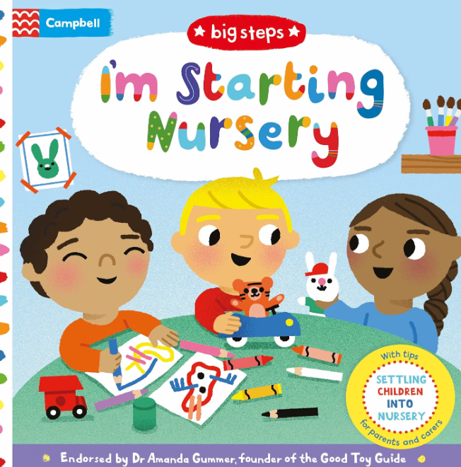 | 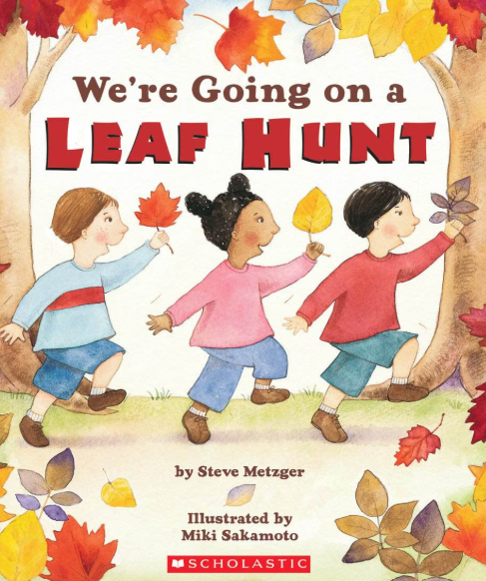 |  | 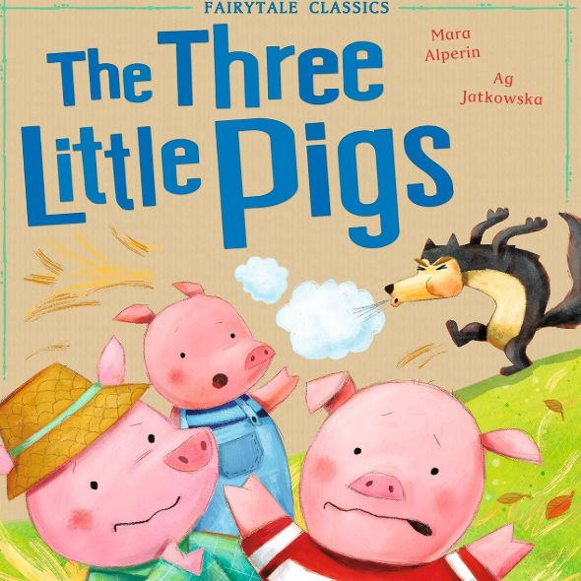 |  | 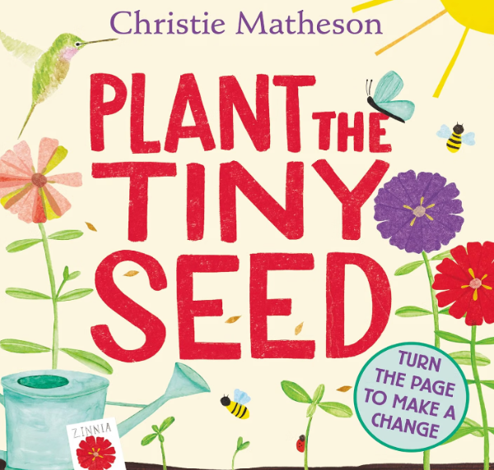 |  | 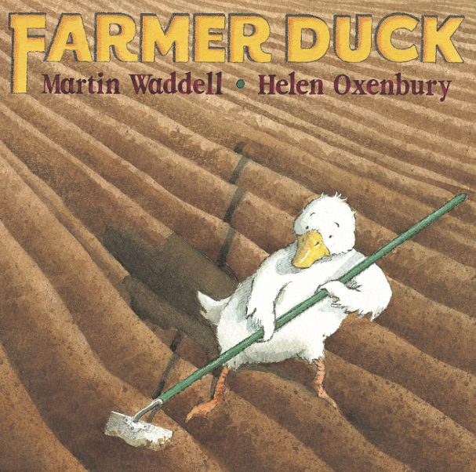 |  |  | 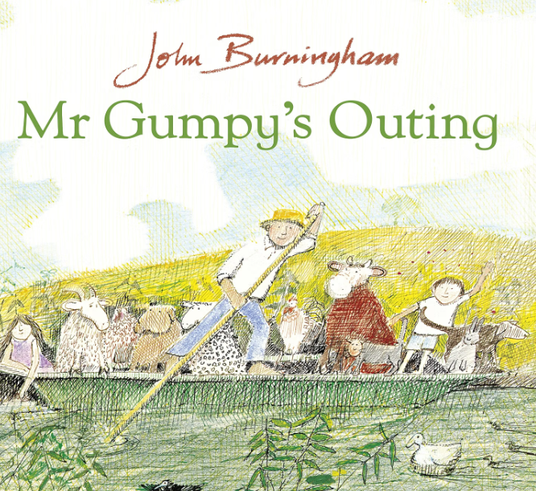
Enrichment Ideas | First Day of Nursery picture  Family tree display.  Bonfire Night | Nativity  Christmas Party |  | Chinese New Year  Pancake Day  Valentine’s Day |  | Easter  Mother’s Day |  | Farm Trip  May Day  Caterpillars |  |  | Father’s Day  Sports Day  Transition to Reception
Communication and Language

Listening, Attention and Understanding  Speaking | Enjoy listening to longer stories. |  | Listening to others in small groups.  Sing a growing repertoire of songs. |  | Develop their communication skills and begin to use more complex sentences to link thoughts. |  | Use longer sentences of four to six words.  Follow simple directions how to plant a seed. |  | Start a conversation with an adult or a friend and continue it for many turns.  Use talk to organise themselves and their play: “Let’s go on a bus... you sit there... I’ll be the driver.” | Be able to express a point of view and to debate when they disagree with an adult or a friend, using words as well as actions.  Use a wider range of vocabulary.
Personal, Social and Emotional Development

Self Regulation  Managing self  Building Relationships | Settling in – building relationships with peers and with staff. | Develop their sense of responsibility and membership of a community. |  | Play with one or more other children, extending and elaborating play ideas.  How to be a kind friend-begin to find solutions to conflicts |  | Increasingly follow rules, understanding why they are important. |  | Talk about their feelings using words like ‘happy’, ‘sad’, ‘angry’ or ‘worried’. |  |  | Preparing for change and the transition to school
Physical Development

Fine motor | Continue to develop their movement, balancing, riding (scooters, trikes and bikes) and ball skills.  Use one-handed tools and equipment, for example, making snips in paper with scissors. | Use large-muscle movements to draw lines and circles and make marks.  Using scissors and tools safely Start eating independently and learning how to use a knife and fork. |  | Use a comfortable grip with good control when holding pens and pencils.  Start to show a preference for a dominant hand. |  | Be increasingly independent as they get dressed and undressed, for example, putting coats on and doing up zips.  Make healthy choices about food, drink and activity. |  | Be increasingly independent in meeting their own care needs, e.g. brushing teeth, using the toilet, washing and drying their hands thoroughly.  Match their developing physical skills to tasks and activities in the setting. |  |  | Collaborate with others to manage large items, such as moving a long plank safely, carrying large hollow blocks.  Use a comfortable grip with good control when holding pens and pencils.
Gross Motor

Literacy

Comprehension | Understand that print has meaning.  Develop their phonological awareness, so that they can: - spot and suggest rhymes  Little Wandle Foundations:  No sounds – focus on Rhyme time and settling children into the setting’s routines. | Understand that we read English text from left to right and from top to bottom  Sensory mark marking  Recognise their own name  Little Wandle Foundations:  Daily Rhyme time phonological Awareness activities  s a t p i n m |  | Understand that print can have different purposes,e.g. a shopping list, story, recipe, etc.  Develop their phonological awareness so they can clap the syllables in words.  Begin to write some of their name.  Little Wandle Foundations:  Daily Rhyme time phonological Awareness activities  d g o c k e |  | Identify and name the different parts of a book, e.g. front cover, pages, etc.  Develop their phonological awareness to recognise words with the same initial sound, such as money and mother.  Write some or all of their name.  Little Wandle Foundations:  Daily Rhyme time phonological Awareness activities  u r h b f l |  | Understand page sequencing.  Recognise words with the same initial sound, such as money and mother.  Engage in extended conversations about stories, learning new vocabulary.  Write some or all of their name.  Little Wandle Foundations:  Daily Rhyme time phonological Awareness activities  j v w y z qu ch |  |  | Use some of their print and letter knowledge in their early writing.  For example: writing a pretend shopping list that starts at the top of the page; writing ‘m’ for mummy.  Write some letters accurately.  Little Wandle Foundations:  Daily Rhyme time phonological Awareness activities  ck x sh th ng nk
Word Reading

Writing

All Literacy is linked to topic, books and children’s interests. Children learn the structure of books and storytelling.
Maths

Number  Numerical patterns | Master the Curriculum  Recognise colours red, blue, yellow, green, purple.  Numerical Patterns  Recognise matching shapes and colours.  Recognise and create matching towers.  Match numicon shapes  Match objects that are the same size.  Matching prints.  Sort by size, colour and shape. | Master the Curriculum  Number  Number 1 – subitising, counting, numeral matching  Number 2 – subitising, counting, linking numeral to amount  Numerical Pattern  Colour AB Patterns  Extend AB Patterns  Fix my pattern  Extend ABC Patterns |  | Master the Curriculum  Number  Number 3 – subitising, counting, numeral matching, composition of 3.  Number 4 – counting 4, numeral 4, composition of 4  Number 5 – counting 5, numeral 5, composition of 5  Numerical Pattern  Recognise squares and rectangles  Recognise pentagons |  | Master the Curriculum  Number  Number 6 – counting, ten frame  Numerical Pattern  Tall and short, long or short  Mass – introducing balance scales, lighter, heavier  Capacity – full or empty, nearly full or nearly empty, comparing containers |  | Master the Curriculum  Numerical Pattern  Sequencing  Position – on and under, in and out, in front and behind  Comparing groups – more than, fewer than  2D Shapes – circles, triangles, rectangles  3D shapes – cubes and cuboids, cylinders, spheres |  |  | Master the Curriculum  Number  Composition of 3  Composition of 4  What comes after – Number track  What comes before – number track  Numbers to 5 – counting, numeral recognition
Understanding the World

Past and Present | Families – who is my family?  Body parts – head shoulders knees and toes.  Introduce vocabulary to describe the weather.  Seasons-know the signs of Autumn.  Autumn hunt on the school field  Celebrations:  - Fireworks/Bonfire Night | Make observations and describe the weather.  Show interest in different occupations.  Use all their senses in hands-on exploration of natural materials.  Continue developing positive attitudes about the differences between people. Celebrations:  • Diwali  • Remembrance day •  • Christmas |  | Seasons-  know the signs of Winter.  Make observations and describe the weather.  Explore ice melting. Where do I live? (features of the local area)  Explore how things work.  Talk about the differences between materials and changes they notice. Celebrations:  • Chinese New year |  | Seasons  -know the signs of Spring.  Make observations and describe the weather.  Plant vegetable seeds and care for growing plants.  Develop mini beast hotels in the outdoor area  Understand the key features of the life cycle of a plant.  Continue developing positive attitudes about the differences between people. Celebrations:  • Pancake Day  • Easter |  | Observe and care for growing animals (Farm trip)  Understand the key features of the life cycle of an animal - Butterfly  Begin to understand the need to respect and care for the natural environment and all living things.  Know the names of farm animals and their babies |  |  | Seasons-know the signs of Summer.  Make observations and describe the weather.  Journeys – Maps  Graduation
People, Culture and Communities

The Natural World

Expressive Arts and Design

Creating with Materials | Take part in simple pretend play, using an objects to represent different things  Begin to remember and sing entire songs.  Self Portraits | Poppy printing  Explore different materials freely, in order to develop their ideas about how to use them and what to make.  Play instruments with increasing control to express their feelings and ideas.  Create closed shapes with continuous lines, and begin to use these shapes to represent objects.  Enjoy dancing and joining in with ring games |  | Begin to Develop complex stories using small world equipment like animal sets, dolls and dolls houses etc.  Draw with increasing complexity and detail, such as representing a face with a circle and including details.  Sing the pitch of a tone sung by another person (‘pitch match’). |  | Develop their own ideas and then decide which materials to use to express them.  Join different materials and explore different textures.  Show different emotions in their drawings and paintings, like happiness, sadness, fear etc. |  | Selecting different tools to create patterns.  Explore colour and colour mixing.  Make imaginative and complex ‘small worlds’ with blocks and construction kits, such as a city with different buildings and a park.  Play instruments with increasing control to express their feelings and ideas. |  |  | Show different emotions in their drawings – happiness, sadness, fear etc.  Respond to what they have heard, expressing their thoughts and feelings.  Create their own songs, or improvise a song around one they know.
Being Imaginative and Expressive

