Reception
 | Autumn 1 | Autumn 2 |  | Spring 1 |  | Spring 2 |  | Summer 1 |  |  | Summer 2
Title | It’s Good to be Me | Celebrate Good Times Come On! |  | Past, Present and Future |  | Amazing Animals |  | Come Outside |  |  | Imagine a Story
General Themes | Starting school  Superheroes  My family  Halloween/magic  Birthdays | Bonfire Night - poem  Diwali – 8th Nov  Autumn  Remembrance Day  Advent  Christmas  The Nativity |  | Around the town  How do I get there?  Space  Vehicles Past and Present  Winter  Antarctica  Chinese New Year – Feb 6th |  | Jungle  Woodland  Living Eggs  Easter  Mother’s Day - 7th March |  | Life Cycles  Growing beanstalks  Minibeasts |  |  | Pirates  Under the Sea  Fairy Tales  Father's Day – 20th June
Texts | 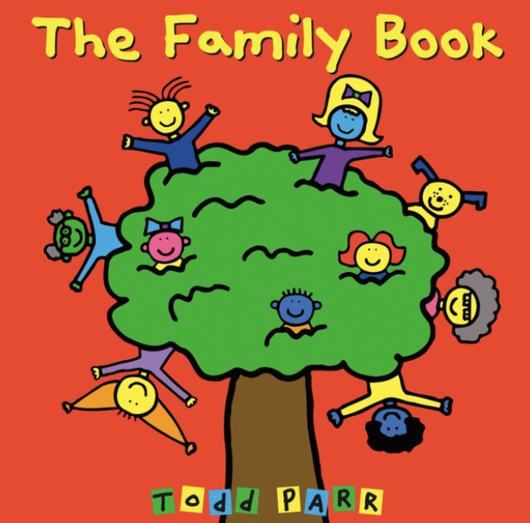 | 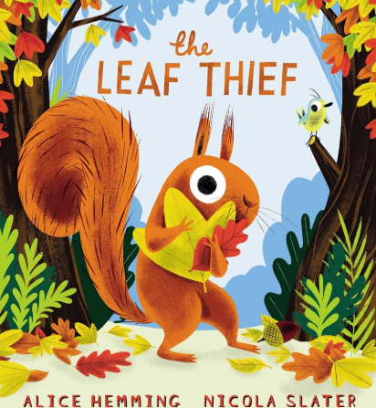 |  | 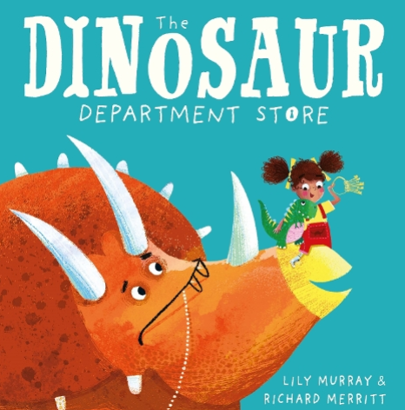 |  | 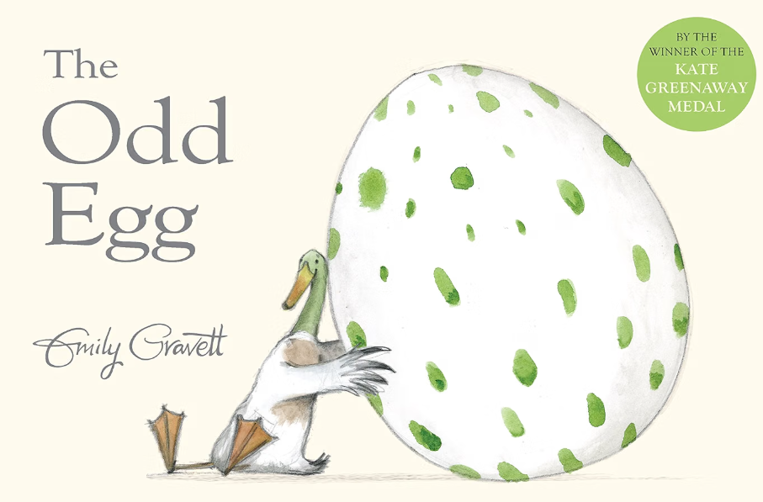 |  | 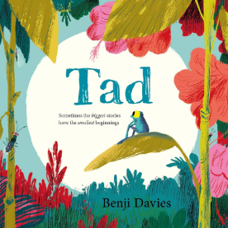 |  |  | 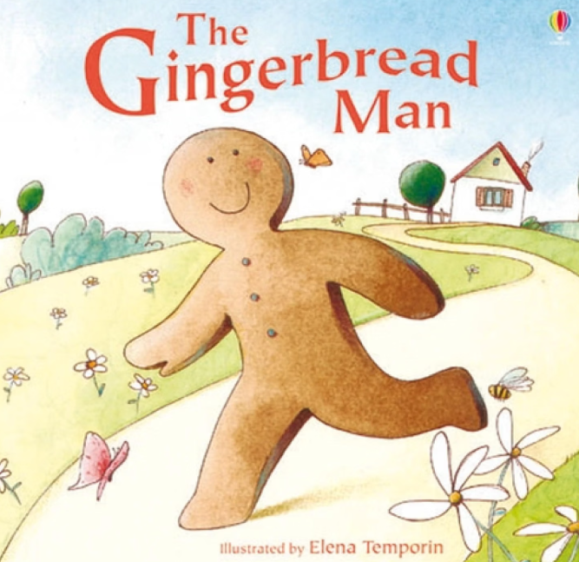
Enrichment | Family Photos | Nativity  Pantomime |  | Chinese New Year - workshop |  | Living Eggs  Mother’s Day – Sunday 7th March |  | Trip to Norton Priory  - Pond Dipping |  |  | Father’s Day – Sunday 16th June  Transition to year 1
Communication and Language

Listening, Attention and Understanding  Speaking | All about me  Settling in  Making Friends |  | Following instructions  Takes part in discussion  Understand how to listen carefully and why listening is important. |  | Ask how and why questions…  Ask questions to find out more and to check they understand what has been said to them. |  | Speaking in full sentences.  Develop questioning skills. |  | Hold conversations when engaged in back and forth exchanges with their teachers and peers.  Model speaking in full sentences using past present and future tenses. | Read aloud books to children that will extend their knowledge of the world and illustrate a current topic. Speak in full sentences using past present and future tenses and making use of conjunctions.
Personal, Social and Emotional Development

Self Regulation  Managing self  Building Relationships | Kapow PSHE  Self Regulation: My Feelings | Kapow PSHE  Building Relationships: Special Relationships |  | Kapow PSHE  Managing Self: Taking on Challenges |  | Kapow PSHE  Self Regulation: Listening and Following Instructions |  | Kapow PSHE  Building Relationships: My Family and Friends |  |  | Kapow PSHE  Managing Self: My Wellbeing
Physical Development

Fine motor | Draw lines and circles using gross motor movements | Teach and model correct letter formation. |  | Begin to form letters correctly. |  | Hold pencil effectively with comfortable grip Forms recognisable letters most correctly formed |  | Use one hand consistently for fine motor tasks  Cut along a straight line with scissors /  Start to cut along a curved line, like a circle |  |  | Form letters correctly using a tripod grip
Gross Motor | PE Sessions  Fundamental Movements | PE Sessions  Fundamental Movements |  | PE Sessions  Gymnastics |  | PE Sessions  Dance |  | PE Sessions  Athletics |  |  | PE Sessions  Throwing and Catching
Literacy

Comprehension | Joining in with rhymes and showing an interest in stories with repeated refrains. | Retell stories related to events through acting/role play. |  | Encourage children to record stories through picture drawing/mark making. |  | Re-read books to build up their confidence in word reading, their fluency and their understanding and enjoyment. |  | Retell a story with actions and / or picture prompts as part of a group - Use story language when acting out a narrative. |  |  | Listen to stories, accurately anticipating key events & respond to what they hear with relevant comments, questions and reactions.
Word Reading | Phonic Sounds: Phase 2 - s, a, t, p, I, n, m, d, g, o, c, k, ck, e, u, r | Phonic Sounds: Phase 2 –  Ff, ll, ss, j, v, w, x, y, z, zz, qu, words with s added at the end (hats sits) ch, sh, th, ng, nk, words ending s /z/ (his) and with s /z/ added at the end (bags) |  | Phonic Sounds: Phase 3 – ai, ee, igh, oa, oo, oo, ar, or, ur, ow, oi, ear, air, er, words with double letters: dd, mm, tt, bb, rr, gg, pp, ff, longer words |  | Phonic Sounds: Week 1: review Phase 3: ai ee igh oa oo ar or ur oo ow oi ear  Week 2: review Phase 3: er air words with double letters longer words  Week 3: words with two or more digraphs  Week 4: longer words words ending in –ing compound words  Week 5: longer words words with s in the middle /z/ s words ending –s words with –es at end /z/ |  | Phonic Sounds:  Week 1: short vowel CVCC  Week 2: short vowels CVCC CCVC  Week 3: short vowels CCVCC, CCCVC, CCCVCC  Week 4: longer words, compound words  Week 5: root words ending in –ing, -ed /t/, -ed /id/ /ed/ - est  Reading: |  |  | Phonic Sounds:  Week 1: long vowel sounds CVCC CCVC  Week 2: long vowel sounds CCVC, CCCVC, CCV, CCVCC  Week 3: Phase 4 words ending –s /s/, -s /z/, es longer words  Week 4: Root word ending in: -ing, -ed /t/ /id/ /ed/ /d/  Week 5: Root word ending in: -er, -est longer words
Writing | Dominant hand, tripod grip, mark making, giving meaning to marks and labelling. | Identifying initial and end sounds. CVC word guided writing. |  | Writing CVC words, Labels using CVC, CVCC, CCVC words. |  | Guided writing based around developing short sentences in a meaningful context. |  | Form lower-case and capital letters correctly.  Guided sentence writing. Dictation sessions. |  |  | Writing sentences using a range of tricky words that are spelt correctly. Beginning to use full stops, capital letters and finger spaces.
Mathematics

Number  Mastering Number | MN Week 1  Subitising  Subitising within 3  MN Week 3  Composition  Explore how all numbers are made of 1s  Focus on the composition of 3 and 4.  MN Week 4  Subitising  Subitise sounds and objects | MN Week 8  Composition  Explore the concept of whole and part.  MN Week 9  Composition  Focus on the composition of 3, 4 and 5 |  | MN Week 11  Subitising  Subitise within 5 focusing on die patterns  Match numerals to quantities within 5  MN Week 13  Composition  Focus on 5  MN Week 14  Composition  Focus on 6 and 7 as ‘5 and a bit’  MN Week 15  Composition  Compare sets and use language of comparison: more than, fewer than an equal number to  Make unequal sets equal. |  | MN Week 18  Composition  Focus on 7  MN Week 19  Composition  Doubles – explore how some numbers can be made with equal parts. |  | MN Week 22  Subitising  Subitising to 6, including in structured arrangements  MN Week 23  Composition  Composition – ‘5 and a bit’  MN Week 24  Composition  Composition of 10 |  |  | MN Week 26  Subitising  Subitise to 5  Introduce the rekenrek  MN Review and Assess  Automatic recall of bonds to 5  MN Review and Assess  Composition of numbers to 10
Numerical patterns  Mastering Number | MN Week 2  Counting, ordinality and cardinality  Focus on counting skills  MN Week 5  Comparison  Comparison of sets – just by looking  Use the language of comparison:more than and fewer than. | MN Week 6  Counting, ordinality and cardinality  Focus on counting skills  Focus on the five-ness of 5 using one hand and the die pattern for 5.  MN Week 7  Comparison  Comparison of sets- by matching  Use the language of comparison; more than, fewer than, an equal number  MN Week 10  Counting, ordinality and cardinality  Practise object counting skills  Match numerals to quantities within 10  Verbal counting beyond 20 |  | MN Week 12  Counting, ordinality and cardinality  Counting – focus on the ordinality and the staircase pattern  See that each number is one more than the previous number. |  | MN Week 16  Counting, ordinality and cardinality  Focus on the staircase pattern and ordering numbers  MN Week 17  Comparison  Focus on ordering of numbers to 8  Use language of less than  MN Week 20  Composition  Sorting numbers according to attributes – odd and even numbers. |  | MN Week 21  Counting, ordinality and cardinality  Counting- larger sets and things that cannot be moved  MN Week 25  Comparison  Comparison liked to ordinality  Play track games. |  |  | MN Review and Assess  Comparison  MN Review and Assess  Number Patterns  MN Review and Assess  Counting
Understanding the World

Past and Present | Family | Christmas |  | Space  Dinosaurs  Transport |  | Day and Night |  | Life cycles |  |  | Occupations
People, Culture and Communities | Birthdays | Diwali  Bonfire Night  Christmas  Remembrance Day |  | Chinese New Year |  | Easter |  | Mini beasts |  |  | Environments
The Natural World | Map of the school grounds. | Autumn |  | Antactica |  | Rainforests  Living Eggs – opportunity to explore the life cycle of a hen. |  | Life cycles – caterpillar, frog  Pond Dipping experience – Norton Priory |  |  | Map work- following a map of the journey of the Gingerbread Man.
Expressive Arts and Design

Creating with Materials | Self Portraits  Frida Kahlo | Clay – Diva lamps |  | Design and make rockets. |  | Printing – Rainforest landscape |  | Watercolour flower paintings. |  |  | Under the sea collage using different materials to create different effects.
Being Imaginative and Expressive | Weekly Music Lesson  Focus: Beat and Tempo  Learning Objectives  To move to the music  To explore different actions  To feel the steady beat  To mark the beat at differing speeds (body percussion) | Weekly Music Lesson  Focus: Beat and Tempo  Learning Objectives  To move to the music  To explore different actions  To feel the steady beat  To mark the beat at differing speeds (body percussion)  Nativity. |  | Chinese New Year Dance workshop led by West End in Schools  Weekly Music Lesson  Focus: Finding the singing voice  Learning Objectives  To use the voice in different ways  To echo sing  To use the voice expressively (dynamics) |  | Weekly Music Lesson  Focus: Finding the singing voice  Learning Objectives  To use the voice in different ways  To echo sing  To use the voice expressively (dynamics)  Mother's Day Performance |  | Weekly Music Lesson  Focus: Structure  Learning Objectives  To perform cumulative songs with actions  To sing call and response songs |  |  | Weekly Music Lesson  Focus: Bringing it all Together  Learning Objectives  To use instruments to accompany singing  To perform independently of other groups  To incorporate elements of music learnt to a performance piece  To perform with enjoyment and confidence  End of Year show – The Gingerbread Man

