Year 1 Africa
2025-26 | Autumn 1  HISTORY |  | Autumn 2  GEOGRAPHY |  | Spring 1  HISTORY |  | Spring 2  SCIENCE |  | Summer 1  GEOGRAPHY |  | Summer 2  HISTORY
THEME | TOYS |  | WEATHER |  | MY TOWN. MY SCHOOL. MY ROAD. |  | PAWS, CLAWS AND WHISKERS |  | KENYA: NJORO |  | SEASIDE HOLIDAYS
Five Enquiry Questions | - What were our grandparent's toys like?  - How do we know what toys were like in the past?  - How have toys changed over the years? Why?  - Are these toys old or new?  - How can we tell these toys are old? |  | - Where in the world is the UK?  - What countries does the UK consist of?  - What gives England, Wales, Scotland and Northern Ireland identity?  - What is the weather like in the UK?  - How does the weather change throughout the year and why? |  | - When was my house built and why is it important to my town?  - When was my school built and who created it?  - Why is Tatton Park important to my town?  - What was it like living and working in Tatton Park?  - What makes Knutsford a special place to live? |  | - What animal groups do bees, birds, and humans belong to?  - How are bees similar to and different from humans and other mammals?  - Do all animals eat the same food (herbivores, carnivores, omnivores)?  - Why are bees important for plants and food growing?  - How can we care for animals like bees and guinea pigs? |  | - Where is Kenya?  - What does Njoro have in common with our town?  - What would school life be like in Njoro compared to at Egerton?  - What is the climate like in Kenya?  - Would England or Kenya be better suited for a lion? |  | - What was going to the seaside like 100 years ago?  - How do they compare to seaside holidays now?  - How do we know what seaside holidays were like 100 years ago?  - Do we go to the seaside for the same reason as people did 100 years ago?  - Do all children prefer seaside holidays 100 years ago or would some prefer todays seaside holidays?
Key subject driver and National Curriculum statements | HISTORY  Learn about changes within living memory. Where appropriate, these should be used to reveal aspects of change in national life |  | GEOGRAPHY  Identify seasonal and daily weather patterns in the United Kingdom and the location of hot and cold areas of the world in relation to the Equator and the North and South Poles |  | HISTORY  Significant historical people and places in their own locality |  | SCIENCE  Animals including humans. |  | GEOGRAPHY  Understand geographical similarities and differences through studying the human adn physical geography of a small area of the United Kingdom, and a small area in a contrasting non-European country. |  | HISTORY  Learn about changes within living memory. Where appropriate, these should be used to reveal aspects of change in national life
ENGLISH TEXT | Meesha Makes Friends by Tom Percival |  | Katie in London by James Mayhew |  | The Lion Inside by Rachel Bright and Jim Field |  | The Curious Case of the Missing Mammoth by Ellie Hattie and James Mountford |  | Somebody Swallowed Stanley by Sarah Roberts |  | Goldilocks and Just the One Bear by Leigh Hodgkinson
ENGLISH WRITING | Labels  Speech and thought bubbles  Recount  Poem | Diary Entry F | Postcard  Bus tour guide | Non chronological report NF | Labels  Speech bubbles  Recount | Journey story F | Recount  Diary entry  Missing poster  Poem | Adventure story F | Character description  Letter  Invitation | Fantasy story F | Poem  Setting description  Diary entry | Traditional story F
CLASS NOVEL | THE THREE LITTLE PIGS  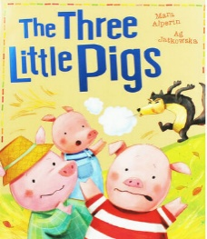 |  | STORM WHALE  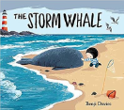 |  | Izzy Gizmo and the Invention Convention 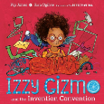 |  | MEERKAT MAIL  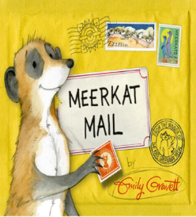 |  | WANGARI’S TREES OF PEACE  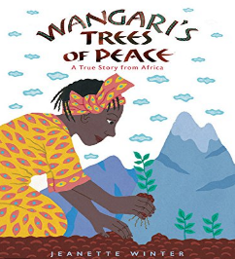 |  | CLEAN UP  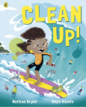
MATHS | Numbers to 10, Number bonds, Addition within 10 |  | Subtraction within 10, Positions, Numbers to 20 |  | Addition and subtraction within 20, Shapes and Patterns, Length and Height |  | Numbers to 40, Addition and subtraction word problems, Multiplication |  | Division, Fractions, Numbers to 100  Time |  | Money, Volume and capacity, Mass, Space
SCIENCE | Everyday Materials  Charles Mcintosh  (1766 – 1843)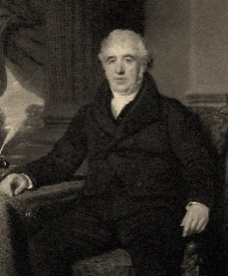 |  | Seasonal Changes  Christopher Wren  (1632-1723)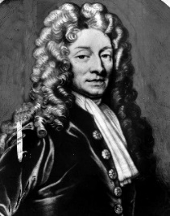 |  | Everyday Materials  Ole Kirk Christiansen  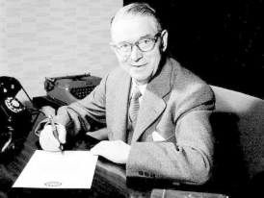 |  | Animals including Humans  Joan Procter  (1897 – 1931)  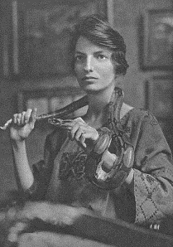 |  |  |  | Plants  Wangari Maathai (1940-2011)  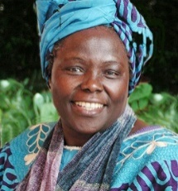
SCIENCE | Seasonal Changes
HISTORY | The history of toys and comparing ones of the past to now. |  |  |  | Significant historical people and places in their own locality |  |  |  |  |  | Seaside holidays 100 years ago
GEOGRAPHY | Our School and Local Area: Where do we live? |  | Weather and Seasonal Changes: How does the weather change throughout the year? |  | Mapping Skills  Local Area: How do we read maps and plan routes? |  | The World: What are continents and oceans and where are they located? |  | Africa: Kenya  What is it like to live in Kenya compared to where we live? |  | Coasts: What are coasts like and how are they different from were we live?
COMPUTING | Online Safety |  | Creating Media: Digital Painting |  | Programming: Moving a Robot |  | Data and Information: Grouping Data |  | Creating Media: Digital Writing |  | Programming: Programming Animations
ART AND DESIGN | Collage  Eric Carle |  |  |  | Painting  Pier Mondrian  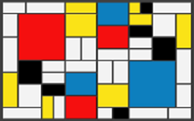 |  | Drawing  Beatrix Potter  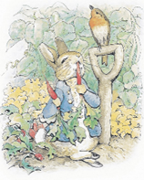 |  | Printing  Estha Mahlangu  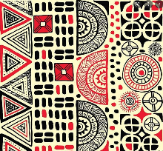
DESIGN AND TECHNOLOGY |  |  | Mechanisms  Design and build a toy (Jack in the box / rabbit in hat |  |  |  | Food Technology  Fruit Kebabs  (Africa Link) |  |  |  | Textiles  Hats
MUSIC | Nursery rhymes & Environmental Sounds |  | Christmas play singing |  | Create a short musical composition using words |  | Compose a piece of music with one layer |  | Exploring African instruments |  | Create musical sound effects and sequences of sound in response to a seaside stimulus
PHYSICAL EDUCATION | Invasion games |  | Dance |  | Gymnastics |  | Net and Wall |  | Athletics |  | Striking and Fielding
RELIGIONS AND WORLD VIEWS |  |  | Christianity: What do Christians believe about God?  What can we learn from Creation stories? |  |  |  |  |  | Islam: What is Islam? |  | Judaism: What does it mean to be a member of the Jewish community?
SPANISH | ¡Hola a todos! |  | Mi país |  | Mi cumpleaños |  | Mi mascota |  | La sorpresa de Nandi |  | De la cabeza a los pies
P.S.H.E.  RSE  (Inc. LGBTQ+ and Consent)  British Values | My Healthy Self: How can we look after our emotions?  Individual Liberty |  | Connecting with Others: How can I help myself and others feel happy and safe?  Mutual Respect |  | The Online World: How do we spend time online?  Tolerance |  | Citizenship: How can I help others and the environment?  Rule of Law |  | Health Protection: How can I protect myself and others in daily life?  Democracy |  | Staying Safe: How can I stay safe?  Individual Liberty
CHILDREN`S RIGHTS | Article 27  Adequate standard of living.   |  |  |  | Article 13  Freedom of expression   |  |  |  | Article 12  Respect for views of the child.  
SDGS | SDG3  Good Health and Wellbeing   |  |  |  | SDG15  Life on Land  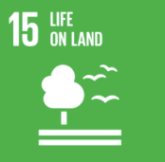 |  |  |  | SDG14  Life Below Water  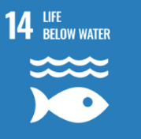
EDUCATIONAL VISITS AND VISITORS |  |  | Christmas Experience at Knutsford Methodist Church |  | Tatton Park History |  | Animal Takeover - workshop |  |  |  | Trip to Warrington Art Gallery and Museum Seaside Holidays Workshop

