Year 2 Australasia and Oceania
2026-27 | Autumn 1  SCIENCE |  | Autumn 2  GEOGRAPHY |  | Spring 1  HISTORY |  | Spring 2  GEOGRAPHY |  | Summer 1  HISTORY |  | Summer 2  SCIENCE
THEME | FIGHTING FIT! |  | POLAR REGIONS |  | FIRE, FIRE! |  | LET`S EXPLORE LONDON |  | FLORENCE NIGHTINGALE & MARY SEACOLE |  | GO WILD!
Five Enquiry Questions | - Do you eat a balanced and healthy diet in a week?  - What makes a balanced diet?  - Which offspring belongs to each animal?  - Do longer legs make you a faster runner?  - What do animals and humans need to survive? |  | - Where are the polar regions and how are they changing?  - What is the weather like in the polar regions?  - What would it be like to live in the polar regions?  - How is the Arctic and Antarctica changing and why?  - Why is it important that we care for our polar regions? |  | - How did the Great Fire start?  - What happened during the great fire?  - How do we know what happened during the great fire?  - Why did the fire spread so quickly?  - How should we re-build houses to stop the great fire happening again? |  | - Where is London and why is it an important city in the United Kingdom?  - What human and physical features can we see in London?  - How is London different from our local area (Knutsford)?  - How do people travel around London and why is transport important?  - What makes London a place that people from all over the world visit? |  | - Who was Florence Nightingale?  - What did Florence do to improve the lives of soldiers?  - Why did she put herself in danger by going to the Crimea?  - Who was Mary Seacole and what was her biggest achievement?  - Why do people remember so much of Florence Nightingale and so little of Mary Seacole? |  | - How would you group these things to show whether they are living, dead or never been alive?  - What conditions will help me grow the healthiest plant?  - What happens to my bean after I have planted it?  - How do animals adapt to suit their environment?  - Do animals need each other to survive? (Food chains)
ENGLISH  TEXT | Troll Swap  by L Hodkinson |  | The Dragon Machine  by H. Ward |  | The Great Fire of London  by E. Adams |  | Major Glad, Major Dizzy  by J. Oke |  | Tidy  by E. Gravett |  | The Tempest
ENGLISH  WRITING | Description  Diary Entry  F | Story with character focus  F | Letter NF  Character Description F | Leaflet NF Adventure Story F | Description F  Instruction NF | Eyewitness Report NF  Fact Sheet NF | Letter NF  Poems | Recount: Diary Entry F | Instruction NF | Persuasive Letter NF | Character Description F  Poem | Retell of a story F
CLASS NOVEL | 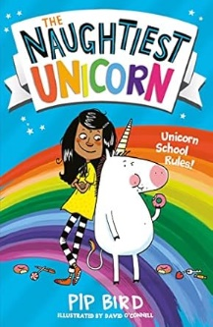  The Naughtiest Unicorn |  | The Christmasaurus  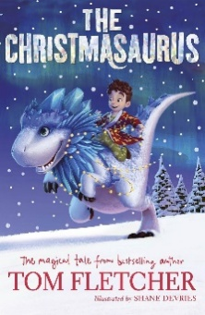 |  | 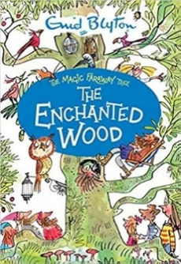  The Enchanted Wood |  | 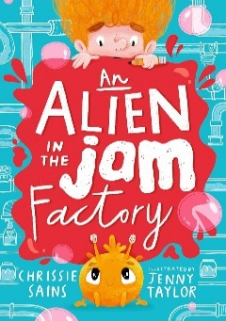  An Alien in the Jam Factory |  | George’s Marvellous Medicines  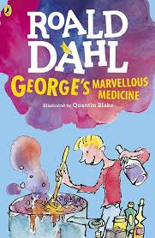 |  | Einstein the Penguin  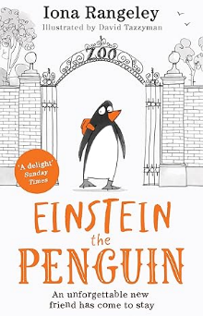
MATHS | Numbers to 100  Addition & Subtraction |  | Multiplication & Division of 2,5 & 10, Length & Mass |  | Temperature  Picture Graphs  Money |  | 2D Shapes  3D Shapes  Fractions |  | Fractions  Time  Volume |  | Re-Cap of the Year
SCIENCE | Animals including humans  Louis Pasteur  (1822-1895)  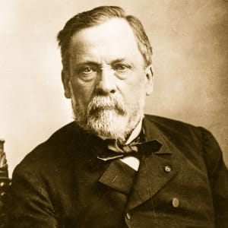 |  |  |  | Everyday Materials  John Loudon McAdam  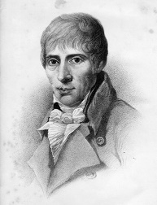  (1756-1836) |  |  |  | Living Things and their Habitats  Plants  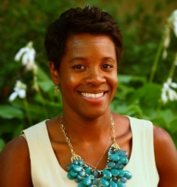  Dr Alexandra Harmon Threat
HISTORY |  |  |  |  | Great Fire of London |  |  |  | Florence Nightingale & Mary Seacole
GEOGRAPHY | Magical Mapping |  | Polar Regions |  | United Kingdom |  | Let’s Explore London! |  | Compare Sydney and London |  | Fieldwork Local Area
COMPUTING | Computer systems and networks – IT around us |  | Creating media – Digital Photography |  | Programming |  | Data and Information - Pictograms |  | Creating media - Music |  | Programming
ART |  |  | Drawing  Picasso  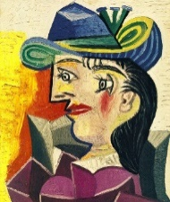 |  | Painting  Paul Klee  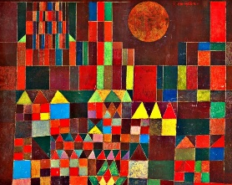 |  |  |  | Sculpture  Aboriginal Art (Australia)  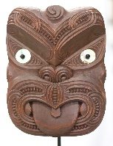
DESIGN TECHNOLOGY | Food Technology  Healthy Sandwiches  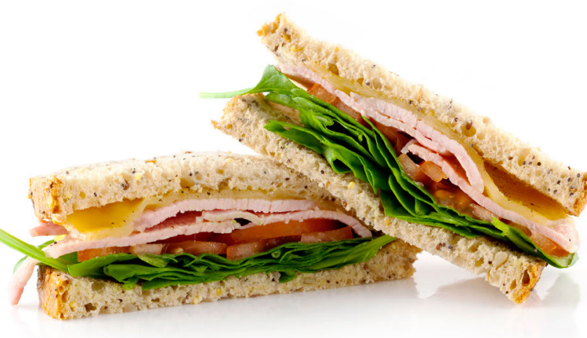 |  |  |  |  |  | Mechanisms  Building a Car  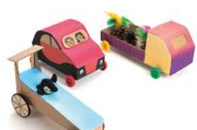 |  |  |  | Textiles  Puppets Sewing  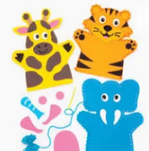
MUSIC | I.D: Pulse, Pitch & Tempo |  | Christmas Production Singing |  | I.D.: Dynamics, Timbre & Rhythm |  | Thematic Singing & Composing  Listening to compositions |  | Recorders |  | Recorders
PHYSICAL EDUCATION | Invasion Games |  | Dance |  | Gymnastics |  | Net and Wall |  | Athletics |  | Striking and Fielding
RELIGIONS AND WORLD VIEWS | Christianity: What is the place of the Church in Christianity?  Sacred Scriptures |  |  |  | Hinduism: What does it mean to be a Hindu?  Sacred Scriptures |  |  |  | Buddhism: What is Buddhism?  Sacred Scriptures
SPANISH | La oruga muy hambrienta |  | Vamos a cazar un oso |  | El monstruo de colores |  | Los piratas |  | En mi estuche |  | Querido Zoo
P.S.H.E.  RSE  (Inc. LGBTQ+ and Consent)  British Values | My Healthy Self : How can we look after our bodies?  Mutual Respect |  | Connecting with others: How can I build safe, kind and caring relationships with others?  Tolerance |  | The online world: How can I stay safe online?  Tolerance |  | Citizenship: How do people belong to a community and earn money?  Rule of Law |  | Growing up: How can we look after and respect our bodies as we grow?  Democracy |  | Staying safe: How can I make safe choices in different places?  Individual Liberty
CHILDREN`S RIGHTS  (link with Jigsaw units) | Article 15  Setting Up or Joining Groups   |  |  |  | Article 24  Health, Water, Food, Environment  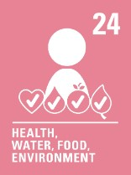 |  |  |  | Article 42  Everyone Must Know Children’s Rights  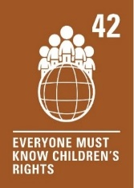
SDGs | SDG 3  Good Health and Well Being  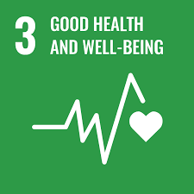 |  |  |  | SDG 13  Climate Action  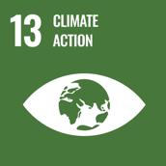 |  |  |  | SDG 5  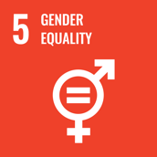  Gender Equality
EDUCATIONAL VISITS AND VISITORS |  |  | Christmas Play |  | The Great Fire of London: Visit to Weaver Hall |  |  |  | Residential to Burwardsley

