Year 3 Europe
2026/27 | Autumn 1  HISTORY | Autumn 2  SCIENCE | Spring 1  HISTORY | Spring 2  GEOGRAPHY | Summer 1  GEOGRAPHY | Summer 2  SCIENCE
THEME | TRIBAL TALES | THE IRON MAN: Forces | LOCAL HISTORY | EUROPE: SPAIN | RIVERS | PLANTS OF THE WORLD
Five Enquiry Questions | - Was Stone Age man simply a hunter gatherer, concerned only with survival?  - What were the biggest changes that developed during the New Stone Age?  - What was it like to live in the Bronze an Iron Age?  - What were the main changes between the Stone and Bronze Age?  - What were the main changes between the Bronze and Iron Age? | 1. .What forces can I see around me in my classroom?  2. Which surface is best to stop you slipping?  3. Which materials are magnetic?  4. Does the size and shape of a magnet affect how strong it is?  5. How does a compass work? | 1. Why did Cheshire become famous for its salt industry?  2. What was life and work like for people in Cheshire’s salt industry?  3. How did Cheshire salt travel from our local area to the rest of the world?  4. How did the salt industry change Cheshire and the wider world?  5. How do we know about Cheshire’s salt-making past? | - Where are Madrid and London, and where are they in relation to the rest of Europe?  - What are the physical and human features of Madrid and London?  - How are Madrid and London similar and different?  - How does the climate of Madrid compare with the climate of London?  - How do people live, work and travel in Madrid and London? | 1. Where do rivers begin and where do they end?  2. What animals and plants live in and around rivers?  3. Why are rivers important to people and the land?  4. How do rivers change as they flow from the mountains to the sea?  5. What happens if we pollute a river, and how can we protect it? | 1. What can we learn about plants from their parts?  2.Does every part of a plant have a job? What would happen without one of the parts?  3. Do plants need oxygen, light and water to grow or can they survive without one?  4. How do plants ‘move’? (seed dispersal)  - 5. Why do different places in the world have different plants?
Key subject driver and National Curriculum statements | HISTORY  Changes in Britain from the Stone Age to the Iron Age | SCIENCE  Forces and Magnets | HISTORY  A local history study | GEOGRAPHY  Europe | GEOGRAPHY  Rivers | SCIENCE  Plants
ENGLISH  text | Coming to England  By Floella Benjamin  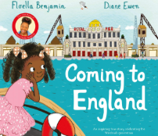 | Winter’s Child  By Angela McAllister  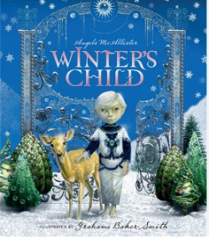 | Fossil Girl  By Catherine Brighton  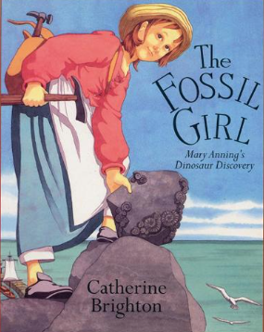 | Big Blue Whale  By Nicola Davies  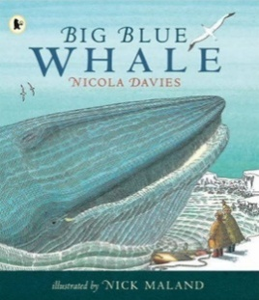 | Amazing Rivers  By julie vosburgh agnone  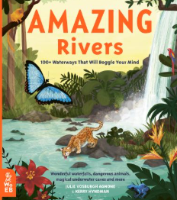 | Merchant of Venice  By Angela McAllister  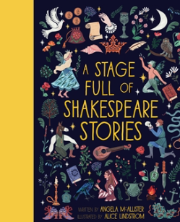
ENGLISH  writing | Letter writing  F | Fantasy story  F | Diary Entry  F | Persuasion leaflet  NF | Adventure Story  F | Persuasion leaflet  NF
Class Novel | THE WILD WAY HOME  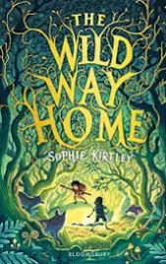 | THE IRON MAN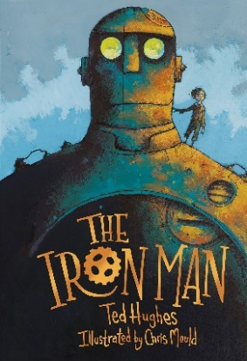 | CHARLOTT’S WEB  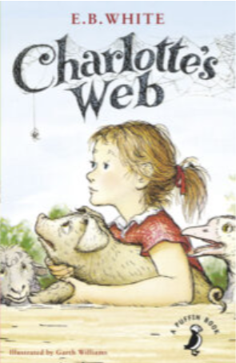 | THE BOY WHO GREW DRAGONS  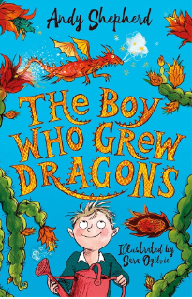 | THE RIVER SINGERS  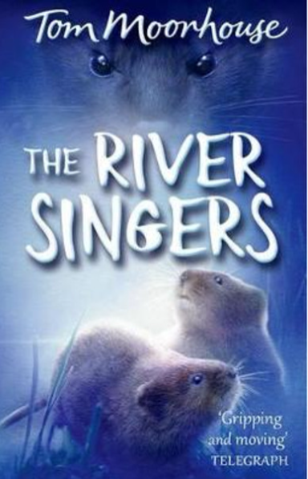 | THE TIME TRAVELLING CAT  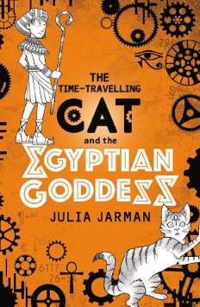
MATHS | Place Value, Addition and Subtraction, Multiplication and Division | Multiplication and Division  Further Multiplication and Division | Length, Mass, Volume | Money, Time, Graphs | Fractions | Angles, Lines and Shapes,  Perimeter
SCIENCE | Animals including Humans  Wilhelm Conrad Rontgen  (1845-1923)  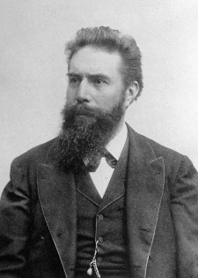 | Forces and magnets  William Gilbert/ Nikola Tesla/ Hans Christian Ørsted  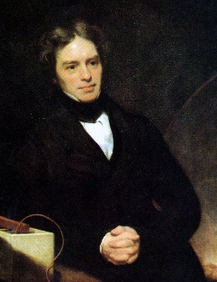 | Rocks  Mary Anning  (1799-1847)  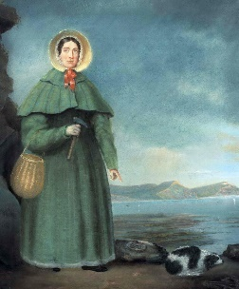 | Light  Joseph swan and Thomas Edison  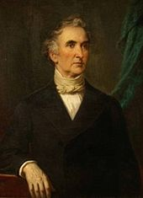 | Plants  Kiara Nirghin  
HISTORY | Study of the Stone Age to Iron Age |  | Cheshire Salt Mines (Local History) |  | Ancient Egypt
GEOGRAPHY  (Including Fieldwork) | Land use: How diverse are local and UK landscapes? |  | Europe: How diverse are its landscapes and places? | Spain  Comparing and contrasting Madrid and London | Rivers  How are rivers formed? | Biomes
COMPUTING | Computing systems | Creating Media A | Programming A | Data and Information | Creating Media B | Programming B
ART and DESIGN | Drawing  Lascaux cave drawings  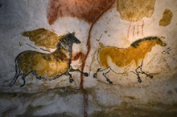 |  | Printing  Orla Kiely   | Collage  Antoni Gaudi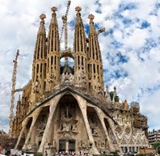 |  | Painting  Georgia O’Keefe  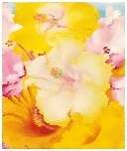
DESIGN and TECHNOLOGY |  | Pneumatics  Monster Machines | Food technology  Healthy Pizzas |  | Textiles  Bunting
MUSIC | Stone Age Composing  Love Music Trust: Stoneage | Christmas Singing | Recorders:  Jazz Genre 1920’s – 1940’s  Frank Sinatra, Nat King Cole, Tony Bennett, Michael Buble | Recorders  Jazz Genre 1920’s – 1940’s  Frank Sinatra, Nat King Cole, Tony Bennett, Michael Buble | Cultural: Spanish Traditional Music | Biome Orchestra
PHYSICAL EDUCATION | Invasion Games | Dance | Gymnastics | Net and Wall | Swimming  Athletics | Swimming  Striking and Fielding
RELIGIONS AND WORLD VIEWS | Judaism: Why are festivals, celebrations and High Holy Days so important within Judaism?  Symbols |  | Sikhism: What does Sikhism teach us about selfless service?  Symbols | Christianity: What is the significance of Easter within Christianity?  Symbols |  | Humanism: What is Humanism and what do Humanists believe?  Symbols
SPANISH | Meet and Great | My Body | My Home | My World | All About School | Spain
P.S.H.E.  RSE  (Inc. LGBTQ+ and Consent)  British Values | My healthy self: How can I take care of my mind and body?  Mutual Respect | Connecting with others: What helps us feel safe and included?  Individual Liberty | The online world: How should we communicate online?  Individual Liberty | Citizenship: What rights and responsibilities do we have?  Rule of Law | Health protection: How can we prevent illness and injury and respond if they happen?  Democracy | Citizenship: What careers do people choose and why?  Individual Liberty
CHILDREN`S RIGHTS |   Article 8  Identity |  | Article 12  Respecting viewpoints   |  | Article 29  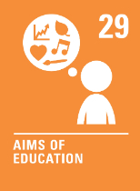  Goals of education
SDGs | SDG 4  Quality Education  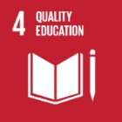 |  | SDG 15  Life on Land  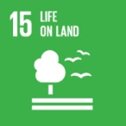 |  | SDG 5  Gender Equality  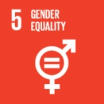
EDUCATIONAL VISITS AND VISITORS | Trips/Visits: Stone Age Workshop |  | Trips/Visits: Pizza Express |  | Trips/Visits: Mr Egypt workshop  Textiles workshop

