Year 4 Asia
2026/27 | Autumn 1  HISTORY |  | Autumn 2  GEOGRAPHY |  | Spring 1  SCIENCE |  | Spring 2  GEOGRAPHY |  | Summer 1  HISTORY |  | Summer 2  SCIENCE
THEME | ROMAN BRITAIN |  | LOCAL AREA |  | STATE OF MATTER |  | INDIA |  | INDUS VALLEY |  | SOUND
Five Enquiry Questions | - Was the Roman army really as Powerful as History suggests?  - Why did the Roman’s want to invade Britain when they were already so successful?  - Did the Celts try to resist the Roman invasion?  - Did the Romans have an impact on Britain during the Roman era and in today’s modern world?  - What was life like in the North West during Roman times? |  | - What is our local area like, and what would we like to change?  - How can we use maps and fieldwork to investigate our local area?  - How can we collect and record accurate data about our local area?  - What does our fieldwork data tell us about what needs changing?  - How could we improve our local area based on our fieldwork findings? |  | - What are solids, liquids and gases, and how are they different?  - How are the particles arranged in solids, liquids and gases?  - What happens to materials when they are heated or cooled?  - How can water change from one state of matter to another?  - Why do some materials change state more easily than others? |  | - What is the climate in India?  - What geographical features could I find in India that I wouldn’t have seen before?  - What are the major rivers in India?  - Why is the population of India more than 20 times bigger than the United Kingdom?  - What is daily life like in India? |  | - How does the Indus Valley civilisation achievements compare to other civilisations?  - What did archaeologists discover about Indus Valley settlements?  - What was everyday life like in the Indus Valley?  - What has been found from the Indus Valley?  - Why were many Indus cities abandoned? |  | - What is it inside my ears that allow me to hear sound?  - How does sound travel from an object to my ear?  - What can stop us from hearing sounds?  - Why does a bell feel like its buzzing when it rings?  - Why does my friend in the distance sound so quiet when I know he’s shouting so loudly?
Key subject driver and National Curriculum statements | HISTORY  The Roman Empire and its impact on Britain. |  | GEOGRAPHY  Local Area |  | SCIENCE  State of matter |  | GEOGRAPHY  Study of India |  | HISTORY  An in- depth study of the  Indus Valley |  | SCIENCE  Sound.
ENGLISH  TEXT | Gorilla  By A. Brown  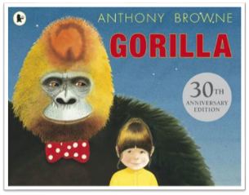 |  | Leon and The Place Between  By A. McAllister  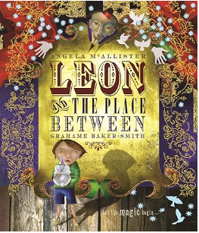 |  | Escape from Pompeii  By Christina Balit  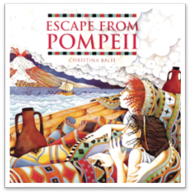 |  | Wisp  By Zara Fraillon  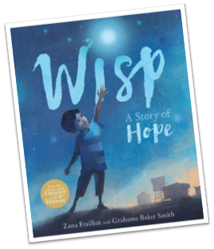 |  | Alba the one hundred year old fish  By Lara Hawthorn  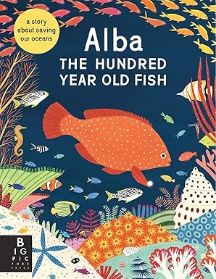 |  | Julius Caesar – by William Shakespeare​  Edited by Angela McAllister​  A Stage Full of Shakespeare Stories  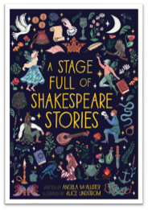
ENGLISH  PATHWAYS | Fact file NF  Diary F  3rd person story F | Fantasy Story F | Character & setting descriptions F  1st person account F | Recount Diary F | Diary F Explanatory Letters NF  Story with dialogue F | Historical Narrative F | Setting & character descriptions F  Poetry F  Diary F | Story with Dialogue F | Information text NF  Voiceover NF | Non-Chronological Report NF | Diary F  Recount NF  Formal letter NF | Playscript F
Class Novel | CALL ME LION  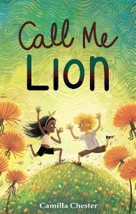 |  | THE WILD ROBOT  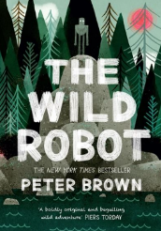 |  | TIGER BOY  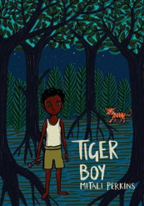 |  | ASHA AND THE SPIRIT BIRD  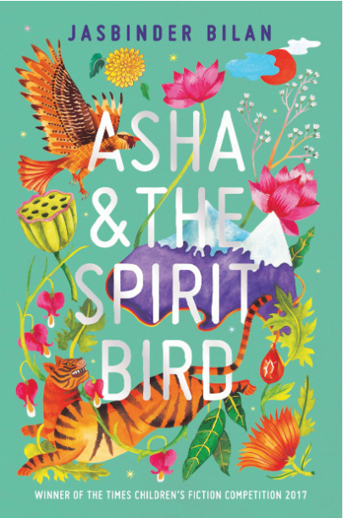 |  | FIREWORK MAKER’S DAUGHTER  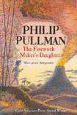 |  | SAM WU IS NOT AFRAID OF GHOSTS  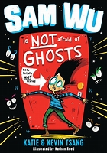
MATHS | Numbers to 10,000, Addition and subtraction within 10,000 |  | Multiplication and Division, Further Multiplication and Division |  | Further Multiplication and Division (Continued), Graphs, Fractions |  | Time, Decimals |  | Money, Mass, Volume and Length, Area of Figures |  | Geometry, Position and Movement, Roman Numerals
SCIENCE | Animals including humans  William Beaumont  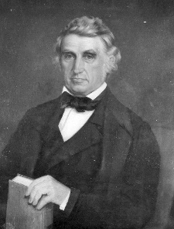  (1785-1853) |  | Electricity  Thomas Edison  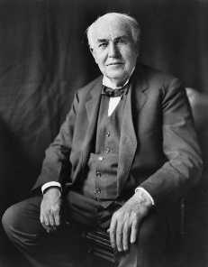  (1847-1931) |  | States of matter  Bernard Palissy  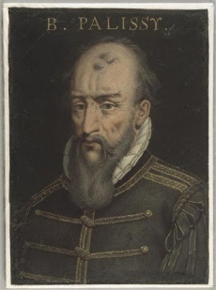  (1510-1590) |  |  |  | Living things and their habitats  Jane Goodall  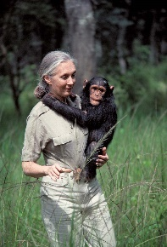  (Born 1934) |  | Sound  Christian Doppler  (1803-1853)  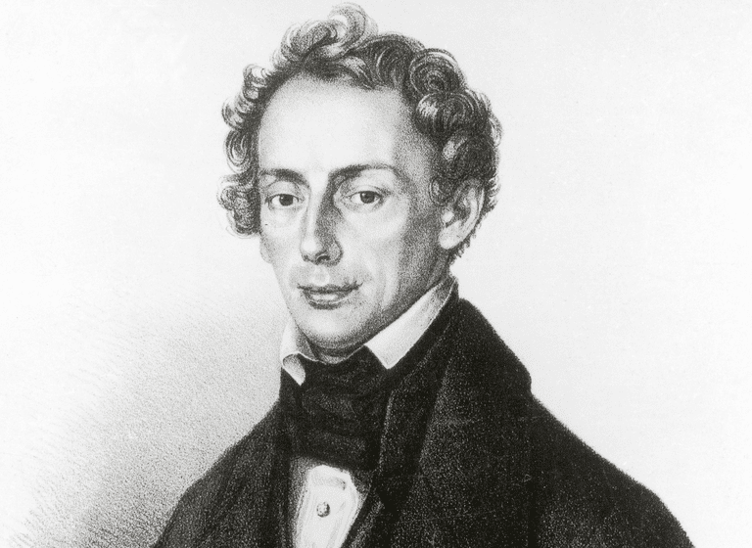
HISTORY | Roman Britain |  |  |  |  |  |  |  | The Indus Valley
GEOGRAPHY | Somewhere to Settle  Why do people choose to settle in different places? |  | Local Area: What needs changing?  Fieldwork |  |  |  | Asia: India  How do India's diverse landscapes and climates affect the way people live and work? |  |  |  | Earning a living  How do people around the world earn a living?
COMPUTING | Computing systems and network |  | Creating Media- Audio Production |  | Programming – Repetition in Shapes |  | Data and Information – Data Logging |  | Creating Media – Photo Editing |  | Programming – Repetition in Games
ART | Textiles  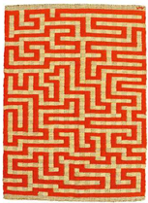  Anni Albers |  |  |  | Drawing  Morton Wayne Thiebaud  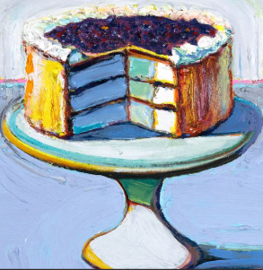 |  | Sculpture  Antony Gormley  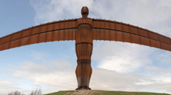 |  | Painting  Katsushika Hokusai  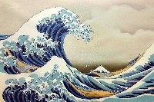
DESIGN TECHNOLOGY |  |  | Electrical Systems  Christmas decorations |  |  |  |  |  | Food Technology  Food of India  (Asia Link) |  | Mechanisms (Levers & Linkages)Pop-Up/Slider Books
MUSIC | Holst’s Planets  Roman Soldier Battle Compositions |  | Christmas Singing |  | Composing with digital devices  Rock ‘n’ Roll 1950’s  Elvis Presley, Bill Haley |  |  |  | Music from different traditions  Cultural: Asian music (Focus:- Indian)
PHYSICAL EDUCATION | Invasion Games |  | Dance |  | Gymnastics  Swimming |  | Net and Wall  Swimming |  | Athletics |  | Striking and Fielding
RELIGIOUS EDUCATION |  |  | Buddhism: What does it mean to follow the Buddha?  Significant figures |  |  |  | Hinduism: What do sacred texts within Hinduism say about God?  Significant figures |  | Islam: What do Muslims believe?  Significant figures
SPANISH | The People Around Me |  | Describing Dragons |  | Time to Eat |  | Tell Me When |  | The Wider World |  | Free Time
P.S.H.E.  RSE  (Inc. LGBTQ+ and Consent)  British Values | My healthy self: How can I make healthy choices?  Individual Liberty |  | Connecting with others: How can we respect each other?  Mutual Respect |  | The online world: How can we decide what to trust online?  Tolerance |  | Citizenship: How can I spend money responsibly?  Rule of Law |  | Growing up: How will my body and emotions change as I grow up?  Democracy |  | Staying safe: What signs help me recognise what is safe or unsafe?  Individual Liberty
CHILDREN`S RIGHTS | Article 17  You have the right to get information  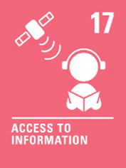 |  |  |  |   Article 15You have the right to set up or join a group |  |  |  | Article 28  You have the right to education  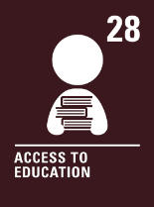
SDGs | 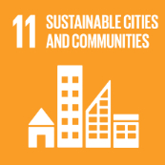  SDG 11 |  |  |  | SDG 6  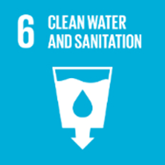 |  |  |  | SDG 8  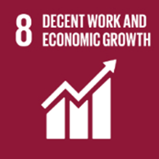
EDUCATIONAL VISITS AND VISITORS | DEVA Roman Centre trip to Chester  Church visit: Harvest Experience |  |  |  | STEM: DOME EXPLORER |  |  |  | Indus Valley Performance

