Year 5 North America
2026/27 | Autumn 1  HISTORY |  | Autumn 2  HISTORY | Spring 1  GEOGRAPHY | Spring 2  GEOGRAPHY | Summer 1  HISTORY | Summer 2  SCIENCE
THEME | ANGLO SAXONS |  | VIKINGS | VOLCANOES AND EARTHQUAKES |  | THE ANCIENT MAYAN | EARTH AND SPACE
Five Enquiry Questions | - What was life like in Britannia at the end of the 4th century?  - How did life change in England after the fall of the Roman Empire?  - Why did the Angles, Saxons and Jutes settle in Britain?  - Were the Anglo-Saxons pulled to Britain or pushed away from their homelands?  - How was Anglo-Saxon Britain Ruled? |  | - How did the Anglo-Saxons Keep Control of their Kingdom?  - Were there any changes in religion and power once the Anglo-Saxons had settled?  - Who were the Vikings?  - Why did the Vikings carry out raids?  - Where did the Vikings settle and how do we know?  - How were Anglo-Saxons and Vikings different? | - What is inside the Earth?  - What are tectonic plates and how do they move?  - Why does the Earth have volcanoes and earthquakes?  - What happens when tectonic plates move?  - Where are the world's volcanoes and earthquakes found?  - Why do volcanoes and earthquakes happen in particular places?  - What happens during a volcanic eruption?  - What happens during an earthquake?  - How do volcanoes and earthquakes affect people and the environment?  - How can people prepare for and respond to volcanic eruptions and earthquakes? |  | - Why did the Maya empire grow when so much of the land they lived in was mountain and jungle?  - What was life like for the rich and poor at the height of the Mayan civilisation?  - Why were the Maya seen as inventors?  - Did the Mayans leave a lasting legacy?  - Why did the Maya civilisation collapse? | - How do the Earth, Moon and other planets move?  - What are Moon phases?  - What is a Solar System and how is it formed?  - How does day and night work?  - Why are the planets different to each other?  - What is space exploration and what is it like to live and work in space?
Key subject driver and National Curriculum statements | HISTORY  A study of the Anglo-Saxons and Vikings in Britain and their struggle for power. |  | HISTORY  A study of the Anglo-Saxons and Vikings in Britain and their struggle for power. | GEOGRAPHY  Describe and understand key aspects of physical geography, including volcanoes and earthquakes. | GEOGRAPHY  Use maps, atlases, globes and digital mapping to locate tectonic plate boundaries, major volcanoes and earthquake zones. | HISTORY  The achievements of the earliest civilizations. | SCIENCE  Earth and Space.
ENGLISH  TEXT | Queen of the Falls  by Chris Van Allsburg |  | Beowulf  by Michael Morpurgo | Arthur and the Golden Rope  by Joe Todd-Stanton | The Darkest Dark  by Chris Hadfield | The Paperbag Prince  by Colin Thompson | Bold and Brave Women from Shakespeare  by Shakespeare Birthplace Trust
ENGLISH WRITNG | Diary |  | Legend Adventure Story | Myths | Biography | Persuasive Information Poster | Recount Monologue
CLASS NOVEL | The Boy in the Tower  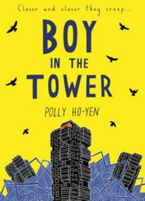  Science Fiction | LOKI  Diary  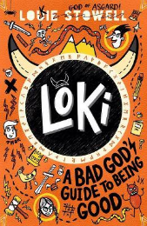 |  | The Girl Who Speaks Bear  Adventure  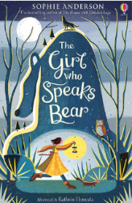 | 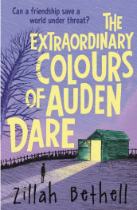  The Extraordinary Colours of Auden Dare | BEETLE BOY  Realistic Fiction  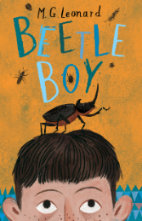 | Malamander  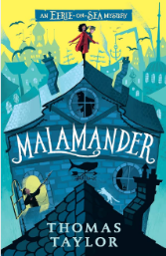  Fantasy Fiction
MATHS | Number and Place Value, Addition and Subtraction | Multiplication and Division, Word problems, Statistics |  | Fractions, Decimals and Percentages | Position and Direction, Area and Perimeter | Fractions, Decimals and Percentages, Shapes | Volume, Roman Numerals, Review and Revision
SCIENCE | Properties and changes of materials |  |  | Living things & their Habitats  David Attenborough  (born 1926 – Present)  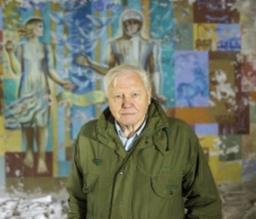 | Animals including humans Sarah Fowler  (born 1987 – Present) 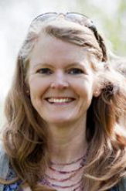 | Forces  Galileo Galilei  1564-1642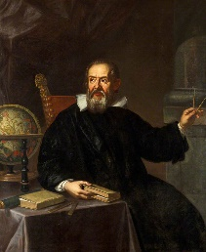 | Earth and Space  Nicolas Copernicus  (1473-1543) 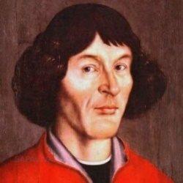
SCIENCE | Spencer Si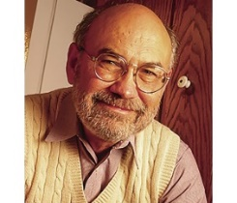lver  (born 1941- Present) | Stephanie Kwolek  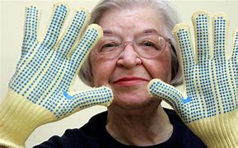  1923-2014
HISTORY | Life in Britain during the times of the Anglo-Saxons and Vikings. |  |  |  |  | Mayans
GEOGRAPHY | Natural Resources | Coasts |  | Volcanoes and Earthquakes  Pensarn Residential |  | North America: Mexico
COMPUTING |  | Creating Media; Video Production |  | Programming A – Selection in Physical Computing | Data and Information – Flat-File Databases | Creating Media – Introduction to Vector Graphics | Programming B – Selection in Quizzes
  Computing Systems
  and Networks
ART | Collage  Kurt Schwitters / Hannah Hoch  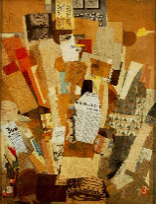 |  |  | Painting  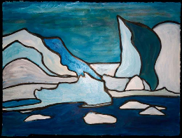  Nerys Levy | Printing  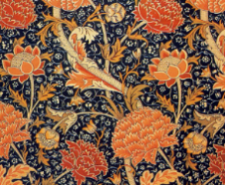  William Morris | Drawing  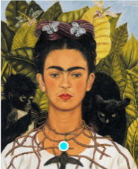  Frida Kahlo
DESIGN TECHNOLOGY |  | Textiles  Stockings |  |  |  | Food technology  Fajitas (Mexico) | Lego Workshop  (Pulleys and Levers)
MUSIC | Improvisation & Composition  Love Music Trust: Improvising Colours | Singing  Mo-Town 1960’s Stevie Wonder, Supremes, The Temptations |  | Wider Opportunities: Love Music Trust | Wider Opportunities: Love Music Trust  Cultural: Mexico | Wider Opportunities: Love Music Trust | Wider Opportunities: Love Music Trust  Composers: Romantic: Tchaikovsky
PHYSICAL EDUCATION | Swimming | Swimming |  | Gymnastics | Athletics | Net and Wall | Striking and fielding
RELIGIONS AND WORLD VIEWS | Buddhism:  What does Buddhism teach us about human experience? |  |  | Hinduism:  What place do festivals, worship and celebrations have within Hinduism? |  | Islam:  What does it mean to be a Muslim?
SPANISH | All About Me | Going Shopping |  | My Clothes | My Routine | My Emotions | The Solar System
P.S.H.E.  RSE  (Inc. LGBTQ+ and Consent)  British Values | Being Me in My World  'Who am I and how do I fit?'  Individual Liberty | Celebrating Difference  Respect for similarity and difference. Anti-bullying and being unique.  Mutual Respect |  | Dreams and Goals  Aspirations, how to achieve goals and understanding the emotions that go with this  Tolerance | Relationships  Building positive, healthy relationships  Democracy | Healthy Me  Being and keeping safe and healthy  Rule of Law | Changing Me  Coping positively with change  Individual Liberty
CHILDREN`S RIGHTS | Article 8  Identity   |  |  | Article 29  Aims of Education  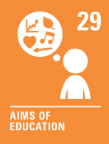 |  | Article 6  Life survival and development  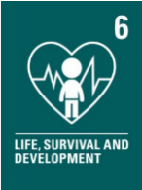
SDGs | SDG 12  Responsible consumption and production  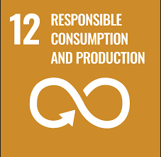 |  |  | SDG 13  Climate Action  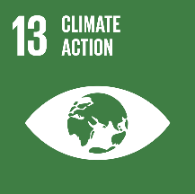 |  | SDG 7  Affordable Clean Energy  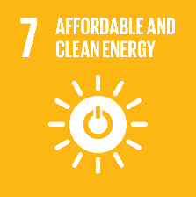
EDUCATIONAL VISITS AND VISITORS | Visitor – Viking Workshop |  |  |  | Pensarn residential | Visit to Bridgewater Hall (Halle orchestra)/Music Showcase LMT | Lego Workshop

