Year 6 South America
2026/27 | Autumn 1  HISTORY |  | Autumn 2  SCIENCE |  | Spring 1  GEOGRAPHY |  | Spring 2  SCIENCE |  | Summer 1  HISTORY |  | Summer 2  HISTORY
THEME | INDUSTRIAL REVOLUTION |  | HEART BEATERS |  | ANTARCTICA |  | EVOLUTION AND INHERITANCE |  | KEEPING HEALTHY OVER TIME
Enquiry Questions | - What were the main changes that took place during this time?  - Why is it so difficult to find out what factory conditions were really like?  - How did town life compare to life in the countryside at this time?  - What were the main changes in transport and did everyone benefit?  - How did the Industrial Revolution affect children and their role in society? |  | - How does a heart work?  - How does our circulatory system keep us alive?  - What do we need to keep our body healthy?  - What affects our heart rate?  - How do diets vary around the world? |  | - What are the features of Antarctica?  - Why is Antarctica called a desert? What are the features of its climate?  - What can we learn about time zones and hours of daylight in Antarctica?  - What features will I include in a scale map of Antarctica?  - How is Antarctica changing and how do we know?  - What impact are humans having on Antarctica? |  | - What evidence is there that living things have changed over time?  - What is inheritance, and how do offspring vary from their parents?  - How do animals adapt to their environments?  - How does the fossil record help us understand evolution?  - What can we learn from the work of Darwin and Anning? |  | - What does the Black Death of 1348 tell us about people’s knowledge of health 700 years ago?  - How much more did they know about keeping healthy by the time of the Great Plague of 1665?  - Why did such huge changes in people’s health suddenly take place about 200 years ago?  - Which were the biggest breakthroughs in people’s health in the 19th century?  - Has everyone become healthier in the last 100 years?  - When was the best time to live in terms of keeping heathy? What would the dates of your preferred lifespan of 80 years be?
ENGLISH  TEXT | King Kong  By A. Brown  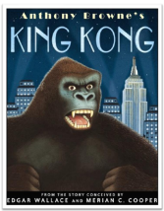 |  | Can we save the tiger?  By M. Jenkins  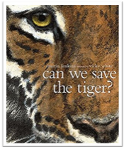 |  | Shackleton Journey  By William Grill  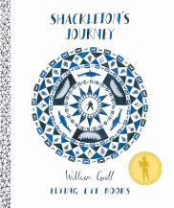 |  | Island by J. Chin  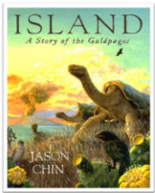 |  | 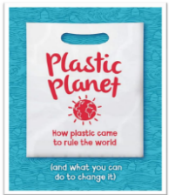  Plastic Planet |  | Poetry for Kids by W. Shakespeare  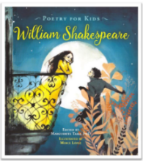
ENGLISH  WRITING | Description F  Diary Entry F | Letter NF  Story Ending | Explanation NF  Non-chron.NF | Persuasive Letter NF | Letter F  Fact File NF | Diary F  Journal | Field Log  Journalistic Report NF | News Report  Description F  Story F | Letter NF  Information Text NF | Speech NF | Biography NF  Poems F | Sonnet F
CLASS NOVEL | STREET CHILD  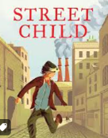 |  | PIG HEART BOY  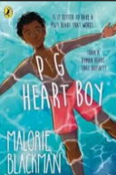 |  | BRIGHTSTORM  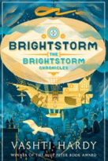 |  | DARWIN’S DRAGONS  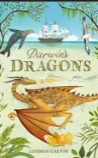 |  | 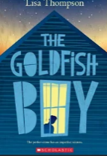  THE GOLDFISH BOY |  | 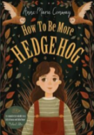  HOW TO BE MORE HEDGEHOG
MATHS | Place Value, Four operations |  | Decimals, Fractions, Measurements, |  | Ratio, Geometry, Area and Perimeter, Position and Movement |  | Graphs and Averages, Negative Numbers, Algebra |  | Volume, Revision |  | Revision, Problem Solving Investigations
SCIENCE | Living things and their habitats  Carl Linnaeus  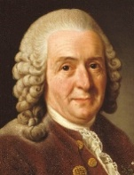  Wangari Maathai (Kenya) — environmentalist and plant biologist who promoted biodiversity |  | Animals including humans  William Harvey  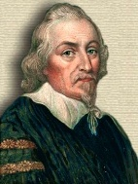  Dr. Daniel Hale Williams (USA) — African-American surgeon who performed first successful open-heart surgery |  | Electricity  Nicholas Tesla  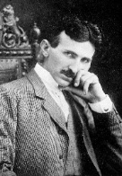  Granville T. Woods (USA) — African-American inventor known as "Black Edison" for railway and electrical devices |  | Evolution and Inheritance  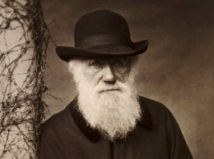  Charles Darwin  Mary Anning (UK) — early palaeontologist; made fossil discoveries crucial to evolutionary theory |  |  |  | Light  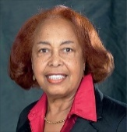  Dr Patricia Bath  Maria Telkes - Hungarian-American, 20th century. Developed solar energy technology — links well with light and energy conversion.
HISTORY | Industrial Revolution  Quarry Bank Mill |  |  |  |  |  |  |  | Keeping healthy over time -  Black Death to today
GEOGRAPHY | North -West England  Manchester: How a city changed! |  |  |  | Antarctica  How are we connected to Antarctica? |  | South America: How does climate affect where people live? |  | Sustainability and Plastic Pollution  How can we reduce pollution and protect the environment globally?
COMPUTING | Online Safety  Computing systems and networks Communication and collaboration |  | 3D Printing |  | Creating media – Web page creation |  | Data and information - Introduction to Spreadsheets |  | Programming: Variables in games, sensing movement  Lego + Drones
MUSIC | Wider Opportunities: Love Music Trust INSTRUMENTS |  |  |  | Cultural: Latin America  Brazil Samba  Love Music Trust: Samba |  | The little train of Cairpira by Heitor Villa-Lobos  Composers: 20th/21st Century:  Hans Zimmer & Leonard Bernstein , Heitor Villa-Lobos  Love Music Trust: Music from the Stage & Screen |  |  |  | Genres & Suggested Artists:  British Pop 1960’s – Now  Beatles, Queen, David Bowie  Love Music Trust: Your Song
ART | Drawing: Cities and Skylines  Stephen Wiltshire  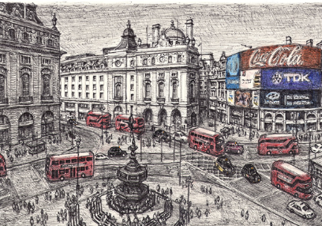 |  |  |  | Painting: Landscape  David Hockney  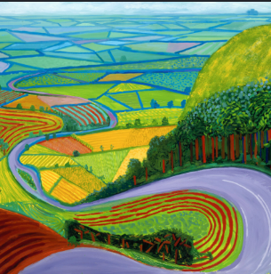 |  |  |  | Sculpture: Sustainability  El Anatsui  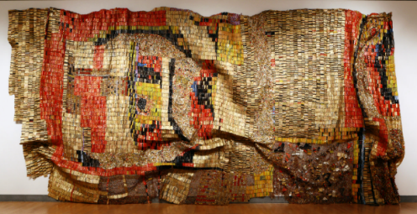
PHYSICAL EDUCATION | Invasion Games |  | Dance |  | Gymnastics |  | Net and Wall |  | Athletics |  | Striking and Fielding
DT | Building Bridges |  |  |  |  |  | Food Technology Fajitas South America |  |  |  | LEGO Workshop  Fairgrounds Rides
RELIGIONS AND WORLD VIEWS | HUMANISM  What can we learn from Humanism? |  |  |  | JUDAISM  Why is the Torah so important within Judaism? |  | SIKHISM  What happens in the Gurdwara? |  |  |  | How can religion promote peace and justice in our society?
SPANISH | My Town |  | Going to the Doctors |  | Animals |  | Our Past |  | In the Classroom |  | Eating Out
P.S.H.E.  RSE  Human Values | My healthy self: How do my choices today shape my future health?  Individual Liberty |  | Connecting with others: What does it mean to stand up for myself and others?  Mutual Respect |  | The online world: How do I feel about the things I see online?  Tolerance |  | Citizenship: How can we protect everyone’s rights?  Rule of Law |  | Staying safe: How can I stay safe as I grow up?  Democracy  Individual Liberty |  | Sex education: How do people become parents and carers?  Individual Liberty
SDGs  &  CHILDREN`S RIGHTS | 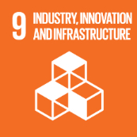  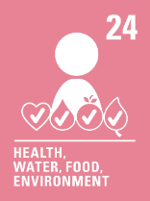 |  |  |  | 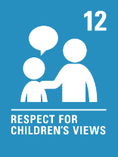  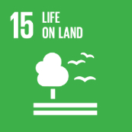 |  |  |  | 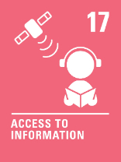  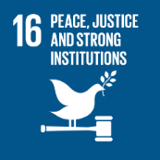
EDUCATIONAL VISITS AND VISITORS | Quarry Bank Mill Trip |  | Enterprise project: Christmas stall |  |  |  | Science WEEK  WORLD BOOK DAY |  | Career Day |  | End of Year Performance

