

**Egerton Primary School**

**Science Policy**

|  |  |
| --- | --- |
| Approved by | Neil McKinlay |
| Last Reviewed | December 2024 |
| Next Reviewed | September 2026 |

**Science Vision at Egerton Primary School…**

**Science at Egerton**

A high-quality science education provides the foundations for understanding the world through the specific disciplines of biology, chemistry and physics. Science has changed our lives and is vital to the world’s future prosperity, and all pupils should be taught essential aspects of the knowledge, methods, processes and uses of science.  
(National Curriculum 2014)

**Introduction**

This document is a statement of aims, principles and strategies for the teaching and learning of Science at Egerton Primary School. It was developed and is updated through consultation with all teaching staff. The learning and teaching of Science at Egerton Primary School aims to promote Science as a core subject which is taught on a weekly basis across the foundation stage and key stages 1 and 2. It is seen as a practical subject that needs to be taught in a practical way (where appropriate) to stimulate curiosity, discussion and investigation. The teaching and learning of Science should be linked to real world experience to encourage children to develop an understanding and enquiring mind. Our vision is to inspire enquiring minds for the future.

**Intent**

The 2014 national curriculum for Science aims to ensure that all pupils:

* develop **scientific knowledge and conceptual understanding** through the specific disciplines of biology, chemistry and physics
* develop understanding of the **nature, processes and methods of Science** through different types of Science enquiries that help them to answer scientific questions about the world around them
* are equipped with the **scientific skills** required to understand the **uses and implications** of Science, today and for the future. We understand that it is important for lessons to have a skills-based focus, and that the knowledge can be taught through this

At Egerton, we encourage children to be inquisitive throughout their time at the school and beyond. The Science curriculum fosters a healthy curiosity in children about our universe and promotes respect for the living and non-living. We believe Science encompasses the acquisition of knowledge, concepts, skills and positive attitudes. Throughout the programmes of study, the children will acquire and develop the key knowledge that has been identified within each unit and across each year group - all learning is accessible for all children regardless of their ability or background The key knowledge identified by each year group is informed by the national curriculum and builds towards identified phase ‘end points’ in accordance with NC expectations. Key skills are also mapped for each year group and are progressive throughout the school (Appendix 1). These too ensure systematic progression to identified skills end points which are in accordance with the Working Scientifically skills expectations of the national curriculum.

The curriculum is designed to ensure that children are able to acquire key scientific knowledge through practical experiences; using equipment, conducting experiments, building arguments and explaining concepts confidently. The school’s approach to Science takes account of the school’s own context, ensuring access to people with specialist expertise and places of scientific interest as part of the school’s commitment to learning outside the classroom. Cross curricular opportunities are also identified, mapped and planned to ensure contextual relevance (Appendix 2). Children are encouraged to ask questions and be curious about their surroundings and a love of Science is nurtured through a whole school ethos and a varied Science curriculum.

**Implementation**

Teachers create a positive attitude to Science learning within their classrooms and reinforce an expectation that all pupils are capable of achieving high standards in Science. Our whole school approach to the teaching and learning of Science involves the following;

* Science will be taught in planned and arranged topic blocks by the class teacher, to have a project-based approach. This is a strategy to enable the achievement of a greater depth of knowledge.
* Existing knowledge is checked at the beginning of each topic, as part of the KWL strategy (What I know, What I would like to Know and What I have Learned) or a quiz. This ensures that teaching is informed by the children’s starting points and that it takes account of pupil voice, incorporating children’s interests.
* Through our planning, we involve problem solving opportunities that allow children to apply their knowledge, and find out answers for themselves. Children are encouraged to ask their own questions and be given opportunities to use their scientific skills and research to discover the answers. This curiosity is celebrated within the classroom. Planning involves teachers creating engaging lessons, often involving high-quality resources to aid understanding of conceptual knowledge. Teachers use precise questioning in class to test conceptual knowledge and skills, and assess pupils regularly to identify those children with gaps in learning, so that all pupils keep up. Tasks are selected and designed to provide appropriate challenge to all learners, in line with the school’s commitment to inclusion.
* We build upon the knowledge and skill development of the previous years. As the children’s knowledge and understanding increases, they become more proficient in selecting, using scientific equipment, collating and interpreting results, they become increasingly confident in their growing ability to come to conclusions based on real evidence.
* Working Scientifically skills are embedded into lessons to ensure that skills are systematically developed throughout the children’s school career and new vocabulary and challenging concepts are introduced through direct teaching. This is developed through the years, in-keeping with the topics.
* Teachers demonstrate how to use scientific equipment, and the various Working Scientifically skills in order to embed scientific understanding. Teachers find opportunities to develop children’s understanding of their surroundings by accessing outdoor learning and workshops with experts.
* Children are offered a wide range of extra-curricular activities, visits, trips and visitors to complement and broaden the curriculum. These are purposeful and link with the knowledge being taught in class.
* Regular events, such as Science Week, allow all pupils to come off-timetable, to provide broader provision and the acquisition and application of knowledge and skills. These events often involve families and the wider community.
* At the end of each topic, key knowledge is reviewed by the children and rigorously checked by the teacher and consolidated as necessary.

**Impact**

The successful approach at Egerton Primary School results in a fun, engaging, high-quality Science education, that provides children with the foundations and knowledge for understanding the world. Our engagement with the local environment ensures that children learn through varied and first hand experiences of the world around them. Frequent, continuous and progressive learning outside the classroom is embedded throughout the Science curriculum. Through various workshops, trips and interactions with experts children have the understanding that Science has changed our lives and that it is vital to the world’s future prosperity. Children learn the possibilities for careers in Science, as a result of our community links and connection with national agencies including the STEM association. They learn from and work with professionals, ensuring access to positive role models within the field of Science from the immediate and wider local community. From this exposure to a range of different scientists from various backgrounds, all children feel they are scientists and capable of achieving. Children at Egerton Primary overwhelmingly enjoy Science and this results in motivated learners with sound scientific understanding.

**Teaching and Learning**

The Science curriculum is mapped to ensure alignment with the national curriculum content and programme of study. Key knowledge relates directly and builds towards the achievement of end of phase (KS1, Lower KS2 and upper KS2) ‘end points’, informed by the National Curriculum statements. Key skills are also mapped so that these are developed systematically and align directly to the specified working scientifically statements as outlined in the NC for each phase. (Appendix 1)

In each lesson, children are guided towards the learning intention through the use of success criteria. The LO (Learning Objective) and success criteria are shared at the beginning of the lesson and reviewed by children at the end. They are subsequently used by the teacher during the assessment and review work of children’s work and are used to identify individual target areas. A working wall will be used to support and celebrate learning throughout each unit of work. This will also be used to support the acquisition of key knowledge and will support the accurate use of an extended specialist vocabulary.

Science is taught in a cross curricular manner, where possible, and integrated into classes ongoing ‘theme’ work to provide more contextual and meaningful learning experiences.

* English – opportunities to write for varied purposes, with the characteristics of different kinds of writing. For example, chronological reports, recounts, balance arguments and note taking
* Mathematics – developing skills in data handling, measurements and mathematical relationships
* Art – understanding of materials and their properties, designing and creating own inventions
* Geography – exploring physical processes
* History – researching Scientist, their discoveries and the impact in today’s society
* Computing – data handling and research
* PSHE – health and safety education

**Planning and Resources**

Key knowledge and skills, in line with the National Curriculum are mapped on the whole school ‘Science Knowledge and Skills Progression Map’ and this shows the key knowledge and skills of each unit and how they build through the school. The school’s own context is also considered and opportunities for learning outside the classroom, including the use of specific school resources (such as the pond, garden and school field) and relevant educational visits, are included on the map and are planned by teachers. Cross curricular links are also mapped to further support the contextual relevance of the Science curriculum. (Appendix 2)

High-quality Science resources to support the teaching of all units and topics from EYFS to Y6, are used consistently and maintained by the subject leader. These are kept in a central store and are labelled and easily accessible to all staff. As well as these, the EYFS classes have a range of resources for easy access to children during exploration. The school library contains a rich and varied supply of Science topic books to support children’s individual research and all classes have access to these during their weekly allocated library slot. Teachers also use Cheshire Library Service for Science books.

**Investigations**

It is essential that children experience and understand the full cycle of experimental science. Specific skill elements of investigations are to be covered discretely across the curriculum however all children should have the opportunity to work through the full process at least once a term this could be as part of the lessons mapped out or as a distinct separate block. The investigation should link closely with the lesson plans. Working scientifically We recognise that it is important our pupils are taught a variety of approaches to answer relevant scientific questions. Over the course of six year, pupils will develop greater understanding of how to working scientifically.

These types of scientific enquiry should include:

* observing over time
* pattern seeking
* identifying, classifying and grouping
* comparative and fair testing (controlled investigations)
* researching using secondary sources (pupils should seek answers to questions through collecting, analysing and presenting data)

**Health and Safety**

Safe working practices are an integral part of all Science activities. All staff are aware of safe and correct handling of tools, materials and equipment. The teaching staff demonstrate to pupils how to work safely and ensures that all children using equipment are properly supervised.

**Assessment for Learning**

As part of the introduction to each new Science topic, teachers review what the children know already and identify what they would like to learn. This informs the programme of study so that it takes account of children’s starting points as well as their specific interests.

Lessons are planned to ensure that key knowledge is developed over time, over the course of each Science block and in the correct sequence. Key knowledge is reviewed by the children and rigorously checked and consolidated by the teacher at the end of each unit of work.

Lessons within each unit are also planned to ensure the systematic development of the key identified skills across the school.

By the end of each key stage, pupils are expected to know, apply and understand the matters, skills and processes specified in the relevant programme of study as set out in the National Curriculum. These are set out as statutory requirements. We also draw on the non-statutory requirements to extend our children and provide an appropriate level of challenge.

Children receive effective feedback through teacher assessment, both orally and through written feedback in line with the success criteria. Children are guided towards achievement of the main objective through the use of process-based ‘success criteria’, provided by and explained by the teacher. Children refer to these during the lesson and they precede outcomes of work in children’s books. The success criteria are used to identify areas of difficulty by children and teachers when reviewing and assessing work.

Ongoing assessment also includes:

* Observing children at work, individually, in pairs, in a group, and in classes.
* Questioning, talking and listening to children
* Considering work/materials / investigations produced by children together with discussion about this with them.

Children’s achievements are shared with parents at Parent Meetings on a termly basis. Parents have access to children’s work and individual dialogue with the class teacher via school online platform - **Seesaw**. Parents see Science displays and evidence of the children’s work through class led assemblies, school presentations and work in their Science books. **DcPro** is used to record the children’s attainment and progress throughout KS1 and KS2. **Tapestry** is used for EYFS.

In EYFS, we assess the children’s Understanding of the World according to the Development Matters statements.

# **As per the national curriculum programme of study, by the end of key stage 1 pupils can:**

(Appendix 3)

* Has experienced and observed phenomena, having looked more closely at the natural and humanly constructed world around them.
* Shows curiosity, asking questions about what they have noticed.
* Has developed understanding of scientific ideas through the use of different types of scientific enquiry to answer own questions, including observing changes over time, noticing patterns, grouping and classifying things, carrying out simple comparative tests and finding things out using secondary sources of information.
* Is beginning to use simple scientific language to talk about what they have found out and communicate their ideas to a range of audiences in a variety of ways.

# **As per the national curriculum programme of study, by the end of lower key stage 2 pupils can:**

* Has broadened their scientific view of the world around them through exploring, talking about, testing and developing ideas about everyday phenomena and the relationships between living and non-living things and familiar environments
* Asks their own questions about what they observe and is able to make some decisions about which types of scientific enquiry are likely to be the best ways of answering them, including observing changes over time, noticing patterns, grouping and classifying things, carrying out simple comparative and fair tests and finding things out using secondary sources of information.
* Draws simple conclusions and uses some scientific language, to both and write about what they have found out. Reads and spells scientific vocabulary correctly and with confidence, using their growing word and spelling knowledge.

# **As per the national curriculum programme of study, by the end of upper key stage 2 pupils can:**

* Has developed a deeper understanding of a wide range of scientific ideas through exploring and talking about their ideas; asking their own questions about scientific phenomena; and analysing functions, relationships and interactions more systematically.
* Has encountered more abstract ideas and is beginning to recognise how these help them to understand and predict how the world operates.
* Is beginning to recognise that scientific ideas change over different periods of time, noticing patterns, grouping and classifying things, carrying out comparative fair tests and finding things out using a wide range of secondary sources of information.
* Is able to draw conclusions based on their data and observations, using evidence to justify their ideas and their scientific knowledge and understanding to explain their findings.

**Recorded Work**

Scientific work is recorded in a variety of ways appropriate to the age of the children and their individual needs in each key stage. This can include teacher observations, photographs, drawings, tables, graphs, written accounts and formal write ups. It is expected that all recorded Science work is to be presented to a high standard but not to the detriment of Science investigations or the teaching and learning aspect of the lesson. The balance of practical activity and length of recording tasks is carefully planned to maintain a scientific emphasis.

**Key Stage One**

The principal focus of Science teaching in key stage 1 is to enable pupils to experience and observe phenomena, looking more closely at the natural and humanly-constructed world around them. At William Patten, children are encouraged to be curious and ask questions about what they notice. Their understanding of scientific ideas is supported through the use of different types of scientific enquiry so that children can answer their own questions, including observing changes over a period of time, noticing patterns, grouping and classifying things, carrying out simple comparative tests, and finding things out using secondary sources of information. Children are supported to begin to use simple scientific language to talk about what they have found out and communicate their ideas to a range of audiences in a variety of ways, including wider school forums such as Science week. Most of the learning about Science is done through first-hand practical experiences, and children are also to begin to use appropriate secondary sources, such as books, photographs and videos.

‘Working scientifically’ is described separately in the National Curriculum programme of study, but is **always** taught through and clearly related to the teaching of substantive Science content in the programme of study. The knowledge and skills progression maps outline how the specific skills of each unit progressively build between years and towards the overarching ‘end point statements’. Throughout the notes and guidance, examples show how scientific methods and skills might be linked to specific elements of the content.

Opportunities are provided for the children to read and spell scientific vocabulary at a level consistent with their increasing word reading and spelling knowledge at key stage 1.

**Lower Key Stage Two**

The principal focus of Science teaching in lower key stage 2 is to enable pupils to broaden their scientific view of the world around them. They do this through exploring, talking about, testing and developing ideas about everyday phenomena and the relationships between living things and familiar environments, and by beginning to develop their ideas about functions, relationships and interactions. Children are encouraged and supported to ask their own questions about what they observe and make some decisions about which types of scientific enquiry are likely to be the best ways of answering them, including observing changes over time, noticing patterns, grouping and classifying things, carrying out simple comparative and fair tests and finding things out using secondary sources of information. They draw simple conclusions and use some scientific language, first, to talk about and, later, to write about what they have found out.

As in KS1, ‘Working scientifically’ is described separately in the National Curriculum programme of study, but is **always** taught through and clearly related to the teaching of substantive Science content in the programme of study. The knowledge and skills progression maps outline how the specific skills of each unit progressively build between years and towards the overarching ‘end point statements’. Throughout the notes and guidance, examples show how scientific methods and skills might be linked to specific elements of the content.

Opportunities are provided for the children to read and spell scientific vocabulary correctly and with confidence, using their growing word reading and spelling knowledge.

**Upper Key Stage Two**

The principal focus of Science teaching in upper key stage 2 is to enable pupils to develop a deeper understanding of a wide range of scientific ideas. At William Patten, children do this through exploring and talking about their ideas; asking their own questions about scientific phenomena; and analysing functions, relationships and interactions more systematically. At upper key stage 2, they encounter more abstract ideas and begin to recognise how these ideas help them to understand and predict how the world operates. Children are also supported to begin to recognise that scientific ideas change and develop over time. The school curriculum provides opportunities for children to select the most appropriate ways to answer Science questions using different types of scientific enquiry, including observing changes over different periods of time, noticing patterns, grouping and classifying things, carrying out comparative and fair tests and finding things out using a wide range of secondary sources of information. Children learn to draw conclusions based on their data and observations, use evidence to justify their ideas, and use their scientific knowledge and understanding to explain their findings.

‘Working and thinking scientifically’ is described separately at the beginning of the programme of study, but must **always** be taught through and clearly related to substantive Science content in the programme of study. Throughout the notes and guidance, examples show how scientific methods and skills might be linked to specific elements of the content.

Opportunities are provided for the children to read, spell and pronounce scientific vocabulary correctly.

**Outdoor Learning**

In addition to the above, Egerton Primary School recognizes the immense value of utilizing the school grounds for outdoor learning experiences, particularly in the context of Science education. The outdoor environment provides a rich and dynamic setting for students to explore, observe, and engage in hands-on scientific investigations.

Outdoor learning experiences are integrated into the Science curriculum to align with the school's commitment to learning outside the classroom. Teachers are encouraged to take advantage of the school's outdoor spaces, including the pond, garden, and school field, as extensions of the classroom. Practical experiences in these areas involve using equipment, conducting experiments, and building arguments, fostering a deeper understanding of scientific concepts.

The school embraces the philosophy that outdoor learning not only enhances academic achievement but also contributes to the overall well-being of students. Exposure to the natural environment fosters a connection with the world around them, encourages curiosity, and promotes a sense of responsibility for the living and non-living components of their surroundings.

Furthermore, the school actively seeks opportunities for outdoor workshops with experts and visits to places of scientific interest, ensuring that students have access to diverse learning experiences beyond the traditional classroom setting. Cross-curricular connections are identified and planned to enhance the contextual relevance of outdoor learning.

By incorporating outdoor learning into the Science curriculum, Egerton Primary School aims to instil a love for exploration and discovery, nurturing inquisitive minds that extend beyond the confines of the classroom. This approach aligns with the school's vision of inspiring enquiring minds for the future, fostering a lifelong appreciation for the wonders of the natural world and the scientific principles that govern it.

**Marking (see policy)**

Much of the work done in Science lessons is of a practical or oral nature and, as such, recording will take many varied forms thus making marking different. It is, however, important that written work is marked regularly and clearly, as an aid to progression and to celebrate achievement. When appropriate, pupils may be asked to self-assess or peer assess their own or other’s work.  
Marking for improvement comments in a child’s book must be relevant to the learning objective to help children to better focus on future targets.

**Achievement in Science**

Achievement in science is celebrated by:

* Displaying work
* Communicating findings in class to others
* Presenting of achievement certificates in Celebration Assembly every Friday
* Entering the Primary Engineering Competition
* Celebrating the British Science Week

**Equal Opportunities**

At Egerton Primary School, we are committed to providing a teaching environment which ensures all children are provided with the same learning opportunities regardless of social class, gender, culture, race, special educational need or disability. Teachers use a range of strategies to ensure inclusion and also to maintain a positive ethos where children demonstrate positive attitudes towards others.

**Inclusion**

Science teaching considers the needs of different individuals and groups for learners and tasks are designed and differentiated as appropriate to ensure an appropriate level of challenge. Supporting adults are also deployed effectively to ensure focussed support where this is necessary.

Teachers use a range of inclusion strategies, including paired work, open questions and direct, differentiated questioning and the activation of prior knowledge and contextual learning. This support the inclusion and motivation of all learners ensuring that optimum progress is made throughout each part of the lesson.

**Role of the Subject Leader**

The subject leader’s responsibilities are:

* To ensure the high profile of the subject and provide a strategic lead and direction for Science in the school.
* To maintain and ensure use of the central supply of Science resources, in accordance with those specific to each year group and topic
* To support colleagues in their teaching of Science and support the CPD of others
* To ensure progression of the key knowledge and skills identified within each unit and that these are integral to the programme of study and secure at the end of each age phase.
* To monitor books and ensure that key knowledge is evidenced in outcomes, alongside and as supported, by SLT
* To monitor planning and oversee the teaching of Science
* To lead further improvement in and development of the subject as informed by effective subject overview
* To ensure that the Science curriculum enables the progress and raises the attainment of all pupils, including those who are disadvantaged or have low attainment
* To ensure that the Science curriculum take account of the school’s context, promotes children’s pride in the local area and provides access to positive role models from the immediate and wider local area to enhance the Science curriculum.
* To ensure that approaches are informed by and in line with current identified good practice and pedagogy; to attend regular opportunities for CPD.
* To establish and maintain existing links with external agencies and individuals with specialist expertise to enrich teaching and learning in Science.
* To organise an annual whole-school Science week, in accordance with the national theme, ensuring a focus on practical and investigative activities.
* The subject leader has specially-allocated time for fulfilling the task of reviewing samples of children’s work, training, liaising with other subject leaders from other schools and organising Science Week.

**Working in Partnership - Parents**

Parental input is highly valued and parents are regularly invited and welcomed into school to share their own expertise with the children. Enquiries from parents and members of the school community with specialist expertise and knowledge are also encouraged. The school will actively seek to establish collaboration with parents and carers who are able to support the teaching and learning of Science at Egerton.

The support that parents and carers provide in supporting their children at home with topic-based homework is also recognised and valued. When these are set, Science homework tasks will be well communicated and have a clear purpose and will often provide children with the means to consolidate or extend their classroom work.

Specific opportunities for parents to take part in Science activities at the school, including Science Week, will be communicated. Special events will also be organised to involve families in scientific activities.

**Subject Leader: Monika Sedgwick**

**Policy Date: October 2023**

**Review Date: June 2024**

**Appendix 1**

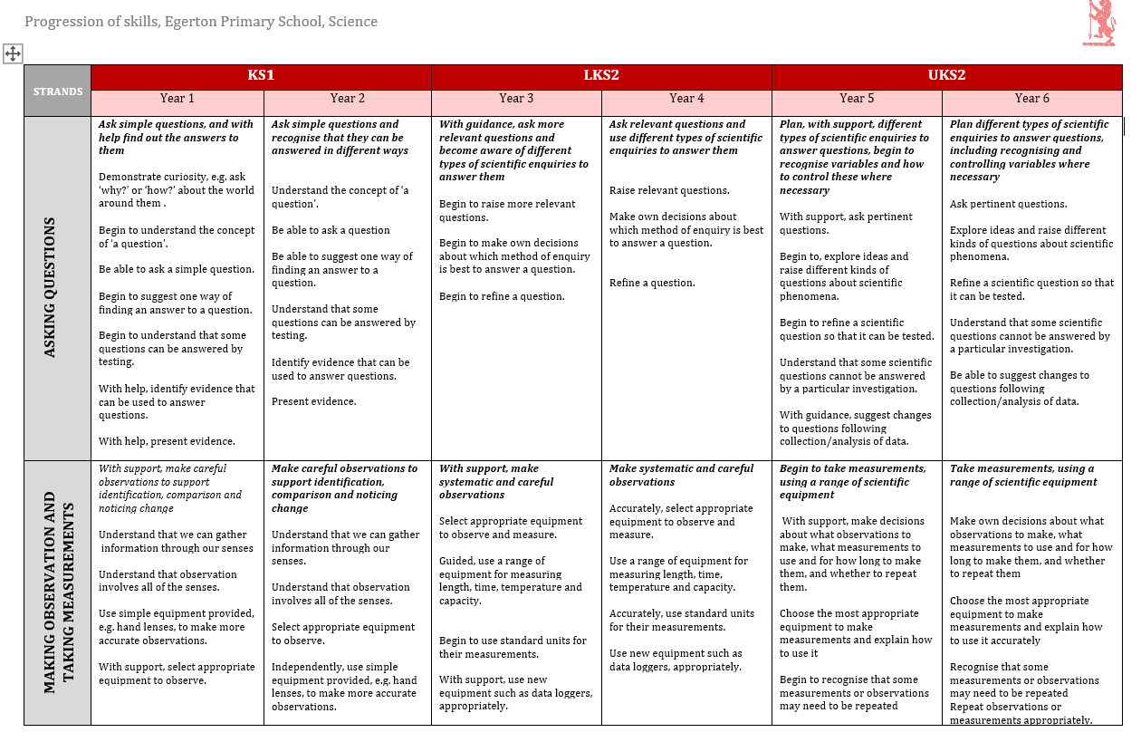

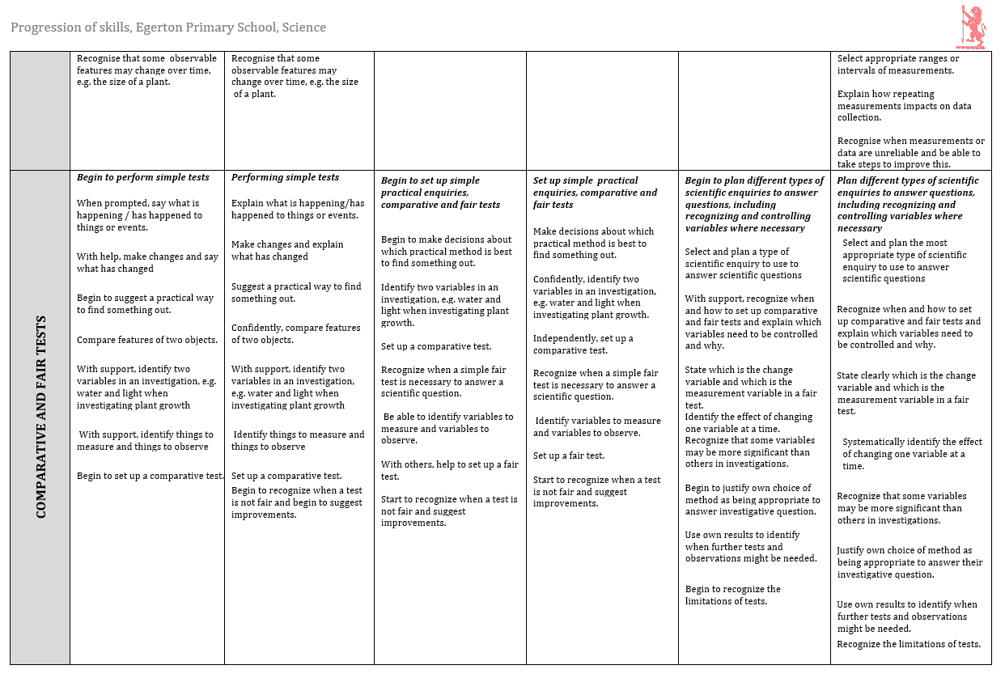

**Appendix 2**

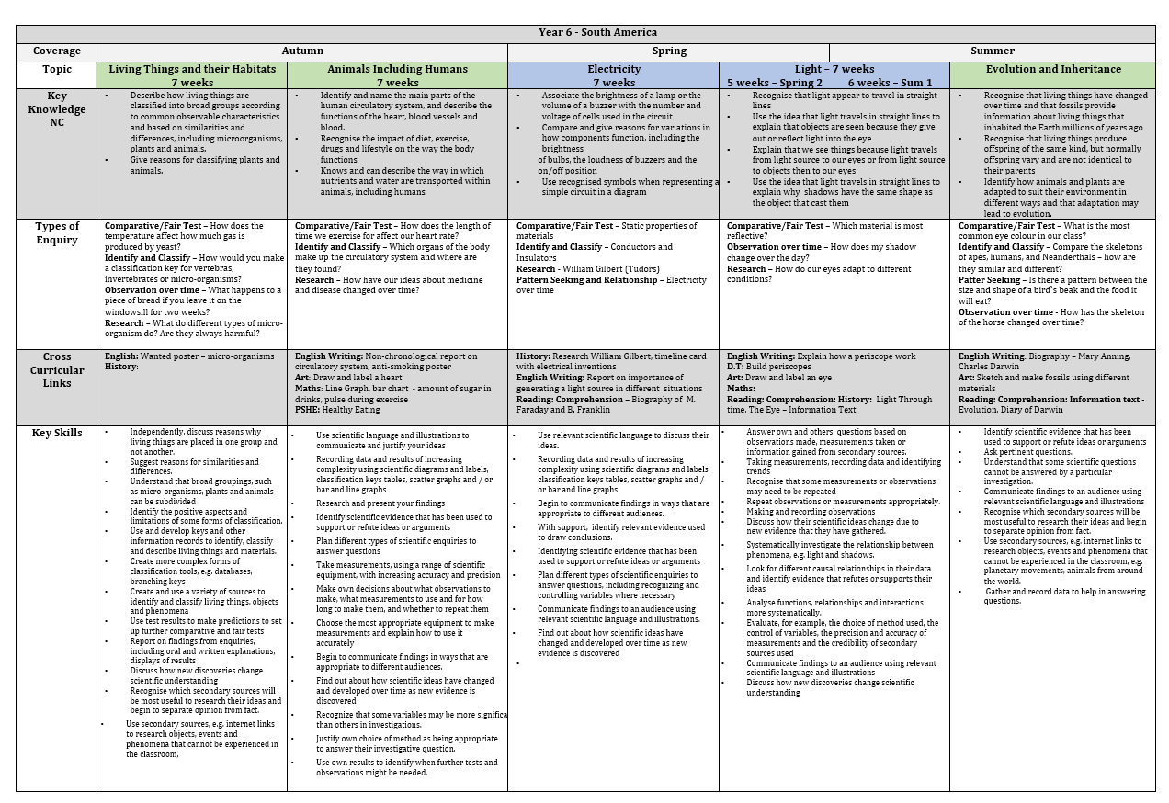

**Appendix 3**

