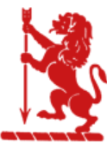
“There is no must in art because art is free.”

Wassily Kandinsky

EGERTON PRIMARY SCHOOL KNUTSFORD
ART END POINTS ASSESSMENT
"Ready to learn. Ready to thrive. Ready for tomorrow."
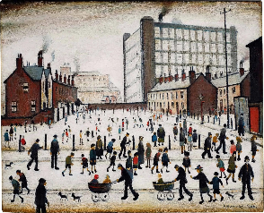
Year 1 Collage
‘L.S Lowry’

End Point Assessment
To improve their mastery of art and design techniques with a range of materials
To learn about great artists, architects and designers in history
I can share some facts about L.S.Lowry
I can describe what I can see in artwork by L.S.Lowry
I can say what is similar or different in two pieces of art work by Lowry
I can tear, cut and glue materials to make a simple collage
I can overlap and layer some materials to make a collage
I can create my own collage using a range of media such as fabric, paper and tissue
I can describe what I like about my own and others work

Key Vocabulary
L.S.Lowry | Laurence Stephen Lowry (1 November 1887 – 23 February 1976) was an English artist. Lowry painted scenes of life in the industrial districts of North West England.
Collage | A piece of art made from different materials
Tear | To pull apart
Cut | Use scissors to divide something into smaller pieces
Layer | To put one thing on top of another
Overlap | One object cover part of another object
Similar | The same
Different | Not the same as another
Shape | Simple outlines with a closed line

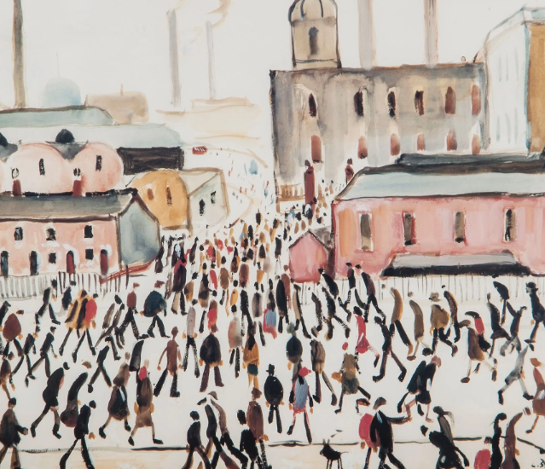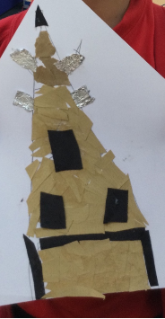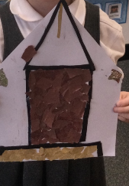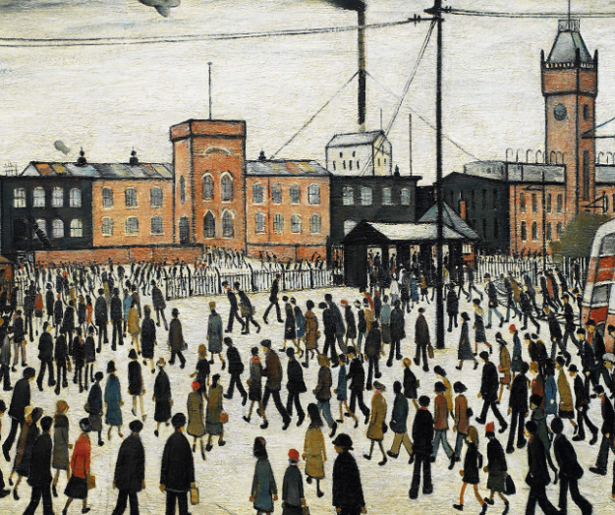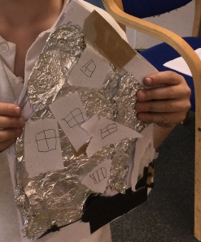

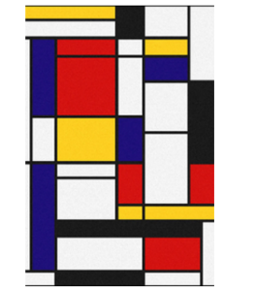
Year 1 Painting
‘Piet Mondrian’

End Point Assessment
To improve their mastery of art and design techniques with a range of materials
To learn about great artists, architects and designers in history
I can share some facts about Piet Mondrian
I can describe what I can see in artwork by Piet Mondrian
I can say what is similar or different in two pieces of art work by Mondrian
I can name the primary and secondary colours
I can create and use textures in my paint
I can create my own painting using varied brushstrokes and brush size
I can describe what I like about my own and others work

Key Vocabulary
Piet Mondrian | Piet Mondrian is a Dutch artist best known for his abstract paintings
Abstract | Art that is abstract does not show things that are recognisable such as people, objects or landscapes. Instead artists use colours, shapes and textures
Primary colour | Three basic colours that can be mixed to create new colours. These are red, yellow, blue
Secondary colour | Colour combinations created by the equal mixture of two primary colours
Mix | To put different things together so that the parts become one.
Brushstroke | The way in which paint is put on to a surface with a brush
Brush size | How big or small the paint comes out because of the tool used
Texture | The feel or look of a surface
Sweep | To apply the paint lightly resembling the movement of a sweeping brush
Dab | the motion with which you pat or apply something to a surface
Shape | Simple outlines with a closed line
Pattern | A repeated decorative design
Similar | The same
Different | Not the same as another
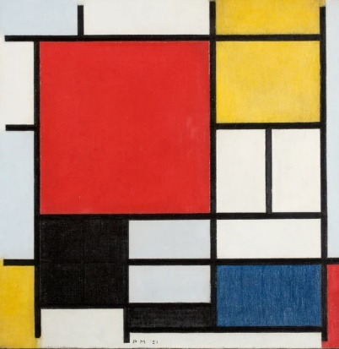
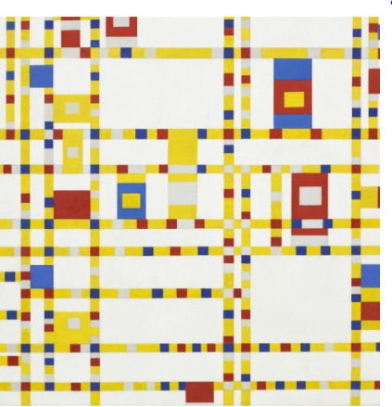

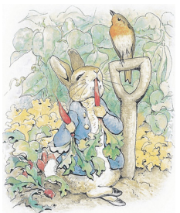

Year 1 Drawing
‘Beatrix Potter`

End Point Assessment
To improve their mastery of art and design techniques with a range of materials
To learn about great artists, architects and designers in history
I can share some facts about Beatrix Potter
I can describe what I can see in artwork by Beatrix Potter
I can say what is similar or different in two pieces of art work by Potter
I can use a variety of tools (pencil, pen, crayons) as I explore line, shape and colour
I can create my own observational drawing using a variety of dry media
I can describe what I like about my own and others work

Key Vocabulary
Beatrix Potter | Helen Beatrix Potter was an English writer, illustrator, natural scientist, and conservationist. She is best known for her children's books featuring animals, such as The Tale of Peter Rabbit.
Illustrator | Illustrators create drawings for books
Line | A long, thin mark
Shape | Simple outlines with a closed line
Colour | A quality of light as our eyes see it
Observe | To notice and comment on the appearance
Draw | Making marks and lines with a pencil or pen
Thick | A larger width of a line
Thin | A thinner width of a line
Similar | The same
Different | Not the same as another

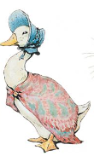
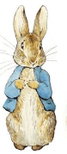
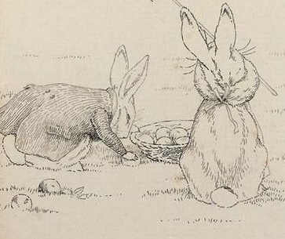

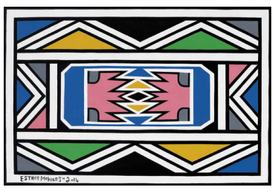
Year 1 Printing
‘Esther Mahlangu’

End Point Assessment
To improve their mastery of art and design techniques with a range of materials
To learn about great artists, architects and designers in history
I can share some facts about Esther Mahlangu
I can describe what I can see in artwork by Esther Mahlangu
I can say what is similar or different in two pieces of art work by Mahlangu
I can design a simple repeating pattern
I can copy an original print
I can demonstrate a range of techniques in my work including pressing, stamping, rolling and rubbing
I can create my own simple print
I can describe what I like about my own and others work

Key Vocabulary
Esther Mahlangu | A South African artist known for her bright and bold abstract paintings
Print | An impression made by any method involving transfer from one surface to another
Roll | A printing technique involving turning over and over on an axis
Press | A printing technique applying pressure with the tool to make a copy
Stamp | A tool used in printing to make a copy of a painted pattern
Rubbings | Marking the paper with a drawing tool whilst an uneven surface is under the paper
Colour | A quality of light as our eyes see it
Shape | Simple outlines with a closed line
Repeating Pattern | The repetition of lines, shapes, tones, colours, textures and forms
Similar | The same
Different | Not the same as another

