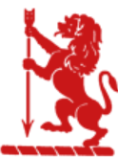
“There is no must in art because art is free.”

Wassily Kandinsky

EGERTON PRIMARY SCHOOL KNUTSFORD
ART END POINTS ASSESSMENT
"Ready to learn. Ready to thrive. Ready for tomorrow."
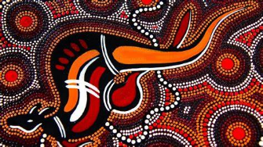
Year 2 Sculpture
‘Aboriginal Art’

End Point Assessment
To improve their mastery of art and design techniques with a range of materials
To learn about great artists, architects and designers in history
I can explain what aboriginal art is
I can explain how aboriginal art was originally created
I can create different lines and patterns using a variety of tools
I can manipulate clay (rolling, kneading, shaping, pinching, cutting) to create shape and form
I can create lines, texture and shapes using different tools
I can create my own clay sculpture in the style of aboriginal art
I can evaluate my own and others work using key vocabulary from the unit

Key Vocabulary
Aboriginal Art | Carvings, paintings and depictions of nature created by Aboriginal people
Line | A mark made using a drawing tool or brush. There are many types of line – thick, thin, horizontal, vertical, zigzag, curved, spiral, diagonal etc.
Pattern | A design where lines, shapes and colours are repeated
Texture | How something feels (soft, rough, smooth, grooved)
Shape | Simple outlines created by closed lines
Clay | A natural material made up of tiny particles of rock
Sculpture | 3D art made by carving, modelling or placing materials together

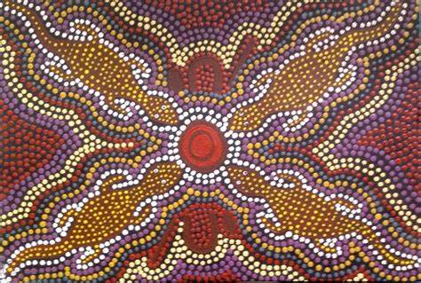
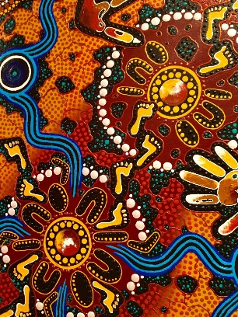
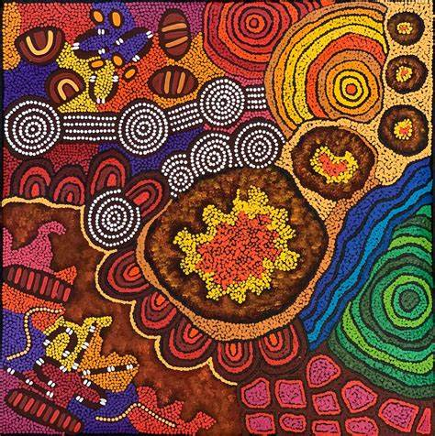

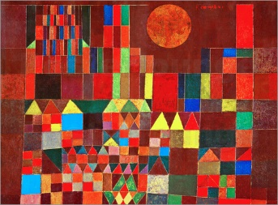
Year 2 Painting
‘Castle in the Sun – Paul Klee’

End Point Assessment
To improve their mastery of art and design techniques with a range of materials
To learn about great artists, architects and designers in history
I can explain who Paul Klee was
I can describe Paul Klee’s art using key vocabulary from the unit
I can name the primary and secondary colours
I can add black and white to create different shades and tones
I can mix a range of secondary colours to create different shades and tones
I can use a range of different sized paintbrushes to paint accurately with
I can create my own city skyline taking inspiration from Paul Klee’s ‘Castle in the Sun’
I can evaluate my own and others work using key vocabulary from the unit

Key Vocabulary
Paul Klee | Paul Klee (18 December 1879 – 29 June 1940) was a Swiss-German artist.
Primary colours | Blue, Red and Yellow
Secondary colours | Purple, Orange and Green created by mixing two primary colours
Shade | A variety of a colour, in regards to how light or dark it is when black or white is added to it.
Tone | How a colour appears when grey is added to it. In real life, tone is created by how light falls onto an object.
Layering | Adding one type of media on top of another when the first media is dry or set.
Media | A type of material used to create art.
Hot/Cold Colours | Warm or hot colours are red, orange, yellow and pink whilst the cold or cool colours are blue, navy, green and purple.
Scales | This refers to size of the artwork. This can be working on a large scale canvas or a small scale piece of card.
Scraping | A technique used in art where you apply different coloured paint over a strip of card, place it at the top of a blank canvas and drag it down, revealing the strips of colour.
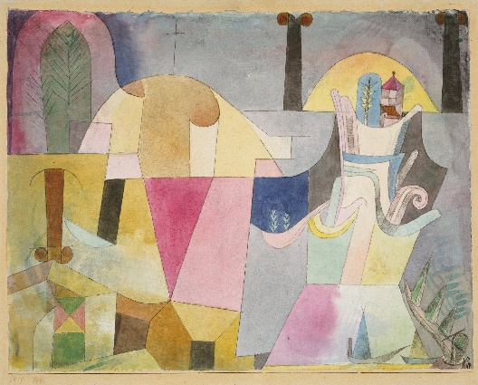
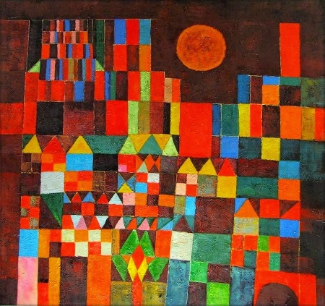
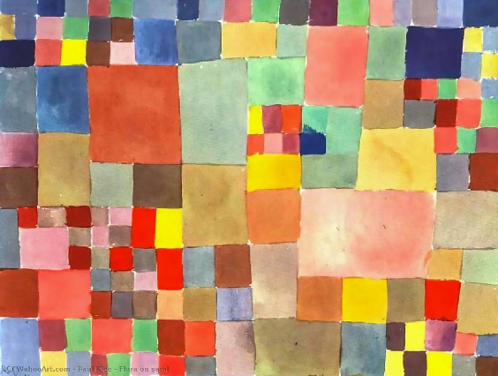

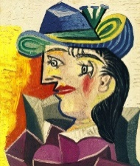
Year 2 Drawing
‘Portraits – Pablo Picasso’

End Point Assessment
To improve their mastery of art and design techniques with a range of materials
To learn about great artists, architects and designers in history
I can explain who Pablo Picasso was
I can explain what a self portrait is
I can describe Pablo Picasso’s portrait art
I can use a variety of different media to create different lines (thick/thin) patterns and colours
I can make rubbings to demonstrate how to create pattern and texture
I can draw a self-portrait using close observation
I can create my own portrait in the style of Pablo Picasso
I can evaluate my own and others work using key vocabulary from the unit

Key Vocabulary
Pablo Picasso | A Spanish painter who is widely acknowledged to be the most important artist of the 20th century. He experimented with a wide range of styles and themes in his long career, most notably inspiring 'Cubism'.
Cubism | Cubist art shows objects or people from many angles at the same time. It makes the subject look as if it is broken up or sometimes made from cubes.
Shading | The darkening or colouring of a drawing with lines or blocks of colour, and is often used to create the illusion of depth or make an object three-dimensional.
Portrait | A photo, painting or drawing or other artistic representation of another person’s face.
Self-portrait | A portrait of an artist or person created by themselves.
Line drawing | An image that consists of distinct straight or curved lines placed against a background.
Detail | A distinctive feature that can be seen and drawn best when observed up close or enlarged.
Pastels | A form of media that can be used to create art. It can be in different forms including a stick and are usually very vibrant colours.
Drawing | An artistic technique in which images are depicted on a surface by making lines.
Line (straight, curved) | A mark made using a drawing tool or brush. There are many types of line – thick, thin, horizontal, vertical, zigzag, curved, spiral, diagonal etc.
Bold | A style of art which is often very visually strong using vivid colours.
Size | The physical dimensions of the objects within a piece of art.
Space | The area around, above, and within an object to create an illusion to the viewer.
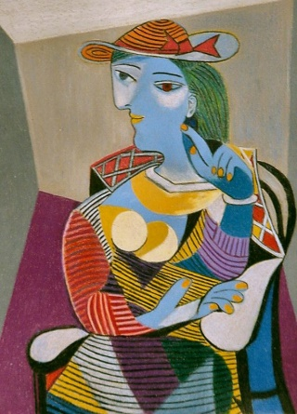
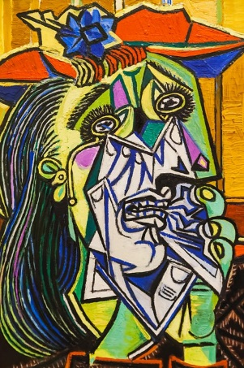
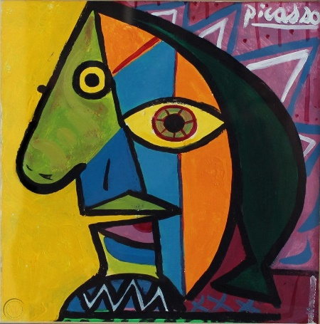

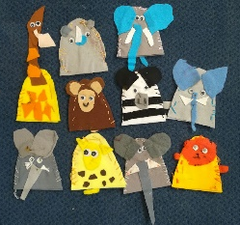
Year 2 Textiles
‘Puppets’ (combined within DT project)

End Point Assessment
To improve their mastery of art and design techniques with a range of materials
To learn about great artists, architects and designers in history
I can use dyeing techniques to change a textiles colour
I can add detail using glue or stitching

Key Vocabulary
Pattern | The repetition or order of a design
Textiles | Materials, including fabrics
Stitching | The act of creating individual stitches by passing a needle and thread through fabric

