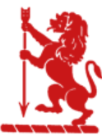
“There is no must in art because art is free.”

Wassily Kandinsky

EGERTON PRIMARY SCHOOL KNUTSFORD
ART END POINTS ASSESSMENT
"Ready to learn. Ready to thrive. Ready for tomorrow."
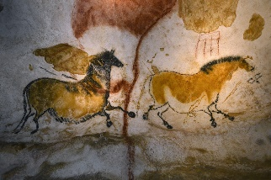
Year 3 Drawing
‘The Lascaux Cave Drawings’

End Point Assessment
To improve their mastery of art and design techniques with a range of materials
To learn about great artists, architects and designers in history
I can explain the importance of the Lascaux paintings and what they teach us about prehistoric art
I can make careful observational drawings of the Lascaux paintings
I can use different media including charcoal, pastels and chalk
I can undertake observation drawings of shapes, line, colour and pattern
I can experiment with the visual elements such as line, shape, colour and pattern
I can create my own prehistoric art
I can evaluate my own and others work linked to the visual elements

Key Vocabulary
Prehistoric Art | Art created in the Stone Age, Palaeolithic and Neolithic periods
Lascaux paintings | Lascaux is famous for its Palaeolithic cave paintings, found in a complex of caves in the Dordogne region of southwestern France
Texture | The physical appearance or feel of something (bumps, ridges, grooves)
Tone | The quality of a colour (warm/colour/bright/dull/light/dark)
Pattern | The repetition and order of a design
Sketch | A rough drawing that is quick and freehand
Smudge | A technique used to blend and soften marks made
Blend | Mixing two colours or values together to soften lines
Observations | To draw or paint a subject as accurately as possibly
Visual elements | Line, shape, value, colour, space, form and texture
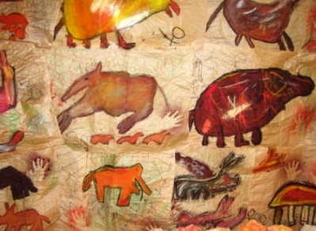
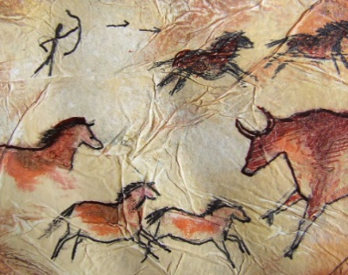
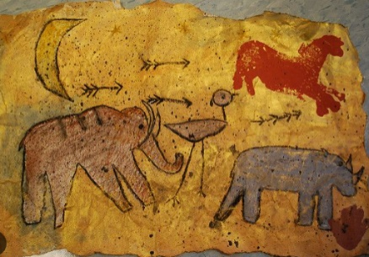

Year 3 Printing
‘Fossil Printing’ - Andy Warhol
End Point Assessment
To improve their mastery of art and design techniques with a range of materials
To learn about great artists, architects and designers in history
I can explain who Andy Warhol is
I can describe the work of Andy Warhol using key vocabulary from the unit
I can name some different printing methods including relief and block printing
I can describe the process of different printing methods
I can replicate patterns from observations
I can create prints using more than one colour
I can create my own printing piece in the style of Andy Warhol
I can evaluate my own and others work linked to the visual elements

Key Vocabulary
Andy Warhol | Andy Warhol was part of the pop art movement. He is famous for exploring popular culture in his work. Popular culture is anything from Coca Cola to pop stars to the clothes people like to wear.
Pop Art | Pop art is all about making art by inspired by things from popular culture
Replicate | A copy, duplicate, or reproduction of a work of art made by the “original artist”
Relief | A printing technique in which the printing surface is cut away so that the image alone appears raised on the surface
Line | Different marks made by a form of media e.g. curly lines, straight lines, sharp lines
Texture | How something feels
Block Printing | Block printing is a relief printing technique that uses a carved material (typically wood, linoleum, or rubber) to transfer ink onto fabric or paper. The block serves as a stamp
Acrylic | Acrylic paint is water-based fast-drying paint widely used by artists since the 1960s
Etch | A form of printmaking created from acid coated in wax
Mark Making | Mark making describes the way artists produce different lines, dots, marks, patterns and textures.
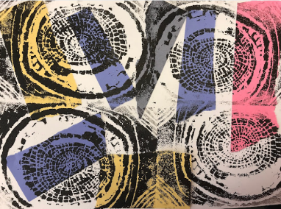
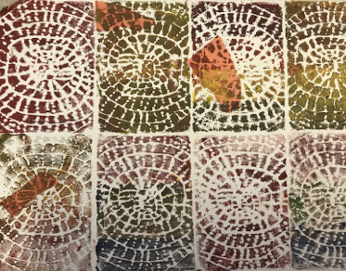
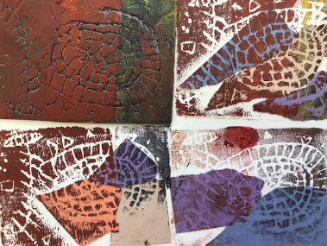

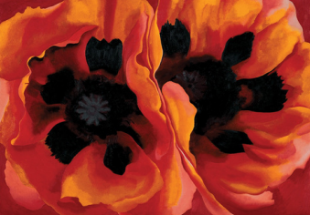
Year 3 Painting
‘Flower Painting’ – Georgia O’Keefe

End Point Assessment
To improve their mastery of art and design techniques with a range of materials
To learn about great artists, architects and designers in history
I can explain who Georgia O’Keeffe was
I can describe the work of Georgia O’Keeffe using key vocabulary from the unit
I can identify which primary colours make secondary colours
I can create tints and shades
I can experiment with different painting tools
I can explore different painting techniques on a range of scales e.g. thin brush on small picture
I can create texture with paint (i.e. block colours)
I can create my own painting in the style of Georgia O’Keeffe
I can evaluate my own and others work linked to the visual elements
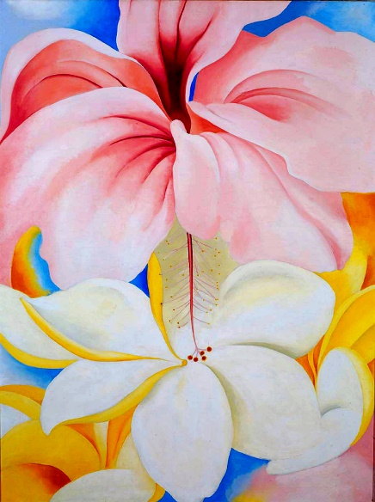
Key Vocabulary
Georgia O’Keefe | Born in 1887, Georgia O'Keeffe was an American artist who painted nature in a way that showed how it made her feel. She is best known for her paintings of flowers and desert landscapes.
Tint | A tint is a mixture of a colour with white, which increases lightness.
Shades | A shade is a mixture with black, which increases darkness.
Effect | Creating effect includes changing the appearance of an image by attempting to mimic art media like paint or pencil, add texture (e.g., cement), or create other changes like blurring
Line | Different marks made by a form of media e.g. curly lines, straight lines, sharp lines
Block Colours | One bold block of colour
Washes | A semi-transparent layer of colour
Primary Colours | Blue, Red and Yellow
Secondary Colours | Purple, Orange and Green created by mixing two primary colours
Brush Strokes | A brushstroke is one of the fundamental tenets of a painting, often used to build up the surface or an image of a work
Visual elements | Line, shape, value, colour, space, form and texture
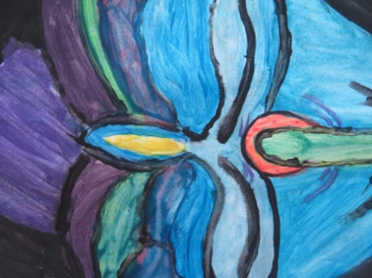
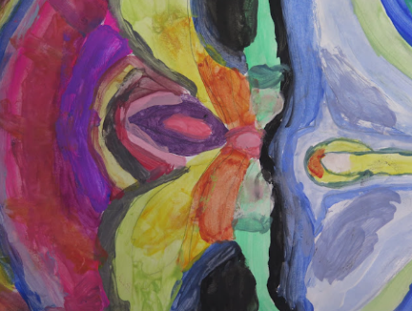

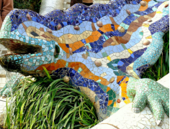
Year 3 Collages
‘Collages’ – Antoni Gaudi

End Point Assessment
To improve their mastery of art and design techniques with a range of materials
To learn about great artists, architects and designers in history
I can explain who Antoni Gaudi was
I can describe the work of Antoni Gaudi using key vocabulary from the unit
I can name some different collage techniques including overlapping, tessellation and mosaic
I can describe the process of different collage techniques including overlapping, tessellation and mosaic
I can use different collage techniques including overlapping, tessellation and mosaic in my own work
I can experiment with different colours and materials to create effect
I can plan my own mosaic collage
I can create a collage using different techniques
I can evaluate my own and others work linked to the visual elements

Key Vocabulary
Antoni Gaudi | Antoni Gaudi, (born June 25, 1852, Reus, Spain—died June 10, 1926, Barcelona), was a Spanish architect
Texture | How something feels
Form | Form is one of the elements of art and refers to three-dimensional objects. Shapes are flat and have two dimensions (height and width). Forms have three dimensions. (height, width and depth).
Pattern | A pattern is a design in which lines, shapes, forms or colours are repeated.
Mosaic | Decoration of a surface with designs made up of closely set, usually variously coloured, small pieces of material such as stone, mineral, glass, tile, or shell
Architect | An architect is a person who plans, designs, and oversees the construction of buildings.
Weave | Weaving is the textile art in which two distinct sets of yarns or threads - called the warp and weft - are interlaced with each other at right angles to form a fabric or cloth.
Art Noveau | Art Nouveau was a compelling and energetic style in the visual arts which spanned from around the early 1890s to the First World War. Art Nouveau artists, inspired by plant forms and nature, took organic subjects and flattened and abstracted them into sophisticated, sinuous and flowing motifs.
Mixed Media | Mixed media art is when the artist combines a mixture of different materials to create their work.
Tessellation | Tessellation is a pattern of shapes that fit together with no gaps or overlaps.
