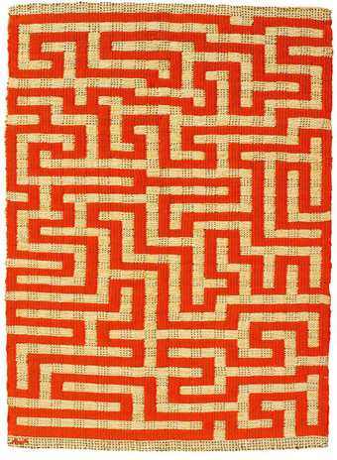
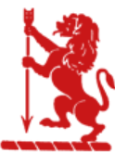
“There is no must in art because art is free.”

Wassily Kandinsky

EGERTON PRIMARY SCHOOL KNUTSFORD
ART END POINTS ASSESSMENT
"Ready to learn. Ready to thrive. Ready for tomorrow."

Year 4 Textiles
‘Anni Albers’

End Point Assessment
To improve their mastery of art and design techniques with a range of materials
To learn about great artists, architects and designers in history
I can explain who Anni Albers was
I can describe the art work of Anni Albers using key vocabulary from the unit
I can create pattern through quilting, weaving, finger knitting and applique
I can cut, join and stitch textiles
I can explain what it means to be ‘aesthetically pleasing’
I can evaluate my own and others work using key vocabulary

Key Vocabulary
Anni Albers | A German-born textile designer who was one of the most influential figures in textile arts in the 20th century
Textiles | A cloth made by hand or machine
Quilting | Quilting is the process of sewing two or more layers of fabric together to make a thicker padded material,
Loom | The device on which you create your weaving
Embroidery | Embroidery is the art of decorating fabric or other materials with designs stitched in strands of thread or yarn using a needle.
Applique | Appliqué is a type of textiles work where small pieces of cloth are sewn or stuck in a pattern onto a larger piece.
Aesthetics | Something that is aesthetically pleasing is enjoyable to look at

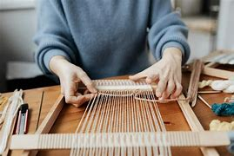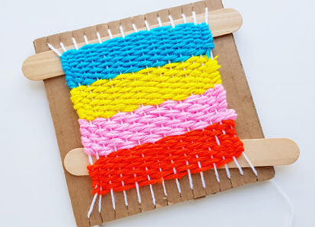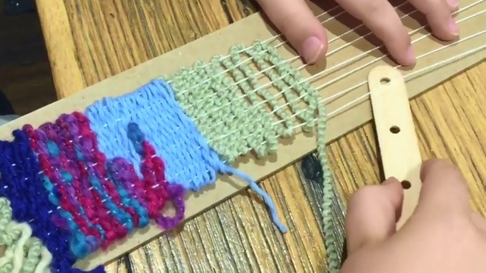

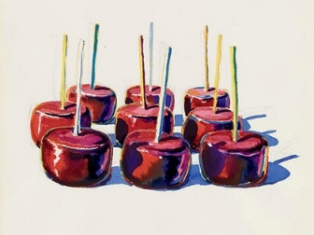
Year 4 Drawing
‘Morton Wayne Thiebaud’

End Point Assessment
To improve their mastery of art and design techniques with a range of materials
To learn about great artists, architects and designers in history
I can explain who Morton Wayne Thiebaud was
I can describe the art work of Morton Wayne Thiebaud using key vocabulary from the unit
I can use different grades of pencil, chalk and charcoal to show texture
I can use line, texture, tone, colour, shape and pattern in my drawing
I can use a variety of shading techniques to show light and shadow
I can draw objects in a third dimension
I can create my own three dimensional drawing taking inspiration from a range of stimuli
I can evaluate my own and others work using key vocabulary from the unit

Key Vocabulary
Morton Wayne Thiebaud | (November 15, 1920 – December 25, 2021) An American painter, associated with the pop art movement, known for his colourful works depicting commonplace objects—pies, lipsticks, paint cans, ice cream cones, pastries, and hot dogs—as well as for his landscapes and figure paintings.
Shape | The appearance of an object that is defined by its outer surface or outline
Form | Structure or shape
Light | Not heavy, full, intense or powerful
Dark | Not light or pale in colour
Shadow | The dark image cast on some surface by a person or thing blocking the light of the sun or another source of light
Outline | A line or shape showing the outside edge of a figure or object
Dimension | Size measured in length, width or depth
Experimental Stimuli | Something that causes or increasing action, feeling or thought

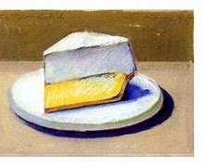
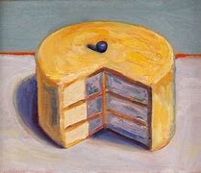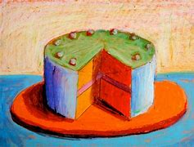

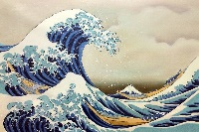
Year 4 Painting
‘Katsushika Hokusai’

End Point Assessment
To improve their mastery of art and design techniques with a range of materials
To learn about great artists, architects and designers in history
I can explain who Katsushika Hokusai was
I can describe the art work of Katsushika Hokusai using key vocabulary
I can make colours by combining primary and secondary colours, black and white
I can create simple colour pallets with increasing accuracy
I can use different brush techniques to create shape, texture and pattern
I can add texture through tints and shades, colour washes and thickened paint.
I can create my own painting in the style of Katsushika Hokusai
I can evaluate my own and others work using key vocabulary from the unit

Key Vocabulary
Katsushika Hokusai | A Japanese artist, painter and printmaker best known as author of the woodblock print series Thirty-six Views of Mount Fuji which includes the internationally iconic print, The Great Wave off Kanagawa.
Texture | The physical appearance or feel of an object, and can be seen through bumps, ridges, grooves and other physical details.
Colour washing | A layer of colour that is almost transparent
Colour blocking | Using contrasting colours and painting them in a space together
Hue | A dominant colour like red, yellow and blue.
Thickened | Paint becoming broader, deeper or denser

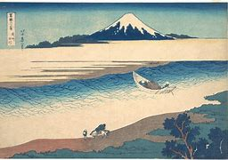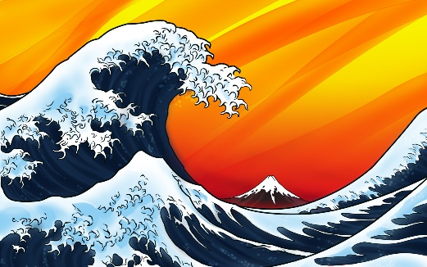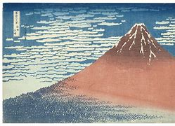

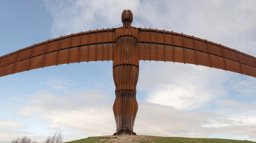
Year 4 Sculpture
‘Anthony Gormley’

End Point Assessment
To improve their mastery of art and design techniques with a range of materials
To learn about great artists, architects and designers in history
I can explain who Antony Gormley is
I can describe the art work of Anthony Gormley using key vocabulary from the unit
I can use clay and other malleable materials to create a sculpture
I can use joining techniques when using clay
I can show an awareness of shape, space and form in my sculpture
I can use materials to create and add detail to a sculpture
I can use recycled, natural and man-made materials to create a sculpture
I can evaluate my own and others work

Key Vocabulary
Antony Gormley | Sir Antony Mark David Gormley (born 30 August 1950) is a British sculptor best known for his work with human forms
Sculpture | Three-dimensional art made by one of four basic processes: carving, modelling, casting, constructing
Malleable | Something that can be shaped and manipulated
Space | An empty area
Brim | The top edge of a hollow object or a flat edge that sticks out
Peak | The top of something
Architect | A person who designs buildings and directs their construction.
Edging | A line where two surfaces meet
Trimmings | Added decoration
Combine | Bringing or joining together a whole
Shadow | The dark image cast on some surface by a person or thing blocking the light of the sun or another source of light

