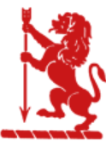
“There is no must in art because art is free.”

Wassily Kandinsky

EGERTON PRIMARY SCHOOL KNUTSFORD
ART END POINTS ASSESSMENT
"Ready to learn. Ready to thrive. Ready for tomorrow."
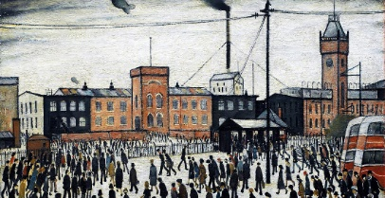
Year 6 L.S. Lowry
Drawing and Painting

End Point Assessment
To improve their mastery of art and design techniques with a range of materials
To learn about great artists, architects and designers in history
I can explain the term ‘contemporary’ art
I can explain who L.S Lowry was
I can explain how Lowry has contributed to art culture and history
I can describe the work of L.S Lowry linking to the visual elements of art
I can understand the concept of perspective and create perspective through line and shape
I can create my own ‘Urban Landscape’
I can select and use wet/dry media in my own work
I can use tone to depict mood and feeling
I can evaluate my own and others work using key vocabulary from the unit
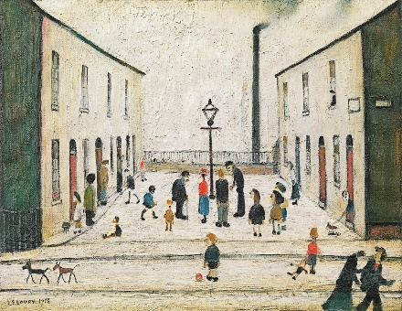
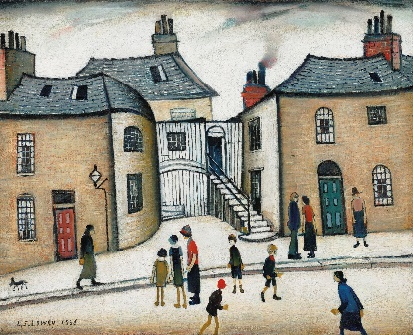
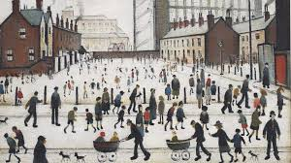
Key Vocabulary
L.S.Lowry | Laurence Stephen Lowry (1 November 1887 – 23 February 1976) was an English artist. Lowry painted scenes of life in the industrial districts of North West England.
Perspective | The art of representing three-dimensional objects on a two-dimensional surface
Urban landscape | The main subject of urban landscape painting is the image of a city with individual houses, streets and squares.
Composition | The arrangement of elements within a work of art
Vanishing Point | In art, the vanishing point of a painting is where the elements of the painting look to disappear, to give it an illusion of depth
Movement | The path or flow of movement that guides the viewer’s eyes in a composition
Scale | The size of one whole object in relation to another
Wet Media | Paints and Inks
Dry Media | Graphite, charcoal, pencil, coloured pencils
Visual Elements | Line, shape, value, colour, space, form and texture
Tone | How light or dark something is
Contemporary | Contemporary art can be defined variously as art produced at this present point in time or art produced since World War II.

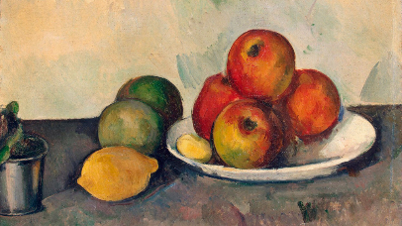
Year 6 ‘Still Life’ Paul Cézanne
Drawing and Painting

End Point Assessment
To improve their mastery of art and design techniques with a range of materials
To learn about great artists, architects and designers in history
I can explain what ‘still life’ is
I can explain who Paul Cézanne was and his contribution to culture/history
I can observe how still life paintings are arranged (composition) and say why the artist has made those choices
I can create light and shade using shading techniques
I can understand the concept of perspective & depict movement in drawings
I can observe an object and translate the shapes and tones onto paper
I can create my own ‘still life’ painting and drawing
I can evaluate my own and others work using key vocabulary from the unit

Key Vocabulary
Paul Cezanne | A French artist well-known for the still life paintings he made.
Arrangement | The way in which objects are placed and organized within the composition.
Background | The area behind the main objects in a still life composition.
Blend | To mix colours or tones smoothly together in a still life painting or drawing.
Colour palette | The range of colours used within a still life composition.
Composition | The arrangement of objects within a still life artwork.
Contrast | The difference in brightness, colour, or texture between objects within the still life.
Dimension | The measurement of the length, width, and depth of objects within the still life.
Focal point | The area of greatest interest or importance within a still life.
Foreground | The area in front of the main objects in a still life composition.
Lighting | The use of light and shadow to create depth and atmosphere within the still life.
Mood | The emotional atmosphere or feeling conveyed by the still life artwork.
Observation | The act of closely studying and examining objects in order to accurately represent them in art.
Tone | The lightness or darkness of a colour within the still life.
Texture | The visual or tactile quality of the surfaces of objects within the still life.
Scale | The relative size of objects within the still life in relation to each other.
Still life | A genre of Western art that shows anything that does not move i.e. food, flowers
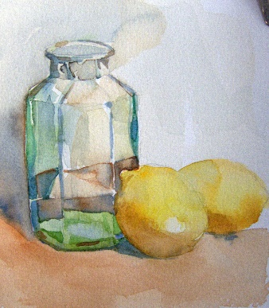
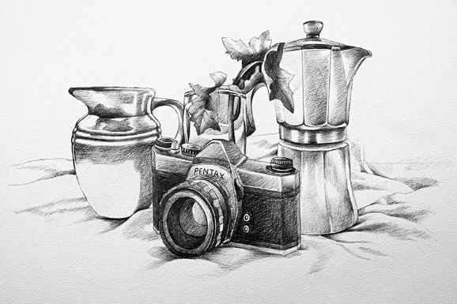
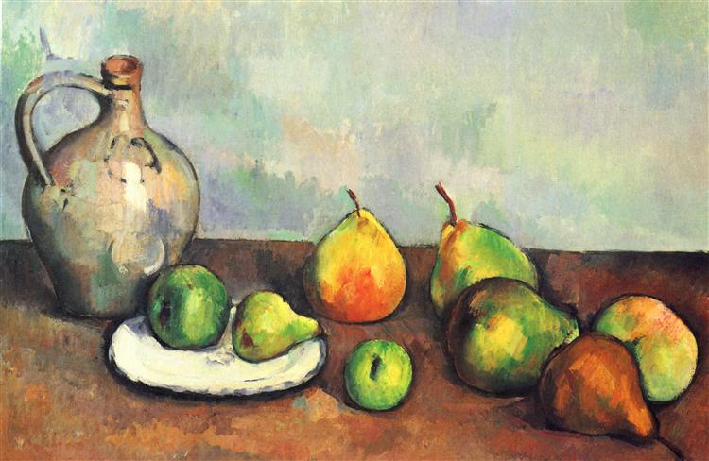

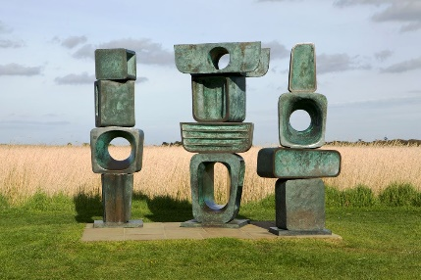
Year 6 Sculpture
Barbara Hepworth, Henry Moore, Alberto Giacometti

End Point Assessment
To improve their mastery of art and design techniques with a range of materials
To learn about great artists, architects and designers in history
I can explain what a sculpture is
I can describe the work of Barbara Hepworth, Henry Moore and Alberto Giacometti
I can plan a sculpture through drawing & other preparatory work.
I can use recycled, natural & man-made materials to create my own sculpture
I can use a variety of materials, other than clay, to create a 3D sculpture
I can describe the different qualities involved in modelling, sculpture & construction.
I can develop skills in cutting & joining (wires, coils, slabs and slips) to add detail
I can use a wide range of vocabulary (form, structure, texture, join, tram, cast, shape, mark)
I can create my own sculpture
I can evaluate my own and others work using key vocabulary from the unit
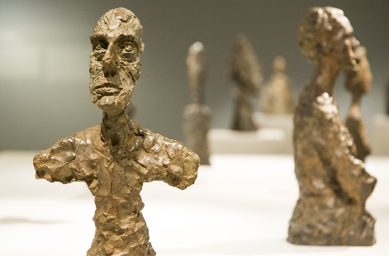
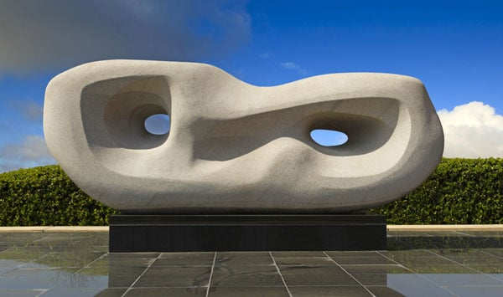
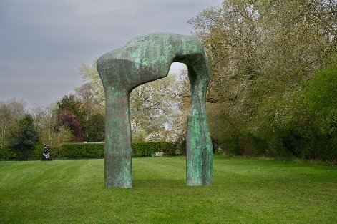
Key Vocabulary
Alberto Giacometti | A Swiss sculptor known for his figurative sculptures, often characterized by elongation and abstraction.
Barbara Hepworth | A British sculptor known for her modernist works in abstract forms, often in stone, wood, or bronze.
Cast | A sculpture made by pouring a liquid material (such as plaster or metal) into a mould and allowing it to harden.
Construction | The act of assembling or building a sculpture using various techniques and materials.
Cutting and joining | Techniques involving the separation and connection of materials, often using tools like scissors, knives, or adhesives.
Evaluate | To assess or judge the quality, effectiveness, or significance of one's own or others' artwork, using specific criteria and vocabulary.
Form | The shape or structure of an object, often in relation to its overall appearance.
Henry Moore | A prominent British sculptor known for his semi-abstract monumental bronze sculptures.
Man-made materials | Synthetic materials produced by humans, such as plastic, metal, or glass.
Natural materials | Materials derived from nature, such as wood, stone, or clay.
Structure | The arrangement and organization of elements within a sculpture, contributing to its stability and aesthetic appeal.
3D sculpture | A sculpture that has height, width, and depth, occupying space in three dimensions.
Wires, coils, slabs, and slips | Various methods and forms used in sculpture construction, such as shaping wire, rolling coils of clay, forming slabs, and applying slips (liquid clay).

