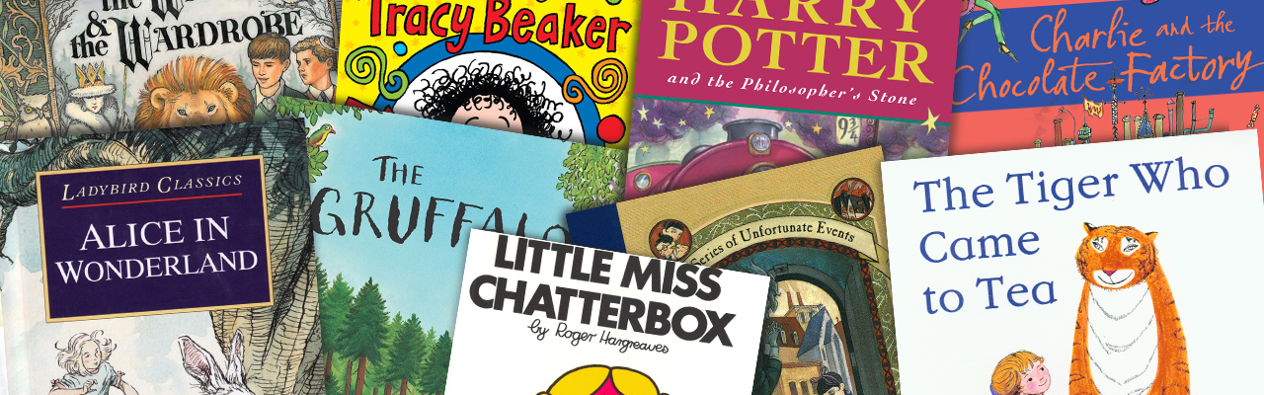**Year 4 Recommended Reading List**

|  |  |
| --- | --- |
| [Image result for billionaire boy](http://www.google.co.uk/url?sa=i&rct=j&q=&esrc=s&source=images&cd=&cad=rja&uact=8&ved=0ahUKEwjLvPH08PrOAhUJPxQKHcwICfgQjRwIBw&url=http://hfcs.primaryblogger.co.uk/2015/06/10/billionaire-boy/&bvm=bv.131783435,d.ZGg&psig=AFQjCNHU-pbDoSy0Li9ffWHN5VLibZzRaA&ust=1473256128502480)**Book** | http://www.thinkingchild.org.uk/wp-content/uploads/2014/07/Butterfly-Lion-cover2.jpg**Author** |
| Bill’s New Frock | Anne Fine |
| Charlotte’s Web | E.B White |
| Why the Whales Came | Michael Morpurgo |
| The Firework-Maker’s Daughter | Phillip Pullman |
| The Snow Walker’s Son | Catherine Fisher |
| Perry Angel’s Suitcase | Glenda Millard |
| Voices in the Park | Anthony Browne |
| Butterfly Lion | Michael Morpurgo |
| Diary of a Wimpy Kid | Jeff Kinney |
| Blitz | Vince Cross |
| https://d4rri9bdfuube.cloudfront.net/assets/images/book/large/9780/5525/9780552545648.jpgThe Suitcase Kid | http://www.gillian-cross.co.uk/images/demon.jpgJacqueline Wilson |
| Demon Headmaster | Gillian Cross |
| Stig of the Dump | Clive King |
| Charlie and the Chocolate Factory | Roald Dahl |
| The Borrowers | Mary Norton |
| Long Way Home | Michael Morpurgo |
| I was a Rat! | Phillip Pullman |
| Measle and the Wrathmonk | Ian Ogilvy |
| Spiderwick Chronicles | Tony DiTerlizzi and Reinhardt Jung |
| The Day the Crayons Quit | Oliver Jeffers |
| https://d4rri9bdfuube.cloudfront.net/assets/images/book/large/9780/4408/9780440866398.jpgThe BFG | https://www.roalddahlfans.com/wp-content/uploads/georcover2.gifRoald Dahl |
| Bambert’s Book of Missing Stories | Reinhardt Jung |
| I Believe in Unicorns | Michael Morpurgo |
| Grandpa Chatterji | Jamila Gavin |
| The Peppermint Pig | Nina Bawden |
| The Twits | Roald Dahl |
| Billionaire Boy | David Walliams |
| The Invisible Dog | Dick King Smith |
| The Legend of Captain Crow’s Teeth | Eoin Colfer |
| George’s Marvellous Medicine | Roald Dahl |
| The 13 Story Treehouse | Andy Griffiths |
| The World’s Worst Children | David Walliams |
| [Image result for the nowhere emporium](https://www.google.co.uk/url?sa=i&rct=j&q=&esrc=s&source=images&cd=&cad=rja&uact=8&ved=0ahUKEwjXh9uh9frOAhWJ1RQKHXqGBBIQjRwIBw&url=https://northeastbookaward.wordpress.com/2015/05/19/the-nowhere-emporium-ross-mackenzie/&bvm=bv.131783435,d.ZGg&psig=AFQjCNE462E03gCLoLBMTMeH09NgWCo7xA&ust=1473257296054807)The Wolf Wilder | https://images.scholastic.co.uk/assets/a/86/1c/134855-ml-554978.jpgKatherine Rundell |
| The Nowhere Emporium | Ross McKenzie |
| Varjak’s Paw | S.F Said |