Dear Parents,
Please find below a range of websites with activities to support your child’s learning whilst at home, followed by a comprehensive list of YouTube educational channels.
Hundreds more online resources can be found in the School Library Association’s lengthy list of home learning and online resources here: School Closure resources (sla.org.uk) and their reading resources here: https://www.sla.org.uk/school-closure-resources-books-and-reading.
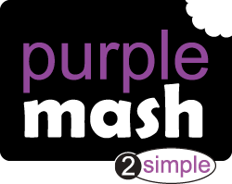 | As you already know there are lots of great resources on this site from topic related activities, maths and English to lots of creative art projects.
 | https://www.purplemash.com/ (logins should be in the front of your child’s reading diary)
 | Great letter formation practise.
 | Cursive Writing Wizard (app)
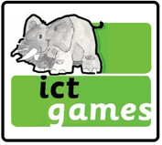 | Another fun way of practising your handwriting.
 | Writing Repeater https://www.ictgames.com/mobilePage/writingRepeater/index.html
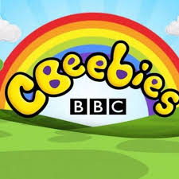 | A variety of games for all here.
 | https://www.bbc.co.uk/cbeebies/games
 | Lots of interactive materials for children aged 1 to 6. They are offering free full access with live classes and on demand classes – parents just need to sign up.
 | https://beanstalk.co/
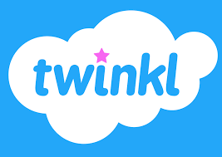 | A wide-range of resources with many free downloads.
 | https://www.twinkl.co.uk
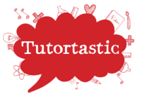 | This site will lead you to a wealth of websites to support home learning.
 | https://www.tutortastic.co.uk/blog/homelearning
 | Oxford Owl for Home is a bright and colourful website with free resources, helpful explanatory videos and a free e-book section.
 | https://www.oxfordowl.co.uk/for-home/
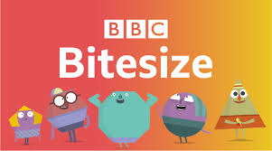 | Lots of educational games and resources for all ages.
 | https://www.bbc.co.uk/bitesize/levels/z3g4d2p
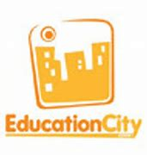 | Select the KS1 option from the home page and there are lots of activities here which will help your child recall previous learning.
 | https://www.educationquizzes.com/ks1/ (logins should be in the front of your child’s reading diary)
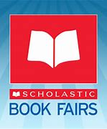 | Free resources from Scholastic.
 | https://resource-bank.scholastic.co.uk/homelearning
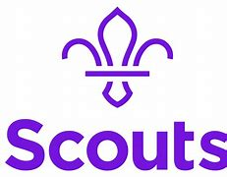 | The Scouts have put together 100 things to do in the “great indoors”.
 | https://www.scouts.org.uk/the-great-indoors/
 | Free access to over 150 lesson plans full of outdoor learning activities.
 | https://www.muddypuddles.com/blog/free-outdoor-lesson-plans-children/
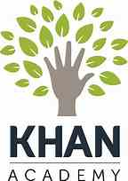 | Free lessons for children aged 2 – 18 offering a wide range of subjects.
 | https://www.khanacademy.org/
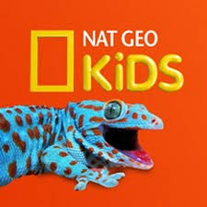 | National Geographic is a great platform for learning and it’s totally free. There are online games, resources and competitions too.
 | https://www.natgeokids.com/uk/teacher-category/primary-resources/
 | Google Arts and Culture uses the website’s Streetview to take you on virtual tours of museums and heritage sites all over the world for free.
 | https://artsandculture.google.com/project/streetviews
 | Explore amazing landmarks from Mt. Fuji to the Great Barrier Reef with Google Treks.
 | https://www.google.com/maps/about/treks/#/grid
 | By using your phone or tablet’s camera, it instantly identifies the exact species of plant, flower, insect or wildlife right in front of you.
 | Free App: Seek by iNaturalist. (Available on Android and Apple).
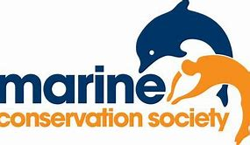 | Marine Conservation Society resources, aimed at ages 5-11
 | https://www.mcsuk.org/coolseas/
 | Girlguiding.org.uk offer a wide range of activities and adventures for families at home.
 | https://www.girlguiding.org.uk/what-we-do/adventures-at-home/
 | Explore dozens of live streams of animals all over the world.
 | https://explore.org/livecams
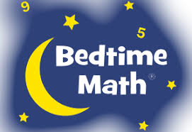 | This website offers math activities for children to enjoy at home, links to research-proven app and fun videos.
 | http://bedtimemath.org/fun-math-at-home/
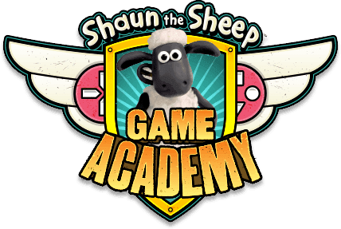 | Learn how to make online games here!
 | https://www.shaunsgameacademy.co.uk/
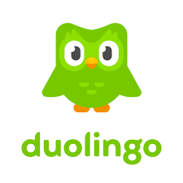 | Learning languages with Duolingo is fun and addictive. Earn points for correct answers, race against the clock, and level up.
 | https://www.duolingo.com/
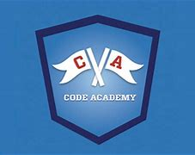 | Learn how to code! (Suitable for older pupils).
 | https://www.codecademy.com/
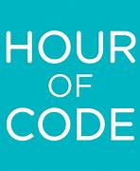 | Try an Hour of Code! Fun, colourful coding activities that can be played on a wide variety of devices and be set for different age levels.
 | https://code.org/learn
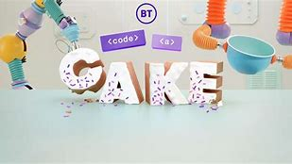 | BT has released a free online experience that introduces more children to the basics of coding while they are at home and off school.
 | https://www.bt.com/codeacake
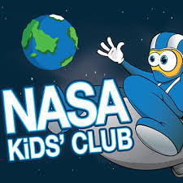 | https://www.nasa.gov/kidsclub/index.html
 | Lots of space related activities for all children.
 | Offering resources, activities, games, apps etc from across all the Science Museum Group’s Museums.
 | https://learning-resources.sciencemuseum.org.uk/
 | Watch science experiments with Colorado University.
 | https://phet.colorado.edu/
 | The Davies Sports 60 Second Personal Challenge is a weekly challenge you can set yourself to help improve your fitness.
 | https://www.daviessports.co.uk/60-second-personal-challenge/
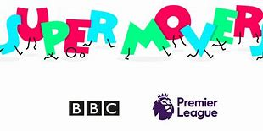 | BBC Super Movers is full of dances and songs designed to help children’s revise different subjects while keeping active at the same time.
 | https://www.bbc.co.uk/teach/supermovers
 | Disney Theatrical offers lots of fun activities based off of their hit musicals such as Aladdin, The Lion King and Frozen.
 | https://disneyonstage.co.uk/education/
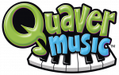 | Quaver Music are offering some free resources and videos.
 | https://www.quavermusic.com/info/at-home-resources/
 | Boost your mental and physical health and wellbeing with the fitnut Superstars.
 | https://www.fitnutsuperstars.com/
 | While we are in lockdown, Audible is offering a wide range of children’s books for free listening online.
 | https://stories.audible.com/discovery
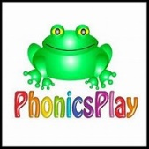 | During this lockdown, Phonics Play are again offering a free log-in for parents at home.
 | https://www.phonicsplay.co.uk/

Educational YouTube Channels
Before choosing to watch any online video, it’s worth taking some to think about these questions:
- Is it suitable for your children? How can you tell? Was it created for children, or is it aimed at an older audience?
- Who created it? How can you be sure that the information in the video is accurate?
- What do your children hope to find out by watching the video? Do they have any questions about the topic before they start? Could you write these down and make a note of the answers as you watch the video?
- Some of the videos have adverts. Why is this?

English
- The Alphablocks are living letters who appear in wonderful videos to help your children learn about phonics and develop their reading skills.
- KidsTV123 has a large playlist of phonics videos that children can watch.
- Fairy Tales and Stories for Kids have lots of animated stories to enjoy. Can your children retell the story to you after they have watched one of the videos?
- BBC Teach has a playlist of English videos to teach your children about punctuation and stories. It also includes ideas for writing, songs and more.
- CBeebies have a playlist of their Bedtime Stories, in which people read popular children’s books. Why not record your own version on a mobile device?
- Watch this collection of book trailers from Scholastic. Could you make a trailer for one of your favourite books?

Maths
- The Numberblocks channel has lots of great videos to help younger children learn about numbers, addition and subtraction.
- The Numberjacks are a group of superhero numbers who appear in educational videos that cover thinking skills, problem solving and maths.
- The Singing Walrus has lots of songs to teach children about numbers and counting.
- Hopscotch has songs to help your children with counting.
- Mr DeMaio creates fantastic educational videos, including this playlist of songs to help your children learn their multiplication tables.
- Laugh Along and Learn also have a collection of Times Tables songs that your children can sing!
- This playlist from Happy Learning English has times tables’ songs, as well as videos about shapes and measurements.
- Math & Learning Videos 4 Kids have a wide range of videos about different maths topics.
- This playlist from BBC Teach explores how maths is used in different areas of life and work. It also includes videos about number, measure and shape concepts.

Science
- Happy Learning English has a large collection of videos about humans, animals and plants.
- Learn about amazing animals with this playlist from National Geographic Kids.
- Hopscotch produces many educational videos. This playlist has songs about habitats, the continents, oceans and planets.
- Operation Ouch produce educational videos about the human body.
- Homeschool Pop has put together a collection of videos that cover a wide range of Science topics.
- SciShow Kids has a wide range of Science videos that answer different questions about the world.
- Science Max carries out huge science experiments. Could your children try similar experiments, but on a smaller scale, at home?

Geography
- Learn about the continents around the world with this playlist from National Geographic Kids.
- BBC Teach has a playlist that can help your primary children to learn about different geographical concepts.
- This playlist from Kids Learning Tube is full of videos to teach your children about countries around the world.

History
- The Horrible Histories channel has some funny videos and entertaining songs that children can use to learn about different periods from history.
- This playlist from Happy Learning English has some animated history videos.
- Clarendon Learning has a large playlist of history videos for children.

Art
- Art for Kids Hub has an enormous range of ‘How to Draw’ videos and art / craft ideas.
- 5-Minute Crafts Play shares craft ideas, experiments and tricks that you can try together.
- Disney Junior also has a playlist of videos from their Art Attack series.
- Easy Kids Craft has lots of enjoyable craft activities that you can complete.
- Free School has a playlist of videos that can teach your children about famous artists from history.

Music
- RelaxDaily has an extensive collection of calming music that your children can play as part of mindfulness activities, or when they are working on other educational tasks.
- Kidz Bop produce child-friendly versions of popular songs. Can your children learn some of the lyrics or dance along with the moves shown in the videos?
- Classical Kids Storytime features children’s stories that are accompanied by classical music.
- Free School has playlists to teach your children about Beethoven and Mozart.

PE
- The Body Coach has a great playlist of ‘5 Minute Move’ videos. These provide short workouts to get your kids moving!
- Little Sports has videos featuring a variety of exercises to help your children stay active at home.
- GoNoodle has videos that teach your children different dance workouts.
- Try different yoga and mindfulness activities with these videos from Cosmic Kids Yoga.
- Footy Pups shares videos to get younger children interested in exercise and to learn different football skills.

More
- National Geographic Kids have a playlist of videos that teach children how different things work.
- TheLearningStation has a playlist of songs to use as Brain Breaks, when your children need a refresh and recharge before they continue their learning.
- Messy Hands has a selection of easy recipes and cooking videos to try with your children.
- Discuss what is happening around the world by watching this playlist of videos from CBBC’s Newsround programme.
- Homeschool Pop has a playlist of timers to use when you would like children to complete a task within a set amount of time!
- Mike’s Home ESL has plenty of games, teaching tips, songs and warm-up activities that you can use with your children!

